Cryomagnets, Interconnections, Superconducting Circuits: What to do in 2012/13 if you are not consolidating splices?
J.Ph. Tock, CERN, Geneva, Switzerland,

Abstract
The interventions affecting the cryomagnets, the interconnections and/or the superconducting circuits, excluding main splices consolidation and QPS interventions will be presented. All the tasks not covered in other talks of this session will be detailed, especially:
- the repair of existing leaks,
- the intervention on Plug-In-Modules,
- the replacement of cryomagnets,
- the consolidation of the connection cryostats,
- the repair of interrupted Y-lines,
- the installation of safety pressure relief devices (DN200 & 160),
- the consolidation of some SAM helium level gauges,
- the use and possible addition of radioprotection samples
- the investigations of open issues like high resistance splices and superconducting circuits non-conformities
Finally, the present plan, work organization and workload for these activities including DS collimators installation, interventions on the beam lines and leaks localization and repair, will be summarized.

introduction
Despite the fact that the consolidation of the main splices will be the most resources consuming activity on the cryomagnets during the next long shutdown, there is in parallel a long list of special interventions on the superconducting circuits and cryomagnets that have to be carried out. Both types of interventions will interfere strongly because:
- they will take place in the same limited space (the LHC tunnel)
- the experienced resources being scarce, a fair sharing will have to be done
- they are often involving work on the same vacuum, cryogenics and/or electrical circuits so a strong coordination will be necessary; first to ensure the safety and also to minimise the losses of time.

In-situ work or cryomagnet replacement
Whenever possible, in-situ repair will be carried out. It is in general less time consuming. It has to be reminded that to replace a “standard” cryodipole in an arc:
- more than 6 different teams have to intervene with heavily interleaved tasks,
- for various reasons, work is taking place on a length of 216 m,
- this could create interference on 3-km long non-sectorised circuit(s),
- it takes 6 weeks between the opening of the first interconnection to the reclosure of the last one,
- about 600 man hours are necessary.
Additionally, some cryomagnets are even more difficult to replace : SSS with jumper, cryomagnet in the dispersion suppressor zones, ...

vacuum related issues

Leaks
Presently, the LHC machine is operated with about 20 acceptable leaks spread around the whole circumference. The leaking subsectors are identified but time has to be allocated before the start of opening of the interconnections outside sleeves (W-bellows) and during the shutdown for localising the leak precisely, for fixing them in-situ and then for validating the repair. Among them, only one is critical: it is located in subsector A27L4 in the sector 34. This is the only one that could trigger a cryomagnet replacement if it cannot be fixed in-situ. The goal will be to fix all of them but it is not excluded that acceptable ones will be left if their repair is not feasible or has a too huge impact. On the other side, new leaks can appear before or during the shutdown that will require intervention.

Plug-In Modules (PIMs)
During the PIMs fabrication, a non-conformity affecting the RF fingers was encountered. It could lead to a failure of this component during the warm-up of the machine.
All the PIMs that will have buckled during the warm-up will obviously be exchanged after localisation thanks to the RF ball. Based on previous sectors warm-up, it is estimated that about 18 units will have to be replaced.
Additionally, some of them were heavily damaged during the initial assembly of the interconnections. To avoid delaying the schedule, they were left as they were but their lifetime could be reduced. The unacceptably damaged ones will be replaced if an inspection by the specialists confirms the need. There should be less than 10 units to replace.
When the LHC machine is left floating, its temperature is slowly increasing. While the centre of the arcs remain very cold, the extremities are warming-up faster and so increasing the risk of PIMs failure or reducing the autonomy. During the 2008-09 shutdown, some sector extremities were already consolidated with conform PIMs. It is proposed to consolidate the remaining ones during the next long shutdown, leading to the replacement of 18 units.
The present baseline is thus to replace about 45 PIMs.
In case of a local warm-up, the failure of a PIM is not excluded. If this happens, this can be detected thanks to the X-ray tomography but the repair will require warming of the neighbouring subsector and venting the beam line to replace the PIM and then, after restart of the LHC, a scrubbing run will likely be necessary to recover the adequate vacuum level. It is important to note that the X-ray tomograph is not a practical systematic inspection tool as it takes several hours to inspect one of the 1700 interconnections. To decrease the risk of PIMs failure in case of a local warm-up, the replacement of QQBI and/or QBQI types PIMs is discussed but is presently not included in the baseline.

Nested bellows
During initial interconnections assembly, about 55 nested bellows were damaged; two of them quite heavily and they were consolidated (see Fig. 1). A thorough analysis by the expert concludes that they can survive a few cycles. As they are working only in case of an error in the cryogenics operation, it is not planned to replace them. This will be confirmed after a very careful inspection. The present procedure to replace them requires a complete exchange of the beam screen so the disconnection of the cryomagnet.
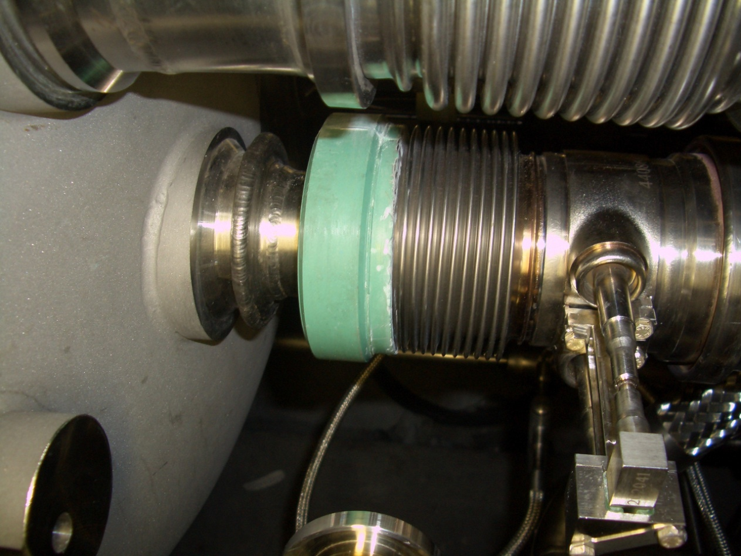
Figure 1: Repaired nested bellows (QBQI.10L5)

Beam screens
After the 34 incident, due to the lack of beam screens with the correct saw-tooth profile orientation, reversed ones were installed [1]. This concerns 12 dipoles in sector 34. Also, there are 2 SSSs equipped with the wrong type of beam screen (see chapter 6 of [1]). This could be an issue for electron cloud build-up and so affecting beam physics and cryogenics. A study is presently on-going to check the necessity to change them. Presently, it is not planned to replace them. Should the study concludes that the correct type needs to be installed, this would involve the exchange of 14 cryomagnets so a very huge work.
In sector 81, one beam screen has a leaking cooling capillary. It was bypassed. The equipment responsible confirmed that its exchange is not necessary.

cryogenics related issues

Stand Alone Magnets helium level gauges [2]
Since the beginning of cryogenics operation, it was noticed that (Semi)Stand Alone Magnets(SAM) helium level gauges readings were not very stable. During the 2008-09 shutdown, two of them were not accessible without major delay: Q6R2 & Q6L8. The baseline is to consolidate them in the next long shutdown.

Leaking Y-lines
The Y line is a copper line, part of the bayonet heat exchanger. Two of them are presently leaking. The impact is that recooling of the concerned cells takes slightly longer. As the interconnections will be opened, the baseline is to fix them: S78:17-19R7 & S81:19-21R8.

Safety pressure relief devices [3]
In the 2008-09 shutdown, some sectors were not warmed up and so, it was not possible to install the DN200 pressure relief devices. Also, the safety pressure relief devices could not be installed on Q6R2 & Q6L8. It is planned to complete the new protection scheme during the next shutdown. About 600 relief valves have to be installed.

Inner triplet passive heaters [4]
During assembly of the Q1 magnet, the applied configuration of the passive heaters (copper braids) on the phase separator reservoir was wrong. The most critical cases (R1&L5) were corrected during the 2008-09 shutdown. The proposed baseline is to intervene on the two most critical cases (L1&R5) in the second part of the shutdown. Time permitting, the four other cases (L&R 2&8) will be also corrected but they are not included in the baseline.

Cryogenics instrumentation
Several cryogenics sensors are not functioning nominally but this does not prevent a smooth operation. During next shutdown, as most of the interconnections will be opened, access will be given to cryogenics instrumentation team for them to solve as many cases as possible.

electr(omechan)ical integrity

Connection Cryostats
In 2008, a short to ground was detected on the RQF circuit in sector 78; it was traced back to the shuffling module of the Connection Cryostat (CC) [5]. It was consolidated in all CC but in sector 56 that was not accessible as already under cool-down. During consolidation of the CC in 11L6 in the 2008-09 shutdown, another non-conformity was detected [6]. A consolidation solution was defined but, again to avoid major delays and as tests have proven that the risk was very low, two CC (L1&3) were not consolidated and one was even not inspected (L8). During the next long shutdown, the baseline is to inspect the CC L8; consolidate it if necessary and also the 2 remaining ones. Note that to install the DS collimators in IR3 [7], the CC in 11L3 has to be replaced by a shorter one. As all the busbar lines in the interconnections will be opened, the opportunity will be taken to perform a careful inspection of the 17 CC and confirm that the fixes applied are sound.

Circuit issues [8]
There are several issues on superconducting circuits. To save time and minimize the risks, they were condemned. It is planned to complete the investigation at cold before the long shutdown and at warm. Then, after identification and localisation of the defect, a repair procedure will be defined and implemented.

Special splices
The 6 kA pray-hand splices have been analysed and presented [9]. The design has been validated by the review committee [10]. In parallel, an exhaustive splice mapping is on-going. During the shutdown, some such line N boxes will be opened for inspection to check the correct workmanship.
During the assembly of the first sector (78), some 600 A line N connections were found non-conform. Most of them were inspected and redone if necessary. For the non-inspected ones, sampled inspections are planned.
The main circuits contain also non-standard splices, namely the 13 kA splices in the DFBAs. Their consolidation will require a specific access procedure. The need for consolidation will be discussed by the LHC splices task force [11].

High inner splice resistance
Thanks to the nQPS system, all inner splices of the main dipole and quadrupole cold masses were measured. [12]. The maximum value in a dipole is 28.1 nΩ and about the same in a quadrupole. Figure 2 shows the cumulative number of dipole cold masses with an inner resistance higher than a certain value. These high resistances are not worrying from the cryogenics or electrical point of view. The concern is that a high electrical resistance can reveal a very bad mechanical contact that could fail and open when submitted to electromechanical forces, for example if the splice quenches.
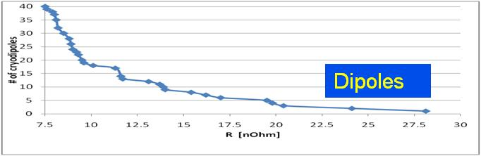
Fig. 2: Dipoles inner splice resistance
In order to estimate the resources and as it is judged a reasonable value [13], the proposed baseline is to replace 8 cryodipoles and 1 SSS, reducing by a factor 2 the highest inner splice resistance in the LHC machine. In parallel, a study and a test programme are launched to gain knowledge on the behaviour of these possibly weak splices.

Electrical non conformities
Some cryomagnets are affected by non-conformities [8]; they mainly concern quench heaters and high voltage withstand level. For various reasons, investigations were stopped as a method to allow continuation of operation was available. Cold and warm diagnostics are planned for all the identified cases. It will be first tried to repair in-situ and, if not feasible, the cryomagnets will be replaced by spare ones. Based on reasonable assumptions, it is estimated that 5 cryodipoles will have to be replaced.

beam dynamics
Following the incident of 19/09/2008 in sector 3-4, it was necessary to substitute several SSSs. For 4 slots, the limited availability of spare Arc-SSS cold masses has not permitted to install SSSs compatible with the LHC baseline layout 2008 [14]. Consequently, some lattice correctors are missing. The RQS.R3B1 is not available anymore and the power of 3 other circuits (RQS.A34B2, ROD.A34B1, ROF.A34B2) is reduced. To restore them completely, four SSSs should have to be exchanged. Discussing with BE/ABP, the priority should be put on the skew quadrupole circuits that require to change the SSSs Q23R3 and Q27R3.
The baseline is to exchange these last two SSSs (Q23 & Q27 R3). This involves a lot of surface work to prepare the spares and their replacement will be quite time consuming as these SSSs are equipped with jumpers, increasing the work to be carried out and the interferences created.
Also, one cold corrector RCBCHS5.L8B1 in Q5L8 is missing [15] but it is replaced by a warm magnet installed next to Q5L8. A replacing SSS is under manufacturing. It is not a priority to perform the exchange unless there are other issues to be considered, such as a potential short in the five remaining dipole correctors.

ds collimators
Ref [7] presents the activities required to install the DS collimators at point 3. This involves the disconnection, displacement and re-interconnection of 32 cryoassemblies. It is not really exchanges of cryomagnets as the baseline is that the removed ones are placed back at their original position.

miscellaneous
Many local interventions will be required for giving access for short interventions, like for example BPM cables checks and possibly repairs, recovery of the radioprotection samples for analysis [16] or installation of new ones.
Last but not least, interventions will be required to solve new issues appearing before the shutdown and also to manage non-conformities generated by the other activities during the shutdown. These last ones will require each time dedicated delicate procedures. 26 % of the resources are allocated to these works which is judged a little too low. 30 % seems more appropriate. Fig. 3 represents the work sharing of the special intervention team based on a team of 20 persons and a work period (opening of the first interconnection to the re-closure of the last one) of 12 months.
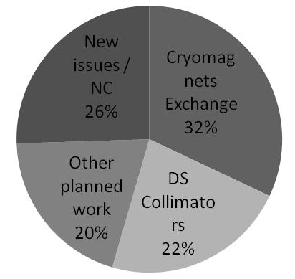
Fig. 3: Allocation of the special intervention team resources

cryomagnets exchange
Table 1 summarizes the current status of the quantity of cryomagnets to exchange. The 32 cryoassemblies concerned by the installation of the DS collimators are not included in this table.
Table 1: Cryomagnets exchange
Reason | Dip | SSS | Tot
High inner splice resistance | 8 | 1 | 9
Electrical integrity | 5 | 0 | 5
Beam optics (Q23R3, Q27R3) | 0 | 2 | 2
Leaks | 1 | 0 | 1
Reversed beam screens (*) | 0 | 0 | 0
TOTAL | 14 | 3 | 17
(*) Note that if cryomagnets with a reversed beam screen have to be exchanged, this would add 12 dipoles and 2 SSSs so almost doubling the total amount.
For this baseline, the spares cryomagnets are expected to be available at the surface before the start of the shutdown.

the special intervention team
To fit this work in a period of 12 months between the first opening and the last reclosure of an interconnection, a team of 20 persons is necessary. The objective is that this team completes its work before the arrival of the teams (train) in charge of the consolidation of the main splices. As the work is specific and sometimes will have to be finalised in-situ, a ratio of minimum one experienced/ one new staff is judged acceptable to ensure a reasonable progress without taking exaggerated risk. The present situation is that 6.5 persons are identified out of the 20 required so leading to ratio lower than 1/3 of experienced staff; it is critical and risky. To lower this risk, the options are :
- To accept a longer shutdown duration allowing to shift experience resources working on the main splices to the special intervention team (eg. Orbital machining of sleeves team)
- To reduce the scope of work of the special intervention team (eg. Number of cryomagets to be replaced)
- To shift experienced resources planned for the main splices consolidation to the special intervention team.
It is important to remind that work will take place all around the LHC circumference, making the coordination and follow-up quite demanding in terms of supervision staff.

conclusions
The list of tasks has been presented. Some of them needs to be confirmed or detailed. In particular, the need or not to replace cryomagnets with reversed beam screens has a strong impact on resources and time needed. Also, the issue of cryomagnets with high inner resistance will be revisited when data is available from analysis and test programme. The special work will extend all over the 27 km of the LHC. The presently identified and available staff leads to a critically low ratio (<1/3) of experienced staff in the team.
ACKNOWLEDGMENTS
The author would like to thank many CERN colleagues for their inputs, in particular V. Baglin, F. Bertinelli, N. Bourcey, N. Catalan, Z. Charifoulline, S. Claudet, P. Cruikshank, P. Fessia, C. Garion, M. Giovannozzi, A. Jacquemod, M. Jimenez, A. Musso, V. Parma, H Prin, C. Scheuerlein, L Tavian, A. Vande Craen.

References
[1] LHC-VSS-EC-0010, Change of beam screen types in cryodipoles for sector 3-4, EDMS 985318, N. Kos
[2] Modification of Helium level gauge feedthrough capillary of (semi) stand alone magnets, EDMS 1093349, J.Ph. Tock
[3] New protection scheme and pressure relief-valve staging of the LHC insulation vacuum enclosure following the 19th September 2008 incident, CERN ATS Note 2010-057, EDMS 1044895, L Tavian
[4] Passive heaters improperly installed on the Q1 phase separator pot, EDMS 982513, 982506, 982524, 982518, 982511, 982525, 982512, 982517, C Darve
[5] Consolidation of the electrical insulation of the connection cryostats busbars, EDMS 1098788, J.Ph. Tock
[6] Consolidation of the connection cryostats busbars, EDMS 1093355, J.Ph. Tock
[7] Installing collimators in the next long shut-down: plans, status and challenges, these proceedings, V Parma
[8] What needs to be done to reach beam energy above 3.5 TeV? Commissioning of essential magnet powering and machine protection systems, these proceedings, N Catalan
[9] Risk assessment of all SC splices in LHC : 6 kA circuits, First LHC Splice Review, J.Ph. Tock
http://indico.cern.ch/materialDisplay.py?contribId=10&sessionId=2&materialId=slides&confId=109100
[10] Report from the First LHC Splices review, Task Force LHC Splices Consolidation, https://espace.cern.ch/lhcsplices/default.aspx
[11] Task Force LHC Splices Consolidation https://espace.cern.ch/lhcsplices/default.aspx
[12] Status of 1.9K Splice Resistances in LHC Main Magnets (interconnects and internals), EDMS 1101534, Z Charifoulline
[13]TETM 17.01.2011, https://te-dep.web.cern.ch/te-dep/internal/TE-TM.html
[14] LHC-LQA-EC-0004, SSS - Arc 34 EDMS 992709, M Modena
[15] QN-ELQA-TP4E-ORC-MCBCHS5.L8B1-001, EDMS 831927, V Chareyre
[16] LHC-LI-EC-0001, Introduction of samples in the arc interconnections, EDMS 906072, L Ulrici

