Implication of increased Beam energy on QPS, EE, time constants
J. Steckert, CERN, Geneva, Switzerland.

Abstract

Increasing the beam energy of LHC is coupled with an increase in current in the main dipole and quadrupole circuits. This paper will show the implications of increased beam energy on the circuit protection (CP) systems. Relevant system details and their limits will be discussed for several operational scenarios. The main focus lays on the system’s behavior during the fast power abort (FPA) which is the most challenging mode of operation. Furthermore measures to mitigate the EM-transients during FPAs are shown.

current situation
During the 2010 run, LHC was operated at an energy of 3.5 TeV. The main bending dipoles as well as the quadrupole magnets had been commissioned up to a current of 6kA. This is half of the nominal current. Minimizing the risk for the magnet interconnects, the energy extraction (EE) time constants had been reduced to τ=52s for the main dipoles and τ=10s for the main quadrupole circuits [1]. Operating with half the current but also half the time constant during EE the voltages in the systems are equivalent to nominal settings (12kA/104s). The 2010 run period had shown that the most challenging situation for the quench protection (QPS) and EE systems is the fast power abort. During this event high inductive and resistive voltages as well as electromagnetic transients and interferences are present. At the same time the QPS system should operate reliably with rather low detection thresholds. Hence the main focus of the next paragraphs will be on energy extractions and their effects on the circuit protection.

System Overview
The picture below shows a schematic layout of a LHC 13kA dipole circuit. 154 bending dipoles are connected in series with two energy extraction systems at both sides of the arc. The power converter is in series with the even-point extraction system. All the relevant voltages which occur during a fast power abort are marked in the drawing.
Figure 1 Main circuit schematic

U_{mag} is the voltage drop over a single super conducting magnet. The symmetric quench detection board of the nQPS measures this voltage and compares it to the adjacent magnets to detect a symmetric quench. U_{mag} at the beginning of a fast power abort can be calculated with (1)
$U_{mag}=\frac{\left(2* R_{dump}*I+m*U_{diode}\right)}{154-m}$ (1)
where R_{dump} is the resistance of the energy extraction resistor, U_{diode} is the forward voltage of the cold diode parallel to each resistor and m is the number of quenching magnets. Given this equation, the magnet voltage is primarily dependent on resistance and current and in second order dependent of the number of quenched magnets ~100mV per quenched magnet.
U_{EEmax} is the voltage drop over the energy extraction resistor. As shown in (2) U_{EEmax} is determined by the value of the resistor and the current in the circuit at the moment of the EE switch opening.
$U_{EEmax}=R_{dump}*I$ (2)
Another important parameter is the time constant of the circuit during EE. It can be calculated with (3)
$τ= \frac{L}{2* R_{dump}}$ (3)
Where L is the inductance of the circuit and R_{dump} is the energy extraction resistor value. Since L is fixed, the dump resistor value is the only way to change the time constant of the circuit. Connected to the time constant is maximum di/dt during the EE. It is
${di}/{dt}= \frac{I}{τ}$ (4)
where I is the Current in the circuit at the beginning of the energy extraction
The following table shows the limits of the parameters introduced above
System | Main Dipoles | Main Quadrupoles
Cold circuit peak voltage U_{ccp} | < 1900V (1600V*) | < 240V
Energy Extraction U_{EE} | < 1300V | < 200V
Common mode power converter U_{pcp} | < 1000 V | < 420V
Max di/dt magnets | 120 A/s | 350 A/s
oQPS max di/dt | < 150 A/s | <1000 A/s
nQPS SymQ U_{mag} | < |14.5V| | < |14.5 V|
Table 1: General system Limits

System Details
The following subsections will briefly describe the relevant system details which lead to the values in shown in Table 1.

Energy Extraction System
The main limit of the EE system is the maximum voltage over the EE switch. Dedicated tests had shown that a voltage up to 1300V for the dipole switches is tolerable. Beyond that point the arc shuts of the switch cannot extinguish the electrical arc anymore. For the quadrupole circuits this limit is at 200V due to a modified arc shut. For all dipole configurations shown in Table 2 the switch voltage is not a limiting factor. However the rating of the quadrupole switch starts to be an issue from beam energies beyond 4TeV. To reduce the electrical arc during switch opening and hence the resulting EM transients, snubber capacitors can be installed in parallel to the switch. Tests had been shown that the arcing is reduced considerably. The figure below shows the snubber capacitors installed inside a 13kA switch sonic cabinet.
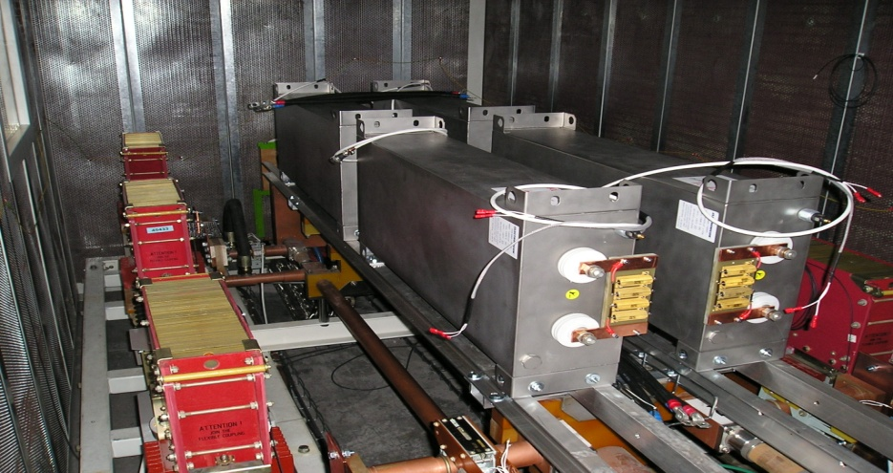
Figure 2 Snubber capacitors installed on a 13kA switch
Another integral part of the EE system is the energy extraction resistor which absorbs the energy stored in the circuit. The configuration of the dump resistors is the only way to vary the time constants of the main circuits. Given the actual design of the resistors time constants of 104s, 68s, 52s, and 34s are possible for the dipole circuits. The quadrupole circuits can be configured to 10, 12 or 15s time constant.

Old QPS system
This system is the primary quench protection of both, dipole and quadrupole circuits. Based on analogue measurement bridges, one of the limiting parameters is the change in current. Above a di/dt of 150A/s the difference in inductance between the apertures of the magnet will unbalance the measurement up to the quench detection threshold of 100mV. This effect as well as the EM transient caused by the arcing switches can lead to spurious heater firing. While the di/dt limit gets critical around 4.5TeV/52s operation, the EM transients caused by the arcing switches is already an issue for 6kA operation. Fig3 shows the signal of all oQPS detectors of one sector during a fast power abort
Figure 3: oQPS bridge signal during FPA

As shown above the electrical arc during switch opening is clearly visible in the aperture difference signal of the oQPS detectors. As mentioned above, snubber capacitors will mitigate the arcing and hence the EM transients.

New QPS system
The nQPS system consists of the bus-bar splice protection board and the symmetric quench detection system. Since the bus-bar supervision board is not active during EE, the remaining system is the symmetric quench detection board (SymQ). The symmetric quench detection board is measuring the voltage across four electrically adjacent magnets and compares them. If any of the differences between these voltages is exceeding the threshold the respecting heater is fired. The limiting factor of this component is the maximum input voltage. The ADC of this system is saturating at a voltage across a single magnet of |15.5V|, hence the protection is not assured beyond that value. Given some margin the limit for normal operation is |14.5V|. According to (1) each quenching magnet increases the voltage load on the other magnets. Therefore the operational parameters have to be chosen with an additional margin allowing a number of simultaneous quenching magnets without exceeding the voltage limits. Another important parameter of the symmetric quench detection is the threshold. In the actual setting the threshold was calculated for a current of 6kA, any operation beyond that current requires a new (lower) detection threshold. Figure 4 shows the difference signal of one SymQ board during an energy extraction from 5.8kA. As shown, the biggest differences in U_{mag} appear during the switch opening.
Figure 4: dUmag of SymQ during FPA from 5.8kA

SYSTEM LIMITS VS OPERATIONAL PARAMETERS
Given the system limits defined by the properties of the various system elements it is possible to crosscheck these limits with the operational parameters for several beam energies. As mentioned above, the two variables are the beam energy and the time constant. Table 2 shows the operational parameters and highlights violations of system limits.

 | τ[s] | I_{RBc} [A] | U_{EE} [V] | U_{mag} [V] | di/dt [A/s] | τ [s] | I_{RQc} [A] | U_{EE} [V] | U_{mag} [V] | di/dt [A/s]
Circuit |  |  | RB |  |  |  |  | RQ
3.5 TeV | 52 | 6000 | 882 | 11.5 | 116 | 10 | 6000 | 74 | 2.3 | 609
4 TeV | 52 | 6000 | 999 | 13* | 130 | 10 | 6400 | 187 | 2.4 | 655
4 TeV | 68 | 6800 | 768 | 10 | 100 | 15 | 6400 | 120 | 1.6 | 421
.5  TeV | 52 | 7650 | 1125 | 14.6 | 146 | 10 | 7200 | 209 | 2.7 | 731
4.5 TeV | 68 | 7650 | 864 | 11.2 | 112 | 15 | 7200 | 135 | 1.7 | 747
5 TeV | 52 | 8500 | 1250 | 16.2 | 162 | 10 | 8000 | 232 | 3 | 812
5 TeV | 68 | 8500 | 961 | 12.5 | 125 | 15 | 8000 | 150 | 1.9 | 527

Table 2: Selected system parameters for different beam energies. The numbers in bold exceed one of the limits set in Table 1. Figures with light gray background are close to the limit.
*15 quenching magnets will increase this value to the limit of 14.5V

Dipole circuit
The current operational state is shown in the first line of Table 2: a beam energy of 3.5 TeV with a time constant of 52s. This setting does not violate any of the system limits. If the energy is increased to 4TeV without changing the time constant, a maximum di/dt of 130A/s is exceeding the magnets’ rated di/dt. Since this rating is only slightly violated and furthermore the current is still far below the max current this should be not an issue. Another parameter which comes close to its limit is the U_{mag}. With 13 volts it is still 1.5V below the limit however, 15 quenching magnets would increase this value to 14.5V. Nevertheless operation at 4TeV with 52s time constant is still regarded to be possible. Realizing the 4TeV with a time constant of 68s relaxes all critical parameters for the CP system.
Any energy beyond 4TeV cannot be operated with 52s time constant due to the violation of at least one critical parameter. However, if a time constant of 68s is chosen the system limits would permit operation up to 5TeV.

Quadrupole circuit
As shown in Table 2 the quadrupole circuit is less critical concerning most of the parameters. The time constants can be varied between 10 and 15s. With the 10s setting as it is in the moment. Operation up to 4TeV is possible. Beyond that energy the time constant has to be increased to 15s. Overall the quadrupole circuits which are limited by the 200V switch rating are less critical than the dipoles circuits

Operation scenarios
To further evaluate the different constraints, limits, risks and benefits. The following paragraphs show different scenarios of operation and discuss the advantages as well as the risks.

Current settings (A)
This scenario neither increases beam energy nor include any hardware changes. The following table shows the pro and contra points of this scenario.
Pro | Con
No hardware changes | No physics gain
Proven, reliable operation | Arcing on switches persist
No increased risk for BB splices | Spurious heater firing on oQPS

Current settings + snubber capacitors (B)
Snubber capacitors are a good way to reduce the overall stress to the system caused by electrical arcs in the switches. Especially the oQPS will profit from these devices.
Pro | Con
Reduced switch arcing | No physics gain
Less system stress | Hardware modifications
No increased risk for BB splices

4TeV, no hardware changes (C)
This scenario leaves the hardware of the circuit untouched and just increases beam energy.
Pro | Con
Physics gain | Increased EM transients
No hardware changes | Increased BB splice risk (higher current)
 | Higher probability for spurious QPS triggers

4TeV, snubber capacitors (D)
This scenario leaves the time constant at 52s but snubber capacitors are installed across the dipole switches. The table below shows the risks and benefits.
Pro | Con
Physics gain | Increased BB splice risk (higher current)
Reduced switch arcing | Hardware modifications

4TeV, increased time constant (68s), snubber capacitors (E)
This scenario is the best for the CP systems as it greatly reduces the overall system load during EE which would lead to reduced false triggering.
Pro | Con
Physics gain | Further increased risk for BB splices (higher current and time constant)
Reduced switch arcing | Hardware modifications
Less system stress

Conclusion
As it can be clearly seen in the scenarios above, the benefit of longer time constants for the CP system are contradictory for the bus-bar splice risk. A good balance between the risks has to be found to operate the circuits in an optimal way. The following graph shows the beam energy versus the time constants versus the CP systems’ limits and the risk for the bus-bar splices. The points of operation for the different scenarios are marked.
Figure 5 System limits vs. beam energy, time constant an possible points of operation

References
[1] K.H. Mess Engineering design order: Change of the Magnetic Energy Extraction Resistors, LHC-DQR-EC-0002 ver.1.0, EDMS Document No. 1013572

4.5TeC, increased time constant (68s), snubber capacitors (F)
Another scenario which is possible from CP point of view is the operation at a current equivalent to 4.5TeV beam energy and a time constant of 68s. While these settings are not violating any limits of the circuit protection systems, the additional risk for the splices makes this scenario rather unlikely

