Review of the consolidation works scheduled for the LHC cryogenic installations during a long shutdown
O. Pirotte, on behalf of the CRG group, CERN, Geneva, Switzerland.
Abstract
The operation of the LHC cryogenic systems during the last two years at half of the nominal energy has highlighted a number of required consolidations. The main projects will be reviewed with emphasis on safety issues, LHC downtime risk and cryogenic systems performance. In addition the implications of the maintenance activities will be also examined. Finally the status, cost, resources and planning of all these activities will be summarized.

INTRODUCTION
In addition to the maintenance works that have to be scheduled during a long shutdown, various major consolidations which concern the cryogenic systems have been identified. Part of these consolidations are recommendations from the Safety Task Force [1], others are non conformities which are usually already listed in Engineering Change Requests (ECR) or internal technical notes. The remaining ones are new proposals to improve the general safety, the LHC downtime risk and the performances of the cryogenic systems.

NON Conformities - Repairs
A substantial part of the CRG activities during the next long shutdown (LS1) will consist in putting in conformity equipments in the LHC tunnel which the group is responsible for.

DFB Vacuum Pressure Relief Devices
During the 2008-2009 long shutdown three sectors were not warmed up: S23, S78 and S81. Consequently it has not been possible to upgrade the High Current Module (HCM) and the Low Current Module (LCM) of the DFB with the new required pressure relief devices [2] [3] [4]. These interventions have to be scheduled during the next long shutdown (LS1) :
- 8xDN230 pressure relief devices on HCM of the DFBAD, DFBAE, DFBAN, DFBAO, DFBAP and DFBAA;
- 4xDN200 pressure relief valves on HCM-LCM links and Q6-LCM links of the DFBAD and DFBAO;
- 2xDN100 pressure relief valves on LCM chimney of the DFBAD and DFBAO.

To improve the safety of personnel in case of helium release, the staging of the relief devices shall be revised and/or deflectors installed. This concerns :
- All the DN230 pressure relief devices on HCM of the 16 DFBAs;
- 29 deflectors for the DN100 pressure relief devices on the DFBA HCM and DFBM;
- 10 deflectors for the DN200 pressure relief devices on the chimneys of the DFBA LCM;
- 23 deflectors above the DN200 pressure relief devices on DFBM and DFBA links;
- 5 deflectors for the DN200 pressure relief devices on the DFBL.

Inner Triplets
To relieve the mitigation measures which prevent the access in the Inner Triplet (IT) area, DN300 ducts which will collect the possible flow of the pressure relief valves installed on the vacuum enclosure after the 2008 incident have to be installed [5]. The cost estimate is 25 kCHF with an intervention of 3 weeks for each inner triplet.

DFBA 13kA Current Leads
To prevent the destruction of the thermal sensors on the 13 kA current leads, the commissioning tests are performed at 1.7 kV. This limits the operation of the LHC at 5 TeV. To restore the conformity with the LHC specification, the complete hardware (connectors, cables and DAQ cards) involved in the measuring chain of the current lead thermometers have to be changed during the LS1 [6].

DFBX Current Lead Control
The regulation of the conventional vapour cooled current leads of the DFBX (120A and 600A) consolidated in 2008 needs to be improved by a more reactive and robust control. Each current lead of each DFBX (8x19) shall be equipped with radiation hard flowmeters.
A budget of 130 kCHF and 3 working weeks for the upgrade in the tunnel is estimated for each DFBX.

DFB miscellaneous issues
Since the DFB have been put into operation, various issues have been indentified which will need interventions during the LS1 :
- Replacement of a metallic flexible hose by a rigid pipe in the DFBAs to avoid leak development due to fatigue and vibration wear (12 DFBAs remaining) [7] [8];
- Repair of the air leak located on a chimney of the DFBAO;
- Upgrade of the DFBAO according to [9] to improve its performance (LHe level control);
- A thermal performance issue has been detected on the DFBMC.5R2. This issue might prevent the LHC operation at 14 TeV. A deep and internal investigation will be required to analyse and resolve this issue.
- Bellows of the vacuum enclosure of the links with the DFBA have been found damaged. Protections shall be installed.

QURC P8
During the 2008 operation of the LHC a downtime issue had been identified on the 1.8K system (QURC). In 2009, during the 2008-2009 long shutdown the 1.8K systems of P4 were upgraded with new cryogenic control valves (CV241) which reduced the downtime. During the LS1, the same upgrade shall be performed on the 1.8K systems at P8.

Standalone Magnets helium level gauges – leaking Y lines
As other consequence of the not warming up of sectors S23, S78 and S81 during the 2008-2009 long shutdown period two standalone magnets (Q6R2 & Q6L8) were not accessible for the consolidation of their level gauge. In addition it prevented also the repair of leaking Y-lines in the sectors S78 and S81. These works shall be completed during the LS1 [12].

SAFETY
Works in relation with safety improvements have been identified.

Instrumentation of the tunnel
The recommendation #12 of the task force report [1] requires to equip each sector of the LHC tunnel with sensors to monitor air temperature and pressure, as well as air speed. These sensors will be monitored by the cryogenic control system.

HRL sectorisation
In line with the recommendation #13 of the task force report [1] the HRL valves need to be motorized in order to improve the cryogenic consignations and to allow safe interventions in the tunnel.

Access platforms
Access to the instrumentation located on the QRL service modules (SM) is very acrobatic. The risk of injuries and of collateral damage to neighbouring equipments is very high. Access platforms shall be installed to allow safe intervention and the maintenance of the equipments. Three categories of platforms have to be considered :
- 223 platforms for the QRL SM in the arcs;
- 63 platforms to access the QRL SM attached to the StandAlone Magnets (SAM) in the LSS;
- 24 platforms to access the QRL SM attached to the DFBAs and the DFBX.
This represents in total 310 access platforms with a cost estimate of 850 kCHF and an installation activity of 4-6 weeks/sector.

Figure 1: study of a retractable access platform for a QRL SM in the arc

cryogenic LHC ACCELERATOR ConsolidationS & new proposals
This section lists the consolidation works that should be achieved in order to improve and consolidate the performance of the cryogenic systems and to reduce the downtime of the machine.

Quench lines
To recuperate the helium after a major sector quench, dedicated lines (Quench Lines - QL) have been installed between the tunnel and the quench buffer vessels located in surface.
Commissioning tests in 2008 have revealed major conflicts during the shrinkage of the lines with neighbouring underground equipments. These tests have also shown that the foamglass® insulation was not adapted and destroyed with the result that electrical equipments were sprayed out with liquid air.
As consequence the quench lines located on odd points can not be put into operation and are partially in operation on even points. The QBV and their function to recuperate the helium in case of a sector quench are also not fully commissioned.
In case of a major sector quench, the helium will presently be released to the atmosphere. This lost of helium represents a cost of 700 kCHF / sector. To avoid an associated major downtime risk (several months) due to lack of helium reserve, it is mandatory to use the new strategic liquid helium storage.
To restore the functionality of all the QLs new integration solutions shall be studied and implemented. The total cost estimate is 650 kCHF and interventions up to 10 weeks / point.

Compressed air distribution to cryogenic instrumentation
The service modules of the QRL are equipped with various pneumatic valves that must be operated with a well determined air pressure. Currently they are equipped with air supply panels that can supply only one pressure (6 bar - minimum pressure for the quench valves) while some of the cryogenic control valves require a maximum pressure of 2 bar for an optimum operation.
In order to improve the performance and the life time of these cryogenic valves, an upgrade of the compressed air distribution panels shall be made. The total cost estimate is 25 kCHF / sector with interventions lasting up to 3 weeks / sector.

Flowmeters on Beam Screen circuits
The operation of the LHC in 2010 has shown issues with the performances of the beam vacuum. Measurements of the heat loads on the beam screens can be used to help to diagnostic the issues linked to the beam dynamics. It requires the installation of flowmeters in the interconnection between the magnets and the QRL to measure the mass flow in the beam screens as shown on Fig 2.
On the basis of an installation of 8 Coriolis flowmeters / sector (every 400 m), the cost estimate is 8x8x20kCHF= 1.3 MCHF.
One has to point out that the related work to implement this consolidation will certainly have to face an integration issue in the interconnections.

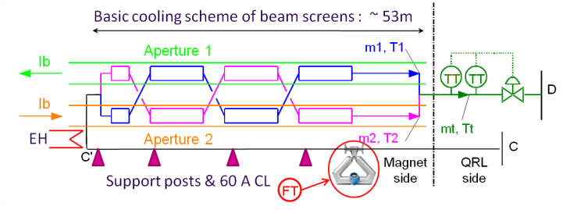
Figure 2: insertion of a flowmeter to measure the beam screen heat load

Pressure measurement on header B
The cryogenic operation of the header B (sub-atmospheric circuit) relies presently on only one pressure transducer located upstream next to the cold compressor system of each sector. Extrapolation and indirect measurements are used to operate the line up to 3 km further to the return module.
To assess the line B operation and introduce redundancy for this mandatory pressure measurement, a pressure transducer shall be installed on each return module (see Figure 3). These pressure transducers shall be of high precision (0.2 mbar in the range 0 - 1 bar), radiation hard and protected by an helium guard. This constitutes a challenging development.
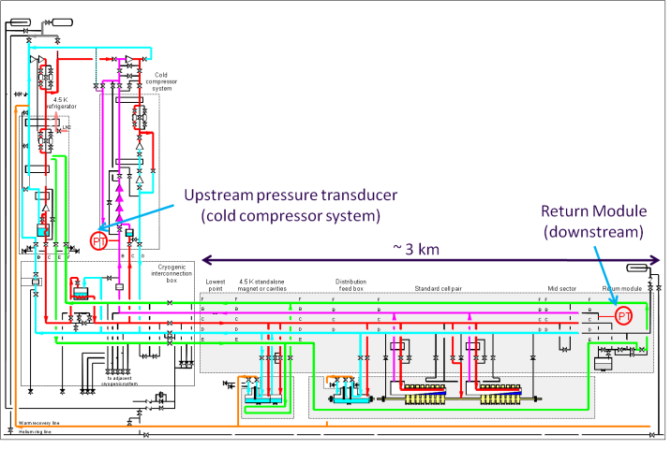
Figure 3: addition of a pressure measurement on the header B on the return module

Decoupling of adjacent sectors
The purpose of this consolidation is to allow the exchange of a magnet or a QRL service module while keeping the adjacent sector in nominal cryogenic operation. This project has already been detailed in the Chamonix 2010 workshop [10].

New refrigerator at P4
In the frame of the HL-LHC project a new refrigerator dedicated to the cryogenic operation of the RF cavities is to be installed at LHC Point 4 [11].
Considering the shutdown period foreseen for the LS2 and the timeframe needed to install and commission such an installation, it is proposed to profit of the LS1 shutdown period to install the necessary pipework in the shaft. A period of 6 weeks has to be foreseen for this task during the LS1.

LHC Experiment ConsolidationS
This section lists the consolidation works that should be achieved in order to improve and consolidate the performance of the cryogenic systems and to reduce the downtime of the ATLAS and CMS experiments.

ATLAS experiment
Potential consolidations for the ATLAS detectors have been listed in [13]. A major downtime risk identified in the ATLAS helium cryogenic system is the operation of the main refrigerator (MR) which relies on a unique high stage compressor. In order to introduce redundancy as well as energy saving a consolidation project of the MR compressor station has been approved. It consists in the installation of a second and new high stage compressor and the upgrade of a booster compressor.
Additional projects to improve the performances of the helium cryogenic systems and reduce the detector downtime are under consideration. One of the main proposals consists in decoupling the operation of the solenoid magnet from the toroid magnets.
The baseline is to carry out all these consolidations during the LS1 period.

CMS experiment
Similarly to ATLAS, it is foreseen to upgrade the compressor station with the installation of redundant compressors to reduce the detector downtime. The baseline is to complete this installation during the LS1 period.

Mandatory Maintenance ACtivities
During the LS1 period, one of the main activities will be the maintenance of the cryogenic equipments. It will be necessary to send back to industry all the 74 screw compressors for a major overhauling. The compressor stations pertain to 5 different manufacturers. The driving factor for the planning are the compressor stations made of 8 Stal® type (ex-LEP QSCA) : about 18 weeks / compressor station. The planning of Figure 4 is based on a standard full revision activity for the compressors with a small contingency margin for special repairs. The total cost of the compressor revision is estimated to 5.2 MCHF.
All the other preventive maintenance tasks (6 weeks / installation) can be carried out in the shadow of the compressor revision and is estimated to 1.6 MCHF.

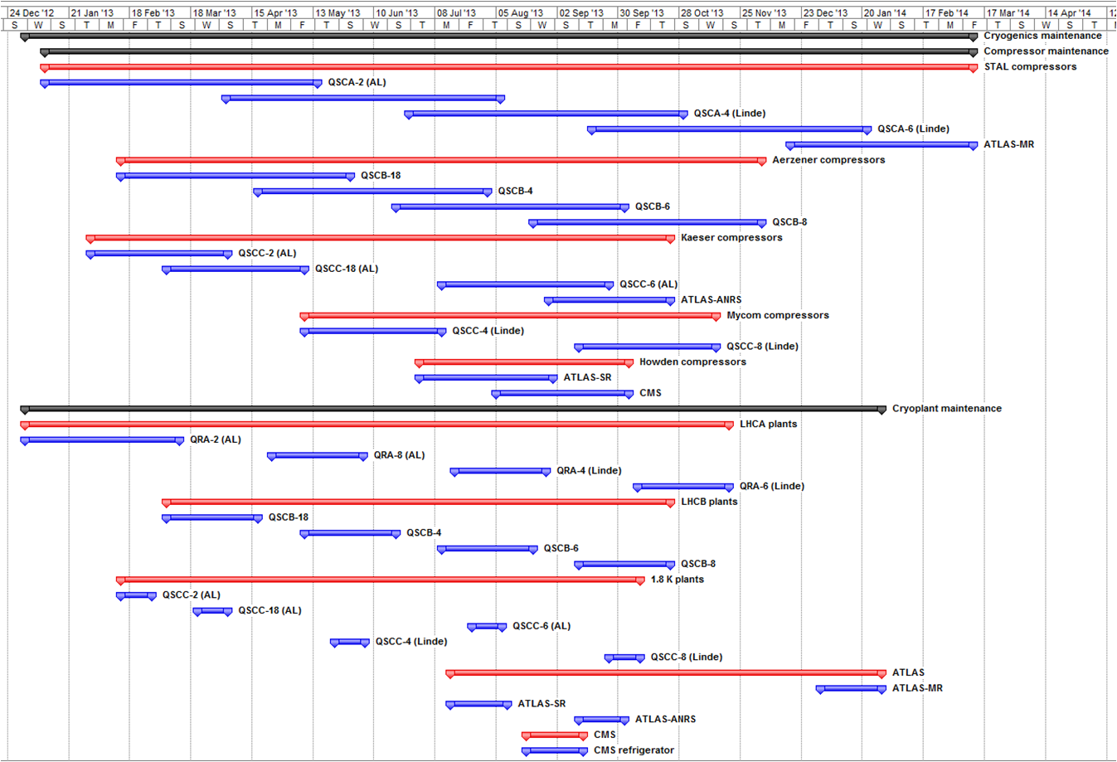
Figure 4: Cryogenic equipments maintenance planning.

Summary
Table 1 presents a summary of the consolidations concerning cryogenic installations activities and their co-activity impact with respect to other groups and the splice consolidation.
Concerning the resource needed to achieve all these consolidation activities, the cost estimates are shown in Table 2, while the Table 3 presents the necessary CERN staff in FTE (Full Time Equivalent).

Table 1: Summary of consolidation activities
Activity | Area | Motivation | Other  groups affected | Conflict with splice
DFBs pressure relief devices | LSS | Restore conformity | VSC, SU | No
IT relief device collectors | LSS | Restore conformity | VSC, MEF,SU | No
DFBA 13 kA CLs | LSS | Restore conformity | MPE, EL | No
DFBX CLs Ctrl | LSS | Operation & downtime | EL, ICE | No
DFB miscellaneous issues | LSS | Operation & downtime | VSC, MME | No
CV241 QURCA/B P8 | US85, UX85 | Operation & downtime |  | No
He level gauge on SAM | LSS | Operation & downtime | MSC, VSC | No
Leaks in "Y"-lines | Arc | Operation & downtime | MSC, VSC | Yes
Instrumentation of the tunnel | LSS | Safety | EL, MEF | No
HRL sectorization | LSS | Safety | EL | No
Access platforms QRL SMs | Arc, LSS | Safety | MME, MEF,SU | Yes
Quench lines | PM, TZ, UL/US | Operation & downtime | MME, MEF, SU, EL | No
QRL SM comp. air distribution | Arc, LSS | Operation & downtime | MSC, SU,MEF | Yes
Additional flowmeters on BS circuits | Arc | Beam dynamics optimisation | MSC, VSC, EL, ICE | Yes
Additional PT on header B | LSS | Operation & downtime | EL, SU, ICE | No
Decoupling of adjacent sectors | UXnn, PM18, US25 | Operation flexibility | MME | No
New refrigerator P4 | PZ45 | HL-LHC | HE | No
ATLAS consolidations | SH1, UX15 | Operation & downtime | PH, HE, EL | No
CMS consolidations | SH5 | Operation & downtime | PH, HE, EL, CV | No
Maintenance | Arc, LSS, SHn | Operation & downtime | HE, IS | Yes

Table 2: Cost estimate [kCHF]
Activity | 2011 | 2012 | 2013 2014
LHC
DFBs pressure relief devices
IT relief device collectors |  |  | 200
DFBA 13 kA CLs
DFBX CLs Ctrl | 100 | 200 | 1100
DFB miscellaneous issues |  |  | 15
CV241 QURCA/B P8 |  | 25 | 20
He level gauge on SAM
Leaks in "Y"-lines
Instrumentation of the tunnel |  | 20 | 10
HRL sectorization |  | 50 | 50
Access platforms QRL SMs | 32 | 432 | 400
Quench lines |  | 50 | 650
QRL SM comp. air distribution |  |  | 200
Additional flowmeters on BS circuits |  | 960 | 320
Additional PT on header B |  | 80 | 30
Decoupling of adjacent sectors |  | 500 | 640
LHC SUBTOTAL | 132 | 2317 | 3635
HL-LHC project
New refrigerator P4 |  |  | 300
HL-LHC SUBTOTAL |  |  | 300
Maintenance
CPs major overhauling |  |  | 5200
Preventive maintenance |  |  | 1600
Maintenance SUBTOTAL |  |  | 6800
TOTAL | 132 | 2317 | 10735
GD TOTAL | 13184

Table 3: CRG FTE estimate
Activity | 2011 | 2012 | 2013 | 2014
LHC
DFBs pressure relief devices |  |  | 0.3
IT relief device collectors |  | 0.2 | 0.3
DFBA 13 kA CLs |  |  | 0.2
DFBX CLs Ctrl | 0.1 | 0.4 | 0.5
DFB miscellaneous issues |  |  | 0.1
CV241 QURCA/B P8 |  | 0.1 | 0.1
He level gauge on SAM
Leaks in "Y"-lines
Instrumentation of the tunnel |  | 0.1 | 0.1
HRL sectorization | 0.1 | 0.1 | 0.1
Access platforms QRL SMs | 0.1 | 0.1 | 0.3
Quench lines | 0.1 | 0.3 | 0.8 | 0.1
QRL SM comp. air distribution |  | 0.1 | 0.2
Additional flowmeters on BS circuits |  | 0.1
Additional PT on header B | 0.1 | 0.3 | 0.2
Decoupling of adjacent sectors |  | 0.5 | 0.8
LHC SUBTOTAL | 0.5 | 2.3 | 4 | 0.1
New refrigerator P4 |  | 0.2 | 0.2
ATLAS |  | 1.5 | 2.5
CMS |  | 0.2 | 0.3
Maintenance
CPs major overhauling | 0.1 | 0.2 | 1
Preventive maintenance | 0.1 | 0.2 | 1
Maintenance SUBTOTAL | 0.2 | 0.4 | 2
TOTAL | 0.7 | 4.6 | 9 | 0.1
GD TOTAL | 14.4

summary - conclusions
The list of the consolidation tasks during the long next shutdown, their potential conflict with the splice consolidation and the related and required resource have been presented. Some of these consolidations need to be approved and/or detailed.
The planning of the full revision of the various compressor stations shall be taken into account with special attention in the general LS1 coordination planning as it directly impacts the availability of the different cryoplants.

ACKNOWLEDGEMENTS
The author would like to acknowledge his colleagues of the CRG group for their inputs for this report.

References
[1] CERN-ATS-2009-002, “Task Force Report - Safety of Personnel in LHC underground areas following the accident of 19th September 2008”, B. Delille, S. Evrard, J. Inigo-Golfin, G. Lindell, G. Roy, L. Tavian, E. Thomas, R. Trant and C. Vollinger.
[2] LHC-DFBA-EC-0007, " Protection of the DFBAs in case of accidental release of helium in the vacuum insulation”, EDMS 1141754, A. Perin
[3] LHC-DFBM-EC-0001, "Protection of the DFBMs in case of accidental release of helium in the vacuum insulation”, EDMS 1142702, A. Perin
[4] LHC-DFBL-EC-0003, "Protection of the DFBLs and of the superconducting links (DSL) in case of accidental release of helium in the vacuum insulation", EDMS 1142810, A. Perin
[5] CERN-ATS-Note-2010-057, "New protection scheme and pressure relief-valve staging of the LHC insulation vacuum enclosure following the 19th September 2008 incident", P.Cruikshank, V. Parma, A. Perin and L. Tavian.
[6] LHC-QIT-EC-0001, “Consolidation of the voltage withstand level for the measuring chain of the current leads thermometers”, EDMS 919146, J. Casas.
[7] Minutes of the eleventh TETM meeting held on 02-sept-2009, EDMS 1020135.
[8] “Failure analysis of DFBAA-1L corrugated flexible hose”, EDMS 1015610, A. Gerardin and S. Sgobba, 2009.
[9] "Modifications of the DFBAC and DFBAO low current modules to improve liquid helium level control", A. Perin, in work.
[10] "Decoupling of adjacent cryogenic sectors", G. Ferlin, LHC Performance Workshop - Chamonix 2010
[11] "New Helium refrigerator for RF cavities, point 4", CRG Technical Meeting, EDMS 1149252, G. Ferlin
[12] Cryomagnets, Interconnections, Superconducting Circuits: What to do in 2012/13 if you are not consolidating splices ?", these proceedings, J.Ph. Tock
[13] "Magnet Cryogenics Consolidation plans for 2011-2012", H. Ten Kate, Special MOM Cryo meeting, 18 May 2010

