What are the consequences of delaying the shutdown from 2012 to 2013 for Radiation Protection?
C. Adorisio, D. Forkel-Wirth, S. Roesler#, CERN, Geneva, Switzerland
Abstract
The residual induced radioactivity in the LHC underground areas in 2012 will is estimated and compared with the levels that would be expected in 2013. With these estimations consequences of delaying the shutdown from 2012 to 2013 will be assessed.
The present paper summarizes only the main conclusions. A detailed discussion can be found elsewhere in these Proceedings [1].

conclusions
Based on the operational scenarios for the LHC during the years 2011/12 [2] (see Table 1), beam-intensity-dependent activation and residual dose rates are expected to increase by about a factor of 4-7 during the 2011 run and by another factor of two during 2012 [1] (see Table 2). Thus, radiation protection constraints and recommendations for shutdowns in 2012 and 2013 are quite similar. Of course, it assumes that losses scale linearly with beam intensity and neglects the contributions from scrubbing or ion runs. The luminosity-dependent activation (mainly the detectors and inner triplets) will increase by a factor of 20-100 until 2013.
Table 1: Operational parameters [1].
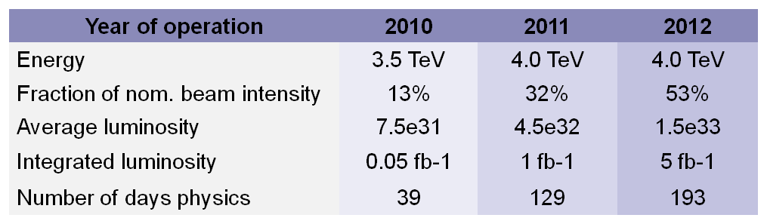

Table 2: Scaling factors derived from operational parameters for short and long cooling times as well as obtained with the generic study for three dedicated cooling times [1].
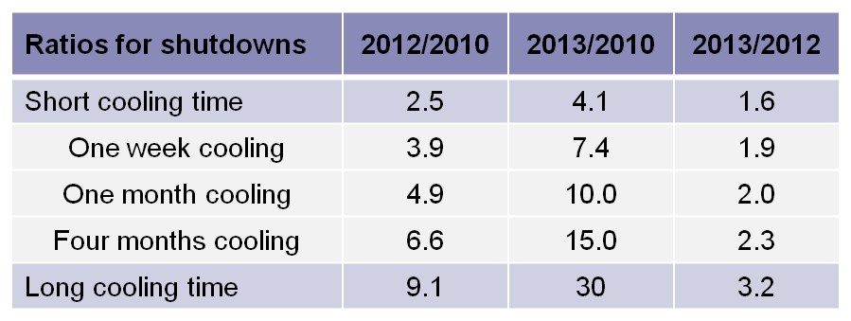

Presently the entire LHC is classified as Supervised Radiation Area [2] with low activation and dose rate levels (January 2011: maximum dose rate in the aisle: 3μSv/h, maximum dose rate on contact to a passive absorber in Point 7: 70 μSv/h). During technical stops and shutdowns in 2012 and 2013 a few limited areas (e.g., IR3/7) will have to be classified as Controlled Radiation Areas where job and dose planning is obligatory.
Residual dose rates in the arcs after the 2012 run are estimated to be very low (no limitation in duration of work) [1]. A few localised areas in the dispersion suppressor regions (loss points of protons or heavy fragments “leaking” from the straight section) might show measurable residual dose rates (<10 μSv/h). Despite low residual dose rates in these areas, components might become “radioactive” according to CERN regulations and dissipation or incorporation of this radioactivity must be prevented (ALARA principle).
Due to significant uncertainties it is important to continuously monitor the evolution of activation (e.g., survey measurements, material samples) to be able to further optimise work plans and schedules. In areas where civil engineering will be required (e.g., dispersion suppressor regions in IR3) concrete samples should be placed in order to demonstrate absence of activation prior to the work.

References
[1] C. Adorisio, D. Forkel-Wirth and S. Roesler, “Radiation Protection: How (radio)active are we going to be?”, this Proceedings (2011).
[2] M. Lamont, private communication (2010).
[3] Règles Générales d’Exploitation – Area Classification, General Safety Instruction, EDMS No. 810149 (2006).

