**Accelerator Magnet R&D in the Perspective of  
a LHeC and a HE-LHC - Synergy or Competition ?**

L. Bottura, B. Auchmann, M. Bajko, A. Ballarino, F. Borgnolutti, P. Ferracin, P. Fessia,

M. Karppinen, G. Kirby, L. Oberli, J.C. Perez, L. Rossi, G. de Rijk, S. Russenschuck, D. Smekens, E. Todesco, D. Tommasini

CERN, Geneva, Switzerland.

Abstract

Beyond HL-LHC, CERN has a number of physics options that offer potential and challenges. This contribution dwells on the long-term projects HE-LHC and LHeC to put the magnet R&D at CERN (resistive and superconducting, slow and fast) in a long-term perspective. In particular synergies and parallel roadmaps will be highlighted. We will show how the on-going development (2012-2015) on low-field, high-field, and low-loss magnets can be used towards longer term objectives.

## INTRODUCTION

The magnetic system for the accelerator complex of CERN consists of an equal mass of superconducting and resistive magnets, each with a weight of approximately 50,000 tons, spread over 3 major machines (PS, SPS and LHC), two large experimental areas, and a number of smaller experiments and accelerator rings. Such a system requires continuous maintenance, and an adequate park of spares. However, the key to insure long-term, reliable and efficient operation of a complex installation such as the one at CERN is to keep the pace with the development of magnet technology. Indeed, being up-to-date insures that innovative corrective and preventive actions are implemented timely, and that new technological opportunities are exploited to maximise the physics outcome.

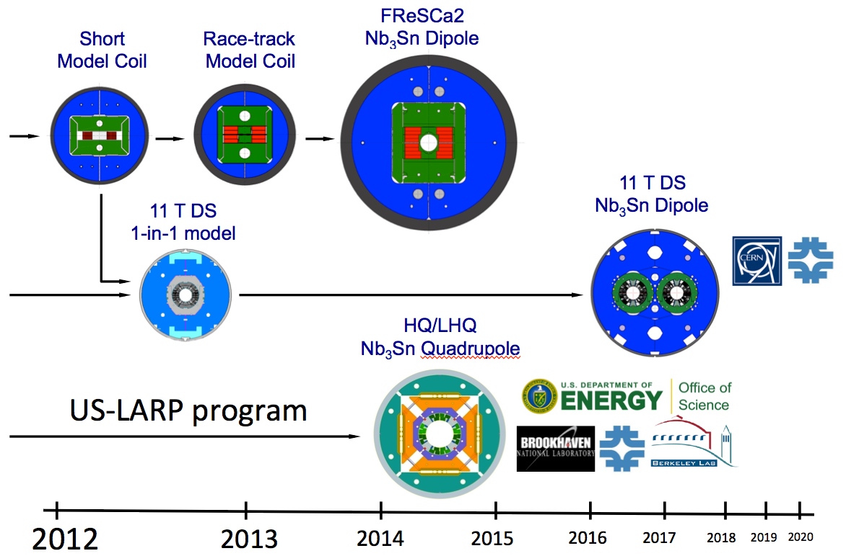

Figure 1. Schematic representation of the main stepping stone in the High Field Magnet program.

In this spirit, we pursue actively a number of research lines in magnet technology, ranging from resistive magnets that generate low but extremely reproducible fields, to magnets that aim at record field levels in accelerator configurations. Needless to say, in the majority of cases this R&D is targeted to specific CERN short-term programs and deliverables. Nonetheless, the results are very relevant to medium- and long-term developments, such as the Large Hadron electron Collider (LHeC) [1] or the High-Energy LHC (HE-LHC) upgrade [2] described in a companion contribution [3].

In this paper we firstly review the present CERN accelerator magnet R&D, providing background on the targets, a timeline, and highlighting relations and dependencies among them. We finally discuss why and how this work is relevant for medium- and long-term accelerator projects such as LHeC and HE-LHC.

## High Field Magnets R&D

The *High Field Magnet* (HFM) R&D work comprises a number of activities devoted at demonstrating accelerator quality magnets with peak field in excess of 10 T (i.e. beyond the well-established capability of Nb-Ti). The backbone of the HFM program started in 2004 with the *Next European Dipole* (NED) Joint Research Activity (JRA) of the EU-Framework Program 6 [4], whose target was to pave the way towards the production of a 100 mm aperture, 13 T dipole built of Nb3Sn cable. The NED program provided the kick-start necessary for conductor procurement and cable development, and was concluded with the demonstration of an industrial production of a wire that achieved current density of 1500 A/mm2 at 15 T and 4.2 K [5]. It was clear already at that time that a large effort was still required to produce a cable with acceptable degradation, and build a high field magnet with accelerator features such as a sufficiently aperture and field quality. Since 2008 the HFM program has provided the possibility to coordinate actions ranging from material research to model coils, and has acted as the *nursing bed* for independent projects such as the 11 T DS dipole [6]. A flowchart view of the HFM programs is reported in Fig. 1, which is somewhat simplified, but can be used as guideline to follow the next sections.

### FReSCa-2

The initial proposal in the NED JRA recalled earlier, was to build a 100 mm aperture, 13 T bore field dipole with accelerator field quality. This ambitious objective was thwarted by a cut of the allotted EU funding during the attribution and following negotiations on the EU-FP6 NED JRA. As a consequence, the NED program focussed on strand and cable development, which was identified as the major milestone. The idea of a large bore, high field dipole, was revived in the following call for the EU-FP7. In preparing this new proposal, based on the experience of wire procurement and cable manufacturing, the requirement of accelerator field quality was deemed too demanding, and was hence dropped. The magnet is intended as a technology demonstration (note that to date the proposed magnet is still a first). Its main use will be as the cornerstone of an upgrade of the FReSCa cable test facility at CERN [7]. For this reason the magnet has been *christened* FReSCa-2.

Presently, FReSCa-2 is a block dipole, with a useful bore of 100 mm, operating field of 13 T (at 10.8 kA), and short sample limit at 4.2 K of approximately 15.5 T (at 13.2 kA). It is based on the bladder-and-key technology invented at LBNL [8], and is being built as a joint venture between CERN and CEA, in a collaboration program that includes technical contributions from RAL (list of partners). The main parameters of the magnet are reported in Tab. I, and a schematic of the design is reported in Fig. 2.

With an outer diameter in excess of 1 m, the magnet requires a dedicated test stand, which is in preparation at CERN, and will allow testing at both 4.2 K and 1.9 K, and powering up to 20 kA. The main magnet components and tooling are being procured, and the magnet assembly is planned at CERN in 2013, for a delivery and test in 2014.

### SMC and RMC

The manufacturing of FReSCa-2 involves a large investment on long lead-time materials and components such as the Nb3Sn cable, where even partial failure would result in a major schedule disruption. For this reason we have defined a number of intermediate stepping stones, model coils of various dimensions that are intended as partial demonstrations and R&D tools towards the manufacturing of the large dipole.

Our first step in the development of Nb3Sn magnets is the Short Model Coil (SMC). Its birth can be traced to a tri-partite agreement (CERN-CEA-RAL) that ensued from the NED activities, in the period of inter-reign between the NED JRA and the acceptance of the FReSCa-2 proposal. The SMC, shown in Fig. 3, is largely inspired by the sub-scale magnets developed at LBNL [9]. It is a bore-less magnets made with racetrack, flat coils. The structure follows the principle of the bladder-and-key assembly. The coils are approximately 187 mm wide and 500 mm long, and so far they have been built with cables of reduced scale with respect to the full size cable of NED, and FReSCa-2. More details on the SMC can be found in Ref. [10]. So far, two SMC were built and tested (SMC1 and SMC3a), one is in construction (SMC3b). Best performance achieved so far was with SMC-3a, with a peak field of 12.7 T on the coil [11].

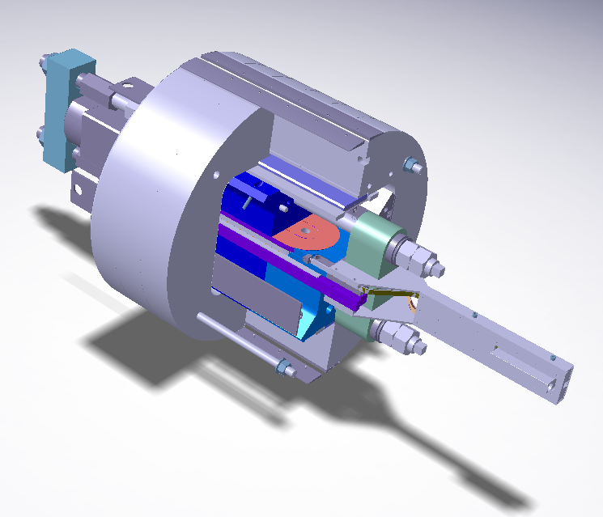 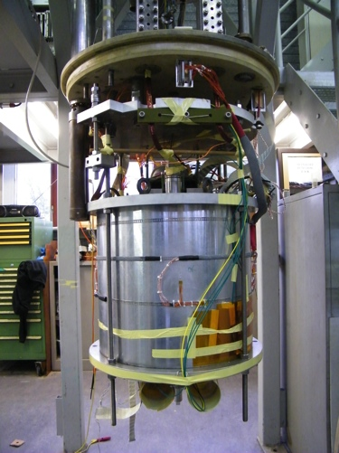

Figure 3. Exploded CAD view of the SMC magnet (left) and photograph of SMC3a ready for test (right).

|  |  |  |
| --- | --- | --- |
| Field | (T) | 13 |
| Operating current | (kA) | 10.8 |
| Operating temperature | (K) | 1.9…4.2 |
| Aperture | (mm) | 100 |
| Outer diameter | (mm) | 1030 |
| Stored energy | (MJ/m) | 3.67 |
| Weight | (tons) | ≈9 |

Table I. Main parameters of FReSCa-2.

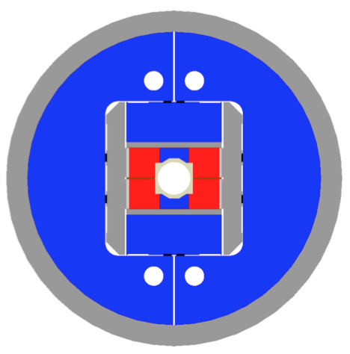 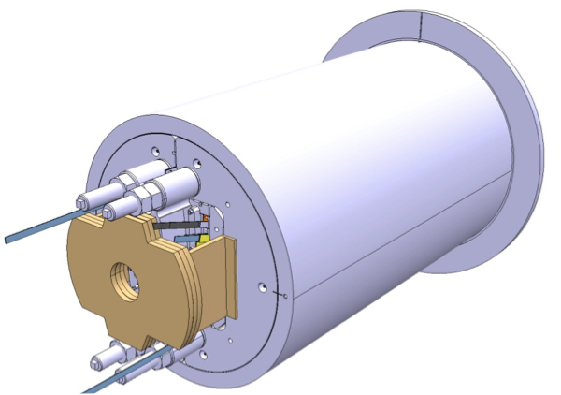

Figure 2. FReSCa-2 cross section (left) showing the coil (red) iron yoke (blue) and structure (grey), and a CAD view of the assembled magnet in its shell (right).

The SMC is the ideal playground for engineers and technicians, and was soon recognized as a basic tool for the test of cable performance over lengths of the order of 100 m, relevant to magnet technology. For this reason we have extended the scope of the SMC program. SMC-type coils will be used to qualify any new high-field magnet cables (see later sections).

Only recently, however, we identified limitations in the test capabilities of the SMC structure. The space available for the coils, and the overall length, are such that it would be impossible to test the quench performance of the full-size cables that will be used for the construction of FReSCa-2, or other magnets of similar stored magnetic energy density (e.g. large aperture IR quadrupoles). For this reason we have designed an up-scaled version, the Racetrack Model Coil (RMC) test magnet, which provides space for one or two racetrack coils, with width of 240 mm and length 800 mm. The design of the RMC can be seen in Fig. 4. We are presently procuring components, and plan to have the first assembly by end 2013, using the full-size FReSCa-2 cable.

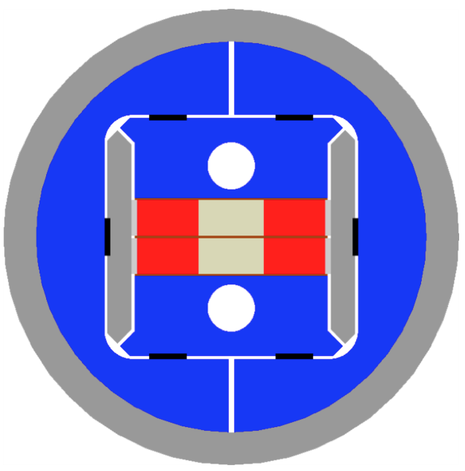 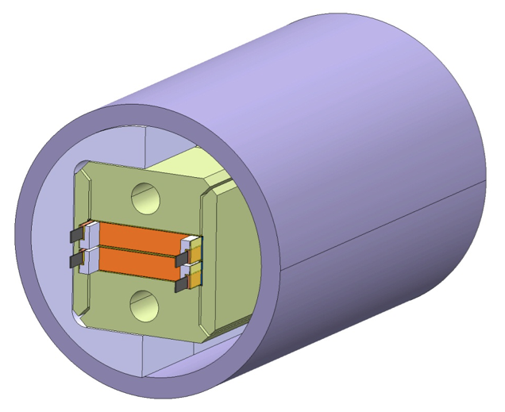

Figure 4. RMC cross section (left) showing the coil (red) iron yoke (blue) and structure (grey), and a CAD view of the assembled magnet in its shell (right).

### 11 T Dispersion Suppressor Dipoles

Operating experience at the LHC, and dedicated beam collimation studies, show that the Dispersion Suppressor (DS) region may require additional protection from beam losses. Additional collimators should be installed on the time horizon of 2018 (LS2) and 2022 (LS3), most likely in a staged approach. Among the options that are considered on how to integrate additional collimators in the LHC DS, the most captivating one is the idea proposed in [6] to substitute one LHC dipole with a shorter magnet producing an identical kick. The space gained would be allocated to the collimator, and the overall impact on the machine optics, operation and installation could be minimal. The analysis performed in [6] has shown that a suitable bore field target for such a dipole could be around 11 T, using available Nb3Sn technology, resulting in a slot of approximately 4 m for the collimator. The design of this 11 T DS dipole magnet has much advanced since its inception [12,13] and a demonstration program is running as a joint collaboration between FNAL and CERN. The main magnet parameters are reported in Tab. II, and a view of the magnet cross section, and a coil manufactured at FNAL is reported in Fig. 5.

|  |  |  |
| --- | --- | --- |
| Field | (T) | 11.2 |
| Operating current | (kA) | 11.85 |
| Operating temperature | (K) | 1.9 |
| Aperture diameter | (mm) | 60 |
| Outer diameter | (mm) | 570 |
| Stored energy | (MJ/m) | 0.92 |
| Weight | (tons/m) | ≈2 |

Table II. Main parameters of DS 11 T dipole.

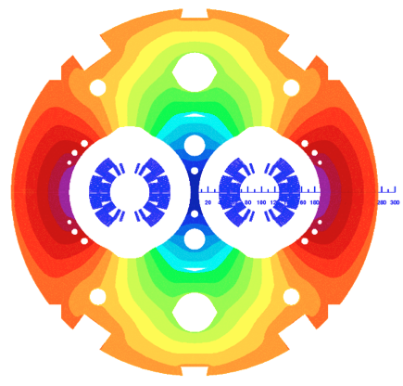 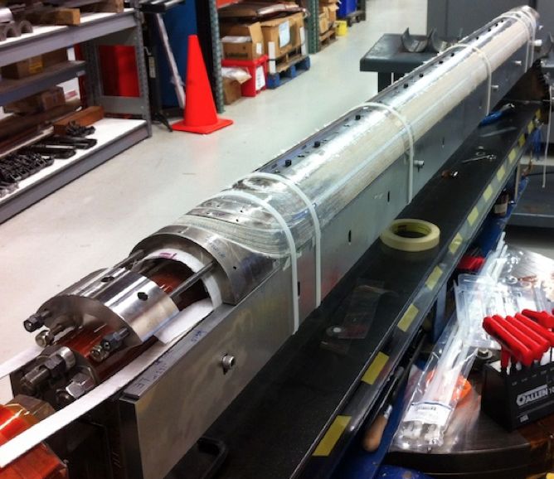

Figure 5. Design of the twin-aperture, 11 T DS MB cross section (left), and the first coil of the FNAL demonstrator ready for heat treatment (right).

Although the basics of wire, cable, magnet winding and structure, magnetics and cryogenics are understood, much work is still required to show that an accelerator quality Nb3Sn magnet can be integrated (for the first time) and will perform in an accelerator. The initial cable specification has undergone considerable development, and is presently being manufactured both at FNAL and at CERN using industrially available strands, as well as R&D material with reduced filament size (to decrease the sextupole field errors caused by large persistent currents). Coils with optimised geometry are being wound at FNAL, and tooling is in preparation at CERN to start in-house winding. Two magnet assembly and supporting concepts have been studied and proposed for test in models. The FNAL/CERN collaboration is following an aggressive program of single and double aperture short models (2012-2013), followed by long prototypes (2014) and eventually the production of the first batch of cold masses (2015-2017) to enter the LHC during LS2. A prime issue addressed by the programme is obviously quench performance and margin, but much attention is already paid to mechanical and practical manufacturing aspects, field quality, and integration in the accelerator. An additional step in the CERN programme will be the construction and test of a set of SMC coils using a cable of similar dimensions to the final one, with resistive core, but not key-stoned. Different insulation schemes will be tested in this SMC (braided insulation with or without a layer of mica), and results are expected in the course of 2012.

### IR Quadrupoles

New quadrupoles with larger aperture than the present Q1, Q2 and Q3 magnets in the LHC are a pivot in the high-luminosity upgrade plan. The US-LHC Accelerator Research Program (US-LARP) has progressed in the development of such magnets, using Nb3Sn to achieve a gradient increased by about 50 % with respect to an equivalent magnet built with Nb-Ti [14]. The companion contribution [15] reports on the recent advances, the remaining challenges and the overall plan of this program until the technology decision Nb-Ti vs Nb3Sn, scheduled in early 2015. Given the advance of the US program in this area, the technology decision will be based on the performance of the HQ and LHQ magnets, with 120 mm aperture. So far the contribution of CERN has been minor, providing input for the choice of critical magnet parameters such as aperture and gradient [14], consulting for matters of field quality, and active participation to the test of models and prototypes [16]. In the course of 2012, however, we plan to start active work on wire and cable procurement, targeting especially design options for large aperture (140 mm), for which no model work is on-going at present.

## Large Aperture Quadrupoles

Although much R&D work is devoted to proving the technology for Nb3Sn magnets above 10 T, Nb-Ti remains the work-horse of present magnet technology and is not neglected. One specific line that is running vigorously is the construction of a model of a large aperture quadrupole for the LHC triplet, which is the legacy of the Phase-I upgrade [17]. This model magnet, which goes under the name MQXC, has a 120 mm aperture, a 118 T/m nominal gradient and is being built jointly by CERN and CEA [18, 19]. The short-model cross section is shown in Fig. 6, together with the first collared coil of two meter length. A summary of the main design parameters is reported in Tab. III.

|  |  |  |
| --- | --- | --- |
| Gradient | (T/m) | 118 |
| Operating current | (kA) | 12.8 |
| Operating temperature | (K) | 1.9 |
| Aperture diameter | (mm) | 120 |
| Outer diameter | (mm) | 570 |
| Stored energy | (MJ/m) | 0.41 |
| Weight | (tons/m) | 1.36 |

Table III. Main parameters of MQXC.

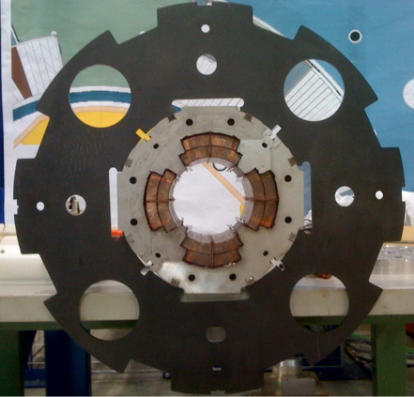 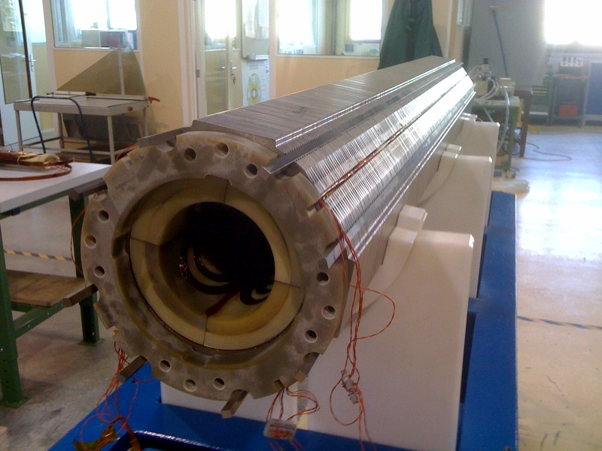

Figure 6. Cross section of MQXC, made of recomposed construction parts (left) and collared coil during the construction of the first trial model (right).

Most important, the model includes several features that should improve heat removal from the coil to the cryogenic heat exchanger, namely a porous cable insulation [20], perforated ground plane and slit quench heaters. With these features we expect a factor four improvement on the local heat removal capability, when compared to the existing magnets in the LHC. This factor is necessary to cope with the increased energy deposition that would be inevitably associated with increased luminosity.

A large aperture IR quadrupole built with Nb-Ti will fall short of the performance that we expect to reach with Nb3Sn. On the other hand this option has the benefit of relying on a well-established technology, a good control of the field quality, and a marginal cost and schedule advantage. It is hence still a valid line of development, and we expect a quantitative evaluation from the test of the model, in the course of 2012. In addition, the development of large aperture Nb-Ti quadrupoles is of relevance for the modifications that are being discussed at the level of the LHC matching sections, and namely on the Q4 that may require significantly larger aperture than the present 70 mm [21].

## Very High Field Magets R&D

When looking at the “life after the LHC”, it is natural to pose the question of the possibility of a higher energy accelerator in the existing tunnel. This evidently calls for magnets with significantly higher bore field than the LHC. Nb3Sn would allow a factor of two increase with respect to Nb-Ti, i.e. a dipole with a bore field in the range of 16 to 18 T. This would be a major step, but possibly not sufficient for the physics reach. Any increase beyond this value requires the use of High Temperature Superconductors (HTS). HTS materials have critical temperature around 80 to 100 K, but, and especially, they exhibit exceedingly large critical fields (100 T and larger), and can hence be used at low temperature as high field superconductors. Finding a use for HTS in Very High Field Magnets (VHFM) for accelerators, whose range we place somewhat arbitrarily above 20 T, would have immense implications for applications such as solenoid magnets for NMR spectroscopy, but also a scale and cost impact on superconducting power generation, storage and transmission.

Presently all this is at the stage of the concept. Although we have proposed a hybrid magnet concept design that uses HTS [22], and active work is on-going at national laboratories (e.g. the FP-7 EuCARD HTS insert, or the VHFSM collaboration of the US-DOE) and industries (e.g. work on 30 T NMR solenoids), none of this research has reached the stage of an accelerator application. Indeed, the basic question that is still unanswered is on the sheer feasibility of such a magnet. For this reason we are in the process of launching a worldwide collaborative work aiming at producing a small-scale demonstrator magnet, built with a HTS cable, and producing a field of 5 T in a 40 mm bore with sufficient field quality to be suitable for use in an accelerator [23]. This small dipole is intended as the demonstration of the technology necessary for a very high field insert in a hybrid Nb-Ti-Nb3Sn-HTS magnet, a field booster from 15 T to 20 T. At the same time, thanks to the enormous temperature margin, such a dipole could find applications in regions of high radiation or energy deposition, operating at intermediate temperature, above the liquid helium range. Table IV gives the targets for the EuCARD2 proposal.

|  |  |  |
| --- | --- | --- |
| Field | (T) | 5 |
| Operating current | (kA) | 5 |
| Operating temperature | (K) | 4.2 |
| Aperture | (mm) | 40 |
| Maximum stress level | (MPa) | 400 |
| Wire/tape JE (20 T, 4.2 K) | (A/mm2) | 750 |

Table IV. Targets for the HTS magnet R&D proposed within the scope of EuCARD2.

The main issues identified are the material selection and properties (BSCCO or YBCO, engineering current density), cable geometry (transposed topology, cable production), coil production (high-temperature heat treatment, insulation and impregnation, structural solutions for very large forces), quench protection (detection of very small voltages, large stored energy and energy density). The proposal is within the wider scope of the EuCARD2 programme, and is presently under evaluation. We expect results on approval and funding in Spring 2012, and negotiations to start by the mid 2012. Once again, we plan to start activities at CERN with strand, tape and cable characterization, follow with the production of model coils of SMC type to develop manufacturing procedures and understand the extrapolation to long lengths, and eventually work on the magnet proper, to give an answer to the feasibility question on the horizon of 2016. Present work at CERN on HTS conductor is concentrated on the development of HTS electrical transmission lines of interest for application to the LHC machine. Experience gained with the development and test of 10 kA range long cables [23a] will be used also for the development of HTS cables.

## Fast Cycled Magnets R&D

Energy efficient, superconducting, fast-cycled magnets would be a holy grail for accelerator applications including high energy physics, nuclear physics, or hadron therapy. The CERN work in this field is so far very limited to two synergistic programs. The first is the original *Fast Cycled Magnet* (FCM) programme [24], started as an alternative to the resistive design of a PS2 [25]. The FCM program is now devoted to the demonstration of a low-loss super-ferric dipole magnet design with a large bore (70 mm gap) operating continuously in trapezoidal cycles of 1.8 T peak field and 1.5 T/s field ramp-rate. This is the typical operating range of the low energy end of the LHC injector chain, but similar design could find applications in dedicated machines for neutrino experiments, or medical applications [26]. The magnet concept contains a number of innovative features, such as the cable, the use of a warm iron yoke, a separately cooled structure, and an optimized support in the cryostat. The FCM demonstrator magnet parameters are reported in Tab. V, and the magnet is shown in Fig. 7.

The main challenge of the programme is to demonstrate reliable and economic operation, and especially a competitive power balance when compared to a resistive magnet solution. Results are expected in the first half of 2012, the demonstrator magnet being now fully assembled and awaiting test in a dedicated station.

The second line of activity in the field of fast cycled magnets is the participation to the procurement of a low-loss cable, and its insulation, for the production of a prototype of a dipole magnet for the SIS-300 storage ring at FAIR [27]. This work is performed within the WP5 of the CRISP EU-FP7 programme. It is in reality a follow-up of the DISCORAP programme [28], approaching completion at INFN, where a dipole with a 100 mm diameter aperture, 4.5 T bore field and maximum ramp-rate of 1 T/s is ready for test. These parameters are comparable to those that would be of interest for a superconducting SPS, accelerating protons up to 1 TeV. The cable to be produced at CERN is similar to one of the geometries already used in the LHC (type 02, dipole outer layer cable), but will be manufactured using low-loss wires of the same type as those developed in the scope of the FCM programme, and additional features such as a resistive strip core that reduces AC loss during ramps. A picture of one such prototype cable recently produced at CERN is shown in Fig. 8.

|  |  |  |
| --- | --- | --- |
| Field | (T) | 1.8 |
| Field ramp-rate | (T/s) | 1.5 |
| Operating current | (kA) | 5.7 |
| Operating temperature | (K) | 4.2 |
| Free aperture | (mm2) | 250(H)x70(V) |
| Stored energy | (MJ) | 0.24 |
| Weight | (tons) | ≈4 |

Table V. Main parameters of FCM.

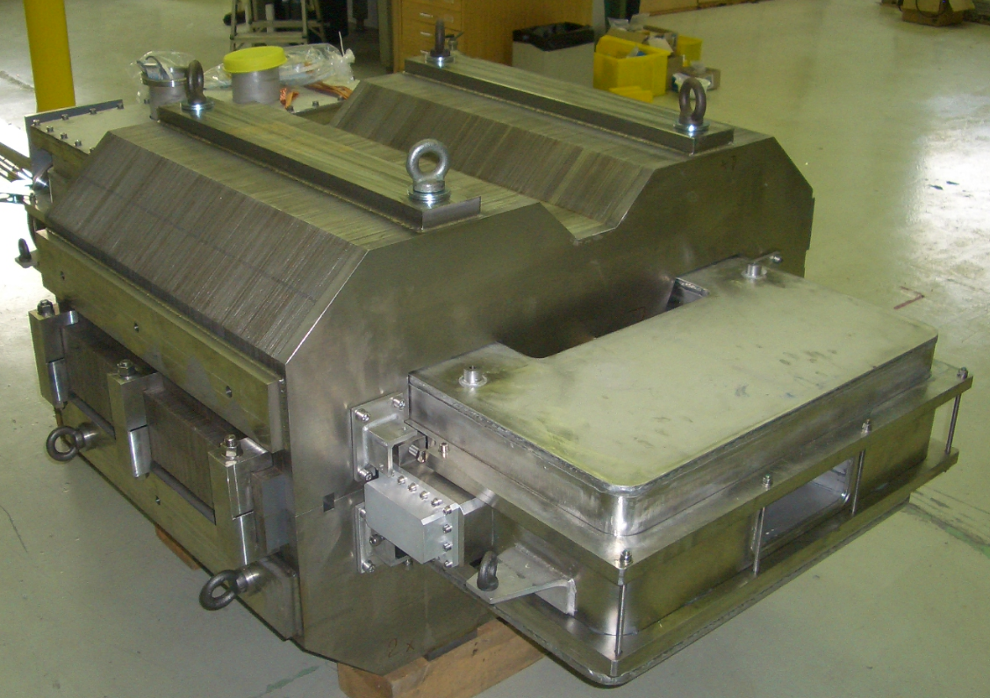

Figure 7. The FCM demonstrator magnet during final assembly.

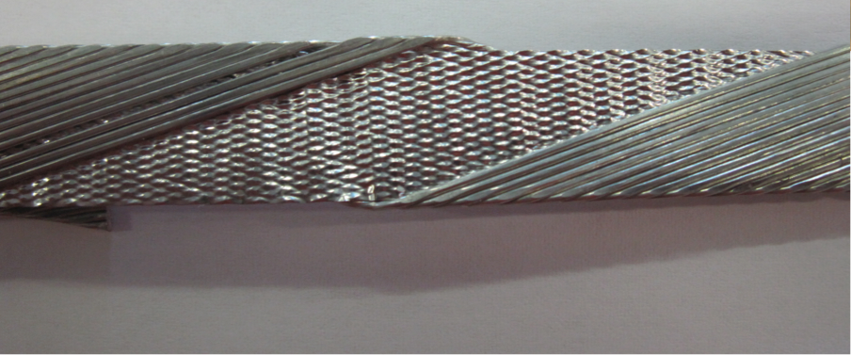

Figure 8. Cored Nb-Ti cable trial for the CRISP SIS-300 prototype.

Both FCM and CRISP programmes are not high priority among the magnet R&D work. Nonetheless, they explore key technological questions on the long-term perspective.

## Low Field Magnets R&D

Electromagnets have a long history since their invention by W. Sturgeon, in 1824, and their use in accelerators is widely spread. Yet, the demands for further developments are many, and include the use of modern engineered materials in the yoke, or permanent magnets, long-term stability, extension of the operating field range and homogeneity, and improvements in the efficiency. One such example is the dipole that would be required by the ring-ring variant of the Large Hadron electron Collider (LHeC) discussed in detail later. This dipole has a nominal operating range of 13 mT to 75 mT with challenging demands on homogeneity and reproducibility. These *low field* accelerator magnets are by no means trivial. At this level of excitation the field quality and reproducibility depend strongly on iron material properties (remanence, coercive field and permeability), and the homogeneity of industrial production may not be sufficient to guarantee the required performance. For this reason the magnetic design must include features to compensate for the material variability, such as the dipole design reported in Fig. 9, from [1].

In this solution the iron laminations are *diluted* by being glued among plastic spacers, and the flux in the magnet aperture is spread out, thus reducing the effect of relative changes among single laminations. Tests performed on prototypes built with this design have shown excellent reproducibility, better than 1 unit of 10-4 of the main field, for a variety of iron yoke materials and grades, as reported in Tab. VI.

## LHeC and HE-LHC

What is the relation between work described in the preceding sections and the scope of an LHeC and of a HE-LHC ?

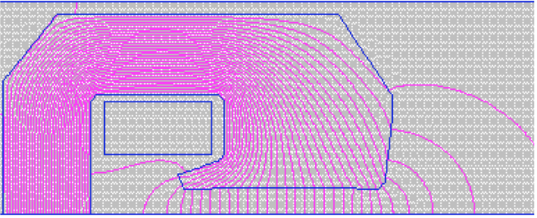

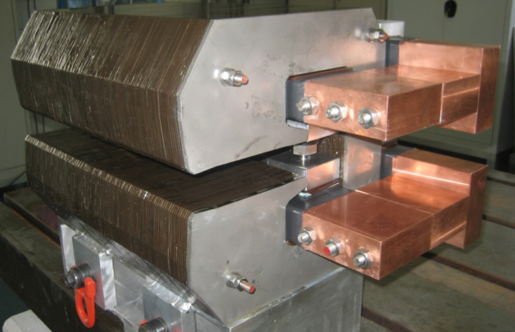

Figure 8. Design of a low field dipole magnet applicable to a variant of LHeC (top) and assembled prototype (bottom).

|  |  |  |
| --- | --- | --- |
|  | Injection | Flat-top |
| Model 1: Ni-Fe steel | 0.5±0.3 | 0.4±0.3 |
| Model 2: Low-C steel | 0.6±0.4 | 0.6±0.5 |
| Model 3: GO 3.5 % Si steel | 0.4±0.2 | 0.6±0.4 |

Table VI. Field reproducibility errors measured on three prototypes of low field LHeC dipoles built at CERN using different materials for the laminations. The error is quoted in units as a systematic error and a random component.

### LHeC demands and challenges

LHeC is “[…] *a new electron-hadron collider, the LHeC, in which electrons* […] *collide with LHC protons*” (verbatim from [1]). As described in [1], an e-beam an e-beam accelerated to 60 GeV in the ring-ring (RR) option, or up to 140 GeV in the linac-ring (LR) option, meets the LHC p-beam at one interaction point. The main challenges from the point of view of magnet engineering are:

* the large number (4000 (RR) to 5000 (LR)) of precise, low-field, low-mass, low-cost magnets for the e- accelerator;
* the nested interaction regions, with large aperture quadrupoles at relatively large gradients, space for traversing beams and appreciable synchrotron radiation heat loads;
* integration in the existing complex and co-activity.

Specifically to the resistive magnets, the most challenging demand comes from the ring-ring option of the LHeC, and is posed by the ring dipoles with the characteristics reported in Tab. VII. Such dipoles have been the successful object of the low field, resistive magnets R&D described earlier.

As to the IR quadrupoles, the two options for the LHeC layout ask for a different range of aperture and gradients, reported in Tab. VIII. To be noted that the Q1 shall focus the proton beam, and have a field-free region for the electron beam. A possible design, applicable to both the ring-ring and linac-ring options, was studied and reported in [1], and is shown in Fig. 9 (linac-ring). Such a *half-quadrupole* has several challenges. The gradient range considered, especially in the linac-ring option, is at the upper limit of the performance of Nb-Ti, and Nb3Sn may be an option. The mechanical structure needs to support the non-symmetric loads from a large aperture coil, providing the required symmetry for field quality. The heat load from synchrotron radiation, to be evaluated, can be large and thus require enhanced heat transfer at the level of the coil assembly. The programs for the LHC IR quadrupoles, both Nb-Ti and Nb3Sn variants discussed earlier, presently address most of these challenges, save the specific non-symmetric structure and field free region.

|  |  |  |
| --- | --- | --- |
| Number of magnets | (-) | 3080 |
| Free aperture | (mm2) | 90(H)x40(V) |
| Magnetic length | (mm) | 5350 |
| Injection field | (mT) | 12.7 |
| Flat-top field | (mT) | 76.3 |
| Good field region | (mm2) | ±10(H)x6(V) |
| Field quality | (-) | ±2·10-4 |
| Injection field reproducibility | (mT) | ±0.01 |

Table VII. Specification for the ring-ring LHeC dipoles.

|  |  |  |  |
| --- | --- | --- | --- |
|  |  | ring-ring | linac-ring |
| Gradient | (T/m) | 137 | 145…175 |
| Free aperture diameter | (mm) | 70 | 92 |
| Fringe field | (mT) | 30 | 370…500 |

Table VIII. Range of gradient and apertures considered for the Q1 of the ring-ring and linac-ring LHeC IR.

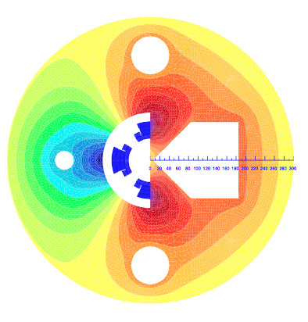

Figure 9. A design concept for the Q1 in the linac-ring LHeC IR, consisting of a half-quadrupole of large aperture (92 mm diameter) and a low field space for the traversing e-beam, reproduced from [1].

### HE-LHC demands and challenges

HE-LHC is “[…] *a 33 TeV centre-of-mass energy proton–proton accelerator in the LHC tunnel* […]”(verbatim from [2]). The magnet challenges of HE-LHC are:

* the accelerator magnets (27 km), i.e. 40 mm aperture, 20 T dipoles, as well as 40 mm (arc) to 50 mm (IR) bore quadrupoles, whose gradient is still subject to optimization;
* a new injector, e.g. a replacement of the SPS (7 km) with a ring of pulsed accelerator magnets with low loss, 100 mm aperture, and 5 T dipoles (and associated quadrupoles);
* the transfer lines (5.6 km), from a SPS+ to the HE-LHC;
* associated issues such as field quality through the large field swing, mechanics, protection, powering, heat loads, stray field

Cost and material issues, as well as the dismantling of the existing LHC, are further challenges that are however relatively far in the future, and are neglected in this discussion.

Among the challenges listed above, the pivot one is to achieve magnetic fields in the range of 20 T in an accelerator relevant configuration (aperture, field quality, protection, operation). This is indeed the objective of the combined HFM and VHFM programs described earlier. As to the injector upgrade, e.g. the superconducting SPS, and transfer lines with increased field, these issues are partially addressed by the fast cycled magnet programmes, and in particular the participation to the prototyping work for the SIS-300 dipole at FAIR.

## Putting it all together

It should be clear at this point that although no specific R&D programme is running for a LHeC or a HE-LHC, many of the elements in the running magnet R&D are relevant to one, the other, or both projects. To quantify this statement, Fig. 10 presents schematically the relations between approved projects and specific magnet issues of LHeC and HE-LHC.

It is evident from the summary table, as each line bears a cross, that essentially all the critical issues in the long-term programs LHeC and HE-LHC are addressed by medium term activities for which we have commitments, major milestones and proposals (SLHC-PP, EuCARD, US-LARP, HL-LHC, EuCARD2). It is also interesting to note that a number of R&D programmes can provide answers to both projects: many columns have crosses in both project fields. In this sense the present R&D is acting in synergic manner.

## References

[1] A Large Hadron Electron Collider at CERN, DRAFT 1.0, LHeC-Note-2011-001 GEN.

[2] The High-Energy Large Hadron Collider, CERN–2011–003, also EuCARD–Conf–2011–001.

[3] F. Zimmermann, “LHeC and HE-LHC: Accelerator Layout and Challenges”, Proceedings of LHC Performance Workshop - Chamonix 2012, in preparation 2012.

[4] A Devred, et al, “Overview and status of the Next European Dipole Joint Research Activity”, Supercond. Sci. Technol. 19 S67, 2006.

summary.pdf

Figure 10. Relations between magnet challenges and approved R&D pgrograms.

[5] T. Boutboul, et al., “Heat Treatment Optimization Studies on PIT Nb3Sn Strand for the NED Project”, IEEE Trans. Appl. Sup., 19(3), 2564-2567, 2009.

[6] G. de Rijk, A. Milanese, E. Todesco, “11 Tesla Nb3Sn dipoles for phase II collimation in the Large Hadron Collider”, sLHC Project Note 0019, July 2010.

[7] A.P. Verweij et al., “1.9 K Test Facility for the Reception of the Superconducting Cables for the LHC” IEEE Trans. Appl. Supercond., vol. 9, no. 2, pp. 153–156, 1999

[8] S. Caspi, et al., "The use of pressurized bladders for stress control of superconducting magnets", IEEE Trans. Appl. Sup., 11(1), 2272-2275, 2001.

[9] H. Felice, et al., “Design and Test of a Nb3Sn Subscale Dipole Magnet for Training Studies”, IEEE Trans. Appl. Sup., 17(2), 1144-1148, 2007.

[10] F. Regis, et al., “Mechanical Design of the SMC (Short Model Coil) Dipole Magnet”, IEEE Trans. Appl. Sup., 20(3), 204-207, 2010.

[11] J.C. Perez, et al., “The SMC (Short Model Coil) dipole: An R&D program for Nb3Sn accelerator magnets”, CERN-ATS-2012-034, 2012, accepted for publication in IEEE Trans. Appl. Sup. 2012.

[12] M. Karppinen, et al., “Design of 11 T Twin-Aperture Nb3Sn Dipole Model for LHC upgrades”, CERN-ATS-2012-033, accepted for publication in IEEE Trans. Appl. Sup. 2012.

[13] A.V. Zlobin et al., “Development of Nb3Sn 11 T Single Aperture Demonstrator Dipole for LHC Upgrades”, Proc. of PAC 2011, New York, 1460-1462, 2011.

[14] E. Todesco, HiLumi LHC Work Package 3 - Magnets for Insertion Regions, available on-line at https://espace.cern.ch/HiLumi/wp3/SitePages/Home.aspx

[15] G.L. Sabbi, “New Magnets for the IR

How far are we from the HL-LHC Target?”, Proceedings of LHC Performance Workshop - Chamonix 2012, in preparation 2012.

[16] H. Felice, et al., “Test results of TQS03: A LARP shell-based Nb3Sn quadrupole using 108/127 conductor”, J. Phys.: Conf. Ser. 234 032010, 2010.

[17] R. Ostojic, et al., “Conceptual Design of the LHC Interaction Region Upgrade : Phase-I”, CERN-LHC-PROJECT-Report-1163, 2008.

[18] P. Fessia, et al., “120 mm Bore Quadrupole for the Phase 1 LHC Upgrade”, IEEE Trans. Appl. Sup. 20 140-143, 2010.

[19] G. Kirby, et al., “Engineering Design and Manufacturing Challenges for a Wide-Aperture, Superconducting Quadrupole Magnet”, CERN-ATS-2012-027, 2012, accepted for publication in IEEE Trans. Appl. Sup. 2012.

[20] P.P. Granieri, et al., “Thermally Enhanced Cable Insulation for the Nb-Ti High Luminosity LHC Inner Triplet Model”, CERN-ATS-2012-038, accepted for publication in IEEE Trans. Appl. Sup. 2012.

[21] L. Rossi, “LHC Upgrade Plans: Options and Strategy”, Proc. of IPAC 2011, St. Sebastian, 908-912, 2011.

[22] L. Rossi, E. Todesco, “Conceptual Design of 20 T Dipoles for High-Energy LHC”, 13-19, CERN–2011–003, EuCARD–Conf–2011–001, 2011.

[23] L. Rossi, “Eucard 2: WP on Magnets for HE-LHC: a First Description”, EDMS 1152224, July 2011.

[23] L. Rossi, “Eucard 2: WP on Magnets for HE-LHC: a First Description”, EDMS 1152224, July 2011.

[23a] A. Ballarino, “Alternative Design Concepts for Multi-Circuit HTS Link Systems”, IEEE Trans. Appl. Sup., 21(3), 2011.

[24] L. Bottura, et al., “The Fast Cycled Superconducting Magnets (FCM) R&D Program at CERN”, Proceedings of HHH-2008, November 2008, W. Scandale and F. Zimmermann Eds., available at http://care-hhh.web.cern.ch/CARE-HHH/HHH-2008/proceedings_hhh2008.htm.

[25] M. Benedikt, B. Goddard, “Design Optimization of PS2”, 1828-1832, Proc. of PAC-09, Vancouver, Canada, 2009.

[26] G. Bazzano, “Status of the Commisioning of the Centro Nazionale di Adroterapia Oncologica (CNAO)”, 283-285, Proc. of IPAC-10,Kyoto, Japan, 2009.

[27] P.J. Spiller, et al., “Design Status of the FAIR Synchrotrons SIS100 and SIS300 and the High Energy Beam Transport System”, Proceedings of EPAC08, Genoa, Italy, June 2008, pp 298-300, 2008.

[28] P. Fabbricatore, et al., “Development of a Curved Fast Ramped Dipole for FAIR SIS300”, IEEE Trans. Appl. Supercond., vol. 18, no. 2, pp. 232-235, 2008.