Access Systems strategy in the accelerator complex and experimental areas
R. Nunes, P. Ninin, E. Sanchez-Corral, T. Ladzinski, CERN, Geneva, Switzerland

Abstract

This paper reviews the main features of the new PS Personnel Protection System (PSPSS) as well as the main milestones for its deployment during the Long Shutdown of 2013-2014. Access conditions in the PS, SPS and LHC complexes during this period shall be described as well as the upgrades and improvements that are under preparation.

PS Personnel Protection SYSTEM Project (PS PPS)
The main difference of the PS accelerator complex with respect to the LHC from an access perspective is the fact that the physical layout of the machines involved is very different.
The LHC is a circular accelerator with two injection tunnels and two beam dumps, and Experiments are located in 4 interaction points along the main ring. The LHC has 5 safety “chains” and 12 EIS-f/m.
In contrast, the PS complex is composed of 19 interlocked zones organised in 17 safety “chains”, in an intricate interdependent layout, illustrated in Figure 1 below.
Furthermore, even if the number of access elements (EIS-a) of the PS complex is comparable to LHC, the number of EIS-f/m is one order of magnitude higher as can be seen in Table 1.

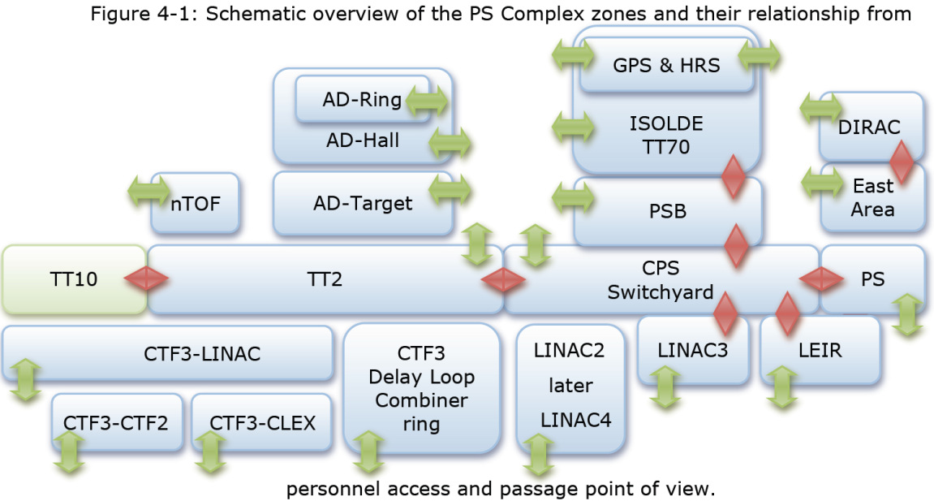
Figure 1: Schematic overview of the PSC Complex zones and their relationship from PACS Functional Specification [1].

Table 1 No. of elements in LHC & PS
 | LHC | PS
Access Points | 36 | 28
Doors | 265 | ~100
Patrol Boxes | 330 | ~110
EIS-f/m/ext | 13 | ~100
Interlock “Chains” | 5 | 17

From a functional point of view there are some differences of the PS PPS when compared to the LACS/LASS.
Although the major radiation-related personnel access risks are addressed, some other risks are considered also in the PS PPS, and are treated as “external interlocks” such as ventilation, laser, etc..
There are 2 additional access modes : Special Permit and Test EIS-f, that allow magnet specialists to enter an area with the magnets on and permit testing of all the EIS-f by interlocking the upstream safety chain respectively.
A new Public Address system shall be installed to replace the existing one for operational needs.
A mini-MAD drawer shall be available at each access point to pass small material.
Finally, maintenance doors shall be installed to allow maintenance of the access points during machine run. The objective is to reduce the unavailability of the access control system during technical stops and shutdowns.
Similarly to the LHC Access System, the PS PPS shall retain some key features such as the iris biometric checks, PAD & MAD with “unicity of passage” features and distribution of trapped keys for restricted mode.

PSPSS Design Status
From the project progress point of view the following phases have been completed:
Functional Specification & Sectorisation are completed, with detailed sectorisation documents circulating for final approval.
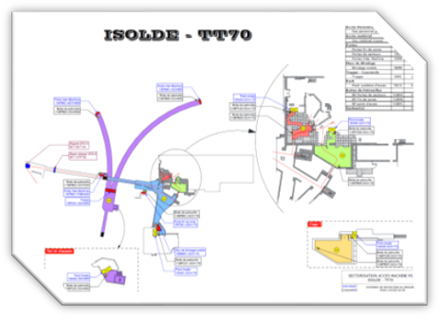
Figure 2 Example of sectorisation drawing for ISOLDE
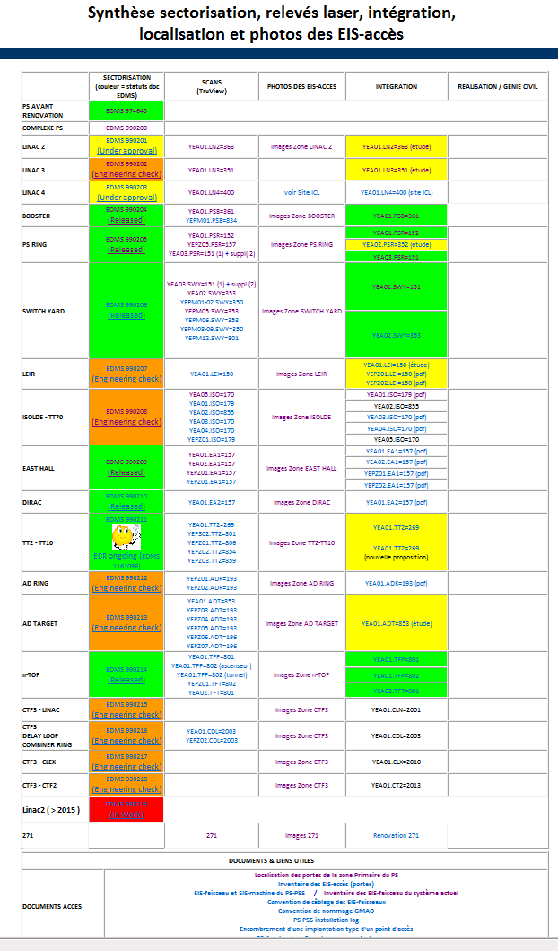
Figure 3 PS PSS Sectorisation and integration page [2]

The preliminary risk analysis document is completed and is pending final approval [3] . All Safety functions have been defined.
The Technical Specification is completed [4] and the contract for study and execution passed. System design is completed, including, architecture design [5] and component selection.
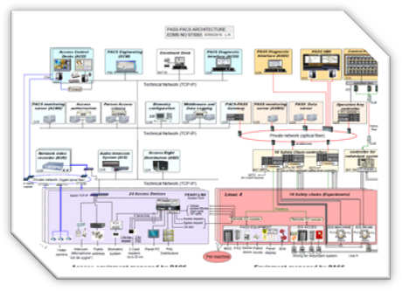
Figure 4 System architecture layout [5]

The Test platform has been built in building 271 and the first Factory Acceptance tests have been completed. The system validation on the CERN platform is scheduled for 2012 Q2.
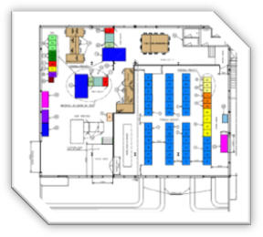 | 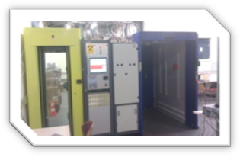
Figure 5 PS0 test platform in building 271

The integration studies are on-going, including Area 3D scans & Detailed Integration Studies.
Some major difficulties are being encountered due to lack of physical space for installation of cables and access points.

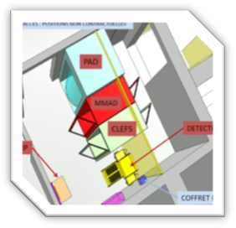 | 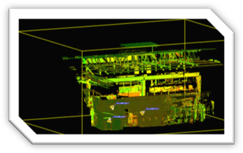
Figure 6 Examples of integration and 3D area scans

PSPSS Work in progress
Work in progress in the PSPSS project includes the installation of Rack Control Room in building 271 on the Meyrin site.
The first functional tests on test platform are due to be completed in 2012 Q2.
Civil engineering preparations are on-going for LS1 (Long Shutdown 1) mostly for the:
- Installation of the access points;
- Construction of new irradiated material buffer zones;
- Construction of new cable trenches/galleries.
New Buffer Zones are to be built at the same time as the new access points and integrated physically with the latter. This has required a close collaboration with DGS/RP & EN/MME in order to optimise the installation works.
Further to a major effort of cleaning up the existing cable trays and installing cables, new cable trenches or complete new cable galleries shall have to be built, and discussions are on-going with EN/EL and GS/SE.
Intense collaboration with EN/MEF, EN/EL & IT/CS is also under way to prepare all the technical infrastructure for the installation of optical fibres, power cabling and copper cabling for controls and remote I/Os.
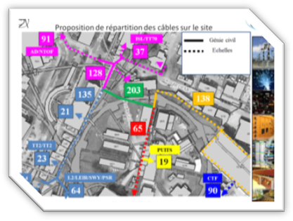
Figure 7 Proposal for cable routing in Meyrin

PS PSS Installation Planning
The main objective is to complete the commissioning of all zones during LS1.
Installations should start in 2012 Q4, beginning with zones in the LHC injector chain.
Assuming approximately 2 to 4 months per zone and installation of 2 zones in parallel with a further 2 months for final system commissioning and testing including DSO tests & OP validation, the installations in the LHC injectors should be operational by April 2014.
The exception is Linac4 which must be ready for Hardware Commissioning tests in 2013 Q1.

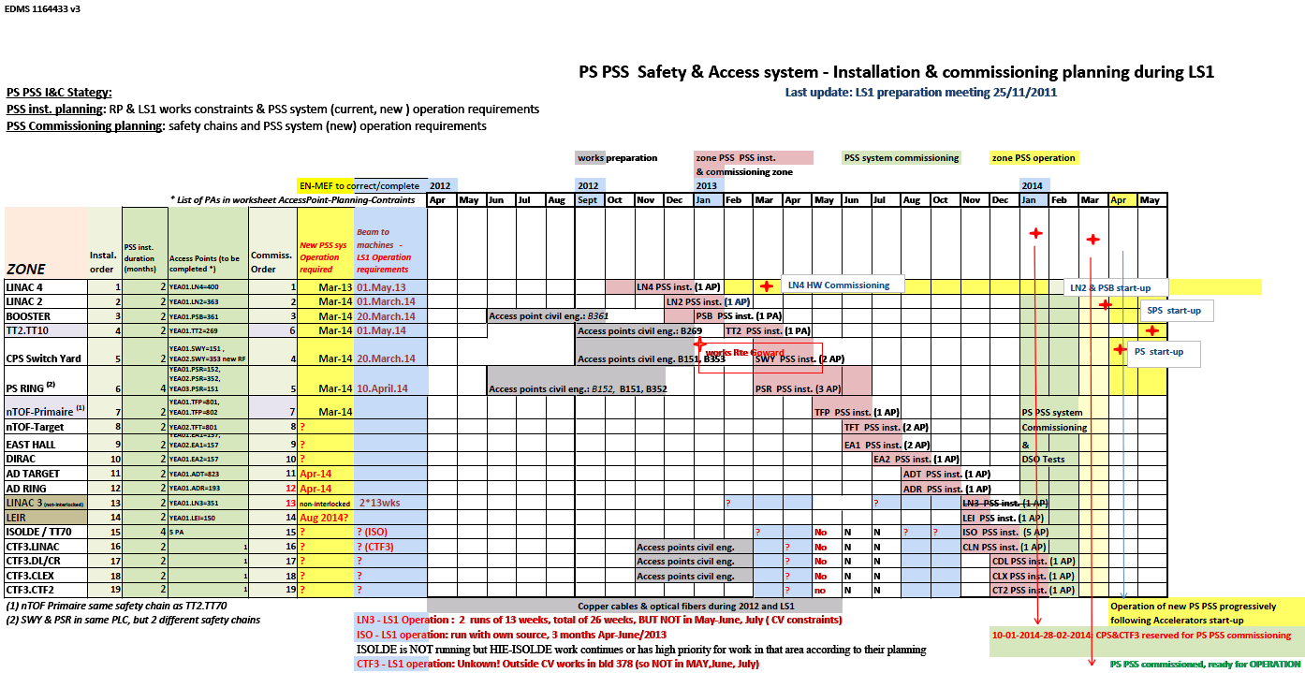
Figure 8 Schedule & planning for PSPSS [6]

The constraints to be respected in the schedule are of 4 distinct types:
- Requirements for Machine run
Some machines shall need to run during the LS1, such as Linac3, CTF, ISOLDE. Operation dates for each are still to be confirmed.
This implies that the current system must be kept fully operational for these zones, including interlocks
- Requirements to give Access
Access must be controlled during the LS1 across all machines in the PS complex.
This implies that the current system must provide full access control functionality (but not interlock)
- RP Constraints
Some work areas are subject to ALARA working conditions, decay time for some areas and DIMR procedures.
- Coactivity Management
Some works by other groups for other projects impact the schedule (e.g. route Goward shielding). This is coordinated with EN/MEF.

PS Secondary Areas Access System
During 2012-2013 a new feature shall be added to the access system of the experimental areas in AD and East Hall that will restrict the patrol mode to users with a formal training. This system is already deployed in the SPS North Area.

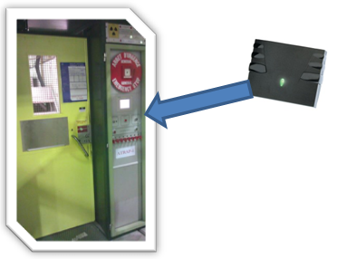
Figure 9 Addition of badge readers in AD and EH

During LS1 and depending on the East Area Renovation project (cf. East Area Day Workshop) some changes are expected in the layout of the PS Secondary Access system.
During the reshuffling of the areas in the East Hall, a spin-off of the command & control of the EIS-f to “CESAR-type” control is envisaged, in order to approximate the behaviour of the system to the SPS North area.
Furthermore it becomes necessary to install building access control to the Hall 157, much as has already been done in building 193 (AD) and EHN1 (North Area)

SPS Primary Areas Access System
During 2011-2012 some modifications shall be done, in particular the upgrade of the SPS SCADA supervision. It was originally developed with FactoryLink, which has in the meantime been bought by Siemens. This product is no longer supported and Siemens suggested migrating the supervision to WinCC. During 2011 some “usual” modifications have already been performed such as the new area HiRadMat & other minor re-sectorisation tasks.
During LS1 no special actions are foreseen, since all resources, human and material, are now devoted to the PS PPS.
The IMPACT tool can be used if needed.

During LS2 however, even if its dates are not yet defined, it is clear that the level of obsolescence of the SPS Access control system will be high.
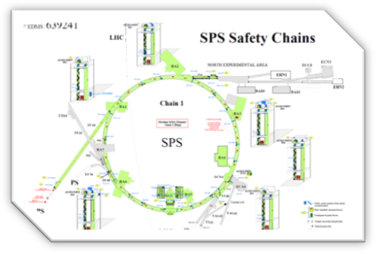 | 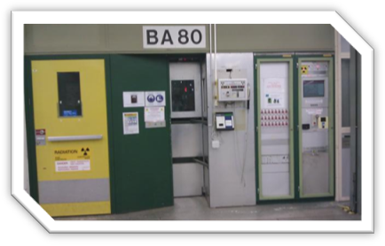
Figure 10 Current status of the SPS Primary Access

A complete rebuilding shall be necessary since it is now running on an obsolete safety & control architecture and there is a rapidly diminishing support for the Siemens S5-series PLCs.
GS-ASE has recently started the Risk analysis phase studies. For resource optimisation similarities with PS & LHC shall of course be explored.
As for the time scale of such a project, its development should start back-to-back with PSPPS project, since we would profit from the expertise and experience of the existing CERN and contractor personnel.

SPS Secondary Areas Access System
In 2011 the SPS Secondary Access Control system was completely rebuilt.
It is now aligned, in terms of basic control architecture with the PS AD and East Hall Secondary Access control systems and has delivered a good & reliable performance.
During 2012, the building access control to the NORTH Hall (EHN1) shall be deployed, in order to enforce the use of the personal dosimeter by people entering the building and also to reduce vehicle parking on “Salève side”.
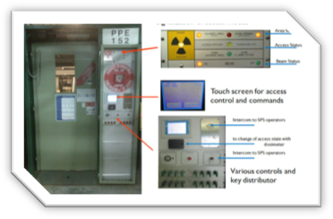
Figure 11 New features of the North Area Access

During LS1 there is one major activity to be conducted in the SPS North Area: the Project for High Intensity Proton Beam (and LOKN refurbishing) is of primary importance to the safety of personnel in the North Area, and the Safety Study is currently under way.

LHC Access Control/SAFETy System updates

LHC Main Updates in 2011-2012
Several new features have been deployed to the LACS such as:
- Integration of access with IMPACT
The access system is now connected to interface with the Intervention Management Tool IMPACT, so as to grant access only to people with an approved activity in a certain underground area, in addition to the relevant administrative and safety criteria.
- Automatic Key Distribution [7]
A new sub-mode has been deployed that delivers the tokens/keys automatically without intervention of the operator. This is useful in order to reduce the workload of the operator when the zones are to be kept patrolled in the Restricted Mode. It has been tested during the 2011-2012 Xmas Break
- 11 new key distributors have been added in tunnel areas
- 2 new PADs in PM54 (CMS) have been installed
- Biometry upgrade (2 eyes) due to lack of spares from the supplier for the existing model. In total 9 out of a total of 36 access points have already been equipped.

LHC Access Improvement Programme
After consultation with main stakeholders BE-OP and EN/MEF, an improvement list has been compiled with the objective to “Improve availability but not compromise on safety”.
The list of issues contains 3 types of improvements
- R2E-motivated relocations
- Performance Improvements (Access points, sectorisation, maintenance, and CCC improvements)
- Scope Increase – Interlock more than Beam &Access

R2E-motivated relocations
The relocation of the UJ14 and UJ16 complete access points is necessary. Both radiation simulations and increased number of unexplained failures motivates the relocation of the complete access points to UL14 and UL16 respectively.
Integration studies are complete, and works are included in the LS1 schedule constraints.
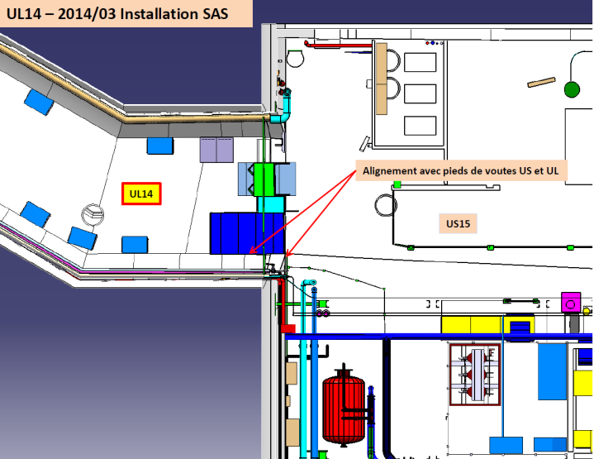 | 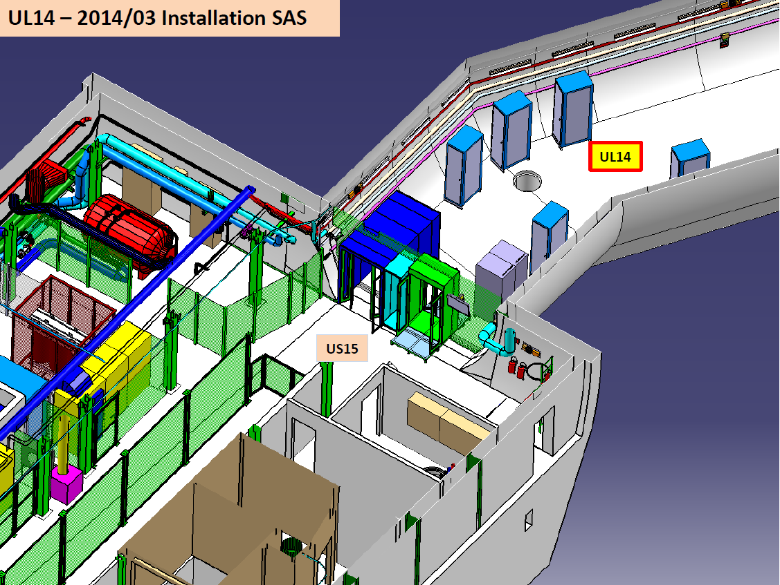
Figure 12 Integration of the UL14 & UL16

Further to these relocations, R2E studies motivate the relocation of the control racks located in UJ56 and UJ76 to USA55 and TZ76 respectively.

Performance Improvements
The list of proposed improvements includes the following key points.
- Access point improvements
- PAD : Avoidance of spurious patrol losses
- MAD : Improvement of human presence detection performance
- Improve information to users on refusal reasons
- Sectorisation improvements
- New Zone/sectors for CLIC pre-alignment tests in TZ32
- RP veto for TI2, TI8 and Dumps
- Maintenance improvement
- Allow maintenance of Access points during beam
- CCC improvements
- Periodic upgrade of LASS IT infrastructure
- Improve monitoring of “really closed” doors in the CCC

Scope Increase
The last type of improvement has the most significant impact on the basic architecture of LACS/LASS and is still pending official formal confirmation.
Currently the LHC Access Safety System (LASS) interlocks only access doors and beam elements in order to cover radiation-related risks.
The future requirements, as we understand them, would require the LASS to partially cover the risks arising from:
- Accidental helium release in the presence of personnel underground (considered possible to occur with superconductive magnets powered above a safe current limit);
- Exposure of the environment to extraction of activated air from the LHC.
The first function would imply interlocking the power converters (via the PIC), if a breach of a predetermined door-envelope occurs.
The second function would imply interlocking the beam if another pre-determined envelope of ventilation doors/walls is breached, since the nominal path of air extraction could no longer be guaranteed.

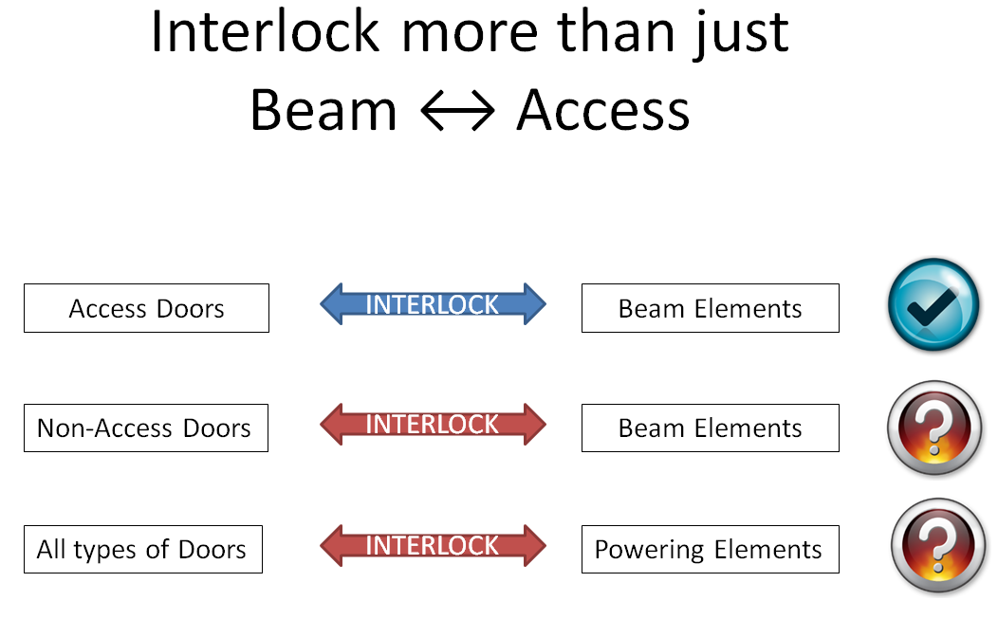
Figure 13 Current vs future LASS interlocks

If these functions were to be implemented, they would increase the number of safety elements involved, and would impact negatively the “availability” of the accelerator.
A formal decision is still expected on this point.

References
- R. Bonzano et al., Functional Specification Of The PSs Complex Access Control System For Primary Zones (PACS), EDMS 901505.
- S. Di Luca, PS PSS Sectorization and integration webpage; http://ps-proj-access-public.web.cern.ch/ps-proj-access-public/
- S. Grau, C. Salatko, T. Ladzinski, Analyse Préliminaire des Risques pour la Rénovation du système de sureté d'accès PS, EDMS 983789.
- P. Ninin et al., Technical Specification for the Supply, Installation and Maintenance of the Safety and Access System of the CERN PS, IT-3685, EDMS 1049701
- L. Hammouti et al., PS complex Personnel Safety System architecture, EDMS 973065
- E. Sanchez-Corral et al., Installation and Commissioning principles and planning of the future PS PSS system, EDMS 1164433
- R. Nunes, LHC Access Control System Restricted Mode, Automated Distribution of keys, LHC-Y-EC-0006, EDMS 1179180

EIS-f/m – Elément Important pour la Sûreté – faisceau/machine
EIS-a – Elément Important pour la Sûreté – accès
MAD = Material Access Device

