R2E – Experience and outlook
M. Brugger, M. Calviani, R. Garcia Alia, J. Mekki, G. Spiezia
CERN, Geneva, Switzerland.

Abstract

The period before 2011 and 2012 LHC operation involved several mitigation actions related to
R2E (“Radiation to Electronics”) project [1] aiming at keeping SEE (“Single Event Effect”) failures at an acceptable rate. In this respect, 2012 very successful LHC operation has continued to provide valuable inputs for the detailed analysis of radiation levels and radiation induced equipment failures, confirming the estimates provided in Chamonix 2012. Radiation levels around LHC critical areas and the LHC tunnel were studied in detail and compared both to available 2011 measurements and previous simulation results, as well as put in perspective to future LHC operation parameters. Observed radiation induced failures were continuously analysed and addressed through early relocation measures and patch-solutions on the equipment level whenever required and/or possible. During LS1 all primary mitigation actions will be completed, involving significant relocation and shielding activities all around the LHC and aiming to allow for nominal operation and beyond. This paper will focus on the observed equipment failures, their relation to radiation levels and extrapolation to post-LS1 operation.

introduction
Based on previous studies [2] and a respective analysis, the 2012 LHC operation was expected to be a key period for the analysis of radiation induced failures on machine equipment. The very successful LHC operation has confirmed the estimates of the radiation levels provided in Chamonix 2012 and proven valuable the early mitigation measures taken in previous years. During 2012 a strong emphasis was put in the detailed analysis of equipment failures which could possibly be linked to radiation effects and to verify if all of them are addressed throughout the LS1 mitigation measures. To study the correlation with radiation in detail, a number of criteria have been set, implying one, several and, ideally, all of the following conditions to be fulfilled:

- equipment failure occurs during periods with beam-on/collisions/losses (i.e., the source of radiation being present)
- the failure(s) is/are not reproducible in the laboratory
- the failure signature was already observed during radiation tests (CNRAD, H4IRRAD and others)
- the frequency of the failures increases with higher radiation levels

For rare cases this implies remaining uncertainties which can lead to failures being incorrectly attributed to radiation. However, as shown in this paper, the performed detailed studies over the 2012 operation period limited these uncertainty cases to only a few. In addition, there is the complementary limitation that the analysis is likely to miss radiation induced failures which do not lead to a beam dump. In addition more complex events where one equipment is affected by radiation can indirectly cause a problem to another one, thus eventually leading to either longer downtimes or beam dumps.

In the following we provide a summary of the radiation levels and the induced failures regarding the 2012 LHC operation, including an estimate of the respective machine downtime. The impact of performed countermeasures is highlighted and conclusions are drawn. It is shown that the detailed monitoring of the radiation levels, as well as the detailed analysis of radiation induced failures are key ingredients to assure the successful LHC operation after the Long Shutdown 1 (LS1), and beyond. In addition to the numerous early mitigation measures performed during 2010-2012, the complete relocation, shielding activities and equipment upgrades will be carried out during the LS1 period. The goal is to reduce the failure rate to achieve a continuous LHC operation at the luminosity levels that will be reached after LS1.

Radiation levels and parameters scaling
The radiation levels in the LHC tunnel and in the shielded areas have been measured using the RadMon system [3]. As in 2011, the major radiation-induced failures, observed during 2012 LHC operation, are Single Event Effects (SEE) on electronic equipment. The probability of having a SEE is related to the accumulated High Energy Hadron (HEH) fluence which is reported in Table 1 for the most critical areas where electronic equipment is installed. The HEH fluence measurement is based on the reading of the Single Event Upsets (SEU) of SRAM memories whose sensitivity has been previously calibrated at various facilities [4] [5]. The results, obtained during 2012 LHC proton operation, show a very good agreement between the predictions [2] and the measurements which are given with an uncertainty factor of 2 (Table 2). It is noted that the comparison is based on a cumulated luminosity of 15fb⁻¹, the foreseen target of the CMS and ATLAS experiments, which has been exceeded thanks to the efficient operation of the LHC machine. The uncertainties of the predictions of the radiation levels depend on the operational parameters because of the peculiarity of the three main categories of radiation sources at LHC: (a) direct losses in collimators and absorber like objects, (b) particle debris from beam-beam collisions in the four main experiments, and (c) interaction of the beam with the residual gas inside the beam pipe. In addition, the effect of the additional installed shielding (during 2011/2012 xMasBreak) is clearly visible for UJ14/16, the latter being the most critical areas during 2011 operation.
The most significant mismatch between predictions and measurements values arises in the areas RR53/57 and UJ76 where the radiation levels are directly impacted by the beam losses and settings of the collimators. A detailed analysis showed that the operational parameters adopted for 2012 (tight collimator settings in IR7 and closed TCL in IR1/5) are fully consistent with the observed measurements.
Another important parameter which affects the radiation levels in some of the critical areas (P4 mainly) is the interaction between the beam and the residual gas in the beam pipe. So far we only have limited experience of operating with a bunch spacing of 25 ns, which might play a role on a possible radiation levels increase due to beam-gas interactions.
Besides the critical areas listed in Table 1 and 2, there are additional zones where electronics is installed and radiations can induce failures in case radiation levels rise further due to beam-gas interactions. I.e, the HEH fluence increased by a factor 10 from 2011 to 2012 (2x10⁶ cm⁻² to 2x10⁷ cm⁻²) in the alcove UX45.
It can be concluded that the present analysis nicely shows that (a) the radiation levels were correctly analysed and measured in the last two years of operation; (b) an efficient monitoring system is an important asset in order to have an online mean of verifying radiation levels in order to control a possible impact on installed equipment.

Table 1: Measured HEH fluence in critical shielded areas in 2012 and 2011.
Area | Measured 2012  (HEH/cm²) | Measured 2011 (HEH/cm²)
UJ14/16 | 1.6*10⁸ | 2*10⁸
RR13/17 | 2.50*10⁸ | 7.0*10⁶
UJ56 | 1.50*10⁸ | 3.5*10⁷
RR53/57 | 2.50*10⁷ | 1*10⁷
UJ76 | 6.00*10⁷ | 5*10⁶
RR73/77 | 5.00*10⁷ | 8*10⁶
UX85B | 3.50*10⁸ | 2*10⁸
US85 | 8.80*10⁸ | 3.5*10⁷
For this, an improved RadMon system (larger sensitivity range, more accurate calibration and longer life-time) is currently in the final prototyping phase [6].

Table 2: Predicted and measured HEH fluence in critical shielded areas for a cumulated ATLAS/CMS luminosity of 15 fb⁻¹ during 2012 operation.
Area | Prediction  (HEH/cm²) | Measured (HEH/cm²)
UJ14/16 | 1.1*10⁸ | 1.3*10⁸
RR13/17 | 1.8*10⁷ | 2.1*10⁷
UJ56 | 1.2*10⁸ | 1.1*10⁸
RR53/57 | 1.8*10⁷ | 3.3*10⁷
UJ76 | 5.5*10⁶ | 1.6*10⁷
RR73/77 | 3.0*10⁶ | 2.4*10⁷
UX85B | 2.6*10⁸ | 2.1*10⁸
US85 | 6.5*10⁷ | 4.4*10⁷

Failures observed in 2012 and CORRESPONDING mitigation actions

The radiation induced failures on the LHC equipment have been analysed by organizing a weekly shift within the R2E project team. The main sources of information were the LHC e-logbook and the meeting on the LHC operation follow-up, daily held at 8h30 [7]. During the year, the collaboration of all the equipment groups was highly appreciated and permitted to improve the performed failure analysis. Once a failure is suspected to be related to radiation effects, the following information is collected and stored on the web page of the RADiation Working Group (RADWG) [8]: a) equipment, b) type of failure, c) location, d) consequence of the failure, e) number of beam fill. In some cases, it is not straight forward to understand if a failure was effectively due to radiation effects. Thus, the event is marked as to be confirmed (TBC) if a further analysis is required to understand what happened. In addition, the number of the beam fill was used as a direct link to insert information also in the Post Mortem (PM) database and in order to track the beam dumps that were due, or possibly due (to be confirmed), to radiations and allow for a respective analysis operators[9]. Table 3 shows the failures due to the SEEs. Four distinct cases are reported:
- Events leading to beam dump (Dump confirmed).
- Events leading to beam dump which are possibly due to radiation (Dump TBC).
- Failures which did not lead to beam dump (No Dump).
- Failures which do not lead to beam dump and are possibly due to radiation (No Dump TBC).
The second part of the Table makes a focus on the destructive failures, i.e. failures which triggered an intervention in the machine to replace a component/system. They represent ~30% of the total number of events leading to a beam dump.
It is important to note that the number of events to be confirmed represents only a small fraction and will thus not affect the overall conclusion.

Table 3: Number of failures due to radiation. A detail view of the destructive events is given below.
Dump Confirmed | Dump TBC | No Dump | No Dump TBC
58 | 10 | 36 | 7
Destructive Failures
Dump Confirmed | Dump TBC | No Dump | No Dump TBC
17 | 1 | 4 | 0

The pie charts in Fig. 1 reports the distribution of the failures per area (a) and per equipment (b). The failures per area are almost equally distributed among the alcoves which were known to be prone to radiations (Table1).

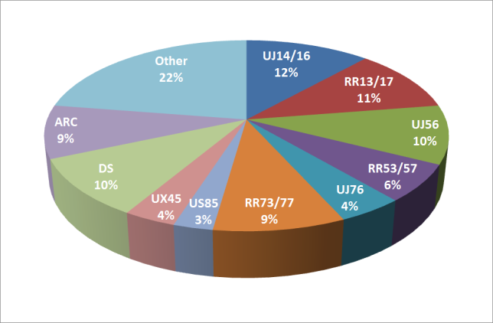
a)
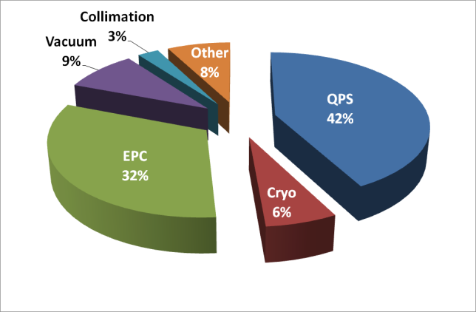
b)
Figure 1. Failure distribution per area (a) and per equipment (b).

As compared to 2011 operation and the respective observed SEE related failures, this also reflects the successful implementation of R2E countermeasures where the focus was put on the most exposed areas, thus bringing all of the critical areas more or less to the same exposure level (also visible in the reported radiation levels for 2012). I.e, the number of failures in the UJs of point 1 is not as dominant as along 2011, showing the effectiveness of the shielding that was put in place in the 2011-12 xMasBreak [2]. The majority of the failures that occurred in the tunnel was related to the Quench Protection System (QPS) electronics. The EPC equipment, installed in the RR areas, presented a recurrent failure due to a destructive event on an auxiliary power supply.
In addition to the shielding at point 1, the relocation of a few sensitive equipment (Cryogenic, Beam, Power interlocks, and UPS devices), as well as the patch solutions applied on the equipment that could not be moved yet, allowed to significantly decrease the overall number of failures with respect to 2011.
In the following subsections, the failure analysis and the envisaged mitigation actions for all the affected equipment groups are briefly summarized.

QPS

Failures on the QPS systems happened both in the tunnel and in the shielded areas. Most of the failures affected the QPS detection system which is based on a Digital Signal Processor (DSP). Other sensitive parts of the QPS system are the communication and the acquisition modules used for the protection of the magnets, the splices and the 600A converters. It is important to note that none of the observed SEE-induced failures compromised the safety of the machines. Various additional countermeasures, as the design and deployment of a data acquisition card based on a rad-tolerant FPGA and the usage of an automatic reset on the microFip, are planned for LS1 to further reduce the radiation induced failures. Moreover, the equipment in the UJ14/16 and UJ56, which caused 30% of the total number of the QPS failures, will be relocated into safe areas.

Power converters

During 2012 operation, an auxiliary power supply of the 600A Power Converters (PC) suffered 14 destructive events. A destructive event was also registered on the 120A power converter. The Function Generator Controller (FGC) was affected by 10 radiation induced failures. The events happened mainly in the UJs of Point 1, RRs of Point 1, 5, and 7, and in the ARC. The affected power supply was tested under radiation and, after several complex iterations due to the commercial nature of such power-supplies, finally the weak component could be identified. It will be replaced on the systems where it is actually installed during LS1. In addition, the new FGC is under design to be radiation tolerant. At long term, both the power stage and the controller (FGC) of the PCs will be replaced by the respective radiation tolerant version. Moreover, already during LS1 the relocation of the PCs will be carried out wherever feasible (i.e. all areas but the RRs).

Cryogenics

The cryogenic equipment also suffered various types of failures. Both destructive and non-destructive SEU failures affected the PLC (Programmable Logic Controller) in Point 4 (UX), 5 (UJs), 7 (UJ), and 8 (US). In addition, the magnet bearing system failed due to single events at point 4 and 8. A few PLCs showed communication errors on the Profibus network. It is important to note that thanks to the mitigation actions implemented along 2011 and in the subsequent xMasBreak, the actual effective (per unit luminosity) number of failures was significantly decreased with respect to the one observed in 2011; in total only 4 failures led to a beam dump. However, each failure has a significant impact on the downtime for the machine. The group has planned and integrated several mitigation actions. The most sensitive PLCs were or will be relocated. The move of the magnetic bearing system is under study.

Collimation equipment

Abnormal communication losses affected the control equipment of the collimation system installed in UJ14, UJ16, and UJ56; only one beam dump was caused. No failure of the power supply was registered. The equipment will be removed from the critical areas during LS1.

Access system

The access doors and the iris scan systems got blocked in many LHC points, even at the surface, in 2012. As a matter of fact, the replacement of all the electronics for the access system is programmed to change obsolete systems. In addition, the failure analysis showed that the fault cases which happened at UJ14/16 and UJ56 are higher in number with respect to other areas and thus expected to be partly related to radiation effects. The relocation scheduled for LS1 should significantly reduce any failures caused due to radiations for the future operation.

Vacuum

Destructive failures of a power supply and communication losses on PLCs were registered in the UJ76 (4 events) and UX 45 (3 events). Given the radiation levels, the failures at UJ76 are most likely related to radiations and, thus, the Vacuum equipment will be relocated during LS1. The failures at UX45 are under investigation.

EN/EL equipments

The Uninterruptible Power Supply (UPS) of the electrical network exhibited a destructive event in the US85 area, the only one remaining in the currently critical areas after the relocation during the XMasBreak 2011/2012. The analysis, considering the observed failure mode, the affected location and the involved power components, demonstrated that the fault was induced by radiation. On this basis, the UPS will be relocated from US85. However, the UPS systems will remain in the REs, but exposed to much lower radiation levels as in the critical areas. Therefore, two types of UPS systems have been tested against radiations at H4irrad; the data analysis is on-going, however already indicating that no additional countermeasures are required besides the already scheduled relocation for the US85 area.

RF equipments

A few failures (3 in total) were registered on a power supply and on vacuum gauges at UX45. Those cases might not be related to radiations. However, the fact that they happened in UX45 where the radiation levels increased during 2012 by a factor 10, suggests keeping those events under investigations, and are thus noted here for completeness.

FAILURE SUMMARY AND OUTLOOKS for Ls1

Table 4 presents a summary of the number of confirmed dumps for the 2012 operation per equipment.

Table 4. Summary of the SEU-induced beam dumps and respective downtime.
Equipment | 2012  #dumps | 2012 downtime  (% of the total) | >LS1  #expected dumps
QPS | 31 | ~40 | 5
Power Converter s | 14 | ~20 | 3
Cryogenic | 4 | ~30 | 1
Vacuum | 4 | ~1 | 0
Collimation | 1 | ~1 | 2
EN/EL | 1 | ~6 | 0
Other |  | ~2 | 5
Total |  | ~250-300 hours | ~10-20

A calculation of the machine downtime caused by the radiation induced failures is also reported in percentage. The latter analysis was performed by using the data collected on the RADWG website and on the PM database. A manual iteration on the data was required to take into account the downtime due to issues not related to SEEs which happened before or after the beam dump and led to longer downtimes than the radiation induced failure itself. Although the analysis is preliminary, it gives a fair indication of the operation time loss due to radiation. The downtime for the cryogenics failures considers the recuperation of the cryogenic temperatures.
Figure 2 reports the reached objectives by the R2E project, with the important support of all the concerned equipment groups, as well as the shielding and relocation teams. The dependency on the actual radiation levels is emphasized by displaying the number of beam dumps normalized to the cumulated luminosity of the CMS and ATLAS experiments. In total, the number of dumps per fb⁻¹ was reduced by a factor of almost four from 2011 to 2012.
In the long-term, and as a requirement for nominal (and beyond) LHC operation, the goal is to have less than one dump per fb⁻¹ when the machine will restart operation after LS1, the latter thus being a crucial period to deploy many mitigation actions.
During LS1, all remaining possibly sensitive equipment will be moved from the critical areas (UJ14/16/56/76, US85, and UX45 partly) to safer areas; additional shielding will be installed in the RR areas; critical systems based on custom designs, such as the QPS and the Power converters will be upgraded or redesigned. On the basis of the first two years of operation, the installation of commercial devices will not be allowed in areas where the HEH fluence is expected to be higher than 10⁷ cm⁻².
Taking into account those countermeasures, a very tentative estimation of the remaining failures for the restart of the machine on 2014 is also given in Table 4. It’s important to note that the latter aims at trying to pinpoint the effectiveness of the mitigation measures, rather than aiming for accurate predictions of failures in the long-term expected to be dominated by so far rare cases, or untracked equipment changes (upgrades, etc.).
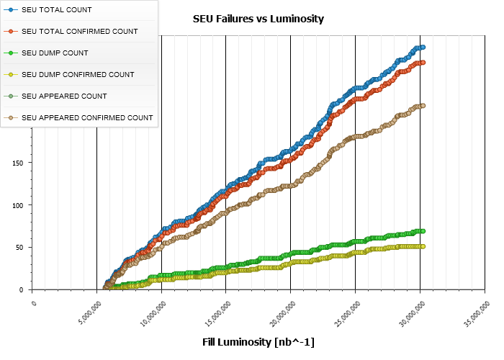
Therefore, in order to assure this result, the R2E activities will continue with the established analysis process and also follow in detail the radiation levels in the ARCs where the radiation levels will increase and also possibly imply long-term cumulative damages, as the Total Ionizing Dose (TID) effects, to be considered. In this context, the
~3 dumps per fb⁻¹
2012
~12 dumps per fb⁻¹
2011
>LS1
< 0.5 dump per fb⁻¹
impact of the 25 ns bunch operation will be studied in detail; areas which were so far characterized by low radiation levels, such as the UX25/45/65, the UJ/UA23, the UJ/UA87, and the RE will be observed. Finally, the upgrades as well as the new developments of custom electronics will be followed and radiation tests advised accordingly.

Conclusions

A summary of the radiation levels and the induced failures for the LHC operation in 2012 has been reported.
About 60 beam dumps were provoked by radiation effects on electronic equipments causing a downtime for the machine of about 250-300 hours. The impact of the radiation effects would have been significantly higher without the countermeasures that were already applied in the past years [2]. Furthermore, the prompt reaction of the groups to design patch solutions for mitigating radiation effects allowed throughout the year 2012 to reduce the number of failures which could have led to a beam dump. In total, the radiation induced failures were reduced by a factor 4 with respect to the 2011 operation.

Figure 2. The number of SEU failures is reported as a function of the CMS/ATLA luminosity. The number of dumps, induced by SEUs, per fb⁻¹ is extrapolated as a figure of merit for 2011, 2012 operation.

Additional mitigation actions are planned for the LS1 period to further reduce the radiation vulnerability of the equipment. Thanks to those efforts, the expected number of radiation induced dumps per fb⁻¹ is expected to be <1. This objective will permit to classify the radiation induced failures as minor, and to operate the LHC smoothly without any significant number of stops related to radiation.
The monitoring of the radiation levels will be a continuous work which aims at reducing the uncertainty factors, mainly related to the beam gas effects and the losses in the collimation areas, as well as to closely monitor the long-term radiation impact on exposed electronic systems. This will allow verifying design assumptions, as well as scheduling preventive maintenance actions when required. The detailed follow-up of the system upgrades and developments remains crucial to reach the above goal.

Aknowledgments
The authors would like to thank all the equipment groups for their active collaboration throughout 2011-12, as well as the EN/MEF group for its continuous support in the relocation and shielding improvements. The authors would like to acknowledge M. Zerlauth for his precious collaboration to set up the SEU failure analysis in the PM database.

References
- R2E website, www.cern.ch/r2e
- M. Brugger et al, “R2E Experience and Outlook for 2012”, Proceedings of LHC Performance workshop, Chamonix 2012.
- G. Spiezia et al. “The LHC accelerator Radiation Monitoring System - RadMON” http://pos.sissa.it/archive/conferences/143/024/RD11_024.pdf.
- K. Røed, M. Brugger, D. Kramer, A. Masi, P. Peronnard, C. Pignard, and G. Spiezia, “Method for measuring mixed field radiation levels relevant for SEEs in the LHC”, Transactions on Nuclear Science, pp.1040-1047, Aug.2012.
- D. Kramer et al. “LHC RadMon SRAM detectors Used at Different Voltages to Determine the Thermal Neutron to High Energy Hadron Fluence Ratio”, IEEE Trans. Nucl. Sci., vol. 58, no. 3, pp. 1117-1122, 2011.
- A. Masi, G. Spiezia, P. Peronnard, M. Donze, M. Brugger, R. Losito, “The new generation of LHC accelerator radiation monitoring system”, Proceedings on RT2012 conference, May 2012.
- https://lhc-commissioning.web.cern.ch/lhc-commissioning/news-2011/LHC-latest-news.html
- http://radwg.web.cern.ch/RadWG/
- http://lhc-postmortem.web.cern.ch/lhc-postmortem/

