14/06/13
Swiss Space Center
Presentation for the Intel ISEF Special Awards Winners
Prepared by:
Stefano Rossi
Checked/Approved/Signed by:

Swiss Space Center
EPFL - Lausanne
Switzerland
14/06/13

1 What’s the Swiss Space Center? 3
2 SwissCube 4
3 Cheops 4
4 CleanSpaceOne 5
5 CubETH 5
6 Other Projects: 6

What’s the Swiss Space Center?
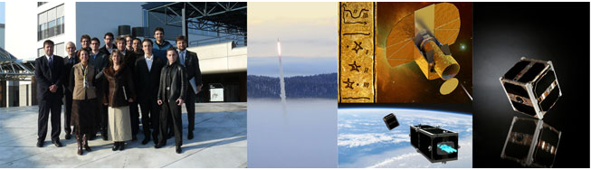The Swiss Space Center experienced significant changes in 2012. In January it’s status grew from regional to national significance. The objectives of the Center thus expanded with the advent of new projects and exciting mandates.
At the heart of the Swiss Space Center since its creation in 2003 is the objective to reinforce the position of Swiss Space stake- holders, whether institutional, academic, or industrial players.
With the evolution in January 2012 from a regional Center to an organization of national significance, the Swiss Space Center stays true to its initial mandate to network Swiss research institutions and industries on national and international levels in order to establish focused areas of excellence internationally recognized for both space R&D and applications. Not only that, but the role to facilitate access to and implement space projects for Swiss research institutions and industries has been greatly strengthened by strategic positioning.
2012 was an exciting and challenging year starting with the launch of the CleanSpace One study that had a very positive echo in the media worldwide, placing Switzerland once again on the international stage. The steady increase of members, the support of hosts and partners allowed the Center to refurbish its Concurrent Design Facility, build up a clean-room for educational purposes and contribute to the advancement of space interest through events and coordination of specific activities.
Most members participated in the Strategic Committee, the advisory body that in 2012 helped in the orientation of the Center and whose major output was a recommendation for new Terms of Reference that will govern the Center in the future.
During the last quarter of 2012, Switzerland was appointed to the co-presidency of the ESA ministerial conference, and in parallel won the ESA Small-sat call for tenders with the CHEOPS proposal. These elements, among others, ensure that the eyes of the international space community are turned towards Switzerland. With its members and partners, the Swiss Space Center will con- tribute in the next years to the excellence of Swiss contribution to space through innovative technological advances, reliable product developments in our industry as well as international collaborations in Europe and beyond.

SwissCube
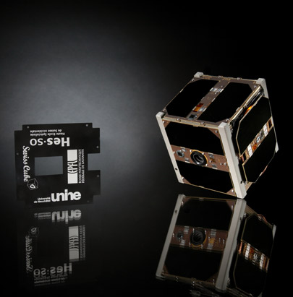
Swisscube is a pico-satellite of 10x10x10cm with a mass of less than one kilogram, it is the first satellite which was completely developed and built in Switzerland in collaboration with several education Swiss institutions; led by the Ecole Polytechique Federale de Lausanne, the University of Neuchatel, the HES-SO and the FHNW took part in the development of the picosatellite. The 23th of September of 2013, it will be on orbit for 4 years after the launch from the Indian Satish Dhawan Space Center (inclination: 98˚, apogee: 725km, perigee: 700km). Swisscube was launched with the PSLV-C14 (Polar Satellite Launch Vehicle) as piggy-bag of the main Oceansat-2 Indian spacecraft for oceanographic monitoring. Other three cubesats and two Rubin satellites were launched together with the Swiss picosatellite: BeeSat (Berlin), ITU-pSAT1 (Istanbul), UWE-2 (Wurzburg).
The SwissCube goal was to characterize the airglow intensity over selected latitudes and longitudes thereby demonstrating that the airglow emissions are strong enough to be measured by an off-the-shelf detector and validating the concept for the development of a low-cost Earth sensor. Unfortunately the camera didn’t achieve the mission due to a reflection problem; however, as the other purpose of SwissCube was mainly educational and to have flight data feedback, almost four years of scientific results have been collected and analysed in comparison with the ground pre-flight tests made by students during the development.
We want to show some good results achieved and some “signal from the space”.

Cheops
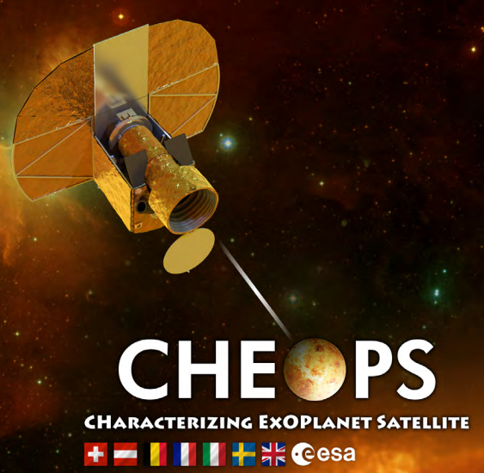
The CHaracterizing ExoPlanets Satellite (CHEOPS) will be the first mission dedicated to search for transits by means of ultrahigh precision photometry on bright stars already known to host planets. By being able to point at nearly any location on the sky, it will provide the unique capability of determining accurate radii for a subset of those planets for which the mass has already been estimated from ground-based spectroscopic surveys. It will also provide precision radii for new planets discovered by the next generation ground-based transits surveys (Neptune-size and smaller).
The main science goals of the CHEOPS mission will be to study the structure of exoplanets with radii typically ranging from 1-6 R_Earth orbiting bright stars. With an accurate knowledge of masses and radii for an unprecedented sample of planets, CHEOPS will set new constraints on the structure and hence on the formation and evolution of planets in this mass range.

CleanSpaceOne
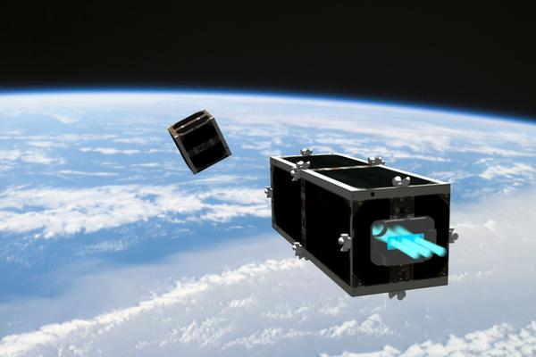

The Earth’s orbit is full of all kinds of floating debris; a growing crowd of abandoned satellites, spent rocket stages, bits of broken spacecraft, and fragments from collisions are rocketing around the planet at breathtaking speeds. NASA keeps close tabs on at least 16,000 of these objects that are larger than 10 cm in diameter. When an operational spacecraft such as a satellite collides with one of them, serious, costly damage can result; often the satellite is complete destroyed. And the collision itself then generates thousands more fragments, further exacerbating the problem.
To move beyond mere rhetoric and take immediate action to get this stuff out of orbit, the Swiss Space Center at EPFL is launching CleanSpace One, a project to build the first prototype in a family of “de-orbiting” satellites.
The cleanup satellite has three major challenges to overcome, each of which will necessitate the development of new technology that could, in turn, be used down the road in other applications.
After its launch, the cleanup satellite will have to adjust its trajectory in order to match its target’s orbital plane. To do this, it could use a new kind of ultra-compact motor designed for space applications that is being developed in EPFL laboratories. When it gets within range of its target, which will be traveling at 28,000 km/h at an altitude of 630-750 km, CleanSpace One will grab and stabilize it – a mission that’s extremely dicey at these high speeds, particularly if the satellite is rotating. To accomplish the task, scientists are planning to develop a gripping mechanism inspired from a plant or animal example. Finally, once it’s coupled with the satellite, CleanSpace One will “de-orbit” the unwanted satellite by heading back into the Earth’s atmosphere, where the two satellites will burn upon re-entry.

CubETH

CubETH is a CubeSat (10x10x10 cm³) satellite under development between ETHZ and EPFL. The satellite will perform precise orbit determination and satellite attitude determination based on GNSS in post-processing and in real-time. The phase A of this project starts early 2013. Students from different sections are needed to accomplish tasks such as mission design, systems engineering, telecommunication, power systems, attitude control, thermal engineering and PCB design.

Other Projects:
-Data Analysis SwissCube
-System Engineering and design:
Electrical design
Telecomunication
Orbital dynamics
Attitude Control
Structures
Advanced materials
-Subsystem and mission optimization and analysis

