# Status of splices in 6 ka CIRCUITS

J.Ph. Tock, CERN, Geneva, Switzerland,

Abstract

This paper gives a progress report on the work done and on-going in the frame of the task force on the LHC splices consolidation.

First, an inventory of the superconducting 6 kA splices all around the LHC machine is given. Then one circuit is presented in detail (Q7L2).

The method and results of superconducting splices resistance measurement are given.

The so-called interconnection “praying hand” splices are detailed: electrical and mechanical specifications, procedure used and tests performed on samples. Preliminary information is given on a possible reinforcement of these splices.

## introduction

There are 94 6 kA superconducting circuits in the whole LHC. This represents about 6 % of the total quantity of superconducting circuits in the LHC. They are used to power individually quadrupoles and dipoles. There could be different classifications, according to:

* The location of the magnet to be powered: inside the continuous cryostat or stand-alone or semi-stand-alone magnets or in some triplets
* The sector the circuits are located in (From 5 to 17 circuits per sector)
* The powering unit (All four main types of DFBs are concerned: DFBA, DFBM, DFBL, DFBX)

The currents corresponding to four energy levels in the 94 relevant magnets are summarised in Table 1 taking the maximum values per “family”. These values are coming from references [1,2].

Table 1: Maximum currents [kA] in “6 kA” circuits

|  |  |  |  |  |
| --- | --- | --- | --- | --- |
| **Family** | **3.5 TeV** | **5 TeV** | **7 TeV** | **7.6 TeV** |
| Q7, Q8, Q9, Q10 | 3.1 | 4.0 | 5.4 | 5.8 |
| Q4, Q5, Q6 | 2.1 | 3.5 | 4.3 | 4.7 |
| D1, D2, D3, D4 | 3.2 | 4.6 | 6.0 | 6.5 |

## CIRCUITS ANALYSIs

The mandate of the “LHC Splices Task Force” [3] includes the in-depth analysis of all the circuits, focusing on the splices. This work is currently in progress and is considerable due to the many different types of circuits. One circuit (Q7L2) has been analysed in detail [4]. In this small circuit (≈ 20 meters), 2 types of superconducting cables (Rutherford and circular) and 5 different configurations of splices have been identified, as shown in Fig. 1. From this first circuit, it can be seen that the variety of splices and the quantity of different types is considerable. Another “(re)discovery” was that “praying hand splices were also present inside some cold masses.

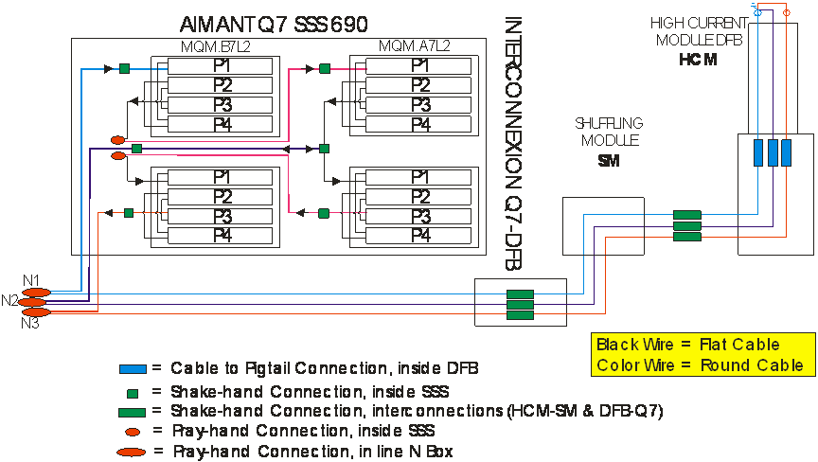

Figure 1: Q7L2 electrical circuit scheme

## measurement of splices resistance

After the 19th of September 2008 incident in sector 34, the recommendation was to map the resistance of all the splices before powering them. As far as 6 kA splices are concerned, no method was available at the beginning of the commissioning. In parallel with the development and validation of the method, MP3 recommended to commission these circuits to reduced currents, corresponding to 3.5 TeV level. In the meantime, a method and tooling to measure the busbar segments resistance have been validated. As a type test, the IPQs (Q7L2 to Q10L2) in the dispersion suppressor left of 2 were measured with a current up to more than 2.5 kA. This has proved that this method is applicable. The results for these four quadrupoles, involving 12 segments with each at least 5 splices each, are that the average resistance per splice is 1.1 nΩ and a maximum excess resistance of 1 nΩ. This is perfectly in-line with the specification of 1.5 nΩ and with the expectation of 1 nΩ.

## Quench protection system for ipqs/ipds

The characteristics of the present quench protection system (QPS) for IPQs/IPDs are summarised in table 2 and compared with the new QPS for the main dipoles.

Looking to the figure of merit (Defined as the product of the detection time by the detection threshold), it can be seen that the present QPS for IPQs/IPDs is already “better” than the new QPS installed for the main dipole. An upgrade is nevertheless possible and under study. It would allow protecting separately the busbars and the splices, reducing the threshold and also making diagnostics and monitoring splices measurements.

Table 2: QPS for IPQs/IPDs

|  |  |  |
| --- | --- | --- |
| **Characteristic** | **IPQs/IPDs (present)** | **Dipole**  **(nQPS)** |
| Detection time | 10 msec | 10 sec |
| Detection threshold | 100 mV | 0.3 mV |
| Figure of merit | 1 mV sec | 3 mV sec |
| Discharge time | < 1 sec | 50 / 100 sec |
| Power supply | 2 UPSs | 2 UPSs |

## interconnection praying hand splices

For a long time, the so-called “interconnection (IC) praying hand” splices were pointed as possibly weak. These splices are powering the IPQs in the Dispersion Suppressor (DS) zones located at the left of 6 of the 8 IPs (Fig. 2). 23 quadrupoles circuits are concerned: Q7 to Q10 at left of P1,2,3,5,8 and Q8 to Q10 at the left of P6. There are 3 IC praying hand splices for each of these circuits so a total of 69 splices.

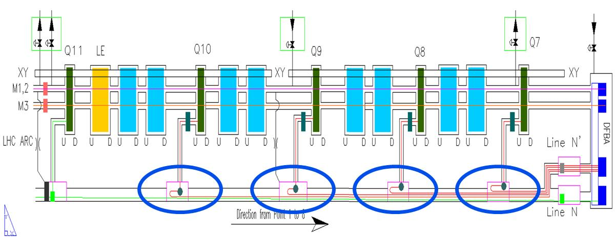

Figure 2: IC praying hand splices location

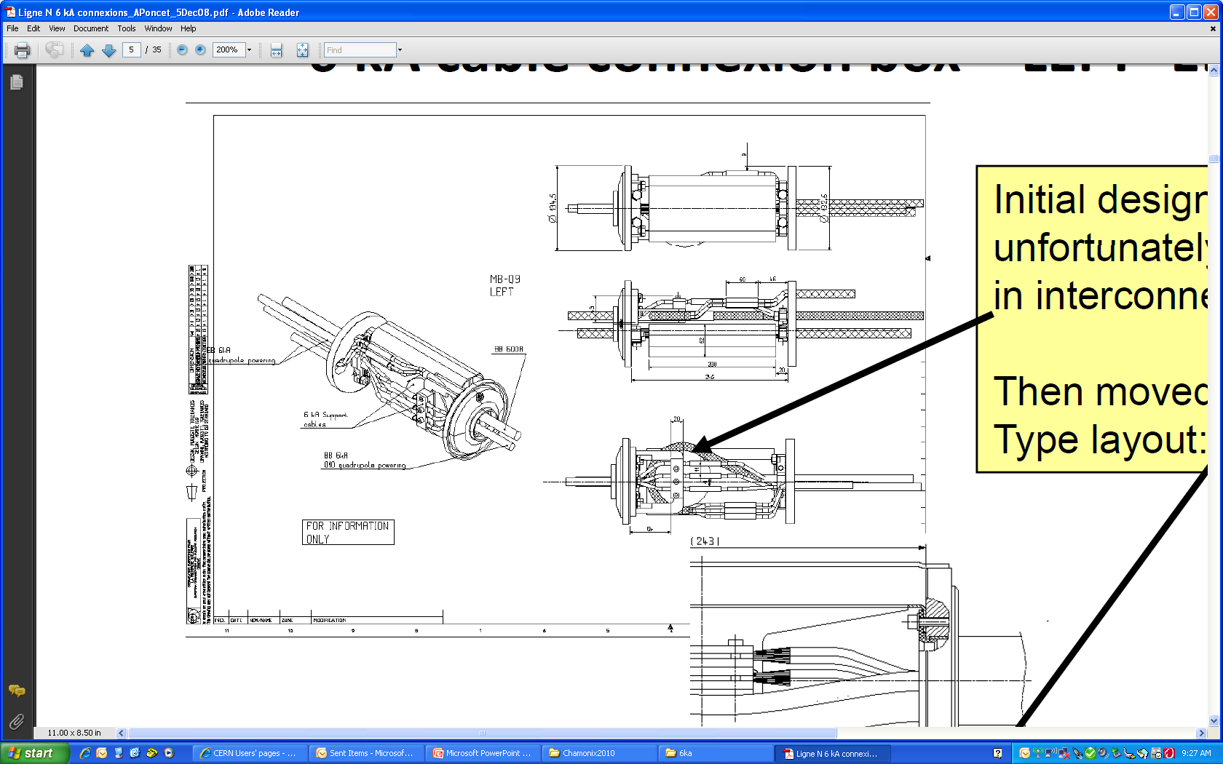

Fig. 3: Initial in-line splice design

The initial design of these splices was in-line or “shaking hands” design as can be seen in Fig. 3. This design is used in the interconnections between DFBA and Q7 and also for the IPQs located at the right of the IPs. Taking the space limitation in the interconnection box, the required bending radius for the superconducting cable was smaller than acceptable. The design was then changed to “hair pin” or “praying hand design” as illustrated in Fig. 4.

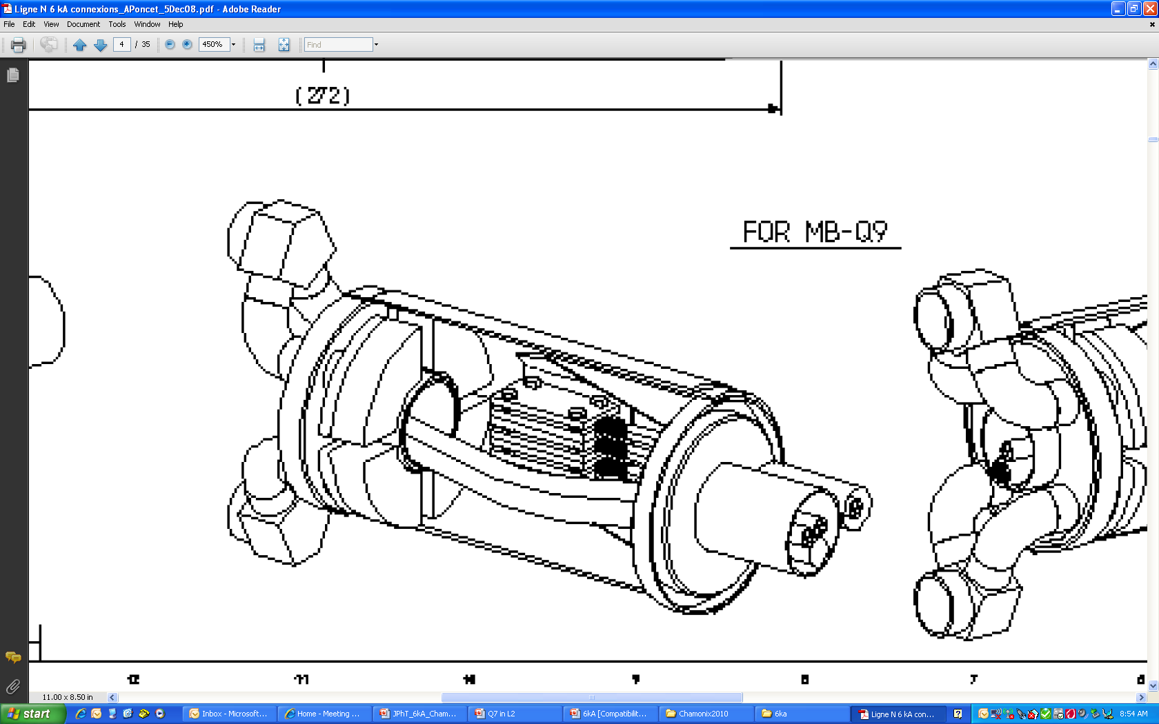

Fig. 4: IC praying hand splice design

Following the identification of possible mechanical weaknesses, the mechanical design was revisited [5]. An a-posteriori mechanical model was derived and is illustrated in Fig. 5. It is dividing the zone of interest in 3 parts: the box around the splice, a free zone and a Kapton belt.

Fig. 5: Mechanical model of praying hand splice

The conclusions of this document are: “The design of the 6 kA “hair-pin” splice connecting the N line cable to the dispersion quadrupoles left of IP should allow them to present sufficient margin as far as mechanical resistance and fatigue behaviour for the lifetime of the machine. Of course this supposes that the quality of the realisation and workmanship has been up to the required level, and that the detailed specification has been thoroughly respected.”

Electrical tests of superconducting loops showed that the average achieved electrical resistance is about 1  nΩ, within the specification of 1.5 nΩ.

The list of assembly operations is the following; all interleaved with ELQA tests:

* Insertion of line N cable
* Stop of the braid
* Metal hose forming
* Preparation of line N extremities (Fig. 6)  
  (Flattening the round cable and stabilisation)
* Cabling
* Soldering (Fig. 7)
* Insulation (Fig. 8)
* Closure of stainless steel sleeves

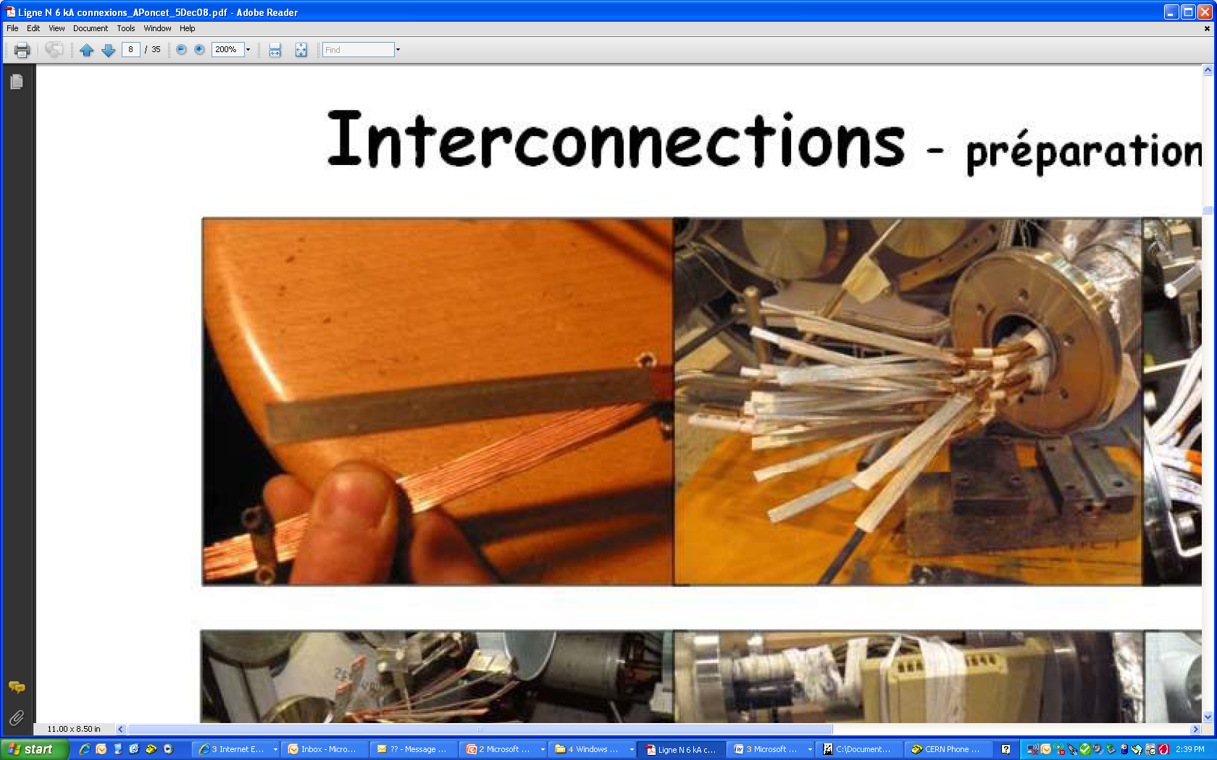

Fig. 6: Preparation of cable extremities

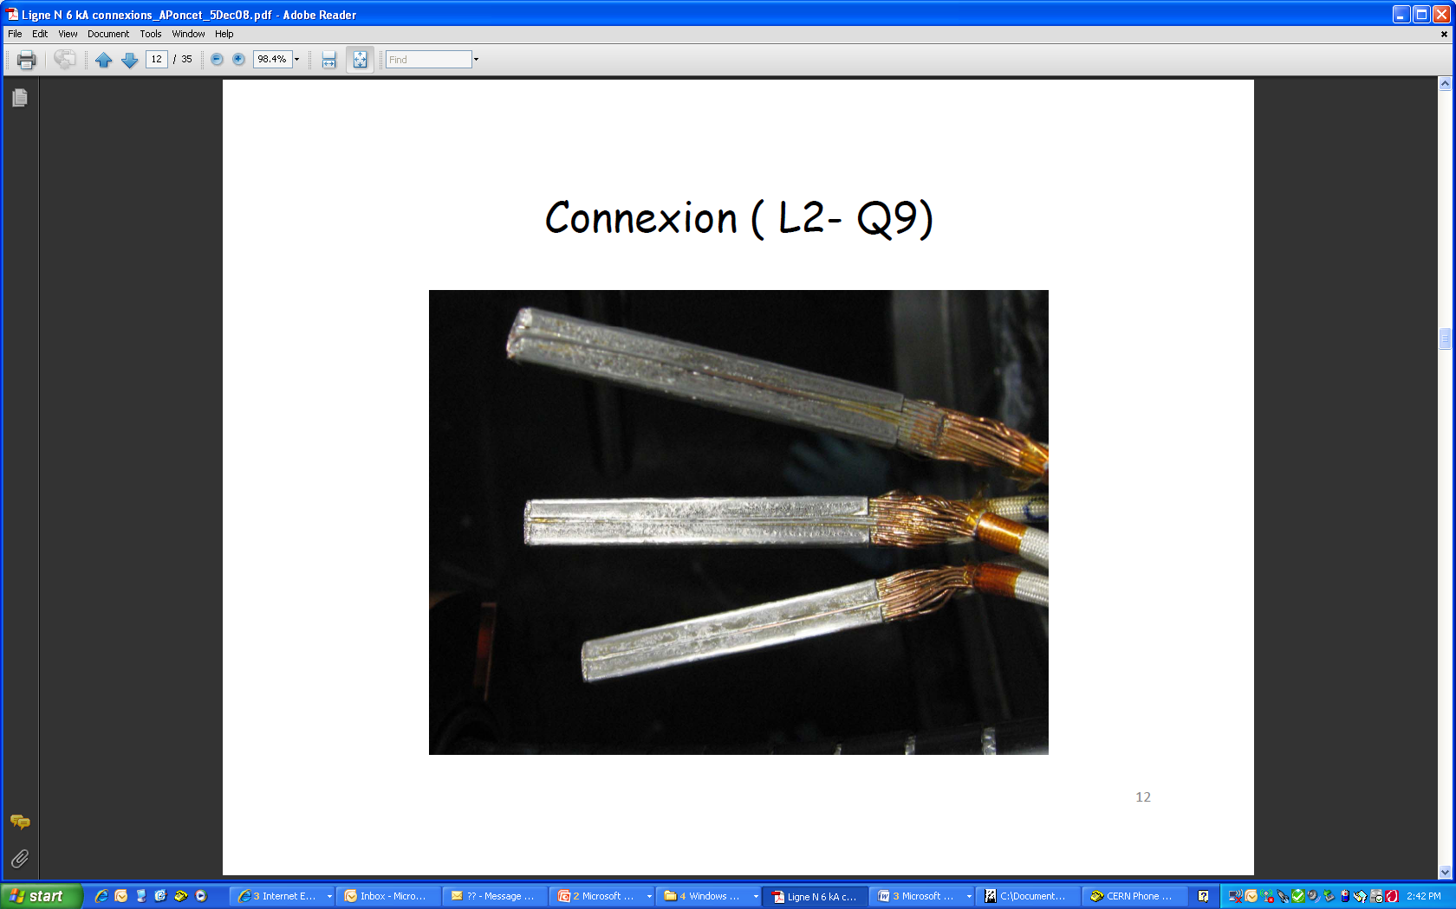

Fig. 7: Soldered IC praying hand splices

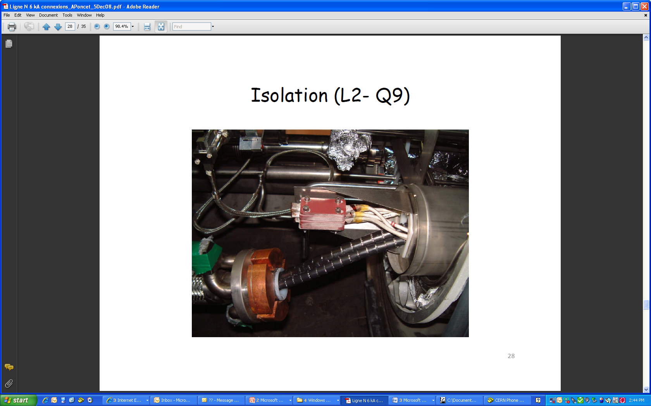

Fig. 8: Insulated splices, ready for IC sleeve closure

### Fatigue testing at room temperature

Fatigue testing was performed at room temperature but in conditions not representative and much more severe than the actual conditions [6]. The sample failed before around the 12 000 cycles specified for the LHC lifetime[7].

### Fatigue testing at cryogenics temperature

Tests on a representative sample in conditions very close to the working ones were carried out in FRESCA (Fig. 9). Two tests were conducted with a constant monitoring of the superconducting resistance. No degradation was noticed. The first test was done at 6 kA and stopped after 1328 cycles. The second one was done at 9 kA and stopped after 1416 cycles. No damage was revealed by visual inspection at the end of the test. Increasing the current by a factor 1.5 increases the loads by 2.25 and should have reduced the lifetime by a factor 10. The fact that this splice is operating in an oxygen free atmosphere should also increase its lifetime by a factor larger than 10. Micrographic examination was done but was not conclusive; cracks were present but could have been there since the beginning. These tests are also reported in ref [5].

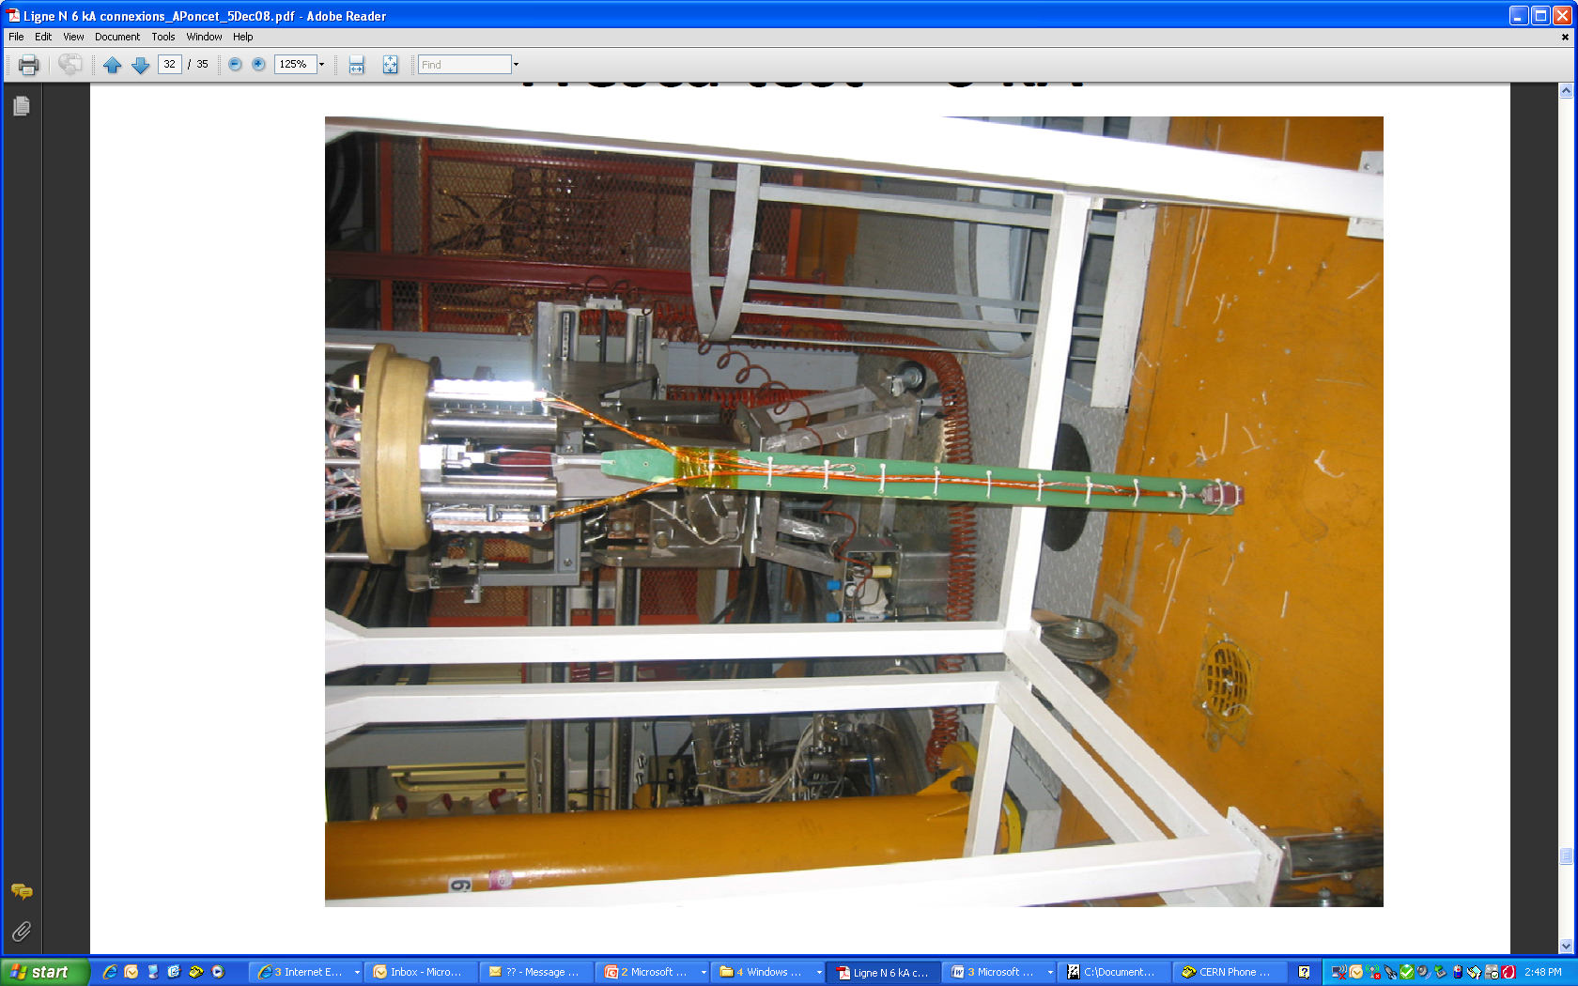

Fig. 9: Sample ready for test in FRESCA

### Documentation

A lot of photographs taken during production of these splices are archived. They are not covering the point L8 but most of the other ones are documented. All images have been looked at and no anomaly has been detected. Nevertheless, the documentation is not complete at 100 %.

### MCI for an interconnection praying hand splice

The interconnection hand praying hand splices are used to power Individually Powered Quadrupoles (IPQs). The current decay in these circuits is very fast (Current is halved in less than 0.1 sec). The detection time is shorter than 10 msec. If an arc is created, assuming a tension of 20 V [8], the maximum dissipated energy is less than 12 kJ. It is also considered [8] that the minimum energy that could in the worst case scenario create a hole with size that would lead to accidental helium release is 100 kJ. So, in the unlikely event of a hole burnt during such an MCI, the helium discharge flow will be much lower than 1 kg/s.

### Tevatron experience

In the frame of the LHC splice task force [9], a similar splice geometry was shown but less supported than the IC praying hand splices. This has led to a failure and burning of the joint. (Fig. 10)

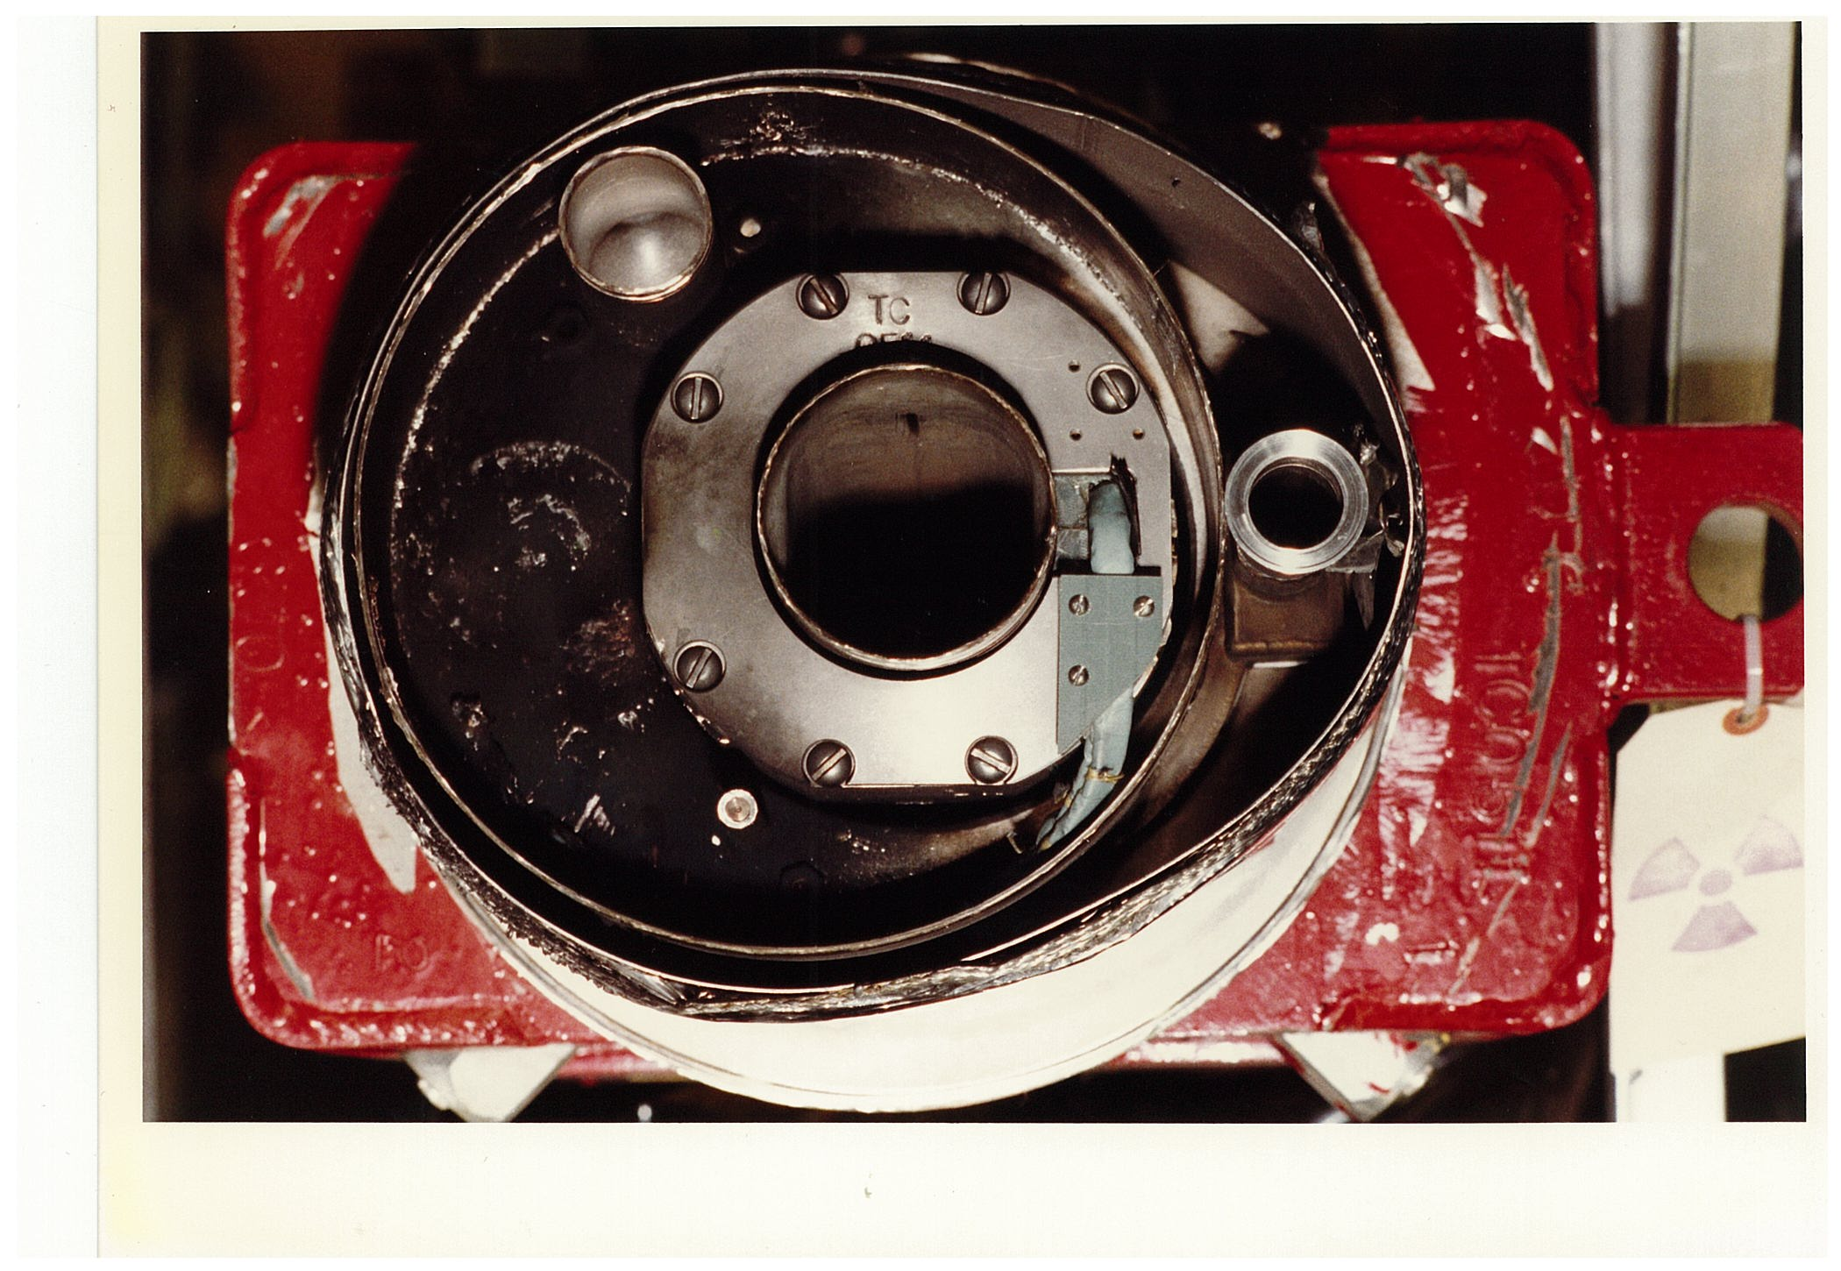

Fig 10: Damages after praying hand splice failure in Tevatron

### Future work for hand praying splices

It is proposed to (re)validate the design with an extra set of samples tested in representative configuration in FRESCA. Some extra finite element studies could also be performed.

A new design with possibly only in-line splices will be tried. It will probably involve more splices. The possibility to add extra copper around the splice will also be studied. This will then have to be thoroughly tested. This is a considerable amount of work.

As the documentation is not complete, it is proposed to open the interconnection boxes whenever accessible for another reason. The priority for inspection and possibly reinforcement of the splices is the 12 splices located in the dispersion suppressor left of point 8 because documentation is lacking for this zone and it was the first one to be assembled.

If feasible from safety and access points of view, imaging with the X-ray tomography with and without current of some splices could be interesting to assess the real motion created by Lorentz forces.

## further works

The work on the LHC 6 kA splices is not completed. The following steps still need to be performed:

* Complete the inventory and schemes of all the 6 kA circuits or families of circuits,
* Map all the splices at superconducting temperature, prior to power them at a current equivalent to an energy higher than 3.5 TeV per beam,
* Upgrade the QPS of the IPQ/IPD during the next shutdown
* Realise the actions proposed above for the interconnection hand praying splices and then review the situation in the light of the news obtained, especially from inspection of actual splices in the LHC tunnel in the dispersion suppressor zone L8.

**ACKNOWLEDGMENTS**

The author would like to thank many CERN colleagues for interesting discussions and in particular, A Jacquemod for his on-going work on the inventory of the 6 kA splices, A Poncet for all the information and studies done on the IC praying hand splices, R Mompo for the development of the method to measure the splices resistance at superconducting temperature and the FRESCA team for the tests carried out on splices samples.

## References

[1] Layout database (http://layout.web.cern.ch/layout/default.aspx?file=navigators.aspx&topid=0&version=1.5&navigator=electrical

[2] Powering specificities for the 8 sectors : EDMS 1-2 1009658, 2-3 883231, 3-4 883247, 4-5 88327305, 5-6 883295, 6-7 883317, 7-8 883182, 8-1 883200

[3] Scenarios for consolidations intervention, F Bertinelli, these proceedings

[4] Task Force LHC Splices consolidation, Meeting 03,  https://espace.cern.ch/lhcsplices/Meeting%203/default.aspx

[5] Revisited Mechanical Qualification of the Soldering solution for the line N 6 KA cable in the “hair-pin” (or “praying hands”) configuration, EDMS 990048, A Poncet

[6] Summary of the cycling tests performed on a 6 kA LHC-type electrical connection, EDMS 993835, A Ballarino, A Jacob

[7] General parameters for equipment installed in the LHC, LHC-PM-ES-0002, EDMS 100513

[8] Access and powering conditions for the superconducting circuits in LHC, LHC-MPP-ES-0002, EDMS 1001985

[9] Task Force LHC Splices Consolidation 8th meeting, P Limon, The Tevatron Experience  
<https://espace.cern.ch/lhcsplices/Meeting%208/default.aspx>