# Overview of all superconducting splices in the LHC machine

N. Catalan Lasheras, CERN, Geneva, Switzerland.

Abstract

*In the past year, the quality of the superconducting splices of the LHC circuits has drawn considerable awareness. While most of the attention is put into the main arc quadrupole and dipole circuits, lower energy circuits, like orbit and optics correctors are considered safer due to the lower energy stored in them. As part of the task force for splice consolidations, we ought to examine the status and potential electrical risks of all circuits in the LHC machine. This paper addresses mainly the 600 A and inner triplet circuits, reviews the known facts, and introduces the working plan for the next months.*

## INTRoduction

A task force for splice consolidation has been created to “To review the status of all superconducting splices in the LHC machine and prepare the necessary consolidation actions for 7 TeV operations” [1]. The case of the high current splices (6 and 13kA) will be addressed in following contributions of this session. In this report, we will review mostly the facts and status on the “low” energy circuits (correctors in his majority) and on the inner triplet circuits. A large part of the material discussed in this report has been already presented and reviewed during the construction of the magnets and their installation inside the LHC tunnel [2].

First of all, when attempting to make a survey of all the superconducting splices in the LHC, we need to consider splices made inside the magnets at the manufacturer premises as well as splices made during their interconnection in the tunnel. Table 1 displays an inventory of the number of splices for every type of circuit and current rating. The total number of superconducting splices is larger than 105. We observe that the number of internal and interconnection splices if very similar. A better quality can however be expected from the internal or magnet splices because they have already been tested at cold, either during manufacturing, or during SM18 reception tests at CERN. On top of this, their mechanical restrain is better than the one of interconnection splices. Nevertheless, the protection of these circuits follows a completely different philosophy than those of the main magnets. The lack of instrumentation does not allow distinguishing between internal and external splices.

Table 1: Inventory of Superconducting Splices

|  |  |  |  |  |
| --- | --- | --- | --- | --- |
|  | **Line** | **Magnet splices** | **Interc. splices** | **Current rating** |
| RB | M3 | 9856 | 3372 | 13 kA |
| RQF, RQD | M1, M2 | 3940 | 6744 | 13 kA |
| Inner Triplet |  | 80 | 112 | 13 kA |
| IPQ, IPD | N’ | 1644 | 532 | 6 kA |
| Spool pieces | M1, M2 | 30860 | 33920 | 600 A |
| Correctors | N | 27006 | 16000 | 600 A |
| IT correctors |  | 704 | 480 | 600 A |

In the first part of this paper, we will try to prioritize the circuits with respect to their stored energy and hot-spot temperature in order to reveal their criticality. In the following section, we will describe the interconnection splices done in 600 A circuits and summarize the results obtained on electrical measurements during the hardware commissioning. The last section provides a short description and status of the interconnection splices in the inner triplet circuits.

## Criticality

The magnetic energy stored in the LHC superconducting circuits ranges from 1MJ on the smallest circuits, like the octupole spool pieces, to more than 1000 GJ for one of the eight arc dipole circuits. For comparison, the energy stored in the beam at nominal conditions and 7 TeV is 360 MJ. Figure 1 shows the energy stored in single circuits of the LHC in decreasing order. In the full vertical axis scale, only the RB and RQ circuits would be visible with 1100 and 200 GJ respectively. Other lattice magnet circuits like the inner triplet or individually-powered quadrupoles (IPQs) correspond to 0.2 and 8 GJ. The energy stored in most of the corrector circuits remains within the MJ range.

|  |
| --- |
|  |
| Figure : Energy stored on each superconducting circuit type present in the LHC. In order to plot all circuits in the same scale, the values for the arc dipole and quadrupole circuits have been divided by 100 while circuits bellow 600 A current rating have been multiplied by 100. |

In most arc circuits, an energy extraction system is activated to rapidly remove the energy from the circuit in case of a resistive transition. For all circuits, the section of the conductor and the amount of copper stabilizer has been sized accordingly to the current decay time as well as to their stored energy.

We have used a simple model to estimate the hot spot temperature reached on a quenching superconducting splice for each type of circuit [3]. The model assumes a very short detection time, constant for all circuits and a perfect splice. The calculation is only aimed to compare the heating on each circuit exclusively due to the cable and bus characteristics and the circuit decay time. Remarkably, a factor 104 in stored energy becomes a factor two in hot stop temperature (see Figure 2). While the quadrupole gives the maximum hot-spot temperature at about 75 K, circuits containing MQT-type magnets reach a temperature of about 25 K. These temperatures are fully acceptable and reflect nominal operating conditions. The main arc circuits are still the more critical but this estimation shows that the risk of opening a splice via an undetected quench is only a factor 2 smaller for some of the corrector circuits. Of course, the damage potential in case of an accidental opening of the circuit remains proportional to the stored energy.

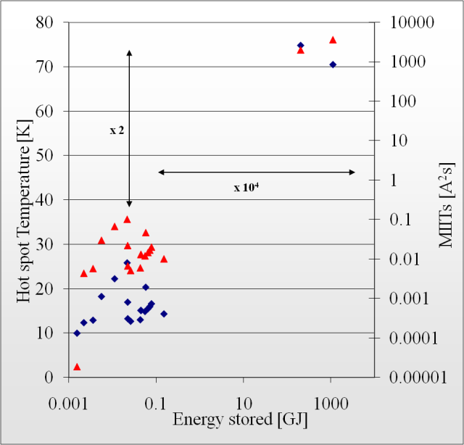

Figure : Hot spot temperature (red triangles) and MIITS (blue dots) of a quenching splice relatively to the energy stored in the circuit.

## 600 A correctors

Spool pieces in what is called the M lines are powered through a set of 10+10 conductors running parallel to the quadrupole bus-bars in lines M1 and M2. At each interconnection, the conductors are ultrasonic welded after cleaning the oxide by friction. The resulting weld resistance is 3 to 5 nOhms measured in samples built during assembly. The ten splices are then insulated individually with Kapton® and held together inside a grooved piece of phenolic glass laminate (VP310).

Optics correctors inside SSS are powered through a bundle of conductors held by a metallic braid inside what is called line N. At every SSS interconnection, the conductors are welded together also by ultrasound. The pairs of welded conductors are insulated and bent together inside the grooves of a high density polyethilene connection box.

In both cases, the full circuit is protected as a single unit from the bottom of the current leads with a resistive voltage threshold of 100 mV.

However, during the first phases of interconnection in the tunnel, the quality assurance put in evidence certain weaknesses in the welding of 600 A circuits, particularly in line N [4]. The presence of insulation between the wires prior to welding, or the reduction of the overlapping contact are some examples of these problems. Measurements done in the Cryolab on samples coming from the tunnel showed a final resistance anywhere from 4 to 19 nOhms.

The suspicious welds were re-done and the quality control improved. In addition, a resistance measurement of the full circuit during powering tests was proposed, as a mean to detect the worst cases [5]. The test consists on calculating the resistance from the voltage measured through the QPS system during current plateaux at 80 A, 200 A, and at nominal current (typically 500 A). The aimed resolution was 1µOhm. This test has been now performed for all 600 A circuits during the hardware commissioning campaign.

The measurements results during the last 2009 campaign are shown in Figure 3. The resistance of each corrector circuit is ordered by the number of splices in the circuit. The first straightforward result is that the resistance is independent of the number of splices in the circuit below 2-4 µOhms which provides the noise floor given by the voltage reading resolution. (a few mV). The measurement can be considered as significant only above 4 µOhms. The measurements obtained in the RCO circuits seem to have a higher average resistance per splice than other circuits. It is indeed the case for the RCO magnets which are expected to have a resistance between 4 and 6 nOhms compared to 4 nOhms for all other circuits. Besides, the resistance measurements for these circuits are performed at lower current as the nominal value is only 100 A, thus the accuracy is much lower what is also seen as a large spread in the measurements.



Figure : Total resistance of the 600 A circuits in lines N and M as measured during the hardware commissioning. The number of splices per circuit is shown in the right axes as a joint line.

The average resistance per splice is plotted in Figure 4 and was used to qualify the circuits during hardware commissioning. The RQ6 circuits in IP3 and IP7 show a systematic excess of average resistance for a moderate number of splices. Indeed, the internal splices in these magnets which consist of six MQTLs together in the same cold mass are indeed made following a different process which may explain the higher resistance. We observe three other circuits (red dots in the figure) for which the resistance value is excessive. The measurements will be repeated in 2010.



Figure : Average resistance per splice for 600 A circuits. For circuits with more than 200 splices, the average resistance drops down to nominal values.

In order to identify potential weak points like splices or unprotected bus-bars, a thorough analysis of the 600 A circuits from the bottom of the current leads is ongoing. The first circuit chosen for this purpose is the MCD as it stores the maximum energy on the M line close to the quadrupole bus-bars.

## Inner triplet 13 kA circuits

Feeding current into the three quadrupoles of the inner triplet is done trough two separate bus-bars of 5 and 8 kA respectively. As for the 600 A correctors, the protection of the bus-bars splices and the magnets is done together using a resistive voltage threshold of 100 mV. The connection between superconductors is brazed together with full copper cables interleaved between the superconducting cables (see Figure 5). The resulting splices are then insulated by a glass fibre tape. The 600 A correctors inside the inner triplet are also brazed together and hold on top of the main bus-bar by a composite piece.

A detailed map of the splices in these circuits, the cable and bus-bar geometry, as well as the location of the voltage taps used for protection is ongoing.

Calorimetric measurements done in the inner triplet cryostat to detect an excessive resistance were not conclusive. Dedicated electrical measurements to estimate the resistance of the interconnection splices are planned either through the QPS system or by a special measurement device as part of the electrical quality assurance.

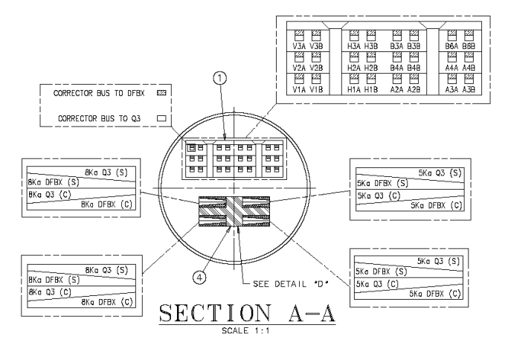

Figure : Cross section of the bus-bar interconnection inside the inner triplet.

## Conclusions AND working plan

Corrector circuits in lines N and M have been controlled during hardware commissioning for very bad splices but the monitoring of single splices is not possible due to the lacking instrumentation.

End to end maps of the electrical circuit from current lead to current lead are still necessary for all circuit types to identify weak points and possible risks. This is especially important for the inner triplet circuits for which the information is more scattered. The work has already started for the 600 A circuits.

The calculations used for defining the circuit parameters and setting the QPS thresholds are based on normal operation of each circuit separately. It is advisable to consider the interactions of several circuits together as well as combined failure modes.

## References

[1] <https://espace.cern.ch/lhcsplices>

[2] J. Ph. Tock. EDMS 455919

[3] G. Kirby. Private communication

[4] D. Tommasini. Report to MARIC Nov 2006

[5] M. Calvi *et al.* LHC project report 1004