Integration issues in the tunnel and impact on general LHC systems

S. Weisz, CERN, Geneva, Switzerland

Abstract
Planning of the various installation works in consideration of the space requirements, radiation levels, existing and missing infrastructures, alignment and survey, coordination issues for upgrade (e.g. collimation upgrade versus IR upgrade) and impact of LHC general consolidation work on the LHC upgrade projects. Options for implementing some of the upgrade work already before the extended shutdown in 2014-2015.

Introduction
Any upgrade of the LHC will require a full study of its impacts inside the existing infrastructure. This integration process is mandatory to understand the details of what needs to be achieved to implement the hardware modifications. It is a crucial step before one can start the planning of the intervention in the field.
The case of the IR upgrade phase 1 [1] is now well advanced: it will be used to illustrate the space requirements, the radio-protection constraints, the existing or missing infrastructure and associated equipment that need to be considered to organize the replacement of the low-β quadrupoles of the high luminosity experiments. The mitigation of Single Event Errors (SEE) [2] adds another level of complexity since it will progressively modify the existing environment. The planning of the installation of the IR upgrade reflects all these considerations, leading to a first estimate of 9 months for the installation of one triplet.
Other LHC upgrades concern the modification of the matching sections of the high luminosity insertions, the installation of collimators in the dispersion suppressors or the consolidation of the RF system. A preliminary review of the corresponding integration issues is presented, together with the constraints to be expected on the planning of the interventions.
The paper will not address integration aspects or planning impacts of the high priority works related to the consolidation or repair of faulty bus-bar interconnects. Other works, part of the completion of the LHC baseline (Ex installation of additional dilution kickers at Point 6), are already prepared to occur during the forthcoming long shutdowns and are not discussed here.
As many of the integration difficulties result from the lack of underground space around the high luminosity insertions, a first description of possible dedicated machine service areas at Point 1 and 5 is provided to launch a reflection.

IR phase 1 upgrade
A detailed description of the IR phase 1 upgrade is available in the Conceptual Design Report [3] issued in November 2008. A short review of the requirements relative to the installation of the new low-β triplets is given here.

Space requirements
The interfaces between the experiments and the LHC remain unchanged. The new low-β quadrupoles are longer than the actual Q1-Q2-Q3, with a total length of 45.2m instead of 32.7m. However the new separation dipole D1 would be a cryogenic magnet and the length of the triplet-D1 assembly is almost unchanged. The overall transverse dimensions of the new magnets are similar to the previous ones, a constraint imposed by tunnel transport limitations. There is thus no problem to fit the new cryostats in the space occupied by the present triplet-D1 assemblies at Point 1 and 5. The interface with the cryogenic distribution line would be displaced and QRL extensions are required: this raised some problems at Point 5 where the tunnel is only 3.8m in diameter instead of the 4.4m available in the straight sections around Point 1. The identification of conflicting elements and the optimisation of the routings, including modification of the service modules and of the cryo-feed boxes, took almost a year: sound solutions are now available, shown on Figure 1 for Point 1 and Figure 2 for Point 5 (work of Yvon Muttoni, Alparslan Tursun and Stefan Maridor).
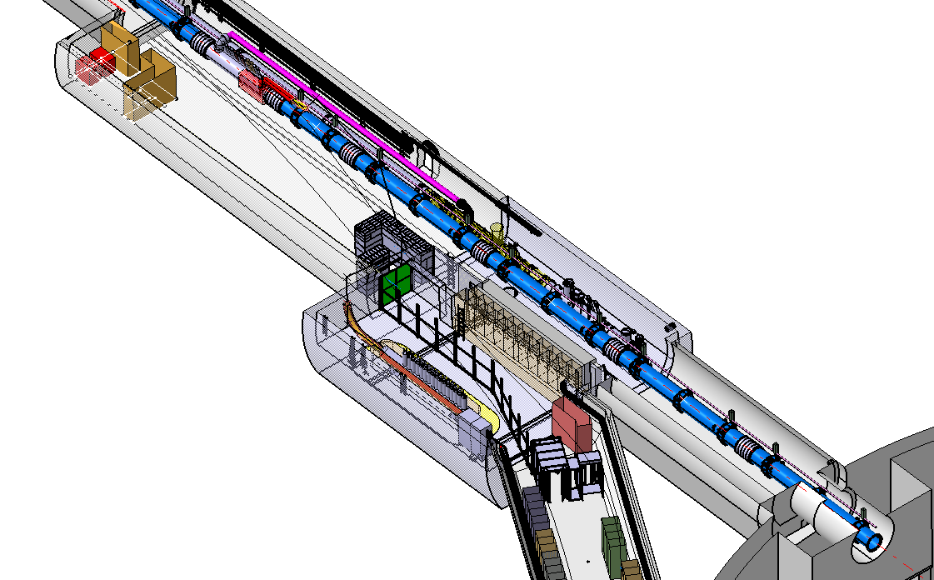
Figure 1: new low-β triplet left of Point 1
Figure 2: New low-β layout left of Point 5

The installation of the new power supplies, of their control equipment and of the quench protection systems is much more problematic. In the case of Point 1, racks would be located in the UL14/16 passage area that by-pass the ATLAS cavern. Due to the lack of space underground, some power converters are in the transport area and would need to be removed to leave way to a magnet convoy (see Fig 3). Control racks would be located on the 3rd floor of the US15, rather far away from the corresponding systems.
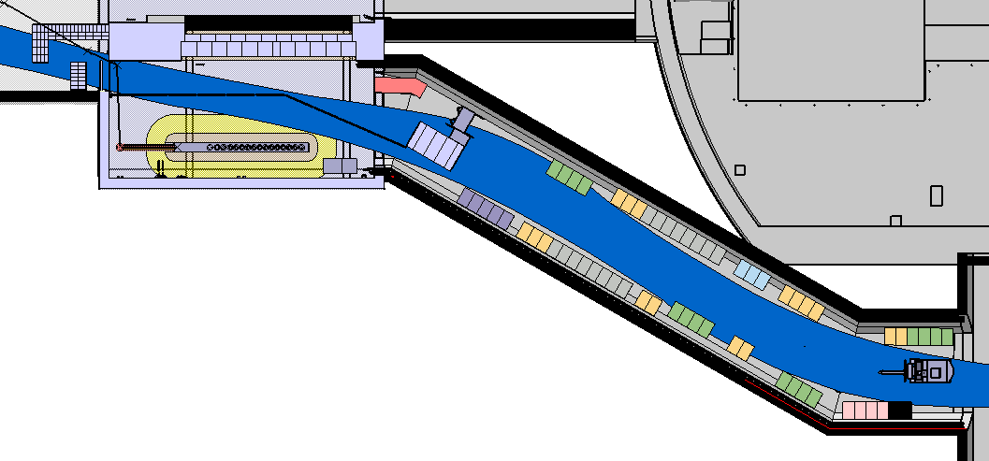
Figure 3: Supply and quench protection systems at Point 1
The dark area is the footprint of the transport zone

There is no complete solution for the right part of Point 5: the supplies and quench protection systems are also located in the by-pass galleries (see Fig 4) but there is no machine underground service (US) cavern at Point 5 to host the controls units.
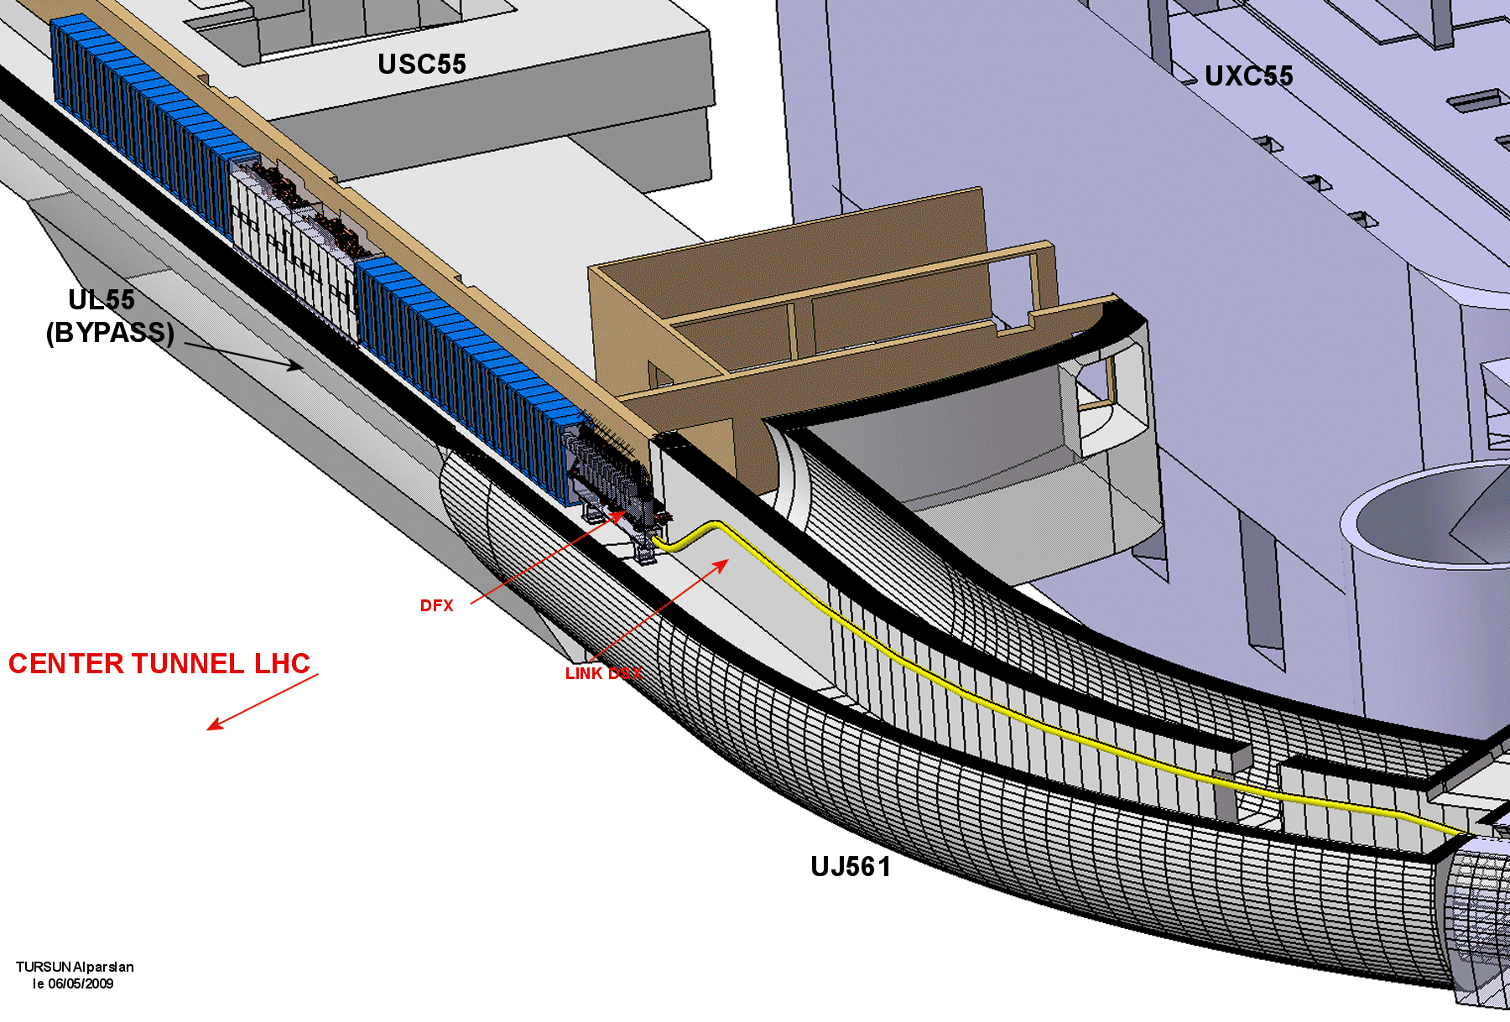
Figure 4: Supply and quench protection systems at Point 5

It is also important to note that the heat load inventories, both for Points 1 and 5, have not been done yet: according to past experience, air cooling units might be required, triggering a new iteration for the integration of the services, with even more demands for space.

Radiation levels in the triplet region
The majority of the debris of proton-proton collisions will travel along the beam line and the charged part will be spread away by the magnetic field of the low-β. The straight sections on both sides of the high luminosity experiments will thus be heavily activated. Figure 5 shows the residual dose rate right of CMS, 1.5m from the beam axis, as a function of decay time, after a one year period at nominal conditions (10⁷ seconds at 10⁹ interaction/seconds). These are the results of a Fluka simulation taking account of the field maps of CMS and of the Q1/2/3-D1 magnets (work by Markus Fuerstner and Stefan Roesler).

Figure 5: Fluka simulation of residual dose rate expected 1.5 m from the beam axis, in the straight section right of Point 5, for different decay time after a nominal year run.
The line shows the limited stay area threshold (50µSv/h)

One sees that the activation remains high along the triplet with a peak at the end of Q2. It is also important along the TAN absorber that collects all neutral debris emitted along the beam axis. Such results indicate that a minimum 2 weeks cool down period must be envisaged before starting any preparation work in these areas.
The situation is even worse as one gets closer to the beam axis. The ambient dose at the surface of the Q1 cryostat is still of the order of 0.25mSv/h after a 4 months cool-down period (see Fig 6). The disconnection of the existing triplet will involve cutting lines and bus-bars in a high radiation area (>100µSv/h) and the people doing the job will probably receive individual/group doses in excess of 1mSv/10mSv respectively: this requires a type III DIMR (Dossier d’Intervention en Milieu Radioactif) preparation file that involves detailed simulation of the doses received during an intervention, a complete radiological risk analysis and the assessment from the ALARA committee [4].
Figure 6: residual dose rate expected at the end of Q1 after a 4 months cool-down period

The dismantling of the existing low-β triplets must be performed by radiation workers, using dedicated tooling and protection that still need to be developed. Such constraint may limit our capacity to carry work in parallel on the 4 triplets on both sides of Points 1 and 5.
The present TAN’s are not compatible with the new triplets: the distance between the centres of D1 and D2 is reduced and the separation between the two beams, at the entrance of the TAN’s, is modified accordingly. The kernel of the TAN’s will be among the most activated elements of the LHC, it would be wise to design as soon as possible a new TAN with an adjustable inter-beam separation that could suit both the present and the future requirements. Being a warm device, the TAN’s could be replaced during any shut-down. The transports of the TAN’s to the surface are delicate operations, in particular from Point 5 since they would have to be conveyed through an entire sector to be lifted either at Point 4 or Point 6: an early replacement is thus appropriate since the elements would be less activated.

Infrastructure and associated equipment
As already mentioned, the installation of the new triplets will require some modifications to the existing cryogenic distribution and the addition of extension lines. The modification of the TAN was also underlined, the TAS should be replaced as well to match with the aperture of the new quadrupoles. The list of works that accompany the installation of the new triplets includes:
- The dismantling, modification and re-installation of the supports and survey systems;
- The modifications to the beam-pipe and vacuum systems;
- Removal and re-installation of the Beam Loss Monitors;
- A new beam instrumentation with the installation of associated services;
- Re-routing of cable trays, pipes, etc…
It should be noted that only the routing of the DSX cold powering link has been studied so far.
Most of these interventions involve the handling of activated material: that will require extensive preparations, development of dedicated methods and tools, with potential restrictions concerning co-activities. Last but not least, many of our contracts with external firms will need to be revised to include the work in a high radiation environment.
It would be an advantage to prepare the corresponding work in advance. Alas, these are tightly linked to specificities of the new triplets and have to be performed during the extended shut-down allocated to the replacement of the low-β quadrupoles. The mentioned early replacement of the TAN would be an exception.

Interferences with SEE mitigation works
The mitigation of Single Event Errors in the electronic equipment can follow 3 main axes: replacement by less sensitive equipment, addition of protective shielding and relocation of the equipment. Problem were encountered at the CNGS with flux of energetic neutrons (>20MeV) of the order of 10⁷/cm²/year. The UJ14/16/56 areas are thus particularly concerned by SEE hazards since the corresponding neutron flux could reach 10⁸/cm²/year after the second year of LHC operation [2]:
- Additional iron shielding in UJ14/16 are under study, a reduction of the high energy neutron flux from 5×10⁹/cm²/year to 1-2×10⁸/cm²/year under nominal LHC conditions seems achievable. It is however not sufficient to insure a safe situation for sensitive equipment and additional measures will probably be required in the long term.
- Additional iron shielding along the low-β triplet right of Point 5 is also being discussed. It would mainly protect the ground floor of UJ56 that hosts the electrical safe room and safety control equipment. The neutron flux on the first floor would only be reduced by a factor 2 and the relocation of the low-β powering seems unavoidable.
This will modify the existing environment, thus additional iterations of the integration of the new triplet, and essentially of their associated equipment, will be needed. A proper coordination of the SEE mitigation actions with the preparation for the IR upgrade to optimize the resources involved is difficult at this stage. The main problem is that we do not know yet the extensions of SEE mitigation actions since we have no precise estimate of the sensitivity of the equipment. Some SEE mitigation actions could be short term only: there is a risk that some shielding or re-routing of services in case of relocation get modified or dismantled on a yearly basis. The scarcity of LHC underground space around Point 1 and 5 is particularly penalizing on this point.

Installation planning for IR upgrade phase 1
A preliminary planning of the activities required to install the new triplets is available in the CDR [3], based on past experience with the replacement of LHC cryo-magnets (Work by Katy Foraz). There are still many uncertainties, as the amount of work concerning the modifications of the cryogenic distribution, but it indicates (Fig 7) that about 9 months should be envisaged for the replacement of one triplet. The installations or modifications of the associated services should be feasible

Figure 7: Schematic of the overpressure and helium release to the surface for the 8 sectors of the LHC.

in the shadow of the magnet installation and interconnection: it should however be noted that this might not be the case if other cryo-magnets need to be replaced elsewhere in the LHC, since the by-pass area would need to stay free for the passage of the magnet convoys.
Given these uncertainties, and the difficulties to mobilise, train and equip with specific tools several teams to work in parallel, a one year machine stop need to be envisaged to install the new low-β triplets on both sides of IR1 and IR5.

modification of the matching sections at IR1 and ir5

The IR upgrade phase 1 will allow to reduce β* below 55cm and/or will offer more flexibility on the choice of crossing angles. However, some modifications of the matching sections are necessary to reach β* in the 30-35cm range [5]. To first order, the quadrupoles need to be displaced to account for the shift of the centre of gravity of the new triplet away from the IR, but extra correctors might also be required. Some very general remarks concerning the intervention in the field can be made:
- The integration work should start as soon as possible, this is mandatory to start the inventory of what needs to be done. This of course means that the specifications must be fixed.
- The reshuffling of the matching section will contain work in high radiation areas (Ex close to the TAN or to collimators) and the handling of activated elements. Estimates of doses that will be received while progressing with the different activity are important input to start proposing a coordination of the work in the tunnel.
- The infrastructure will be modified, as the cryogenic distribution or the DSL powering link. All of these must be planned together with the displacement of the quadrupoles, taking account of the difficulties to carry co-activities in a limited space. The logistic can become a serious problem when one tries to limit the length of the shutdown, especially for worksites around Point 5 since all material must be lifted up or down via Point 4 or 6.
- The powering of the matching sections at Point 1 and 5 is located in the RR’s: the energetic neutron flux is expected to be ~10⁹/cm²/year under nominal LHC condition, and there is no space for shielding. There is thus a high probability that the SEE mitigation actions will substantially modify the environment in the coming years: the integration must stay in line with all these developments.
A tentative planning for the displacement of the MS quadrupoles has been studied (Fig 8 – work by Katy Foraz): besides all the uncertainties, it indicates that the global timescale for the interventions is again of the order of 9 months per matching section, when including warm-up, cool-down and powering tests.
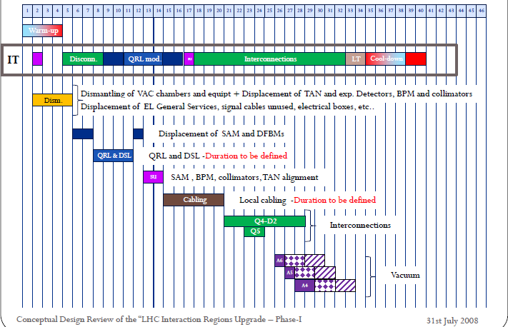
Figure 8: Preliminary planning of the modification of one matching section
It should be noted that the activities involved are very similar to those of the IR upgrade phase 1: magnet transport, alignment, interconnections, modifications of cryogenics and powering equipment, etc. Full parallelism with the IR upgrade phase 1 will be very difficult since the same teams would be in charge of both projects.

Additional collimators
The present LHC collimation system provides optimum robustness but its ideal performances limit the beam intensity to 40% of nominal [6]. A very aggressive upgrade program is proposed to reach, and ultimately go beyond, the nominal LHC parameters. It includes:
- The installation of 2 TCLP collimators at Points 1 and 5: the collimators are available and the corresponding slots are prepared. The collimators could be installed during a normal shutdown, to be coordinated with TOTEM at Point 5.
- The installation of 30 “advanced phase 2” collimators at Point 3 and 7: the R&D prototyping is ongoing (prototype installed in the SPS in January 2010) and the corresponding infrastructure has been prepared. The collimators could be installed during normal shutdowns as they become available.
- Installation of cold collimators in the dispersion suppressors on both sides of Points 3 and 7.
- Installation of cold collimators in the dispersion suppressors on both sides of Point 2.
- Installation of 4 additional warm collimators at Point 1 and 5, associated to a lower β* optic. The corresponding infrastructure must be prepared, this installation could occur with the modification of the matching sections mentioned previously.
- Installation of cold collimators in the dispersion suppressors on both sides of Points 1 and 5. This is not planned at present, but might become needed in the future …
The installations of the cold collimators that appear on the items 3, 4 and optionally 6 require displacing the 12 cryo-magnets of the dispersion suppressors concerned: this means disconnecting, transporting, aligning and re-connecting each of these magnets and the replacement of the connecting cryostat. Most of the remarks made previously concerning the modification of the matching sections apply here just as well:
- The integration work is of paramount importance to identify all potential conflict: the displacement of the DFBA’s and the interferences with the injection line left of Point 2 are serious concerns.
- The work will occur in activated areas, the proposed collimators are in fact precisely in charge of absorbing the protons losses in these areas.
- The shift of the DS magnets will require important modifications to the infrastructure and the cryogenic distribution.
- The control and powering systems in the RR’s around Point 7 will undergo several modifications to mitigate the SEE hazards.
The activities involved in the installation of cryo-collimators are similar to those of the IR upgrade phase 1 and reshuffling of the matching sections. The ability to do these works in parallel during a single extended shutdown clearly depends on the number of teams that can be mobilised.

consolidation of the RF system
The RF system will most probably require consolidation work as the beam intensity will increase. There is also a strong incentive for a dedicated 4.5K cooling plant that would bring much more flexibility to run the cavities and extra cooling for the triplet left of Point 5. Finally, crab cavities at Point 4 offer an opportunity to increase the luminosity without increasing the beam currents nor the bunch spacing, which is particularly interesting when the reduction of β* becomes less efficient. The experience gathered with the LHC does not allow yet telling the way to go or to set priorities on future RF upgrades. Still, one could note that:
- Installation of 200 MHz capture cavities: space has already been reserved for 4 cavities on each beam and the infrastructure will not require important modifications. The ACN’s could thus be installed during a normal shutdown.
- Installation of transverse damping and feedback: space has been reserved for one additional module on each ring and the ADT’s could also be installed during a normal shutdown.
- Installation of RF dedicated 4.5K cooling capacity: this requires a new underground refrigerator cold box and new cryogenic distribution lines. The integration work as not started yet, but there is probably enough space available in the UX45 cavern. The installation of a cooling plant during a single shut down is quite challenging, the work could span over consecutive shutdowns, and the final modification of the cryogenic distribution would occur at the end.
- Crab cavities at Point 4: space allocation becomes problematic if both the 200 MHz capture cavities and the additional dampers need to be installed. The temperature of the crab cavities (2K or 4.5K) has a strong impact on the modifications of the cryogenic distribution. All these specifications are essential and we need a more mature proposal to evaluate the integration issues.

Underground service galleries at Point 1 and 5
Space limitation in the machine underground areas at Points 1 and 5 has been mentioned several times. The integration of the control and powering equipment for the IR upgrade phase 1 is already problematic; Additional correctors associated to the reshuffling of the matching sections would also require additional space for their powering equipment; The possibility to shield or to relocate equipment in view to mitigate SEE hazards is very limited; Finally, additional cryogenic power for the low-β triplets might be required as the LHC approaches or even go beyond the assumed ultimate luminosity.
The possibility to dig extra shafts and service caverns around Point 1 and 5 was also mentioned previously during this Chamonix 2010 workshop: the shafts could provide alternate overpressure and helium release to the surface in case of a MCI [7]; New service caverns would allow relocating power converters from the RR’s alcoves to radiation free areas [8]. A preliminary study has been carried along the schematic drawing of Figure 9 (work by John Osborne).

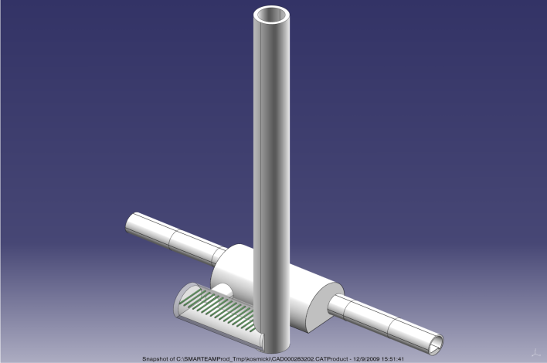
Figure 9: Possible layout of an additional shaft and service cavern close to the RR’s around Points 1 and 5

The cavern at the bottom of the shaft is large enough to relocate all the equipment that is presently installed in the RR. The shaft would only be used to access and remove the soil during the Civil Engineering activities and it will not be further used for underground access. The distance between the new service cavern and the existing RR should provide a good shielding to allow performing the CE works while the LHC is in activity; the small linking gallery could be completed during a shutdown. However, proper damping of the CE vibrations while the LHC is running must also be considered.
The cost estimate for the two shaft-cavern-junction assemblies at Point 1 (80 m depth) is 16.5 MCHF, including site installation, consultancy fees and drawings, and a 10% contingency for unknown or missing items. The corresponding cost for Point 5 (90m depth) is 20.7 MCHF, the difference comes essentially from the need to freeze the ground to dig the shafts at Point 5. It is obviously a very important investment, but it is important to note that the cost of the service caverns represents “only” ~25% of the total amount. A timescale of 4 years should be considered from the approval of the project to the date the 4 caverns are ready to install equipment: half of that time would be preparation work up to the signature of the contracts, and the CE work itself would take about 2 years.
If it appears that new service caverns, as sketched on Figure 9, are unavoidable to relocate the RR’s equipment, one could envisage complementing the underground areas with full service galleries (see Fig 10).

Figure 10: Sketch of a service gallery left of Point 5

Relocation of equipment into such service galleries would definitely solve the long term SEE mitigation problems. Space would become available for the different insertion upgrade scenarios that are presently considered. The size of the service galleries could also be optimized to host additional cryogenic systems and the equipment associated to a local crab cavity scheme.

summary
The preparation work of the IR phase 1 upgrade included studies of constraints associated with underground space requirements, radio-protection, existing or missing infrastructure and associated equipment to be installed for the new triplets. The mitigation of Single Event Errors will also modify the existing environment and the integration must stay in line with these developments. A preliminary planning indicates about 9 months for the installation of one triplet and a one year stop of the LHC should be envisaged for the entire IR upgrade phase 1 since the same teams would have to intervene at 4 locations.
Modifications of the matching sections of the high luminosity insertions or installation of collimators in the dispersion suppressors would have to face similar problems. Besides, they would include the same activities on the cryo-magnets: disconnection, transport, re-positioning and alignment, re-connection and tests. The ability to perform these works in parallel during a single extended shutdown depends on the number of teams that can be mobilised.
Limitation of underground space around the high luminosity insertions is the source of most LHC upgrade integration concerns. Dedicated machine service areas at Point 1 and 5 would imply very important investments: a reflection should start without delay to understand it they are a necessity for the long term.

References
[1] Overview of IR Upgrade scope and challenges, R. Ostojic, Proceedings of Chamonix 2010
[2] Review of critical radiation areas for LHC electronics and mitigation actions. Radiation monitoring and first results, M. Brugger, Proceedings of Chamonix 2010
[3] Conceptual Design of the LHC Interaction Region Upgrade – Phase I, LHC Project Report 1163
[4] How radiation will change your life, D. Forkel-Wirth, Proceedings of Chamonix 2010
[5] Optics Challenges and Solutions for the LHC Insertions Upgrade Phase, S. Fartoukh, Proceedings of Chamonix 2010
[6] Summary of the collimation upgrade plan, R. Assmann, Proceedings of Chamonix 2010
[7] Protection of underground areas and He release to surface, S. Weisz, Proceedings of Chamonix 2010
[8] Where are we with the Long-term plans and the CERN-wide radiation Policy, R. Losito, Proceedings of Chamonix 2010

