# Luminosity optimization and leveling

J. P. Koutchouk, CERN, Geneva, Switzerland.

Abstract

The Phase II of the LHC Upgrade is very ambitious with an increase by one order of magnitude of the machine luminosity. In this regime, the proton burning by the luminous collisions becomes overwhelming, causing a rapid decay of the beam currents and hence luminosity. Simultaneously, the beam-beam forces are maximized by the search of high performance. This paper focuses on mitigations that should provide the requested high performance while minimizing the adverse effects of fast proton burning and strong beam-beam forces. One key ingredient is a luminosity levelling principle that potentially increases the integrated luminosity, contrary to the usual method contemplated. To minimize the limiting effect of long-range beam-beam collisions, wire compensation is shown to be effective and mature for implementation. Finally, possible complementary provisions are given.

## Introduction

It was quite natural to start the studies of the LHC upgrade by specifying the target peak luminosity (1035 cm-2s-1, i.e. 10 times the nominal one)[1].This quantity is indeed a predictable beam dynamics parameter that can be optimized in a feasibility study, contrary to the integrated luminosity that requires machine operation scenarios including a large number of qualitative hypotheses. This large increase in LHC luminosity however qualitatively changes the luminosity decay regime: it becomes dominated by the proton burning. For the target luminosity, the luminosity lifetime becomes comparable to the time it takes to prepare the beams or carry out mild repairs that operations usually require. A mathematical optimization leading to shortening the run duration may thus not be very realistic. Another approach is luminosity levelling. This topic has been occasionally mentioned, e.g. [2] and its actual potential generally judged rather controversial. Lately, a new principle has been proposed [3] and studied in detail for one of the upgrade path [4]. Its increased potential and ease in implementation allows re-considering luminosity levelling.

While the luminosity decay due to proton burning can be easily anticipated, the adverse impact of the strong beam-beam effect arising from increased performance shall be the ultimate performance limit. It is known after a large number of simulation studies that the long-range beam-beam effect is the performance limit for the nominal LHC. A compensation scheme was proposed [5] in 2000. Since then, a number of studies, numerical and experimental, have taken place that can now allow conclusions for decision making. Other proposals exist (electron-lens compensation, fully coupled crossing) that are mentioned.

## Operations efficiency

Before considering sophisticated means for upgrading the LHC luminosity, it appears worth considering the potential in improving the operations efficiency. This approach is indeed systematically pursued to improve the integrated luminosity of colliders. At the time of the LHC upgrade however, we can speculate that the corresponding reserve in performance improvement should have been exhausted.

Indeed, given its expected complexity, the LHC has been equipped with outstanding beam instrumentation and a variety of powerful linear and non-linear families of correction circuits. They already allowed to measure and understand the LHC at injection in an exceptionally short time as compared to former experience. These instruments and correctors have the potential of automated feedback on all quantities normally controlled during operations (and beyond). Therefore, unless qualitatively new and not reproducible beam dynamics phenomena occur, a turn-around time reasonably close to the minimal one should be at hand, excluding down-time. Automatic injection and acceleration would not be a new unexplored field. Already in the 1980’s the ISR beam was automatically injected and accelerated at an intensity level about 5 to 10 times above its natural stability level. To recover stability, automatic injection involved automatic periodic measurements of the longitudinal beam distribution by Schottky scans, and suitable mathematical transformations to compute non-linear corrections from quadrupole to dodecapole to stabilize on-line the beams by effectively keeping quasi-invariant the transverse stability diagram.

We can therefore reasonably assume that the reserve in performance improvement arising from better operations efficiency at the time of the LHC upgrade should only offer a modest contribution compared to the ambitious goal of the upgrade.

## Why Luminosity levelling in sLHC?

The luminosity decay in many storage rings is dominated by parasitic effects, such as the emittance blow-up induced by side-effects of the beam-beam interactions. With operational experience, the luminosity lifetime recovers towards its predictable llvel. sLHC enters a new regime where a fast unavoidable luminosity decay is due to the proton burning in the luminous collisions. For example, table I shows the overwhelming predominance of the proton burning in a scenario where the peak luminosity of 1035 cm-2s-1 is obtained by increasing the bunch charge to 2.3 1011 ppb, reducing the β*-function and recovering from the crossing angle loss by an early separation scheme.

Table 1: Luminosity decay sources for sLHC peak luminosity

|  |  |
| --- | --- |
| Source | Time constant [hr] |
| Proton burning | **5.8** |
| Intra-beam scattering | 46 |
| Rest gas collisions | 39 |
| Luminosity from above sources | 4.1 |

Figure 1 shows the luminosity lifetime versus the peak luminosity for a range of scenarios where the bunch current is modified together with the focusing, the number of bunches and the beam emittance. The main point is that the luminosity lifetime only weakly depends on the details of the scenarios and is reduced to a few hours at a peak luminosity of 1035 cm-2s-1. This short lifetime entails a large variation over the duration of a run (typically 5) of the luminosity and related quantities, e.g. of the peak heat deposition in the triplet superconducting coil.

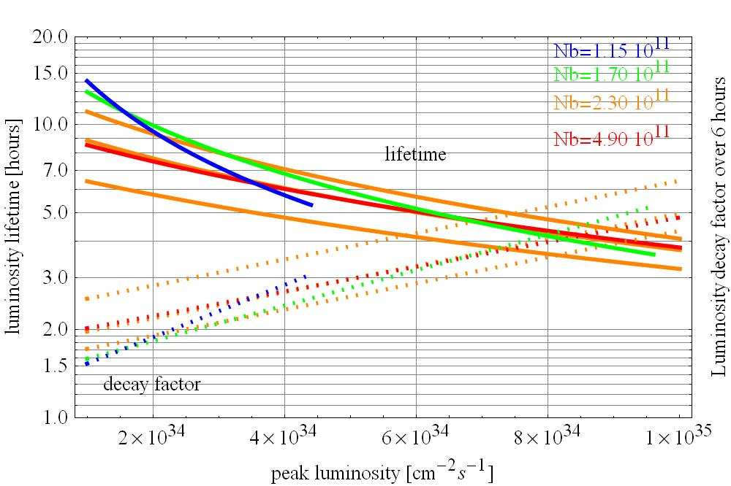

*Figure 1: luminosity lifetime and decay factor versus peak luminosity*

This unusually large luminosity decay and decay factor over a run calls for luminosity levelling to optimize the data taking and minimize the required “over-design” of the detector and machine components, due to this large decay factor.

## Methods of luminosity levelling

In a machine with a crossing angle of significant impact, it is necessary to consider simultaneously the impact of a luminosity levelling scheme on the luminosity, on the head-on beam-tune shift and on the long-range beam-beam effect. The first two are given by Eq. (1):



If the crossing angle *θc* vanishes, the luminosity levelling can only be carried out by varying *β\** and the beam-beam tune shift is independent of the levelling. This simple dependence may be violated close to the hourglass limit, where the bunch length *σs*becomes of relevance. When the crossing angle does not vanish, as is the case of the sLHC, three levelling methods may a priori be contemplated: levelling via *β\**, via the crossing angle *θc* and via the bunch length *σs*. The bunch charge *Nb*and the emittance *ε* evidently do not lend themselves to levelling.

### Levelling via β*

Due to the crossing angle, the head-on beam-beam tune shift becomes dependent on *β\**. It will increase as *β\** is increased, i.e. reach a maximum at the beginning of the run. At least two strategies of levelling via *β\** can be contemplated with different impacts on the performance:

Strategy of invariant beam-beam effect

The beam-beam problem remains invariant if all distances, expressed in local rms beam size, are kept constant. To achieve this requirement during levelling, the crossing angle *θc* has to be reduced during levelling like . Hence, the head-on beam-beam tune shift dependence on *β\** becomes:



The constant k depends on the specific scenario. For a scenario where the levelling would require initially increasing the *β\**-function from 25 cm to 50 cm, the increase of the head-on beam-beam tune shift could require decreasing the bunch charge by a factor 1.4 and hence the luminosity by a factor of two. This is the maximum loss possible. Its exact value will depend on the value of the beam-beam limit effectively observed in the LHC. If it is 0.01 as assumed so far, the luminosity loss inherent to levelling via *β\** would exceed 30%.

Strategy of best use of the physical aperture

If one accepts a variation of the beam-beam problem during the levelling (beam-beam tune shift, excitation of resonances, detuning terms) towards weaker effects, a strategy of best use of the triplet aperture can be followed. The physical beam separation is then kept constant and the variation of the head-on tune shift becomes:



In the same scenario as above, the maximum luminosity loss is 50% and, for a beam-beam limit of 0.01, the luminosity loss related to the peak bunch charge allowed would reach 15%.

In addition, and unrelated to the luminosity losses already quoted, one should expect another significant loss on the luminosity integral due to the clipping of the luminosity below its peak value. This effect has not yet been quantitatively estimated in realistic scenarios.

Implementation of levelling via *β\**

The significant advantage of levelling via *β\** is the absence of specific hardware requirements except possibly an increased strength of the separation bump correctors to allow the second strategy.

In operation, this method is expected to be challenging, due to a large number of optical side effects in addition to possible variations of the beam-beam problem. The tunes, chromaticities, linear coupling, the closed orbits all around the machine, especially the beam overlap at the crossing points will change and need corrections or feedback of high precision without interruption of the data taking.

At the Tevatron, this method was contemplated but never implemented: given the observed extreme sensitivity of the Tevatron beams to optics changes, only one *β\** step change could be considered, requiring switching off the detectors and separating the beams prior to the *β\** step change. The overhead of the method and required development time was considered not rewarding [2].

### Levelling via the crossing angle θc

The fundamental difference between the levelling via *θc* and the levelling via *β\** discussed above stems from the different dependencies of the luminosity and beam-beam tune shift (Eq. 1). The major difference arises in the initial phase of the levelling, where the beam-beam tune shift is reduced instead of being increased, just like the luminosity is reduced with respect to its peak value without levelling. This offers a new degree of freedom whereby the bunch charge can be increased above the maximum value allowed without luminosity levelling. This maximum value is defined by single beam intensity limit. In other words, this levelling principle allows stocking “spectator” protons that will be gradually put into operation as the crossing angle is reduced. This method has been carefully analyzed as an important application of the Early Separation Scheme [6] [4]. Examples of scenarios are given on figure 2. The duration of the levelled plateau depends on the choice of the value of the levelled luminosity and on the implementation of the variable crossing angle. All intermediate scenarios are possible. One can note that, at the estimated bunch charge limit given by the electron cloud effect, a very large luminosity can be sustained during about one shift. A qualitative advantage of the scheme is apparent on figure 2: high intensity beams suffer low beam-beam tune shifts and vice-versa. This is likely to decrease the overall complexity.

The implementation of the levelling via the crossing angle requires new hardware: crab cavities [7] have the largest potential and detector compatibility. They rely on active systems never implemented so far in hadron machines. The Early Separation Scheme [4] requires the installation

*Figure 2: Luminosity levelling scenarios via the crossing angle.*

of dipoles at the end of the detectors. Their potential is slightly less but the technology robust and the system passive. Background to the detectors can be minimized but cannot not suppressed. The standard crossing bumps cannot be used for this type of levelling, as the beam separation at long-range interaction points and in a good fraction of the matching section would be significantly modified. For larger angles, larger aperture magnets would be required. Smaller angles would unacceptably limit the maximum bunch charge.

This levelling method, contrary to levelling via *β\** does not exhibit any optical side effect for the beams. The length of the luminous region is however initially reduced [4].

### Levelling via the bunch length σs

In equation 1, the bunch length and the crossing angle have an identical effect if they can be varied in the same relative range. Levelling via the bunch length has the further advantage of an increase of the length of the luminous region. However, while the crossing angle can be significantly increased and decreased, the range of bunch length variations is very limited due to its weak dependency on the RF voltage (power ¼). Lengthening the bunch by a factor of 2 brings the acceleration in a regime dominated by beam loading [8]. The potential of bunch length reduction is negligible or would require an unreasonable increase of the RF voltage. Nevertheless, this method could be seen as a complement at the beginning of the levelling, given its ease of implementation and absence of identified side-effects.

## Beam-beam compensation

### Motivations

Levelling is an answer to the very fast decay of the luminosity. This is only one aspect of the beam-beam problem. All colliders have experienced the operational difficulties of approaching the so-called beam-beam limit. The latter is indeed fuzzy, has various expressions in various machines and appears to depend on parameters that are not controlled, at least at the required degree of accuracy. In addition to the “conventional” beam-beam issues arising from the head-on interactions, LHC is exposed to long-range beam-beam interactions of sufficient strength to set the limit of the LHC performance, in simulation. If these beam-beam limits would be lower than anticipated, the loss in luminosity would be fast, quadratic with the beam-beam limit. Likewise, a potential gain follows the same fast variation...

To illustrate the nature of the beam-beam problem in hadron colliders, that remains largely phenomenological, a few observations are provided below. They should shed some light on the beam-beam effect to be expected in the LHC. Figure 3 [9] demonstrates the important side-effects of the beam-beam interactions in one of the Tevatron stores (store 5155). While the antiproton losses are consistent with the luminous proton burning, the loss rate of the proton is much higher, showing an example of side effects of the beam-beam interaction.

## 

*Figure 3: example of beam loss rate in collision, from [9]*

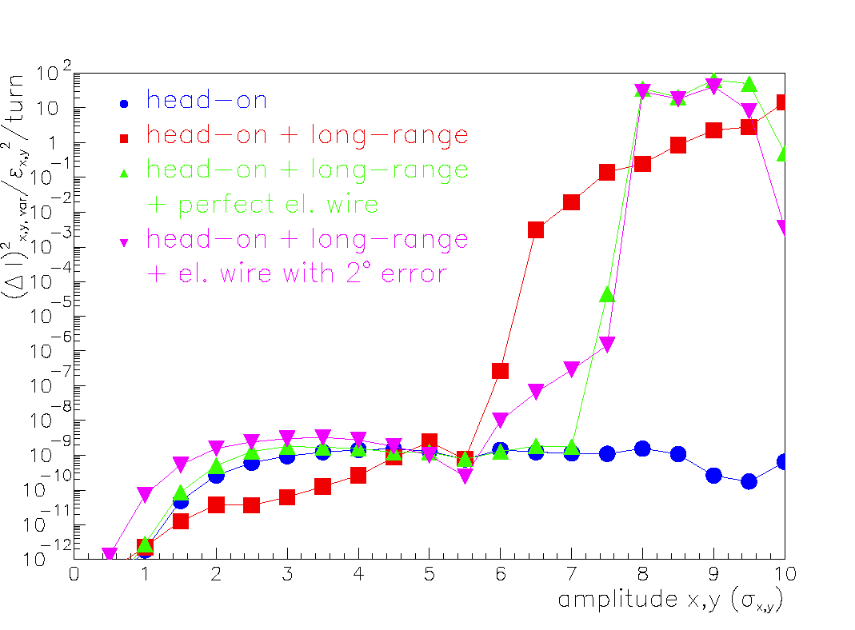

*Figure 4: Diffusion versus amplitude in the nominal LHC [10]*

Figure 4 from [10] demonstrates the overwhelming effect of the long-range beam-beam interactions at the LHC. The head-on beam-beam effect alone would be stable at the LHC. However, when the long-range beam-beam effect is added, a strong diffusion occurs for particle amplitudes above 5.5σ.

Figure 5 [11],[4] further shows that the optimal tunes are different for the head-on and long-range beam-beam effects. It stems from recent SPS experiments. The LHC long-range beam-beam effect is simulated by powering a current-carrying wire at a suitable distance from the beam. The tune dependence of the beam loss shows that the optimal tune for minimizing the long-range beam-beam effect (0.285) is significantly different from the optimal tune for head-on collisions (0.32). A means to compensate one of the two effects would alleviate this potential difficulty.

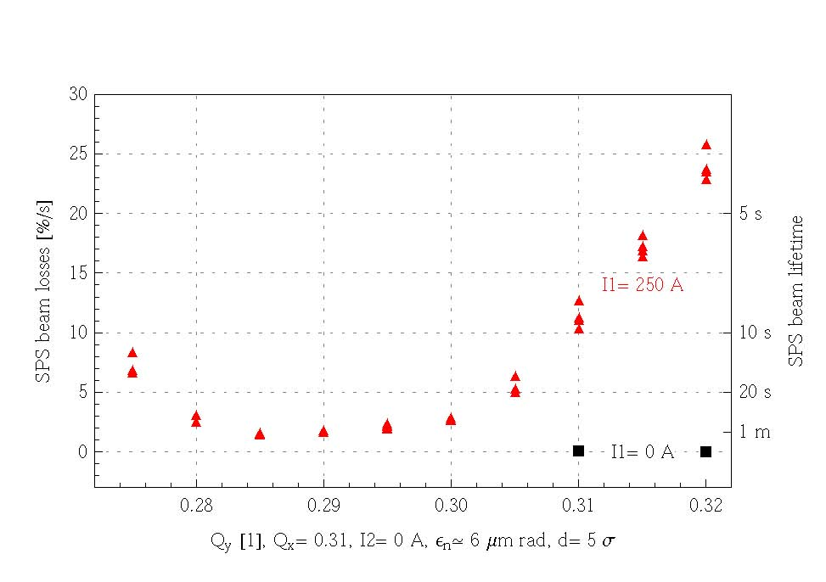

*Figure 5: Tune dependence of the LHC long-range beam-beam effect simulated in the SPS [11], [4].*

### Long-range beam-beam compensation

A long-range beam-beam compensation scheme using wires inside the vacuum chamber was proposed in 2000 [5]. Figure 6 from [5] shows the layout of compensators,

*Figure 6: long-range beam-beam compensator layout [5]*

placed on either side of an interaction point, between the D1 and D2 magnets at the position where the beta functions are equal in both planes. At this position, the betatron phase shift between perturbation and compensation is only about 2 degrees. The beams are sufficiently separated to allow moving devices between them. The corresponding space has already been reserved for the nominal LHC optics.

The efficiency and robustness of the compensation have been studied in detail by several authors in numerical simulations, e.g. [5], [10],[12],[13],[14]. A SPS experimental set-up was built to simulate the LHC long-range beam-beam effect and its compensation with appropriate betatron phase shift between perturbation and compensation. All results obtained from numerical and experimental simulations are consistent and show significant efficiency and robustness for a dc system whose strength can be mitigated to compensate regular and pacman bunches [12]. An example from numerical simulations [15] is given on Figure 7. Another example from recent SPS experiments [11],[4] is given on Figure 8. In both cases, the significant perturbation produced by

*Figure 7: Recovery of the emittance blow-up by long-range beam-beam compensation, from [15].*

the long-range beam-beam encounters is fully suppressed by the compensation. The technology for a pulsed system has not been established yet.

*Figure 8: SPS beam intensity (upper curve) and lifetime (lower curve) vs time [11],[4]. I1 is the long-range simulator while I2 is the compensator. When the wire simulating the long-range beam-beam interactions is activated (I1=250A), a clear decay of the SPS beam current is observed. When either this excitation is suppressed, or compensated by the second wire, the beam current decay is suppressed.*

### Other possible approaches

This short communication only allows mentioning two other complementary approaches that may have a high potential in the LHC and deserve detailed evaluation:

* The electron lens, e.g. [16] could ideally cancel the head-on beam-beam effect and in practice reduce the detuning and/or resonance excitation. It may as well be used as a long-range compensators for the early separation scheme where a few encounters occur at a beam separation of 5σ, i.e. too close to the beam for wire compensators.
* The crab waist scheme [17]. This ingenious scheme, by suppressing a class of focusing aberrations, allows higher luminosity and was demonstrated in Dafne. A collaborative CERN-INFN study is scheduled within the FP7-EuCARD project.

## Conclusions

The fast decay of the luminosity for a luminosity target of 1035 cm-2s-1 clearly calls for luminosity levelling, whatever the scenario. Levelling via the crossing angle is by far the most promising method. It requires either crab cavities or an Early Separation Scheme. Integrating the principle of levelling in an upgrade baseline scenario changes the project objectives: the target luminosity would become 5 to 6 1034 cm-2s-1 stable over 5 to 8 hours, with a multiplicity of about 100 for 25 ns spacing. Luminosity levelling has the further advantage of decreasing the dependency of the performance on parameters and scenarios. The long-range beam-beam compensation is mature for implementation. A rapid implementation would allow the study years in advance of the primary LHC performance limitation and possibly orient the upgrade strategy. Other methods to act upon the beam-beam effect deserve LHC studies, such as the electron lens and the crab waist scheme. In most options, a better knowledge of the possible impact of a large Piwinski angle is required.

## Questions & answers

* Is it possible to level via the time of arrival?

With respect to the beta waist, the detector longitudinal acceptance of typically ±10cm is insufficient to modify significantly the focusing. The control and suppression of the beam separation at the crossing would be an additional difficulty.

* What is the status of the Early Separation Scheme proposal?

A detailed PhD study has been carried out by G. Sterbini [4]. Enough information is now available for decision making.

## Acknowledgments

The author wishes to acknowledge discussions, contributions or support by E. Shaposhnikova, L. Rossi, G. Sterbini. F. Zimmermann, the SPS “wire MD team” with G. Burtin, R. Calaga, G. Sterbini, R. Tomas, F. Zimmermann and the author, W. Fischer, T. Sen and the USLARP colleagues, especially in the CARE-HHH framework.

## References

[1] F. Ruggiero (editor), LHC Luminosity and energy upgrade: a feasibility study, LHC Project Report 626, 2002.

[2] V. Lebedev, “Levelling with beta*”, CARE-HHH-BEAM07, CERN 2007,

<http://indico.cern.ch/getFile.py/access?contribId=12&sessionId=5&resId=2&materialId=slides&confId=20082> .

[3] J.P. Koutchouk, K. Ohmi, G. Sterbini, “Increasing the integrated luminosity of sLHC by luminosity levelling via the crossing angle, CERN-AT-2008-017 and EPAC 2008.

[4] G. Sterbini, “An early separation scheme for the LHC luminosity upgrade”, CERN-THESIS-2009-136 These N. 4574. –Lausanne: EPFL, 2009.

[5] J.P. Koutchouk, Correction of the long-range beam-beam effect in LHC using electro-magnetic lenses, 19th IEEE PAC, Chicago, 18-22 June 2001, p. 1681.

[6] J.-P. Koutchouk, “Possible quadrupole-first options with β* <= 0.25 m”, Workshop CARE-HHH LHC-LUMI-05, Arcidosso, 2005.

[7] R. Calaga *et al.,* LHC crab cavities, Proc. CARE-HHH-2008 workshop, CERN-2009-004, p. 133.

[8] E. Shaposhnikova, private communication, 2010.

[9] V. Kamerdzhiev, Beam-beam compensation with Tevatron electron lens, LARP Miniworkshop, SLAC, July 2-4, 2007.

[10] F. Zimmermann, Weak-strong simulation studies for the LHC long-range beam-beam compensation, Proc. of a workshop on beam-beam effects in circular collidres, Fermilab, June 25-27, 2001, FERMILAB-Conf-01/390T.

[11] G. Sterbini *et al.,* SPS MD report in preparation.

[12] U. Dorda, Compensation of long-range beam-beam interaction at the CERN-LHC, CERN-THESIS-2008-055, TUV, Vienna, 2008.

[13] C. Milardi *et al.,* Wire compensation of parasitic crossings in DAFNE, Proc. EPAC’06, 2006.

[14] J. Shi, L. Jin, W. Herr, Study of the wire compensation of long-range beam-beam interactions in LHC with a strong-strong beam-beam simulation, Proc. EPAC’02, 2002.

[15] J. Qiang, 3D strong-strong simulations of wire compensation of long-range beam-beam effects at LHC, PAC09, 2009.

[16] W. Shiltsev, Electron lenses for compensation of beam-beam effects, HHH-CARE-APD BEAM07, CERN, 2007.