Test of Low-Dropout voltage regulators with neutron and protons

AUTHORS

S. Abovyan, V. Danielyan, M. Fras, O. Kortner, H. Kroha, R. Richter
(Max Plank Institut fuer Physik, Munich, GE)

B. Bianchi, M. Cesaroni, L. Falconi, A. Ratto, P. Ricci, A. Santagata
(ENEA, Centro Ricerche Casaccia, Roma, IT)

M. Corradi, I. Longarini, R. Lunadei, R. Vari
(INFN Roma-1, Roma, IT)

P. Gkountoumis
(CERN, Geneva, CH)

ABSTRACT

The ATLAS Muon System will be upgraded for the High-Luminosity phase of LHC. Its new on-detector electronics should withstand a non-ionizing dose equivalent to 10¹³ n/cm² (1 MeV eq) and have a negligible rate of single-event effects. Commercial low-dropout (LDO) voltage regulators have been considered as a practical solution for powering on-detector electronics. We present results from the irradiation of 7 types of CMOS LDOs at the fast neutron reactor RSV TAPIRO at ENEA Casaccia (Roma) and at a 200 MeV proton beam at PSI (Zurich).

SUMMARY

The Muon System of the ATLAS experiment at CERN LHC will be upgraded for the high-luminosity phase of LHC to cope with higher rates and higher radiation levels.
Most of the Muon-System on-detector electronics will be replaced. Commercial low-dropout (LDO) voltage regulators have been considered as a robust, low-noise and economic solution to power distribution. The appropriate COTS components should be selected based on their capability to comply to radiation requirements.
The requirement for non-ionizing energy loss (NIEL) for the new electronics is 10¹³ n/cm² (1 MeV equivalent on Si). The fluence of high energy (E>20 MeV) hadrons will be up to 10¹¹ hadrons/cm² during 10 years of operation. For reliable operation, the LDOs should provide stable output voltage, have a very small rate of recoverable failures (SEE) and a negligible number of destructive failures. We tested 7 different types of CMOS LDOs, monitoring online the output voltage of 10 samples of each type. Irradiations were performed in the Radial Channel 1 of the RSV TAPIRO fast neutron reactor at ENEA Casaccia (Roma), to test resistance to NIEL, and at the PIF 200 MeV proton beam at PSI (Zurich), to test SEE. The experimental setup and the results are presented and discussed in this communication.

TPS7A8500RGRT
TLV75101PDSQR
TLV75901PDRVT
ISL80102IRAJZ-TK
ISL80103IRAJZ-TK
LP3964EMP-ADJ/NOPB
LP3856ESX-ADJ/NOPB

Table 1: Part numbers of LDOs tested in this campaign.

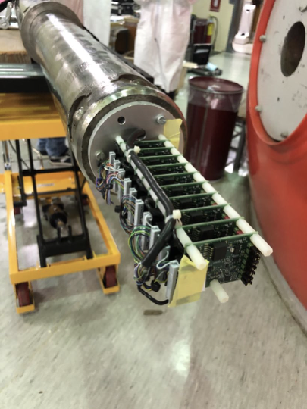

Figure 1: Stack of LDO test boards ready to be installed in the Radial Channel 1 of RSV TAPIRO reactor.

