# Beam observations with different bunch spacing and overall synthesis

G. Arduini, V. Baglin, H. Bartosik, G. Bregliozzi, P. Chiggiato, S. Claudet, O. Dominguez, J.M. Jimenez, G. Lanza, K. Li, H. Maury, E. Métral, T. Pieloni, F. Roncarolo, G. Rumolo, B. Salvant, L. Tavian, F. Zimmermann, CERN, Geneva, Switzerland

U. Iriso, CELLS, Barcelona, Spain

Abstract

Machine studies have been performed at the end of the 2010 proton run to study the machine performance with bunch trains with 50 and 75 ns spacings in preparation for the proton run in 2011.

The results of the observations and measurements will be summarized and compared with existing models. Possible running scenarios for 2011 will be outlined.

## INTRODUCTION

At the end of the proton run 2010 a series of Machine Development sessions, from Friday 29/10 to Thursday 4/11 were dedicated to the setting-up of the LHC with bunch trains with a spacing of 50 ns and the study of the beam dynamics at injection, ramp and high energy, including collisions. These sessions were interleaved with physics runs (TOTEM run, ALICE length scale calibration, longitudinal luminosity scan) and other machine development subjects (abort gap filling characterization and quench tests with a wire scan).

The main aim of the studies with 50 ns beams [1] was the investigation of potential problems for 2011 operation, e.g.:

* potential vacuum issues at number of bunches comparable with those achieved with 150 ns,
* long range beam-beam effects,
* electron cloud effects,
* RF and longitudinal aspects and issues related to the higher total intensity in the LHC and injectors (e.g. capture efficiency),
* background and luminosity/beam lifetimes in collision.

The setting-up and the studies with 50 ns beams spanned a period of 126 hours of which approximately 78 hours could be effectively used. The setting-up period took approximately 2.5 shifts (beam time) as initially expected [1].

After an initial physics fill with 108 nominal bunches (9x12 bunches) important dynamic pressure rises were observed at injection when filling with trains consisting of 24 bunches each. The first attempt led to the closure of the vacuum valves in point 7 (VVGSH.774.6L7.R) after the injection of 108 nominal bunches per beam as the vacuum interlock level of 10-7 mbar was reached on two vacuum gauges. The evolution of the vacuum pressure on the penning gauge VGPB.773.6L7.R on the (uncoated) cold-warm transition of Q6L7.B2 (warm-cold transition with NEG coating only on the warm side of the transition) is shown in Fig. 1.

In that area the two beams circulate in different vacuum chambers. It must be noted that pressure rises had been observed with 150 ns spacing beams only in common vacuum chambers, particularly at positions where the two beams overlapped. The pressure rise could be suppressed by applying a solenoidal field of ~ 50 Gauss indicating the presence of an electron cloud [2].

After these observations, emphasis for the machine studies has been given to the characterization of the electron cloud build-up and its effects and to the study of the evolution of these effects with time, to characterize the effectiveness of scrubbing at 450 GeV in suppressing the electron cloud effects at injection, during the ramp and at high energy.

The behaviour of the 75 ns beam with respect to electron cloud effects has been studied in another dedicated machine study period from Wednesday 17/11 to Saturday 20/11 for a duration of 74 hours of which 65 hours could be used for the setting-up of the injection and capture of the 75 ns beam and for the studies with 75 and 50 ns beams [3].

Fig. 1: Pressures and total intensity for the first two fills with 50 ns spacing. The gap in the data between 01:00 and 03:00 was due to an acquisition/logging problem related to the change from summer to winter time.

The electron cloud build-up with 50 and 75 ns spacing beams has been studied by means of vacuum pressure measurements in the straight sections and by cryogenic measurements for the arcs and is mostly discussed in a companion paper [2]. Simulations have been performed to benchmark the experimental data and the observations are consistent with a Secondary Electron Yield of 2-2.1 and a reflectivity coefficient of 0.6-0.7.

## EFFECTS ON BEAM

The electron cloud building up along the bunch train interacts with the proton bunches and can couple the motion of consecutive bunches or even the motion of different longitudinal slices of a bunch as a result of the pinching of the electron cloud during the bunch passage. For that reason electron clouds can be responsible of single and coupled-bunch instabilities in the horizontal and vertical planes.

In a dipole field region electrons spiral around the magnetic field lines and their motion in the plane perpendicular to these lines is essentially frozen already at injection (magnetic field strength is 0.535 T). Therefore no pinching occurs in the plane perpendicular to the field lines and no horizontal single bunch instability is expected to originate from electron cloud in dipole field regions [4][5][6][7].

The single bunch instability occurs when electron cloud densities -before the bunch passage- exceed a certain threshold (typically in the range of 1011 electrons/m3).

Fig. 2 shows the evolution of the vertical emittance of a single bunch for different values of the electron cloud density at injection energy in a field free region and for proton bunch with nominal parameters.

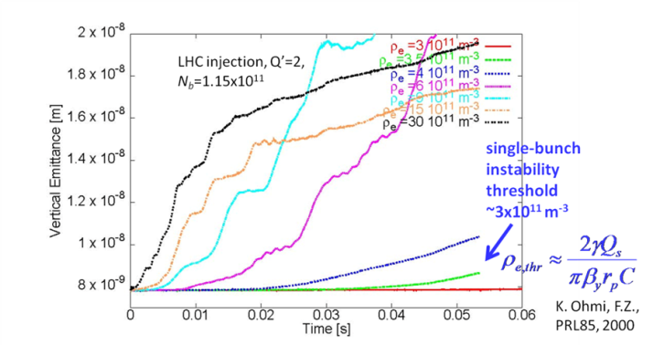

Fig. 2. Evolution of the vertical emittance of a single proton bunch for different values of the electron cloud density at injection in a field free region in the LHC and a chromaticity Q’ of 2 units [8].

More recently, simulations have been performed with the beam parameters during the machine development session in October-November confirming the above expectations and indicating that the threshold electron density is minimum in the straight sections at injection energy (see Fig. 3).

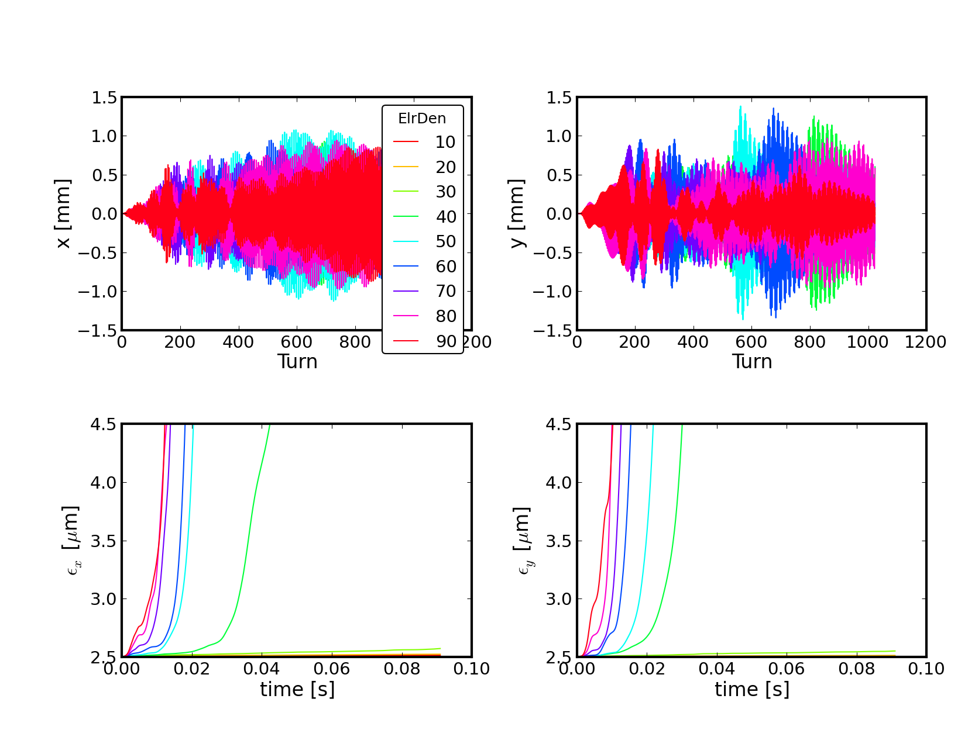

1. 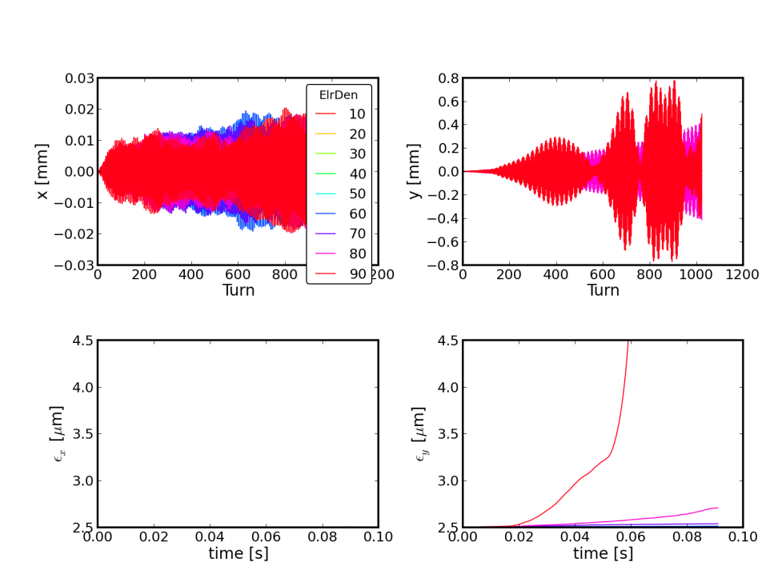
2. 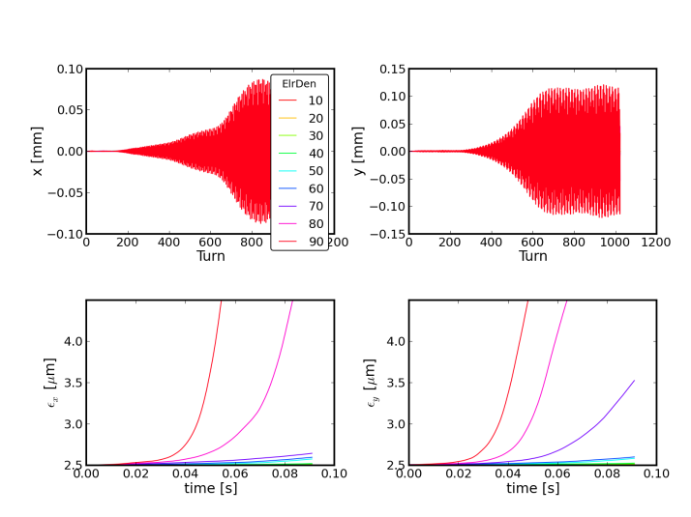
3. 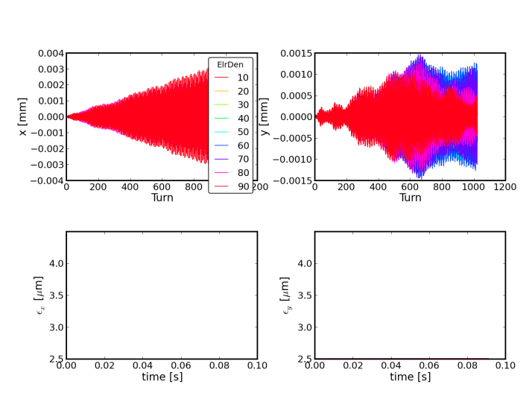

Fig. 3. Evolution of the vertical emittance of a single proton bunch for different values of the electron cloud density at injection in the LHC for low chromaticity in field free (1) and dipole regions (2) and at 4 TeV in field free (3) and dipole (4) regions. The electron densities are shown in 1010 e-/m3 units. The initial transverse emittance of the beam was 2.5 m and the vertical chromaticity Q’=2.

Below the threshold electron density for the onset of the single bunch instability, transverse blow-up is observed due to incoherent effects deriving from the highly non-linear fields generating during the bunch passage. As a result of these phenomena transverse emittance blow-up is observed along the bunch trains in correlation with the build-up of the electron cloud. Fig. 4 represents the tune footprint of the LHC beam at injection energy and for an average electron density of 1011 e-/m3 under the pessimistic assumption that this density of electrons is distributed all around the machine and assuming that dipole fields are present in 70% of the machine circumference while in the remaining 30% of the machine no field is present.

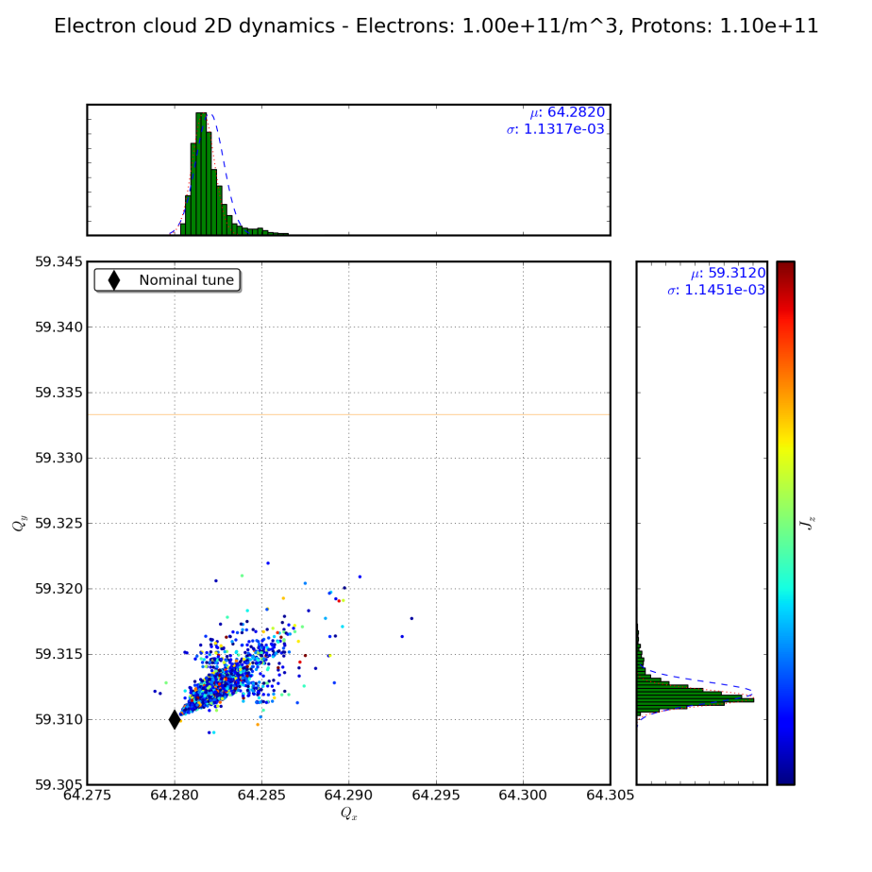

Fig. 4. Tune spread due to the pinching of the electron cloud during the bunch passage at injection energy. A transverse emittance of 2.5 m was considered.

The tune spread due to electron cloud pinching can be as large as 0.01 at 450 GeV/c (worst case). It must be noted that for a large number of bunches (>600) with a spacing of 75 ns the heat load measured in the arcs was ~10 mW/m (close to resolution limit) corresponding to an average electron density of 5×1010 e-/m3 assuming an average electron energy of 100 eV and ~800 bunches. For that reason the 75 ns beam was at the limit of single bunch stability and/or incoherent effects even for low heat load in the beam-screens of the arcs and in the pessimistic assumption that the electron cloud density is uniform along the LHC circumference.

### Observations with 50 ns beam at injection

The transverse emittances measured along a bunch train of 36 bunches with 50 ns spacing (injected after a train of 12 bunches with a spacing of 35.7 s) are shown in Fig. 5. A blow-up of the emittance is visible starting in the second half of the train. This is consistent with the observations on the dependence of the pressure rise as a function of the bunch train length [3]. These measurements were taken with typical machine settings at injection (damper gains close to maximum, 4 units of chromaticity in both planes).



Fig. 5 Transverse emittance along a bunch train of 36 bunches for Beam 1.

The rise-time of the transverse instability observed at 450 GeV/c was ~1 s horizontally and a few tenths of a second vertically as shown in Fig. 6.

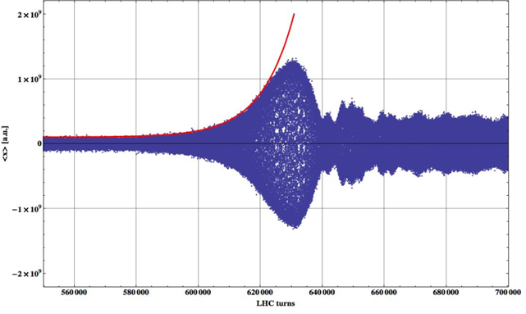

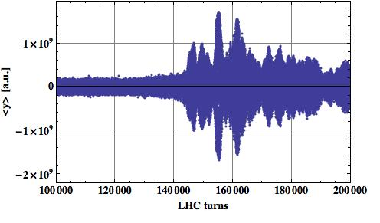

Fig. 6. Time evolution of the horizontal (top) and vertical (bottom) beam positions as measured by the BBQ after the injection of a train of 36 bunches in addition to 12 bunches circulating in the machine.

The transverse emittances measured along 4 consecutive trains of 24 bunches spaced by 1.85 s (injected after a train of 12 bunches with a spacing of 35.7 s) are shown in Fig. 7. The vertical blow-up is mostly affecting the last two trains.

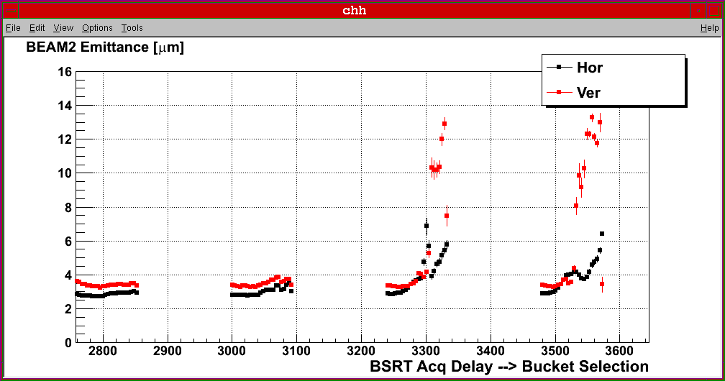

Fig. 7. Transverse emittance along 4 trains (spaced by 1.85 s) of 24 bunches.

This is a consequence of the fact that the decay time of the electron cloud after a bunch train passage is larger than the batch spacing (in this case 1.85 s) [2][3] and therefore the electron cloud density reaches a value critical for beam stability (perhaps saturation) only towards the end of the third batch. These measurements were taken with typical machine settings at injection (damper gains close to maximum and 4 units of chromaticity in both planes).

The smaller vertical emittance of the last bunch of the last two trains is the result of the losses mostly affecting those bunches.

Large chromaticity and large injected emittance have proven to have a stabilizing effect on the single bunch instability induced by electron-cloud both in simulations and experiments in other machines and in particular in the SPS [4][8]. The effectiveness of these cures has been demonstrated also in the LHC and they could be used to increase the number of bunches during scrubbing while minimizing beam instabilities and losses.

The transverse emittances measured along 7 consecutive trains, each consisting of 24 bunches, spaced by 1.85 s (injected after a train of 12 bunches with a spacing of 35.7 s) after having increased the horizontal and vertical chromaticities to 14 units in both planes are shown in Fig. 8. The measured emittance blow-up is reduced by more than a factor two also for the trailing bunch trains.

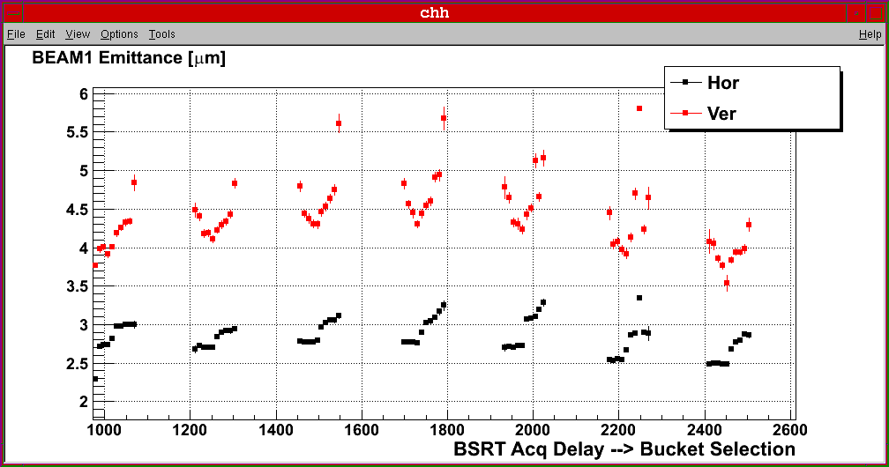

Fig. 8. Transverse emittance along 7 trains (spaced by 1.85 s) of 24 bunches. Chromaticity was set to 14 units in both planes.

The blow-up is further reduced after having increased the chromaticity to 18 units and after increasing the transverse emittance of the beam delivered by the injectors from 2-2.5 m to 3-3.5 m (see Fig. 9).

In spite of that some blow-up is still observed that could be related to the above mentioned incoherent effects of the electron cloud pinching.

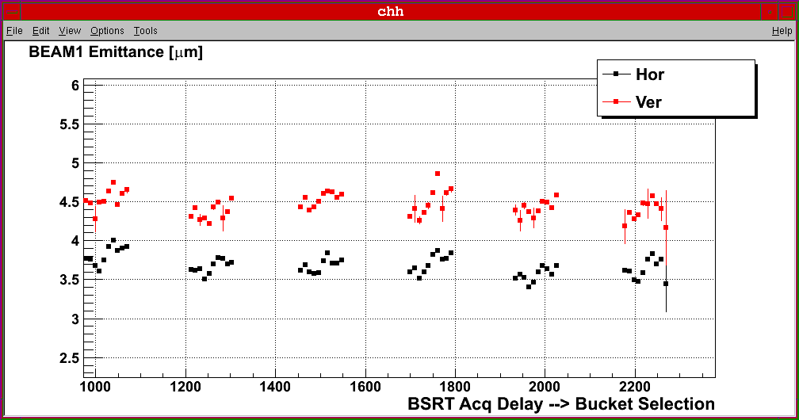

Fig. 9. Transverse emittance along 6 trains (spaced by 1.85 s) of 24 bunches. Chromaticity was set to 18 units in both planes and transverse emittance blow-up was applied in the injectors.

### Observations with 50 ns beam at 3.5 TeV

At injection, operation with large chromaticity seems to be required even for large gains of the transverse feedback pointing to single bunch instabilities at frequencies outside the bandwidth of the feedback as observed in the SPS [6].

At 3.5 TeV instabilities have been observed, when the transverse feedback is switched OFF, with beams consisting of trains of 24 bunches (12+4x24) instead of trains of 12 bunches (9x12) for the same total number of bunches (108) and with the same settings (tune, chromaticity, octupole strengths). The rise time of the instability was few tenths of a second in the horizontal plane and 1 to 2 seconds in the vertical plane as shown in Fig. 10.

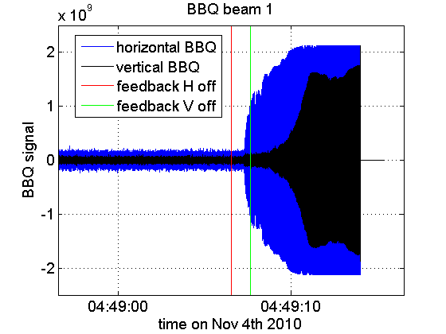

Fig. 10: Time evolution of the horizontal (blue) and vertical (black) beam position as measured by the BBQ at 3.5 TeV when the transverse feedback is switched OFF. The accuracy of the logged timing of the transverse feedback switch OFF is approximately 1 second.

### Observations with 75 ns beam at injection

Coupled-bunch oscillations at low frequency (~1-2 MHz) were observed also for the 75 ns beam at injection (see Fig. 11), mostly in the horizontal plane, although it is not clear whether they are induced by the electron cloud. In the vertical plane blow-up was observed even when operating the machine to high chromaticity (Fig. 12). This is compatible with instabilities and incoherent effects generated by the electron cloud close to threshold electron density.



Fig. 11. Snapshot of the delta signal (product of the horizontal displacement and of the bunch profile) provided by the Head-Tail monitor for a train of 24 bunches at injection.

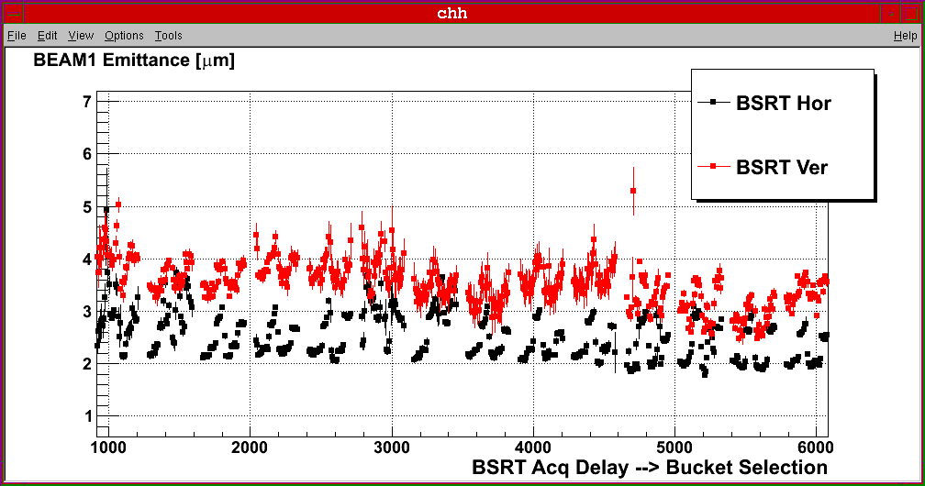

Fig. 12. Transverse emittance along 14 trains (spaced by 1.005 s) of 48 bunches. Chromaticity was set to 20 units in both planes.

## summary and PRELIMINARY SCRUBBING RUN PLAN

Electron cloud effects (vacuum pressure rise in the straight sections, heat load in the arcs, instabilities and transverse emittance blow-up) have been observed for 50 ns beams. Although a reduced vacuum activity has been measured with 75 ns beams, acceleration of nominal trains of 936 bunches would lead to vacuum pressures larger than 2×10-7 mbar (interlock level) and scrubbing is required to accelerate and collide more than 200-300 bunches with 75 ns spacing with no significant pressure rise assuming that the vacuum conditions after the technical stop will remain the same as those after the scrubbing run (i.e. assuming that no intervention affecting the machine vacuum will be carried out).

Low values of heat load due to electron cloud in the beam screens (close to the detection limit of 5-10 mW/m/aperture) have been measured for the 75 ns beam while a clear increase of the temperature of the beam screen of the triplet-D1 magnets in point 2 and in point 8 has been observed and in particular on the left side of point 8. This implies that no significant scrubbing of the arcs can be expected with 75 ns beams.

The typical signatures of electron cloud instabilities have been observed with 50 ns beams. For the 75 ns beam vertical blow-up correlated to coherent and incoherent effects typical of electron cloud densities close to threshold have been evidenced. For both beams these effects translate into low beam lifetime and losses. For that reason a scrubbing run is recommended starting with a 50 ns beam.

The comparison of the dynamic pressure rise in the uncoated portion of the straight sections and the heat load in the beam screens of the arcs for a 50 ns beam at injection, during the ramp and at 3.5 TeV before and after scrubbing at 450 GeV clearly shows a reduction of both phenomena [2] although the electron current of 1 mA/m, corresponding to a heat load due to electron cloud of 100 mW/m/aperture (assuming an average electron energy of 100 eV) has not been achieved so far. Furthermore the above value of the electron current cannot be maintained during the whole period of the scrubbing and it will decrease with the progress of the scrubbing.

The aim of the scrubbing run is to reduce the electron cloud density at the beam centre to less than 1010 e‑/m3 for 75 ns (and possibly 50 ns) beam operation with close to 1000 bunches to remain well below the threshold for the onset of the electron cloud single bunch instability and minimize the tune spread which is at the origin of the incoherent blow-up observed both with 75 and 50 ns beams. At the end of the scrubbing run the heat loads in the beam screens due to electron cloud should remain below the detection limits for 50 ns beams with more than 1000 bunches.

According to simulation results Secondary Electron Yield (SEY) lower than 1.8 are required in dipoles and field free regions in order to operate in the above regime of electron cloud densities (<1010 e-/m3) for 75 ns beams at 450 GeV/c and at 3.5-4 TeV/c. The above values of the SEY are within reach within ~1 week of scrubbing with 50 ns beams assuming an efficiency of ~30% and an optimistic electron dose rate (e.g. not considering the reduction of the flux of electrons in the last part of the scrubbing) [2] and provided that the behaviour of the cryo-surfaces is similar to that of surfaces at room temperature as indicated by laboratory experiments [2].

Experience in the SPS (see Fig. 13) shows that scrubbing with 25 ns beams allows operation with 50 and 75 ns beams with no significant electron cloud build-up.

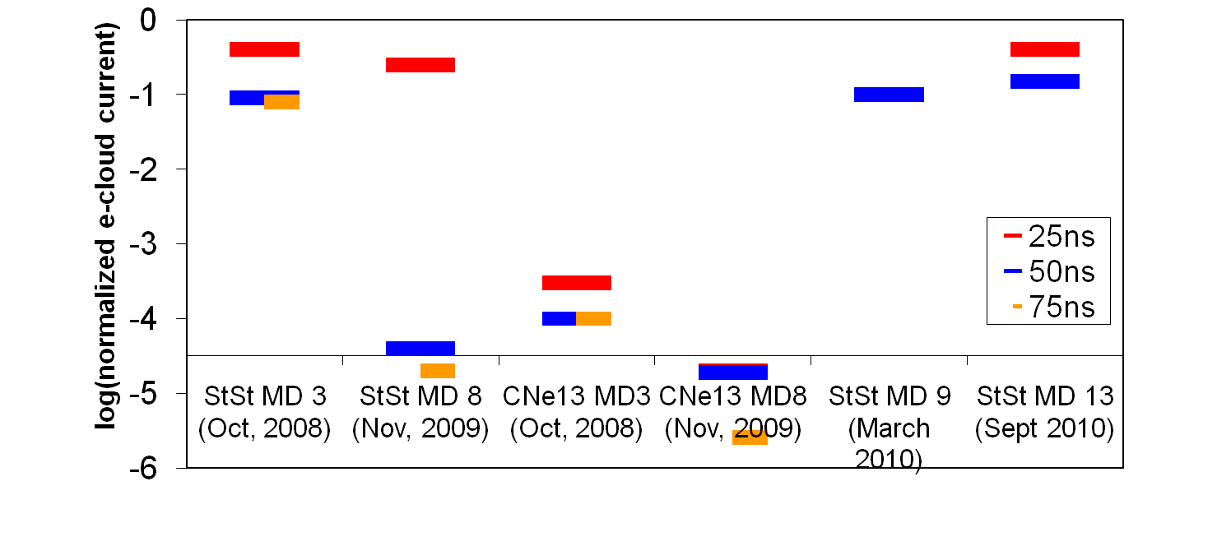

Fig. 13. Electron cloud signal measured for beams with different bunch spacing. A reduction by more than 3 orders of magnitude has been measured with 50 and 75 ns beams after scrubbing with the 25 ns beam in the SPS (see highlighted columns - courtesy M. Taborelli).

The following prerequisites must be present before the start of the scrubbing run:

* injection of 4 trains of 36 bunches (50 ns spacing) per SPS extraction up to nominal transverse emittance should be set-up in advance (this requires 3-4 days of preparation) [9];
* machine protection should be set-up for high intensity at 450 GeV/c (up to 1404 bunches);
* RF should be conditioned for operation at high intensity;
* the transverse feedback should be set-up for high intensity operation with 75 and 50 ns beams;
* solenoids (experimental and anti e-cloud) should be OFF in order to condition all the machine;
* vacuum interlock levels should be temporarily set to 2x10-6 mbar when and where pressure rises limit the progression of the scrubbing and compatibly with machine and experiment protection.

A preliminary schematic plan for the scrubbing run is presented below:

* In the first half of the scrubbing run (Day 1-2): an increasing number of trains of up to 4x36 bunches with 50 ns spacing (1.3-1.5x1011 p/bunch assuming operation with 75 ns at 1.2x1011 p/bunch to allow for current decay) with nominal emittance and up to a total 1404 bunches will be injected compatibly with vacuum rise, heat loads and beam stability. Heat load on the beam screen and RF stable phase (proportional to energy loss) [10] will be monitored as well as vacuum evolution to follow up the scrubbing progress. Large chromaticity and nominal emittances will be required to stabilize the beams and low lifetime, as observed during the scrubbing run, can be expected.
* In the middle of the run (Day 3-4): the sensitivity to orbit excursion, radial position and energy will be studied. For that reason the separation bumps and crossing angles should be varied with a high intensity circulating single beam at 450 GeV in order to address the localization of the scrubbing in dipole field regions and possibly “scrub” in these conditions. A ramp with a 50 ns beam with a few hundred bunches according to progress should be planned to confirm the effectiveness of the scrubbing at 450 GeV for operation at 3.5 TeV. Injection of 75 ns beam should be considered as well to evidence any difference in the distribution of the electrons with 50 and 75 ns beams.
* Second half of the scrubbing run (Day 5-7): the transverse emittance of the beam should be decreased to maximize the energy of the electrons. Recent simulations have shown that, close to the multipacting threshold, smaller transverse emittances enhance the electron cloud build-up. The chromaticity should be reduced (if possible) to maximize the beam lifetime.
* End of the scrubbing run (Day 8): ramp with a 50 ns beam with few hundred bunches to assess effectiveness of the scrubbing and provide input for requirements for operation at 50 ns.
* Start physics with 75 ns with fast ramp-up in intensity to 900 bunches.

## Acknowledgements

Discussions with R.-W. Aßmann and P. Collier and the support of the beam instrumentation, injection, operation and radiofrequency teams are gratefully acknowledged.

## References

[1] G. Arduini, LHC Machine Committee, 06/10/2010, <https://espace.cern.ch/lhc-machine-committee/Minutes/1/lmc_71.pdf>.

[2] J.-M. Jimenez et al, “Vacuum and Cryogenics observations for different bunch spacing”, these Proceedings.

[3] G. Arduini, “50 and 75 ns operation”, Proceedings of the LHC Beam Operation workshop, Evian, 7-9 December 2010.

[4] F. Zimmermann, “Review of Single bunch Instabilities Driven by an Electron Cloud”, Proceedings of the 31st ICFA Advanced Beam Dynamics Workshop (ECLOUD '04), CERN-2005-001 (12 January 2005) pp. 279-312 and references therein.

[5] E. Benedetto, F. Zimmermann, “Analysis of the Electron Pinch during a Bunch Passage”, Proceedings of the 31st ICFA Advanced Beam Dynamics Workshop (ECLOUD '04), CERN-2005-001 (12 January 2005) pp. 81-87 and references therein.

[6] G. Arduini, T. Bohl, K. Cornelis, W. Höfle, E. Métral, F. Zimmermann, “Beam Observations With Electron Cloud in the CERN PS & SPS Complex”, Proceedings of the 31st ICFA Advanced Beam Dynamics Workshop (ECLOUD '04), CERN-2005-001 (12 January 2005) pp. 31-47 and references therein.

[7] G. Arduini, “Electron Cloud and Ion Effects”. CERN SL-2002-056-OP. Proceedings of the 2002 European Particle Accelerator Conference, 3-7 June 2002, Paris, France, T. Garvey, J. Le Duff, P. Le Roux, Ch. Petit-Jean-Genaz, J. Poole, L. Rivkin, Eds., pp. 94-98 and references therein.

[8] E. Benedetto, G. Rumolo, D. Schulte and F. Zimmermann, “Simulation study of electron cloud induced instabilities and emittance growth for the CERN Large Hadron Collider proton beam”, PRSTAB **8**, 124402 (2005).

[9] M. Meddahi, private communication.

[10] E. Shaposhnikova, LHC Beam Commissioning Working Group Meeting, 23 November 2010, <https://lhc-commissioning.web.cern.ch/lhc-commissioning/meetings/20101123/LHC-BC-WG-Min23November10.pdf>