Covid-19 in Nigeria
The first case of COVID-19 was confirmed in Infectious Disease Centre, Yaba, Lagos State, Nigeria on the 27th February, 2020. An Italian citizen arrived at the Murtala Muhammed International Airport, Lagos at 10:00 p.m. on 24th February, 2020 on-board a Turkish airline from Milan, Italy. He visited his company's site in Ogun State the following day where he presented himself at his company's staff clinic. The physician-on-duty had a strong suspicion of the presence of the virus. This led him to refer the Italian citizen to Infectious Disease Hospital (IDH) and the COVID-19 status was confirmed (Nigeria Centre for Disease Control, 2020).
The Nigeria Centre for Disease Control (NCDC) started the contact tracing of ‘Persons of Interest’ which included all persons on the manifesto of the flight that brought the index case to Nigeria, as well as people who had close contact with the index case while in Lagos and Ogun State. After a period of two weeks, a cluster of cases was detected in Lagos and Abuja, this was noted to be the emergence of the nationwide spread of the virus. The Federal Government, through the Nigerian Civil Aviation Authority (NCAA), restricted International commercial flights into the country, effective from 23rd March, 2020. (Onyeji, 2020) On the same day, Nigeria registered her first fatality; a 67-year-old male returnee from the United Kingdom who already had underlying medical issues that were been managed before his death. The death occurred in the Federal Capital Territory, Abuja (Nigeria Centre for Disease and Control, 2020).
The Federal Government responded with the authorization of the closure of all non-essential services (businesses and industries) and restricted movement of people in Lagos State, Ogun State and the Federal Capital Territory, Abuja, on 29th March, 2020. Most State Governments restricted public gathering and there were restrictions on Inter-state movement. The Federal Government later authorized the gradual easing of lockdown in the previously restricted states on the 4th May, 2020.
The nationwide spread of the virus led to the Federal government of Nigeria effecting certain measures to contain the virus. The available information on the virus and the welfare of her citizenry were guiding beacons in periodic restrictions to maximize containment. Educational and Religious institutions were the first bodies restricted before containment measures extended to non-essential services (Onyeji, 2020).
The Federal Government with the aid of different ministries and governmental agencies put up a formidable response in the fight against COVID-19 in Nigeria. Leading the frontlines is the Federal Ministry of Health; the ministry is tasked the formulation and implementation of policies related to COVID-19 in Nigeria with collaboration with relevant ministries and agencies. The Federal Ministry of Health through its Accreditation Committee are involved with inspection of public and private treatment centers for COVID-19 confirmed cases. Furthermore, the ministry handles the training guidelines and personal protective equipment [PPE] distribution for frontline workers for this novel disease. The ministry is strongly supported by the Presidential Task Force for the Control of the COVID-19 (PTF) and the Nigeria Centre for Disease and Control (NCDC).
President Buhari set up a 12-member task force to champion the battle against COVID-19 in the country. The Task Force is chaired by the Secretary to the Federal government, Mr. Boss Mustapha and Dr. Sani Aliyu is the National Coordinator of the Group (Ameh, 2020). The task force's mandate is to create a workable National Response Plan that would be revised on a daily basis as requirements change. The strategy must follow international best practices while taking into account the local circumstances prevailing in the country. The Task Force has been given six months to fulfil its mandate. (Ailemen, 2020).
Moreover, the Nigeria Centre for Disease and Control has been given the mandate to lead preparedness, diagnosis and response to outbreaks of COVID-19 in Nigeria. The parastatal publishes regular updates on reported cases, discharged cases and deaths related to COVID-19 via its website and social media channels. The mission of the NCDC is to protect Nigerians' health through evidence-based prevention, integrated disease surveillance and response programs, using a single health strategy, driven by research and led by a professional workforce.
The initial performances of the various institutions and agencies of the Government showed the ill-preparedness to combat the virus but the subsequent responses have been phenomenal. This is evident in the containment of the ongoing pandemic spread in Nigeria that began February, 2020. Although, the spread potential is yet to be properly estimated, containment strategy has proven quite effective. A major contributor to the spread worldwide was increased travel, modern transport networks made it easy for travelers to transmit the virus, hence, the ban on inter-state travel was an appropriate containment measure (AbdulAzeez, 2020).
Due to the nature of the symptoms, only people who have been tested can be easily identified as infected. The test results have shown a rising number of people confirmed to have COVID-19. Though a significant number of people recover from the infection, the greater concern lies with those who are yet to be tested. The ease of transmission coupled the rate of interaction amongst the populace indicates that the confirmed cases are merely a small share of the actual numbers. This is demonstrated by the rate of newly confirmed cases by the day. According to the daily reports provided by NCDC, Lagos State with the highest population density in Nigeria has been recording the largest number of confirmed cases.
Kano State became a state of interest due to the number of deaths recorded, the State government released a report indicating that the deaths were not related to COVID-19. However, there were allegations that autopsies were not carried out.
….. To be continued

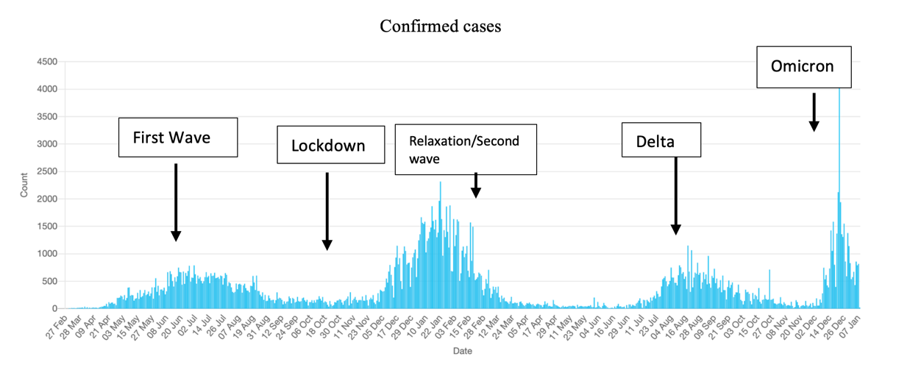
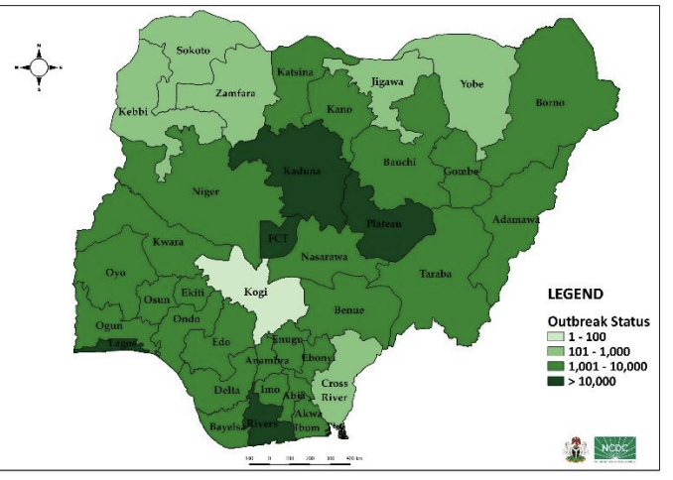
Cumulative Distribution of confirmed cases as at 26th Dec 2021

Reference:

