Clarification on the technology to be used for the positron capture in the positron source for the FCC-ee injector (WP3) and for the experiment to be carried out at PSI (WP6).

Authors: P. Craievich, R. Zennaro and I. Chaikovska

WP3. Positron source: target and capture system – I. Chaikovska
Task 3.1 Physics design of the positron target and capture system – I. Chaikovska
Task 3.2 Capture system: Concepts of a SC solenoid and/or of Flux Concentrator – Michal Duda Task 3.3 Capture system: Design of the RF structures and NC solenoids – R. Zennaro
Task 3.4 Capture system beam dynamics – S. Ogur
Task 3.5 Design and integration of positron target area – S. Gilardoni
Task 3.6 Design of target mechanical system – S. Gilardoni
WP6. Proof of principle positron source in SwissFEL – R. Zennaro
Description of the work packages
One of the objectives of the CHART project related to the positron source, which aim to contribute to the innovation and development of accelerator concepts beyond existing lepton injector technology is summarized here: High yield positron production and capture concept with proof of principle. Novel concepts for the production target and positron capture are investigated in theory and experiment with the goal to demonstrate production yield values and efficiencies well beyond present state-of-the-art.
An important boundary condition is that, a few months ago, the review meeting suggested to continue using the two-bunch scheme as the baseline for the FCCee injector design. The repetition rate should be still defined and currently the range of 100-200 Hz is under investigation. Furthermore, beam dynamic simulations have shown that the flux concentrator can guarantee positron production even with some safety margin. Based on these assumptions, the flux concentrator as presented in CDR still remains the baseline for use as a matching device for the positron capture. The technology based on a pulsed magnet is well established in other laboratories and has proven to be suitable for FCC-ee as well. Now it would be important to start the mechanical design including the integration of the target into the flux concentrator and to carry out simulations to define the shielding and thermo-mechanical simulations to define the complexity of the device as a whole. More probable the modification of the current design could be necessary. Operation of the flux concentrator at 100 Hz must be checked experimentally. As far as the current design is concerned, operation at 200 Hz represents an intrinsic difficulty. In this case, design of the flux concentrator should be further developed to allow for 200 Hz operation mode.
Eventually, the objectives of this study are to have the reliable and robust design of the positron source for the FCC-ee using the flux concentrator as a matching device (together with the first mechanical integration) and get a cost estimate to be included in the technical design report.
A possible alternative to the flux concentrator is to use a superconducting (SC) solenoid as a matching device. From the results of the latest simulations, it seems that a positron yield even higher than the flux concentrator scheme can be achieved. The positron capture simulations are ongoing and several iterations to be performed between the magnet design (PSI magnet group), heat load and radiation dose calculations (CERN-STI group), mechanical design (CERN-STI) and beam dynamics simulations (IJClab and CERN) to define the best magnet parameters (see Figure 1). The first simulations to estimate the radiation effects on the SC solenoid have also shown promising results regarding the use of the SC magnet in an environment with high radiation losses. On top of that the recent decision to limit the operation mode to two bunches per RF pulse in the injector makes the SC option very attractive. However, this remains a new technology to be used in positron sources and a demonstration of its feasibility and effectiveness should be made. In such a way, the feasibility studies and demonstration of the use of SC solenoid is the main purpose of the experiment at PSI together with the studies of the innovative target based on the hybrid scheme.
The drive beam parameters available for the experiment at PSI are the following: beam energy 6 GeV with a maximum charge of 200 pC at a repetition rate of 1 Hz (limited by the radioprotection issues). These parameters are very different from those envisaged for the FCC-ee injector, where the charge will be ~3-4 nC at a repetition rate up to 200 Hz. This difference in the drive beam parameters leads to a considerable simplification in the engineering of the SC solenoid-target system, when compared to a possible engineering for the FCC-ee injector. Engineering and mechanical design for the beam test at PSI will be performed by the PSI with the support of CERN experts. Such experiment, which implies important resources, is significant and justified only if it allows the development and test of new technology such as the SC solenoid and hybrid positron production scheme. The test of this new solution for the matching device can be extremely motivating and important not only for FCC project but also for a larger scientific community.
As far as planning and milestones are concerned, the FCC-ee Injector study/CHART project foresees that the CDR/TDR with cost estimation will be finished by end 2023 or with the extension by end 2024 while the experiment at PSI is carried out and the results analyzed by end 2024 or with the extension by end 2025. For this reason, as for now, the baseline for the FCC-ee injector remains the flux concentrator. However, a comparison between a solution involving the flux concentrator and the SC solenoid should be made taking into account the positron yield, the complexity of the devices and the costs. This comparison will be a useful reference for future decisions to use one technology or another in the FCC-ee injector.

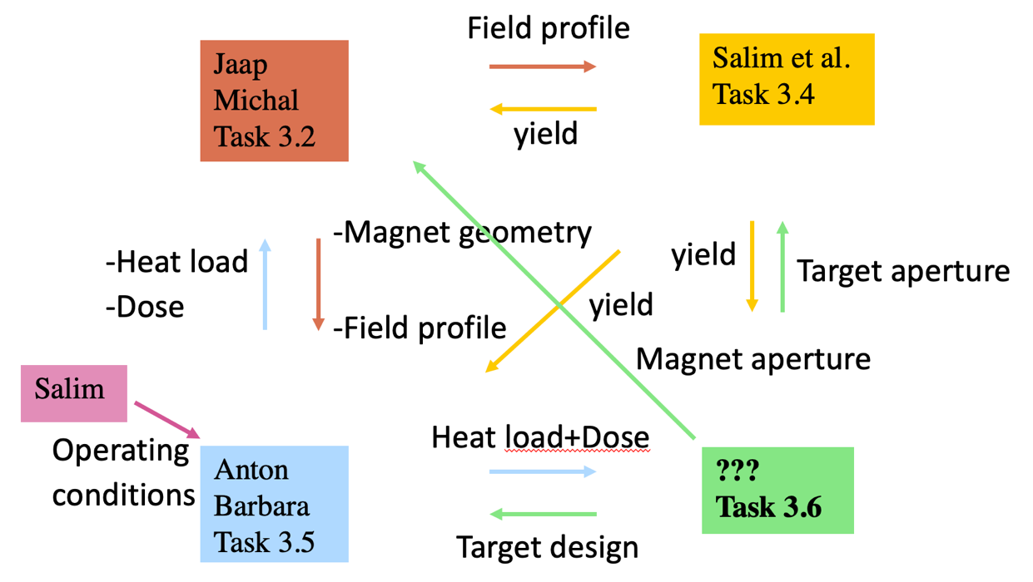
Figure 1: Interfaces between different groups (and people in charge in the corresponding Tasks) working on the SC solenoid design to be used for positron capture.
Deliverables for Task 3.5 and 3.6
For both classical and hybrid schemes of the positron production and FC and SC solenoid as a matching device:
- Evaluation of radiation level/environment and required shielding for HW protection.
- Calculation of the power dissipated on the structures (FC/SC solenoid, DC solenoid, acc. sections…).
- Conceptual design of the production target (including thermo-mechanical assessment, definition of baseline material). Specifications of the target cooling system. Definition of R&D threads that will be required in order to progress in the studies.
- Design of the target systems and integration of the capture devices downstream the production target (with shielding assembly) including support and handling system.
- Preparation of the contribution on the corresponding topics for the CHART report and the FCC-ee TDR.

Email from M. Calvianion 24.01.2022
As anticipated, we’ve slightly restructured some tasks within the SY/STI Group in order to follow-up the FCCee activities.

The main change related to the organization of the Target and Target Systems activities, which will now involve (a fraction!) of two people you’ve not met before. They are both very expert on operational and project activities. Jean-Louis Grenard will be following the design and integration of the positron target area, while Antonio Perillo-Marcone will follow the design of the target mechanical systems. This task is missing one critical resource, that we’ve asked the FCC Project to cover in urgency. I would kindly ask to add Jean-Louis and Antonio to all relevant mailing lists (as all of us). For the time being Tim will work on other subjects and will not be involved in FCCee tasks.

Of course Anton (and Barbara) will continue with all the excellent work done so far (please note a slightly rephrasing of the name of the task).

As mentioned, we propose a slight reorganization of the tasks, that you can see below – we are essentially adding one.

We also proposing you a list pf possible deliverables, still to be discussed of course, and to be integrated in the overall project schedule and milestones (which I’ve understood Paolo will provide at the meeting on Thursday).

Organization:
- Task 3.5 Radiation effects and heat load in target and capture system (Anton Lechner + Barbara Humann (DOCT) )
- Task 3.6 Design and integration of positron target area (Jean-Louis Grenard)
- Task 3.7 Design of target mechanical system (Antonio Perillo-Marcone + FELL/DOCT new resource)

Deliverables (proposal):
- Evaluation of radiation level/environment and required shielding for HW protection.
- Calculation of the power dissipated on the structures (FC/SC solenoid, DC solenoid, acc. sections…) and assessment of the long-term radiation damage in sensitive components.
- Conceptual design of the production target
  - Thermo-mechanical assessment, definition of baseline material
  - Functional specifications of the target cooling system
  - Definition of R&D threads that will be required in order to progress in the studies
- Design of the target systems and first conceptual integration of the capture devices downstream the production target (with shielding assembly) including supports and potential handling system.
- Preparation of the contribution on the corresponding topics for the CHART report and the FCC-ee TDR.

Maybe we could have a separate chat all together in order to present you both Jean-Louis and Antonio and decide how to move on?
I would really encourage to have regular (short) discussions to get the activities going.

Looking forward to a successful collaboration,
Marco

