Doc NO. | REV. | VALIDITY
2616389 | 1.0 | DRAFT
REFERENCE
MED-OP-21 Tb-155#2 24-08 TO 27-08-2021
Date: 2021-07-27

MEDICIS Collection and Operation report
Report oN

MEDICIS EXPERIMENT : MED-005
target : 721M Re
isotope collected : Tb-155
IRRADIATION: DIRECT FROM 24/08 to 25/08
COLLECTION : 25/08/2021 18:00 – 27/08/2021 09:15
spectroscopy : 27/08/2021 10:26
SHIPPINg : No
Radiochemistry : No
document Prepared by: | document TO BE checked by: |  | document Approved BY:
CHARLOTTE DUCHEMIN | THIERRY STORA  ERIC CHEVALLAY  LAURA LAMBERT  EDGARS MAMIS  REINHARD HEINKE  UMAIR KHALID
contributors list:  DOSE RATE MEASUREMENTS PERFORMED BY HSE-RP-AS  RECEPTION AND SHIPMENT ORGANISED BY HSE-RP-CS |  | DIFFUSION LIST:

HISTORY OF CHANGES

REV. NO. | DATE | PAGES | DESCRIPTIONS OF THE CHANGES
1.0 | 2021-08-25 | 11 | First draft by C.DUCHEMIN

TABLE OF CONTENTS
1. OVERVIEW, PREPARATION OF THE SAMPLE AND RECEPTION AT CERN 3
1.1 OVERVIEW 3
1.2 IRRADIATION OF THE TARGET 3
2. TARGET RETRIEVAL AND DOSE RATE MEASUREMENTS AT THE DECAY POINT 4
3. COLLECTION 4
3.1 PREPARATION 4
3.2 SEPARATION, IMPLANTATION 6
3.2.1 PRELIMINARY SET-UP, OBSERVED ISSUES, SEPARATION AND IMPLANTATION 6
3.2.2. IMPLANTATION 8
3.3 EXTRACTION OF THE SAMPLES 9
4. SPECTROSCOPY 10
5. PRODUCTION ESTIMATE WITH FLUKA 10
6. EFFICIENCY based on FLUKA estimate and HP Ge gamma-spectroscopy 11
7. SHIPPING 11
8. USEFUL LINKS 11

OVERVIEW, PREPARATION OF THE SAMPLE AND RECEPTION AT CERN

OVERVIEW
MED-005 Run: Objective of this collection (Tb-155) was to assess the feasibility of producing Tb-155 with high-specific activity for MED-005 (IST Portugal). This document gives a summary of the different steps followed from the irradiation of #721M (Ta rolls) to the retrieval and measurement of the collection foils. The parameters used for this collection are given in this document.
It is completed by irradiating Ta rolls target #721M at ISOLDE with 1.4 GeV protons delivered by the PS Booster and its subsequent mass separation at MEDICIS.

IRRADIATION OF THE TARGET
The irradiation of the target has been performed on the HRS irradiation point using the low trolley for direct impact of the 1.4 GeV proton beam on the target container between 24/08 and 25/08/2021.

Table 1: Details of the target
DETAILS OF THE TARGET
Target reference | 721M Re ion source
Target type | Tantalum rolls (342 g)
Mass Markers | No
Production | ISOLDE 1.4 GeV – Direct irradiation
Irradiation start | Irradiation end (EoB) | Irradiation time (h) | poT | Average current (microA) | Cumulated current (microA.h) | Direct or Indirect irradiation
24/08/2021 15:45 | 24/08/2021 16:30 | 0.75
24/08/2021 17:30 | 24/08/2021 19:15 | 1.75
24/08/2021 23:25 | 25/08/2021 14:56 | 15.52 | 7.78E+17 | 1.92E+00 | 29.78 | Direct

TARGET RETRIEVAL AND DOSE RATE MEASUREMENTS AT THE DECAY POINT
The MEDICIS target #721M was retrieved on 25/08 dose rate measurements at the decay point were performed.
Table 2: Details of the dose rate measurements performed on the target
Direct or indirect irradiation | Dose at decay point (mSv/h) | Time of measurement | Time from EoB  (h)
Direct | 673 | 25/08/2021 15:18 | 0.37
Direct | 637 | 25/08/2021 15:23 | 0.45
Direct | 553 | 25/08/2021 15:37 | 0.68

COLLECTION

PREPARATION
The foils were loaded in MEDICIS collection chamber on 23rd of August morning with foil M148 (Zn coated Au foil) in position 1, scintillator in position 2 and foil M149 (Zn coated Au foil) in position 3.
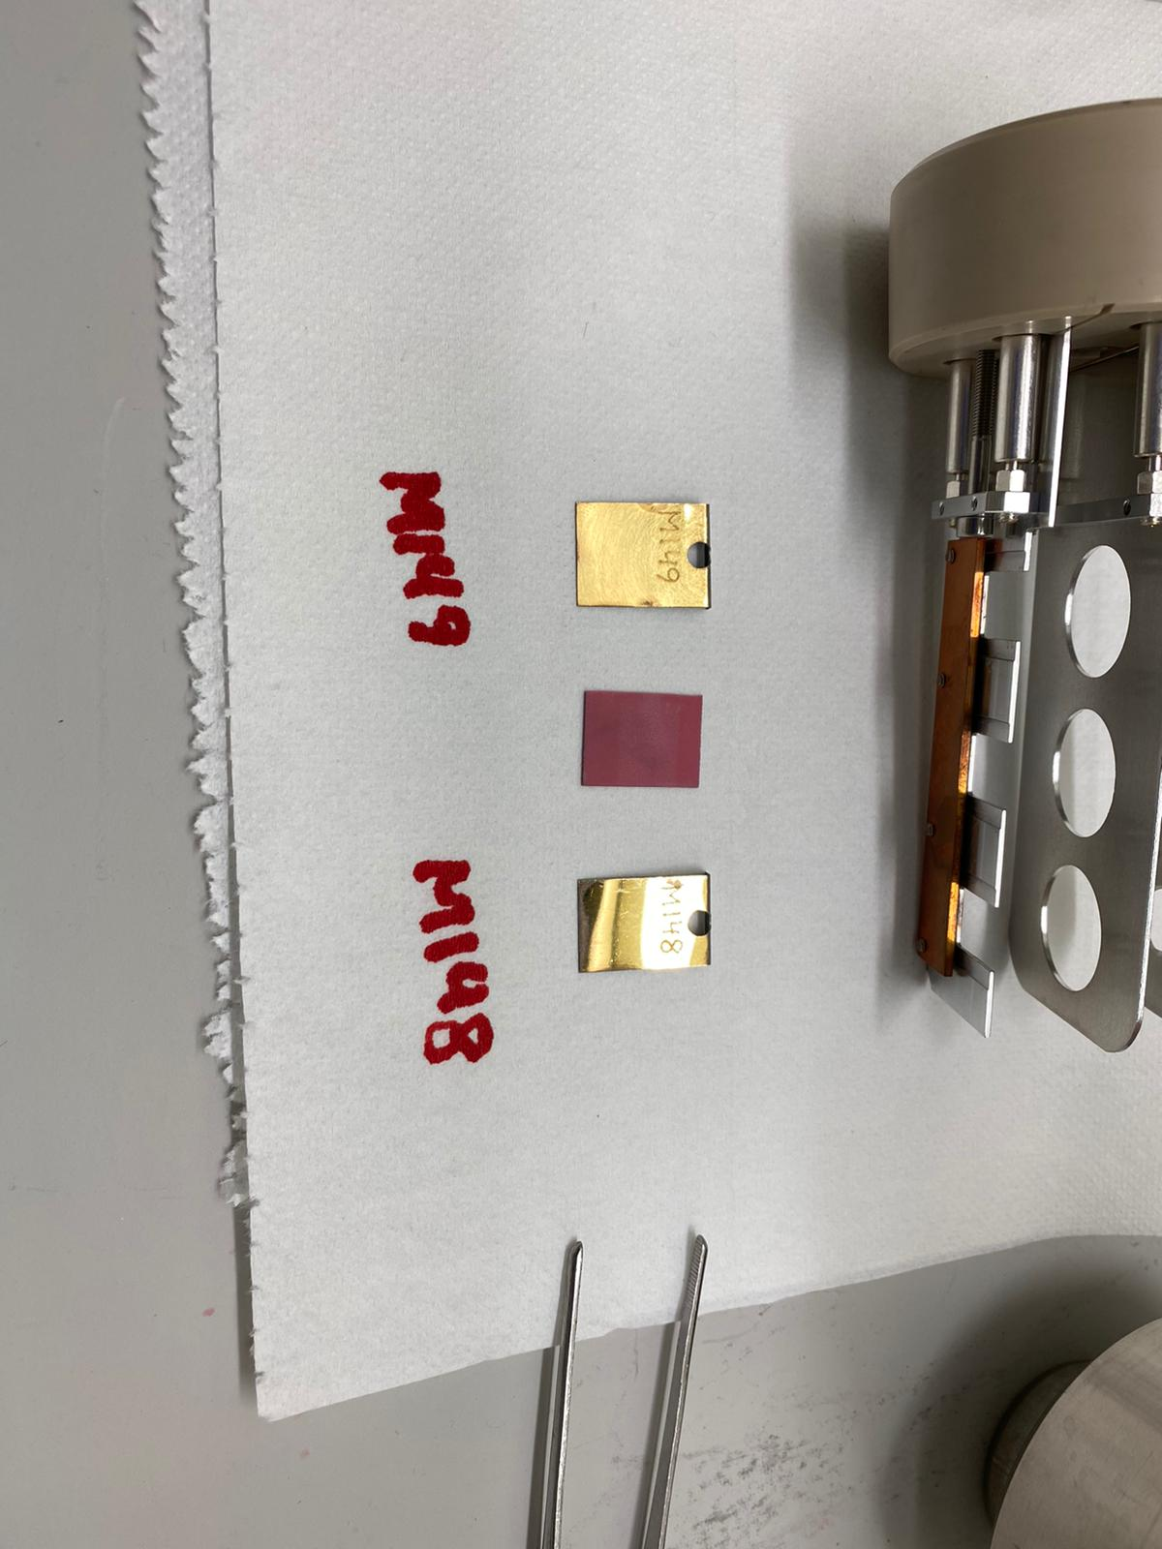
Figure 1: View of the foils M148, scintillator & M149 ready to be loaded inside the sample holder
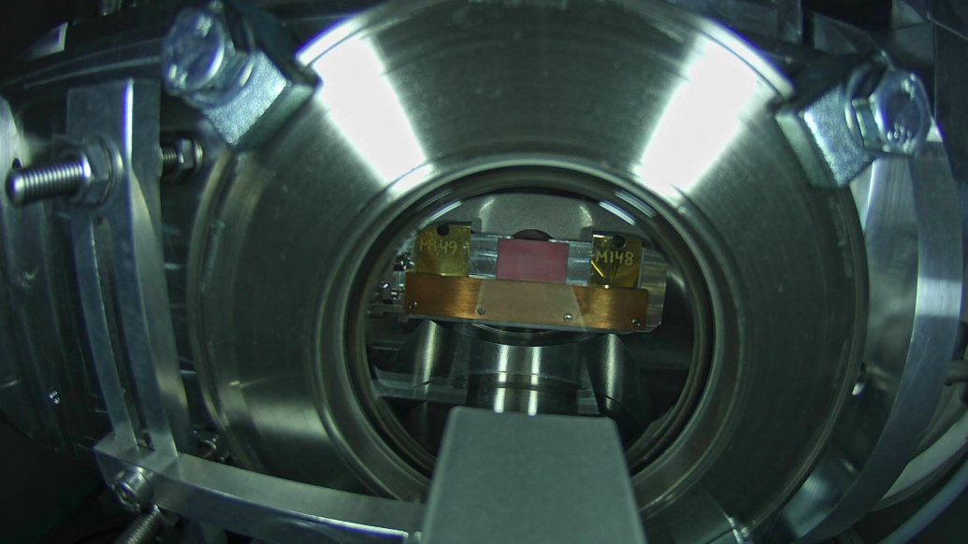
Figure 2: View of the foils inside the collection chamber

SEPARATION, IMPLANTATION

PRELIMINARY SET-UP, OBSERVED ISSUES, SEPARATION AND IMPLANTATION
On Tuesday 24th of August afternoon, the target #721m has been sent to ISOLDE on the low trolley for a direct irradiation. The target has been retrieved on Wednesday 25th of August at 3 pm (see details in Table 1 and Table 2). On Wednesday 25th of August it is estimated a Tb-155 activity of 6.5 GBq at 6 pm (after 3 hours of cooling time).
On Wednesday 25th of August, the target #721M has been placed on the front end at 4 pm and the line and target heated to 210 and 50 A, respectively. The target container has been heated to 100 A and the pressure was good with 5.4E-6 mbar. The target has been further heated to 150 A keeping the line at 210 A. The line temperature has been increased to 300 A and the extraction electrode placed at + 60 mm (+59.841 mm). The slits have been closed to L = + 11 mm and R = +3.5 mm. The separated beam current at mas 155 was 1.1 pA.
The target has been heated to 350 A and then to 400 A followed by an increased to 550 A since no activity was detected by the kromek.
The beam profile at 550 A is given in Figure 3.
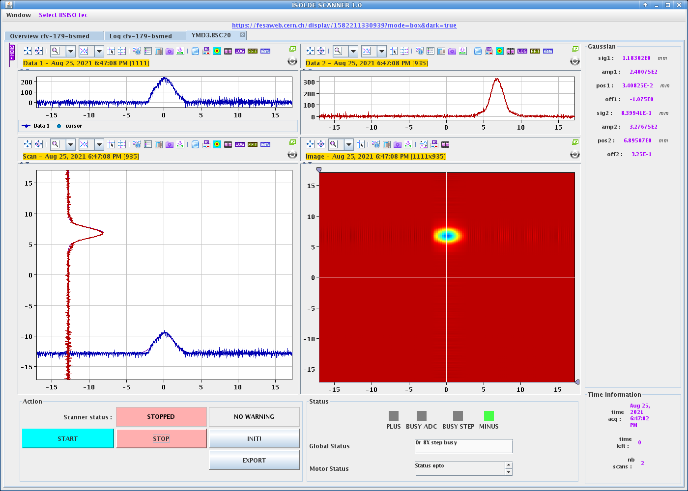
Figure 3: Beam profile at mass 155
The target has been heated to 600 A and a mass scan has been started from mass 135 to mass 165 with lasers on (see Figure 4).
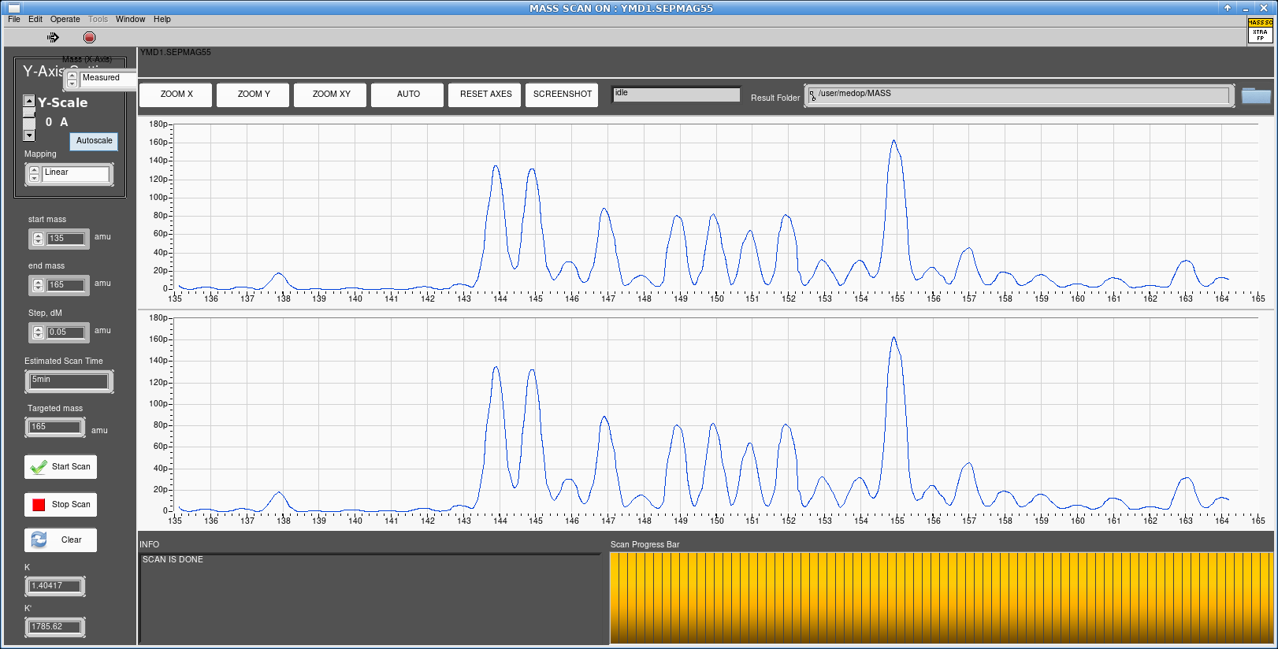

Figure 4: mass scan with target container at 600 A
The target has been heated to 650 A for collection of Dy-155 overnight. An activity of 6.58 MBq of Dy-155 has been measured a 22:14.
On Thursday 26th of August, the Dy-15 activity was 4.0 MBq at 07:19 am. This activity decreases to 3.6 MBq at 08:52 am with 2.1 MBq of Tb-155 detected.
The target container has been heated to 700 A giving an intensity on the sample of 149 pA and a total current of 1.5 nA.
The activity values given by the kromek at 09:07 am were the following:
Tb-155 = 1.91 MBq, Dy-155 = 3.58 MBq, Ce-139 = 225 kBq, Dead Time = 7.8 %.
The target container has been heated to 750 A and the line at 310 A at 09:15 am. The intensity on the sample was 725 pA. However the kromek activities were not increasing.
The target container has been heated to 780 A followed by 800 A (2330 ºC). At 800 A the sample intensity was 2.1 nA and the separated current was 1.7 nA.
A mass scan has been started showing no laser on/off exact (mass 155 intensity = 1.8 nA) and only 50 pA of TbO (at mass 171).
Therefore, the separator has been put back on mass 155 and collection re-started on foil M149.
The target container temperature has been increased to 810 A without any change on the activity estimated by the kromek and increased further to 820 A (2370 ºC).
At 15:50 the activities given by the kromek were the following:
Tb-155 = 3.29 MBq, Dy-155 = 2.51 MBq, Ce-139 = 300 kBq, Dead Time = 7.1 %.
At 16:05 the activities given by the kromek were the following:
Tb-155 = 3.47 MBq, Dy-155 = 2.48 MBq, Ce-139 = 288 kBq, Dead Time = 7.1 %.
Giving an implantation rate of 720 kBq/h of Tb-155.
The target container has been heated to 830 A (2400°C) giving a total beam of 2.2 nA.
At 17:00 the activities given by the kromek were the following:
Tb-155 = 3.18 MBq, Dy-155 = 2.40 MBq, Ce-139 = 275 kBq, Dead Time = 7.0 %.
The target was left at this temperature for implantation overnight.
On Friday 27th of August, at 9:15 am the collection has been stopped and the foils have been retrieved. The target container was at 830 A.
Summary activities measured by the kromek:
M149: 4.11 MBq Tb-155, 702 kBq Dy-155, 399 kBq Ce-139 (including a background) - Reference time 27/08/2021 09:20. Efficiency = 0.06%
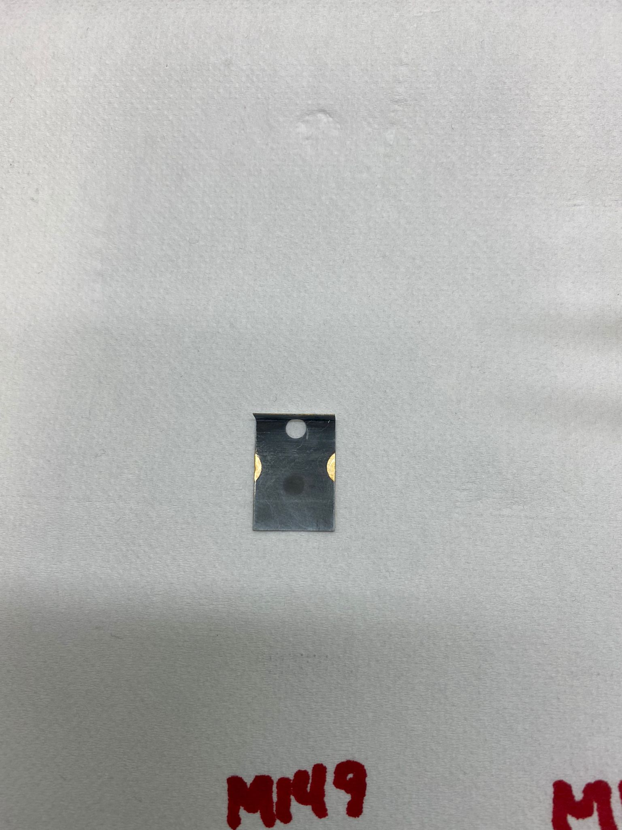
Figure 5: foil M149 implanted
The Table 3 below gives the parameters used for this separation of Tb-155.

Table 3: Parameters of separation
PARAMETERS USED FOR Tb-155 SEPARATION #2 2021
Target | #721M
Target line temperature | 300 - 310 A / 2180ºC - 2230 ºC
Target temperature during collection | 600 –830 A / 1970 °C – 2400 °C
Laser parameters | 2 step scheme:  Step 1: Grating Tisa, 430mW @ 11553.5/cm x2  Step 2: Tisa 1, 1.25W @ 12169.2/cm x2  1-color scheme:  Tisa 3, 1.33W @ 12307.1/cm x2  Pulse ca. 50ns before 2 step scheme
High voltage | 60 kV
Extraction electrode | +60 mm (reference) (+59.841 mm measured)
Einzel | 22.8 kV
Electrostatic deflectors | V1=-V2=250V V3=-V4=250V
Slits | Left = +11.0 mm Right = +2.5 mm
MAG55 | 72.63 A
Teslameter | 258.8 mT

IMPLANTATION
The table 4 below gives a summary of the gold foils characteristics and implantation duration and measured activity (online activity with the kromek detector) for each foil.
Table 4: Details of the Tb-155 implantation on each foil
DETAILS OF THE GOLD FOILS / COLLECTION CHAMBER
Foils Number | Position 1 : M149 – implanted Tb-155
Foils Number | Position 2 : scintillator screen – not implanted
Foils Number | Position 3 : M148– not implanted
Gold foils characteristics | 0,50mm thickness  500 nm Zn coating
DETAILS OF THE IMPLANTATION M149 (position 1)
Time of collection | 25/08/2021 18:00 – 27/08/2021 09:15
Activity estimated by the Kromek GR-1 | 4.1 MBq Tb-155 (1.7 MBq remaining in the chamber after extraction) = 2.4 MBq estimated on the foil
DETAILS OF THE IMPLANTATION Scintillator (position 2)
Time of collection | Not implanted
Activity estimated by the Kromek GR-1 | -
DETAILS OF THE IMPLANTATION M148 (position 3)
Time of collection | Not implanted
Activity estimated by the Kromek GR-1 | -

EXTRACTION OF THE SAMPLES
Operators: Umair KHALID, Edgars MAMIS, Thierry STORA, Laura LAMBERT, Elodie AUBERT (MEDICIS), Matthieu DESCHAMPS (CERAP)
The collection foils have been extracted on the 27th of August. Table 5 gives the related IMPACT reference and the collective and maximal individual dose rate received.
A dose rate of 10 uSvh/h has been measured at contact of the container and 10 uSv/h at 10 cm from the collimator with the foils (H*10 - AD6). 230 uSv/h have been measured with the Victoreen (H’0.07).
930 uSv (beta, H’0,07)/ 18 uSv/h (gamma) has been measured at 10 cm of the implanted foil M149. 2.6 mSv (beta, H’0,07) has been measured at 1 cm.
A remaining activity inside the collection chamber of 1.68 MBq Tb-155 and 143 kBq Ce-139 has been measured by the Kromek GR-1.
Table 5: Details of the dosimetry received during Tb-155 foil retrieval
REFERENCE 177467
Impact number (foil retrieval) | 177467
DIMR | 7997251/1
DOSIMETRY | uSv
Collective dose | 0
Individual dose (max) | 0

SPECTROSCOPY
Spectroscopy was performed on the collection foil M149 with a Falcon 4 HPGe gamma detector in 375/T7-C64 on 27/08/2021.
During the measurements, the foil M149 was located at 150 cm from the detector. The spectrum was collected during 900 seconds with a dead time of 1.1%. The activity values given in Table 6 is reported to the time of the g-spectrometry measurement.
Table 6: Details of the gamma-spectrometry performed on the collection foils
Collection foil | Radionuclide | Half-life | Ref. | Conf. | Weighted Mean Activity  (Bq/unit)
M149  CR-113665 | Dy-155  Tb-155  Ce-139 | 9.9 hours  5.32 days  137.64 days | 27/08/2021  10:26 | 0.961  0.956  0.999 | 6.20E+05 ± 4.9%  2.25E+06 ± 3.5%  1.63E+05 ± 11.9%

PRODUCTION ESTIMATE WITH FLUKA
This section gives a production estimate of Dy-155 and Tb-155 activity that has been produced in the target after direct irradiation with a reference date at the 25/08/2021 at 6 pm.
Table 7: Nuclide inventory in the target for Dy-155 and Tb-155 (25/08/2021 6 pm)
Irradiation scenario
* 1.) beam intensity: 1.2E+13 p/s, irradiation: 2700 s (45 minutes), cooling: 3600 s (1 hour)
* 2.) beam intensity: 1.2E+13 p/s, irradiation: 6300 s (1 hour, 45 minutes), cooling: 15000 s (4 hours, 10 minutes)
* 3.) beam intensity: 1.2E+13 p/s, irradiation: 55860 s (15 hours, 31 minutes), cooling: 10800 s (3 hours)
* Total nr. of particles: 7.78E+17
Dy 66 155 8.12E+10 Bq +/- 1.29%
Tb 65 155 6.54E+09 Bq +/- 1.80%

EFFICIENCY based on FLUKA estimate and HP Ge gamma-spectroscopy
Table 8 gives the detail of the separation efficiency.
Table 8: efficiency calculations at time of the EOC based on the g-spec measurements
Collection foil | Radionuclide | Start of collection | End of collection | Activity in target (Bq) | Ref. g-spec measurement | Measured activity  (Bq) | Efficiency  EOC  (%)
M149  CR-113665 | Tb-155 | 25/08/2021  18:00 | 27/08/2021  9:15 | 6.52E+09 | 28/07/2021  10:26 | 2.25E+06 | 0.03

SHIPPING
No shipping.

USEFUL LINKS
7.1. IMPACTS
Retrieval of Tb-155 foils:
https://impact.cern.ch/impact/secure/?place=editActivity:177467

7.2 SHARED DATA
https://espace.cern.ch/MEDICIS-Workspace/_layouts/15/WopiFrame.aspx?sourcedoc=/MEDICIS-Workspace/Shared%20Documents/Operation%20reports%202021/5-%20721M-%2025082021-27082021/721M-Kromek-values.xlsx&action=default

