Review meeting 19/04/2022
- Talking Points
  - Minimum thickness of the vacuum chamber to avoid leak tightness

Action Items
Action | Responsible
- Ask to the vacuum group about the bake out temperature | (G & T)
- Find the alloy that better suits our requirements | (T)
- Check in ANSYS asymmetries (variable thickness) and misalignments | (T)
- Check grain size with ultrasonic technology after buying the material to machine | (G & T)
- Perform a cleaning operation after the manufacturing and ensure a clean storage before installation | (G & T)
- Notepad
- Multidirectional forged aluminium alloy
- Aluminium alloy resistant to pitting corrosion to avoid leak tightness
- Aluminium alloy with good mechanical properties (tensile strength and yield strength) after baking out at 260 ºC during 100h (check with the vacuum group the baking out temperature)
- Avoid chlorides or fluorides in the aluminium alloy
- Fine grain: ten grades over the thickness ($10 μm$). Check the size with ultrasonic technology
- Apply a safety factor of 2 between standard and engineering properties
- Check in ANSYS asymmetries (variable thickness) and misalignments
- After manufacturing and before installation perform a cleaning process

2219 (Standard properties)
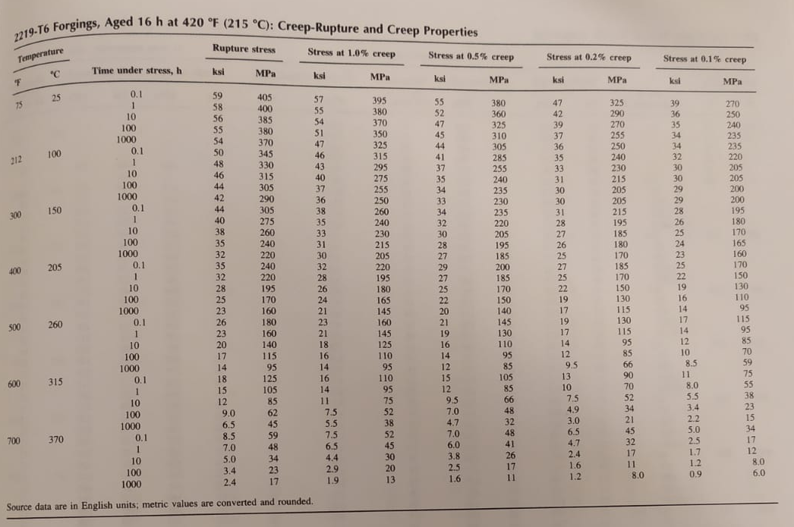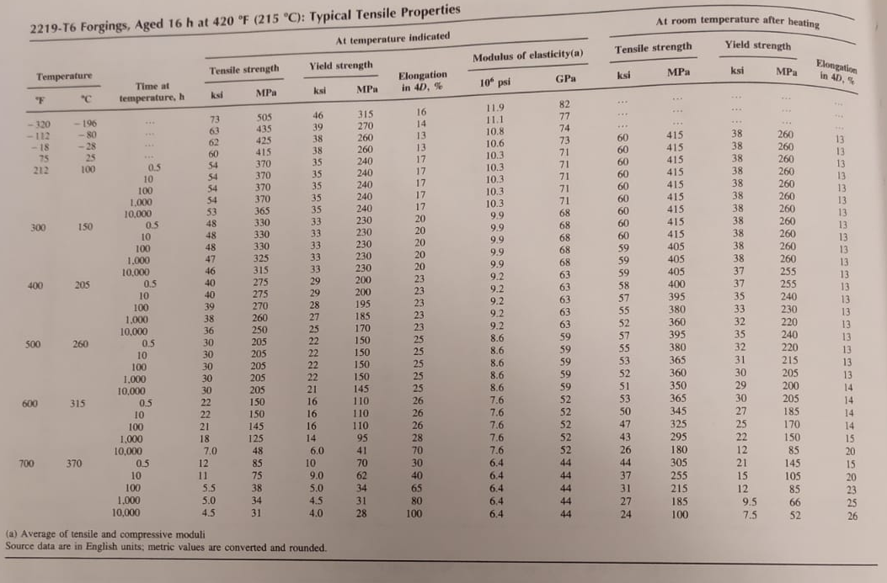
5083H0 (Standard properties)

