Muon collider international cooperation

WP7 Muon Collider Magnetic Systems

Task 3 Fast Ramped Accelerator

Mom “Material properties for accelerator Magnets” 23 November 2022

Participants: Fulvio Boattini (CERN), Luca Bottura (CERN), Marco Breschi (UNIBO), Herbert De Gersem (TUD), Nicholas Sammut (Uni Malta)

F. Boattini introduced the acceleration magnets basic technological requirements.
The main challenges are related to the very fast Bfield variation, in the order of 36kT/s and to the high field intensity required in the vacuum chamber, up to 2.2T.
In a resonant circuit, the Bfield oscillation can be expressed by an equivalent sinusoidal as shown in Figure 1. In that example the sinusoid equation is the following:

Therefore the soft magnetic materials should be characterized in the frequency range up to 1kHz and with very high field values in the range of 2T so already in saturation for the vast majority of them.

Figure 1: Sinusoidal equivalent of fast linear acceleration with a Tramp = 700us
N. Sammut explained the operation principle of equipment he has at the University of Malta (Figure 2). The system is designed to characterize small samples of magnetic materials in DC and therefore it cannot be directly used for the analysis described above.

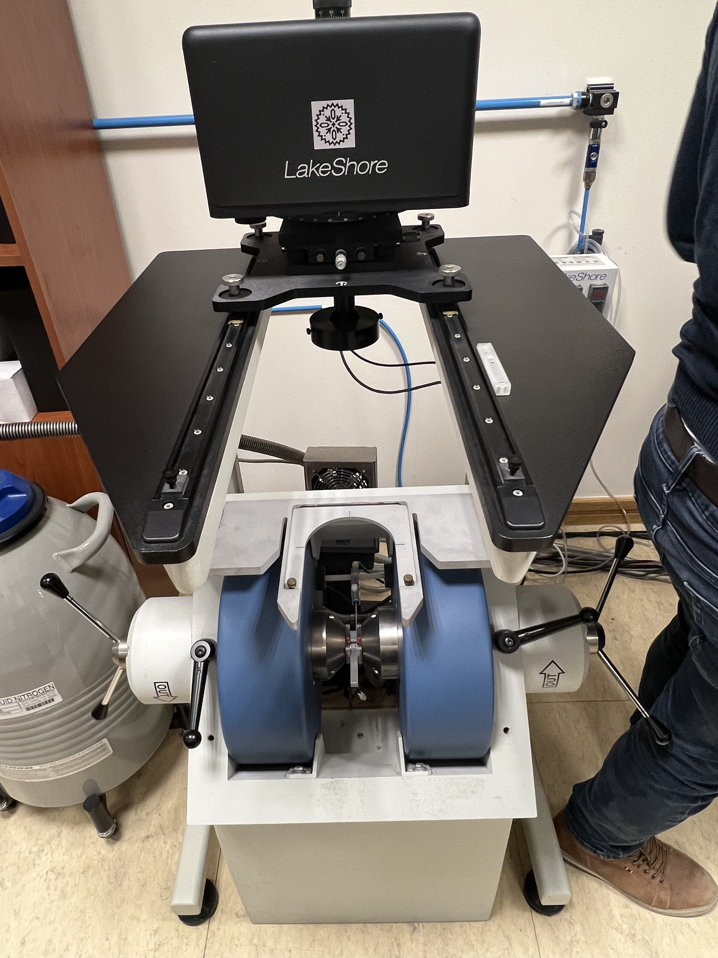Figure 2: Magnetic material characterization equipment
H. De Gersem and M. Breschi proposed different approaches whereby a suited model could be built and used with calorimeter approach, to directly measure the losses of a given magnetic material with the desired frequency and Bfield load, provided an appropriated power supply is available.
M. Breschi proposed to use a capacitor discharge type of supply similar to the one we are studying for the real application.
H. De Gersem proposed to investigate the scientific literature and find out how these measurements are normally performed.
F.Boattini proposed to have a joint cooperation on the subject. For example CERN could check if the power converter for the tests is already available on site (depending upon the required power and frequency…).
L. Bottura added that steel sheets samples of different materials may also be already available at CERN.
Action: Analyze literature and ask expert colleagues for suggestion on which is the most useful model to build for the characterization of the magnetic materials. Also CERN experts in magnetic measurements (Marco Buzio) can be consulted.
Who: M. Breschi, H. De Gersem, N. Sammut
When: We would like to organize a second meeting with proposals at the end of June

