Exercise Instrumentation
A cryogenic component requires a 100 W electrical heater for evaporating liquid helium at 4.2 K, the heater is made of a 25 ohm foil attached to the vacuum side of a cryogenic tank. The wire running in the vacuum space has a length of 2 m. Please calculate the minimum wire cross-section that will not allow a temperature rise above 50 K, assuming that the worst accidental condition occur at ambient temperature (293 K) and vacuum. To calculate the wire cross section, you can use the following equation:
$$-k(T).π.r^{2}.\frac{dT}{dx}=ρ(T).i^{2}.\frac{dx}{π.r^{2}}-2.π.(r+Δ).dx.ε.σ.\left(T^{4}-{T_{0}}^{4}\right)$$
Where T is the wire temperature, T_{o} is the ambient temperature, x is the longitudinal position along the wire, k is the thermal conduction, r is the wire radius, Δ the insulator thickness assumed to be 0.3 mm, $ρ$ the electrical resistivity, σ the Stefan Boltzmann constant and ε the emissivity assumed to be 0.9.
Consider using either copper wires (RRR 30) or manganin wires. Discuss advantages or disadvantages of either type of wire like thermal conduction, wire power loss, etc. What type of wire would you recommend for carrying 2 A?
Would there be a difference if a higher purity copper wire is used in what concerns the minimum cross section that avoids thermal run away in the worst conditions that are before cooling down under vacuum?
Values are available in tables or figures below.

Solution

Calculation for wire radius
The maximum temperature is reached when the derivative dT/dx = 0. The radius is obtained by finding the zero for the equation:
$$ρ\left(T\right).i^{2}.\frac{1}{π.r^{2}}-2.π.\left(r+Δ\right).ε.σ.\left(T^{4}-{T_{0}}^{4}\right)=0$$
The electrical conductivity is calculated by using the table that shows the temperature coefficient as follows:
$$ρ\left(T\right)= ρ\left(293\right)*(1+Tcoefficient*\left(T-293\right))$$
For copper and manganin the resistivity at 343 K is 2.00424*10^-8 [Ω.m] and 4.82048*10^-7 [Ω.m].
The current is calculated from the supplied power (100 W) and the heater resistance (25 ohm) and it is 2 A. It also means that a 50 V dc supply is being used.
By zeroing the equation, the radius for copper and manganin is respectively 0.000163 [m] or 0.163 [mm] and 0.00058 [m] or 0.58 [mm].
If you do not use a mathematical program for finding zeroes, the solution can be found by:
- Assuming that there is no insulation and finding the radius by using the equation that can be solved algebraically
- By using the radius found with no insulation use excel and make a table of the equation by varying the radius.
- The solution would be the radius that provides zero on the excel table.

Wires thermal load calculation.
The thermal load of the wires can be calculated by using the conduction integrals from 300 to 4 K and using 30 RRR copper and manganin. The total thermal load coming through one of the wires is respectively for copper and manganin is 0.0059 W and 0.0023 W. For supplying the electrical heater TWO wires are required, it means that the thermal load of the wires shall be duplicated, for copper and manganin the total thermal load is therefore respectively 0.012 W and 0.0046 W.

Wires electrical resistance.
In nominal conditions (it is when one side is at 4.2 K) the wire electrical resistance is difficult to calculate because it depends on the temperature profile.
For 30 RRR copper the resistance changes by a factor of 30 when the temperature is reduced. An upper boundary for the resistance can be estimated by assuming a wire resistivity provided by the value at 293 K; this yields a total series resistance for the wires (2 x 2m) of 0.8 ohm. Because a 50 Vdc supply is used the current is reduced to 1.94 A and the power dissipated by the heater is 93.9 W instead of 100 W.
The total power dissipated along the wires is 1.94 A * 0.8 ohm = 3 W
This is a gross overestimation of the wire resistance because for copper the thermal conductance is enhanced between 20 to 50 K and it can be expected that a significant part of the wire is colder and the overall resistance will be much lower.

Manganin case
For manganin a lower boundary can be calculated by assuming that the resistivity is the one shown for 10 K; note that the resistivity reduction is -12% that is extremely low when comparing the behavior of 30 RRR copper. For manganin the total series resistance for both wires is 1.59 ohm. This resistance is in series with the heater and because a 50 Vdc supply is used the current is reduced to 1.88 A and therefore the power supplied by the heater is 88.4 W instead of 100 W.
The total joule heating of the manganin wire is significant, it is 1.88 A * (1.59 ohm)^2 = 6.65W. It is difficult to estimate the proportion of the heat exiting from the cold and warm sides of the wires. The thermal conduction at 10 K is about 12 x lower than for 300 K and a temperature profile along the wire need to be calculated to determine the Joule heat reaching the heater.

Comments
By calculating the radius not to exceed a temperature of 50 K in worst conditions and the corresponding thermal conduction through the wire is would be tempting to propose the use of manganin to transport electrical current because the thermal power is lower when the current is switched OFF.
For applications that require precision on the dissipated electrical heat, probably copper is more suitable because the series resistance is much lower than the one that would have a manganin wire.
Mostly copper would be used because it is simpler to procure and alloy wires availability is more limited. As for the selection of the best sensor for a given application it is difficult to give an answer as to what would be the best wire material as it would depend on the requirements and how the wire is used.

Annex: data for copper and manganin

Resistivity data for selected materials at temperatures above 293 K
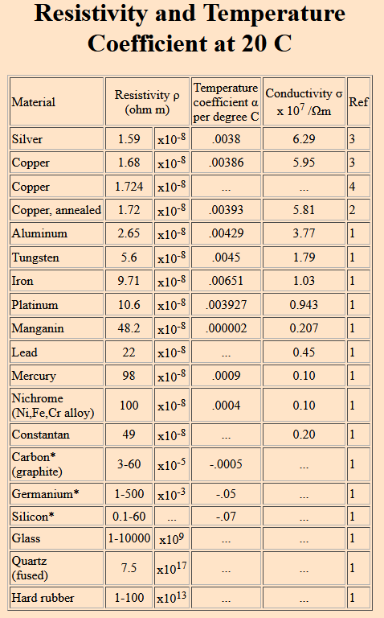

Cryogenic resistivity of selected alloys:
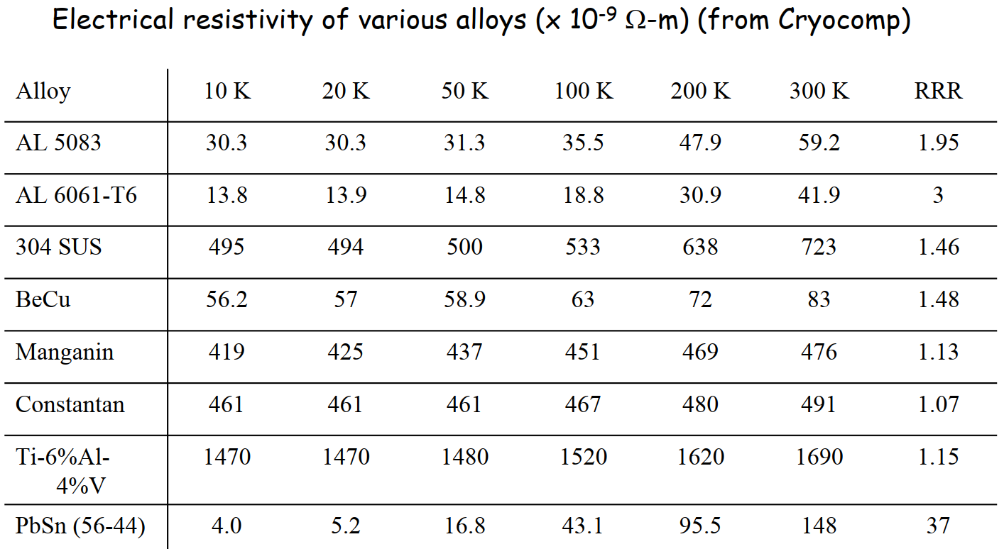

Copper resistivity:
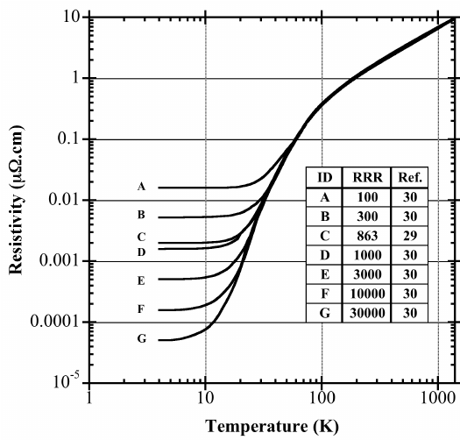

Themal conductivity integrals of selected materials:
