ISOLDE
Machine Supervisor last week |  |  | Lefteris Fadakis
Machine Supervisor this week |  |  | Alberto Rodriguez
Beam Scheduled
GPS | Yes | HRS |  | Yes |  | HIE-ISO |  |  | Yes
Beam Availability by Destination (AFT)
GPS | 99.3% | HRS |  | 100% |  | HIE-ISO |  | -
Facility Status
Summary | GPS  Users shared beam between two different experimental lines.  9 Lithium (Li) on GHM(IS659) and 75 Gallium (Ga) on IDS(IS668).  Proving once more the versatility of ISOLDE.  Both successfully took beam until the morning of Thursday the 6th.  Monday 10th new (used) target #534 in place  HRS  CRIS (IS737)  On Tuesday target #858 UC-Ta was installed.  Wednesday 5th  Using recommended beam tuning target temperatures, was not possible to get more than 60% through the Cooler with a set up done on the 23rd of May. They had 80%.  Thursday 6th  Increased target temperature for yield checks.  Got 85% through the cooler buncher. On different beam (59Co) instead of 39K  CRIS experiment used stable beam 39 Potassium (K) to fine tune their set up .  Friday 7th  Proton scan on 26Na and target yield checks.  We started suspecting that the Au mm had an issue. We tried all possible combinations but could not see Au.  Many thanks to Mia for staying late to finish the yields.  CRIS took 197Au around 21h00 and during the weekend.  Monday 10th  Had time to quickly check 39K set up with warmer target. Got 81% through the RFQ.  Sebastian took 197Au to the tapestation to clarify the composition.  CRIS had issues to see any Au. They decided to use 238U to improve the beam tune to their set up. Also visited 221Fr.  REX-HIE  Students from the Advanced Training School on Operations of Accelerators were profiting from learning how to operate and set up the LINAC.  Created a reference set up for A/q= 2.5 at 11.2 MeV/u
Issues | GPS  - Line Heating trip stopped beam production for 45 minutes. (06/06/24 04:17)  - Lost heating of target #534. Vacuum went off. Had to restart the heating  https://logbook.cern.ch/elogbook-server/GET/showEventInLogbook/4085370  - Lost heating when trying to increase the line heating from 250A to 300A (11/06/24 9a.m)  HRS  1 Picture = 1000 words  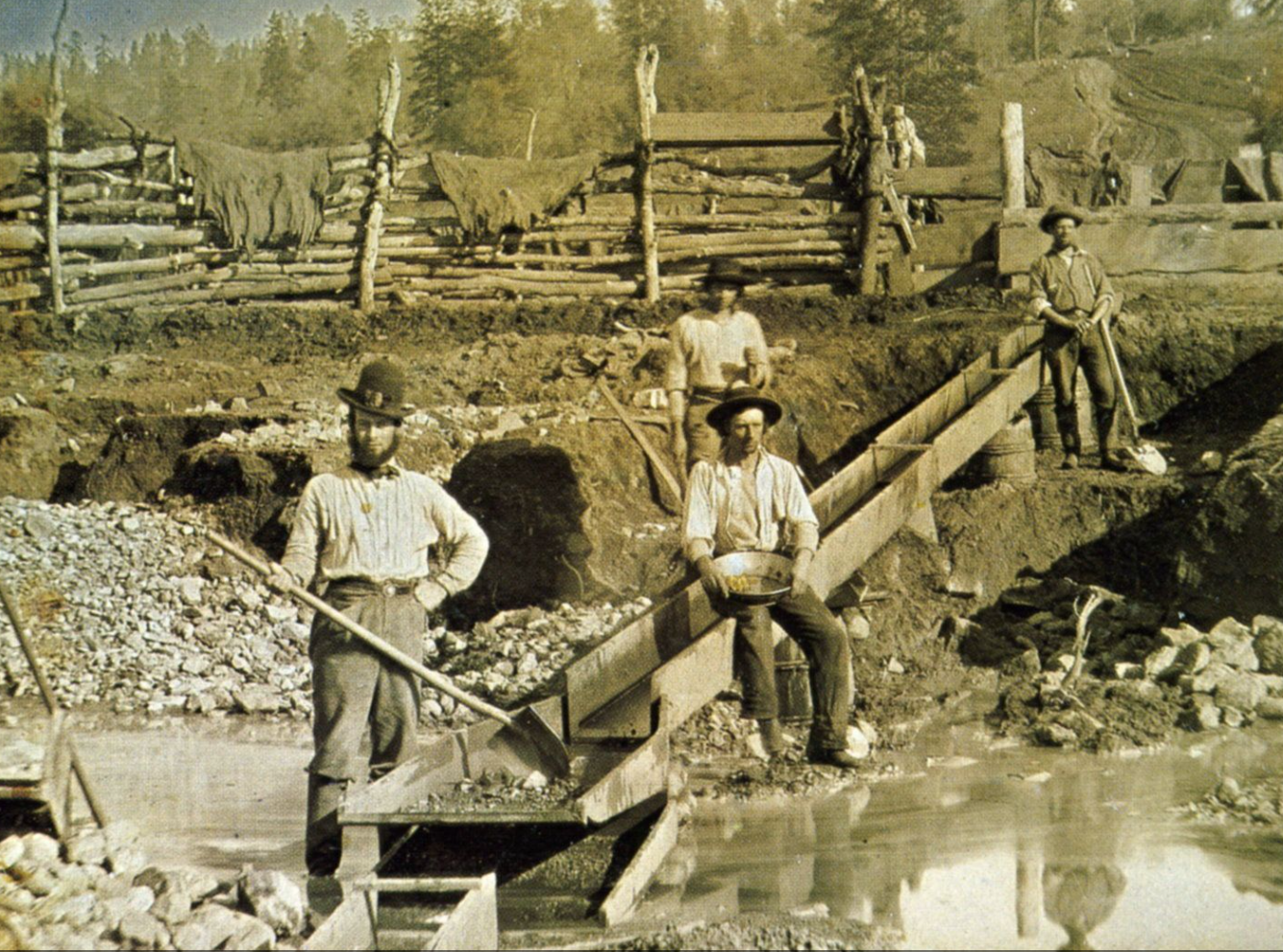  - Had to repeat the process of opening and closing the target shutter three times until the shutter was successfully opened and we could start the beam preparation.  - HT was stuck in 30kV. We had to reboot the FEC (CFX-170-mkisht1) to regain control. Note that the HT of GPS was not affected.  - Issue with RFQ power supplies. The FEC controlling them (cfc-170-rrfqc-iseg1) was off. First line had to come and replace it.  https://logbook.cern.ch/elogbook-server/GET/showEventInLogbook/4081735  - Issue with the Siemens PLC outside the RFQ cage (RA01.RFQC) It is very dim. This needs to be decommissioned.  https://logbook.cern.ch/elogbook-server/GET/showEventInLogbook/4081540  - Issue with the RFQ He bottle needle valve. I went up to 4000 on the valve and the pressure in HRS 40 did not become worse. Went inside the RFQ, the bottle still had 50bar. Only by the third time we tried to open-close the valve it did open, and we could see an effect.  https://logbook.cern.ch/elogbook-server/GET/showEventInLogbook/4081765  - Tuning with “Beam tunning” temperatures was very hard. Could not get more than 60% through the cooler. Tried 39K, 23Na(mm). Once TISD increased the temperature then 80% was achievable.  - Could not find Gold (Au) on any of the three mass markers(mm)  - Line heating power supply broke. EPC first line had to replace it.  General  Issue with vacuum application. GUI becomes unresponsive and we need to kill it and open again. [Ticket Open]  https://logbook.cern.ch/elogbook-server/GET/showEventInLogbook/4085275
Plans | GPS  Monday the 10th new target #534 Sn VD7 goes in place.  HRS  CRIS experiment beam tunes with stable 238U.  REX-HIE  Completion of the SRF cavities commissioning and continuation of beam commissioning
Intervention Request
Yes / No | Duration |  |  |  | Preferred date/time
Reason
Impact

