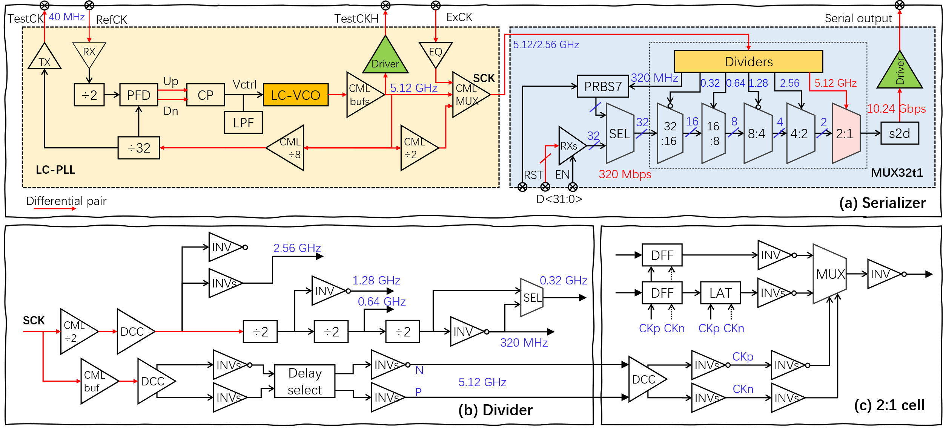
Figure 1. Schemes of the serializer
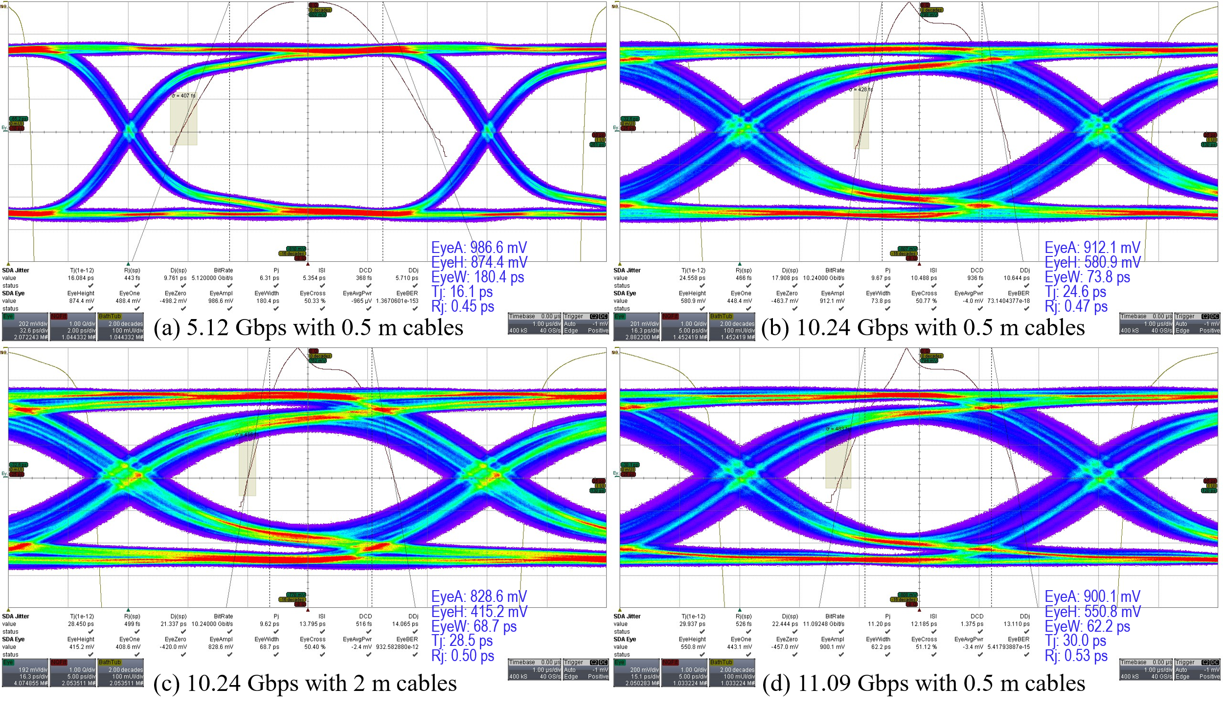
Figure 2. Eye-diagram performance

