Action Plan
  - Thesis internship 24/25 - CERN BBQ

Preface
In the fourth year of the Applied Physics program at the Amsterdam University of Applied Sciences, the student is required to complete an internship. For this, an action plan is written, which serves as preparation for the final portfolio required to complete the internship.
The project plan outlines the objectives and approach for the work to be carried out at CERN within the Beam Instrumentation group. It describes the tasks that will be undertaken to develop a recommendation on how the existing algorithm for obtaining the tune frequency can be improved for the beam that circulates in the LHC. This may be accomplished by experimenting with different algorithms and comparing their outcomes.
CERN, the European Organization for Nuclear Research, is home to the world's most powerful particle accelerator, the Large Hadron. CERN's purpose, based in Switzerland, is to investigate the universe's basic particles and drive scientific advances, including the discovery of the Higgs boson. CERN brings together researchers from all around the world to further our knowledge of matter and the forces that control it.
CERN's Beam Instrumentation group is responsible for ensuring the stability and precision of particle beams in the Large Hadron Collider. They design and maintain diagnostic tools that monitor various beam properties, including position, intensity, and tune frequency.

Contents
Preface 1
Contents 2
Tabel of Figures 3
Nomenclature 3
1. Introduction 4
1.1. Betatron oscillation 4
1.2. Signal reconstruction 6
1.3. $50$ Hz Harmonics 7
1.4. Digital twin 7
1.5. Existing code 8
2. Goal 9
2.1. Streamlining 9
2.2. Known issues 9
2.3. Comparison 9
2.4. Characterisation of BBQ systems 10
3. Research questions 11
3.1. Code optimization 11
3.2. BBQ characterisation 11
4. Methode 12
4.1. Numerical Method: 12
4.1.1. Steps for Optimization: 12
4.2. Experimental Method: 13
4.2.1. Steps for Testing: 13
4.2.2. Expected Outcomes: 13
4.2.3. Safety Measures: 13
4.3. Characterisation 14
5. Deliverables 15
5.1. Optimization 15
5.2. Characterisation 16
6. Bibliography 18
Appendix A: AI responsibility 19
Appendix B: Personal goals 20
Appendix C: Planning 21

Tabel of Figures
Figure 1: Block diagram of a BBQ system. [4] 4
Figure 2: This figure illustrates a quadrupole magnet used in the LHC for beam focusing. The magnetic field direction determines whether the beam is focused in the horizontal or vertical plane. [14] 4
Figure 3: The difference in beam focusing in the horizontal and vertical planes is due to the orientation of the magnetic fields from the quadrupole magnets. Each magnet focuses the beam in either the horizontal or vertical plane, depending on the magnetic field direction. By rotating the quadrupole magnets $90°$, the beam can be focused sequentially in both planes. 5
Figure 4: This figure illustrates a dipole magnet used in the LHC for bending of the beam and maintaining its circular trajectory. [14] 5
Figure 5: Comparison of two sampling scenarios: (1) sampling frequency equal to the oscillation frequency, leading to aliasing (green), and (2) sampling frequency at twice the maximum bandwidth, ensuring proper signal reconstruction (red). 6
Figure 6: Illustration of the relevant frequency spectrum, highlighting the usable region for signal analysis, where the observed frequency increases up to the revolution frequency before it starts to decrease, compared to the real frequency. 6
Figure 7: Ideal frequency spectrum showing a clear, distinct peak representing the tune. 6
Figure 8: Example of data pulled with the 50 Hz harmonics. 7
Figure 9: Example of a simulated tune spectrum, with artificial added 50. Hz harmonics. [10] 7
Figure 10: Flowchart explaining the working of the existing Python code. [13] 8
Figure 11: Tune peak filtered out due to an error in the window algorithm. [13] 9
Figure 12: Flow chart numerical methode. 12
Figure 13: Example graph of window placement in the data, illustrating how the window is positioned to capture the tune peak. 15
Figure 14: Example flow chart showing the workflow of the improved Python code, including the algorithms and their corresponding steps for processing data to extract the tune peak. 15
Figure 15: Example table of comparison of online and offline processed tune values from LHC 2025 run with modified parameters of the non-feedback BBQ system. 16
Figure 16: Grouped bar chart comparing the tune values extracted from the online and offline processing systems for different parameter adjustments. 16
Figure 17: Example table for characterisation of different BBQ systems. 16
Figure 18: Example of the bar chart to visualize the SNR of each BBQ system 17

Nomenclature
abbreviation | definition
BBQ | Base-Band Q
CERN | European Organization for Nuclear Research
dB | Decibel
FFT | Fast Fourier Transformation
LHC | Large Hadron Collider
Q | Tune
SNR | Signal-to-noise ratio

Introduction
In the Large Hadron Collider (LHC) at the European Organization for Nuclear Research (CERN), protons are accelerated to $99.9999991\%$ the speed of light. These protons are grouped together into bunches, and all the bunches circulating in the accelerator collectively form the beam. Each bunch contains approximately $1.15⋅{10}^{11}$ protons, and with up $2808$ to bunches in the LHC, the total number of protons in the beam can reach around $3.23⋅{10}^{14}$. [1] This beam undergoes betatron oscillations, repetitive transverse movements in horizontal and vertical planes. The number of these oscillations per turn is referred to as the tune (Q). Monitoring and adjusting the tune is crucial for ensuring beam stability and prolonging its lifetime. [2]
To achieve this, the LHC employs a system called Base-Band Q (BBQ). The BBQ system (Figure 1)consists of an electromagnetic pick-up, followed by a diode-based detection and acquisition system. It detects small modulations in the beam caused by intensity variations and betatron motion, converting these signals to a baseband frequency. In the LHC, this baseband frequency falls within the audible range, allowing for precise monitoring of the tune. [3] [4]
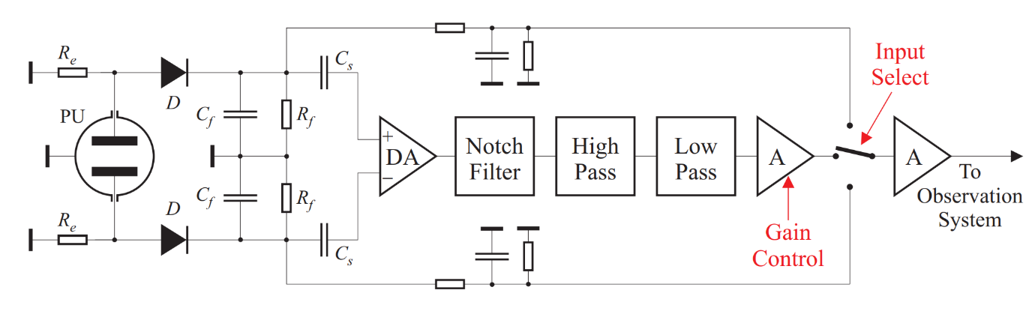
This method of finding the tune can increase the signal level. The frequency resolution can be measured in order of ${10}^{-5}$ and the amplitude sensitivity in order of $10$ nm. This is all achieved by using a simple piece of hardware. [3] [4]
Figure 1: Block diagram of a BBQ system. [4]

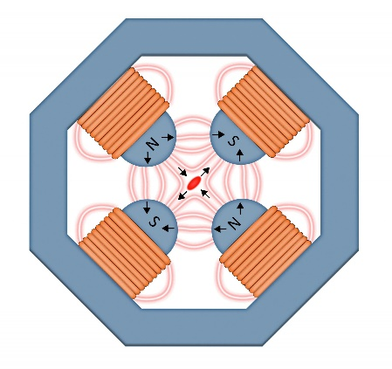
Betatron oscillation
Figure 2: This figure illustrates a quadrupole magnet used in the LHC for beam focusing. The magnetic field direction determines whether the beam is focused in the horizontal or vertical plane. [14]
The beam in the LHC ideally moves along a perfect circular path. However, in reality, it undergoes small deviations in the form of betatron oscillations. These transverse oscillations occur in charged particles due to the presence of quadrupole magnets. Quadrupole magnets are responsible for focusing the beam as it travels along the circular path, but they can only act in one plane at a time. Because the particles are charged the experience a force due to the Lorentz Force, which focuses the beam in one plane and defocussed the beam in perpendicular direction. As a result, a single quadrupole magnet can only focus the beam in either the horizontal or vertical plane, depending on the orientation of its magnetic field.
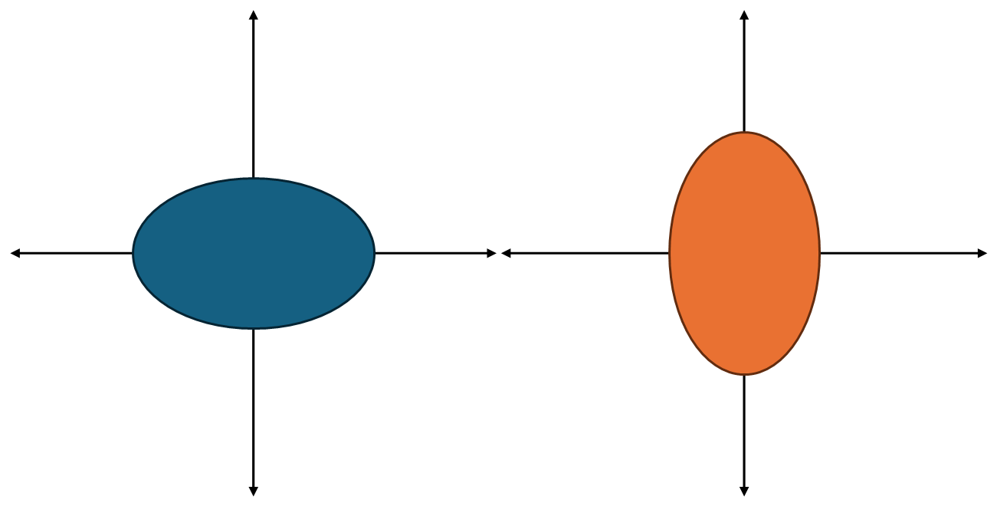
To ensure that the beam remains stable and does not defocus in one plane, the magnets rotate by 90°, alternating the direction of the magnetic field. This rotation allows the beam to be focused in both the horizontal and vertical planes as it moves through the accelerator ring. However, because the quadrupole magnets focus the beam sequentially in alternating directions, the shape of the beam changes over its cycle. This dynamic adjustment leads to the observed betatron oscillations, as the beam constantly adapts to maintain stability while being manipulated by the alternating quadrupole magnets.
Figure 3: The difference in beam focusing in the horizontal and vertical planes is due to the orientation of the magnetic fields from the quadrupole magnets. Each magnet focuses the beam in either the horizontal or vertical plane, depending on the magnetic field direction. By rotating the quadrupole magnets $90°$, the beam can be focused sequentially in both planes.
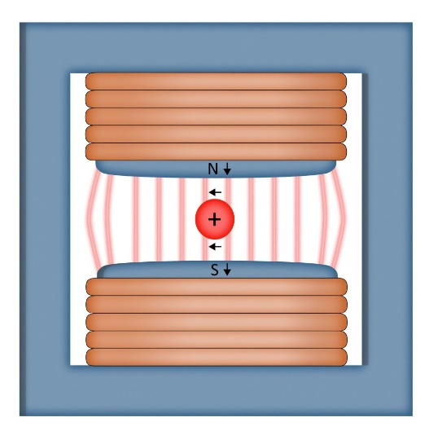
In addition to the quadrupole magnets, dipole magnets play a key role in guiding the beam along the LHC’s circular path. While quadrupole magnets focus the beam, dipole magnets are responsible for bending the beam’s trajectory, keeping it confined to the ring. Dipole magnets generate a magnetic field that bends the path of the charged particles, allowing them to stay on their circular trajectory. The LHC contains thousands of dipole magnets arranged in a precise configuration that controls the beam’s radius of curvature.
Figure 4: This figure illustrates a dipole magnet used in the LHC for bending of the beam and maintaining its circular trajectory. [14]
Although dipole magnets do not directly contribute to betatron oscillations in the same way quadrupole magnets do, they are essential for maintaining the beam’s overall trajectory. Any misalignment in the dipole magnets or imperfections in their field strength could cause the beam to deviate from the ideal circular path, potentially amplifying betatron oscillations or leading to beam instability.
Besides the magnetic fields from the quadrupole and dipole magnets, several other phenomena can influence betatron oscillations in the LHC. These include beam intensity, where space charge effects from high particle density can distort the beam; beam-beam interactions, which occur when multiple particle bunches interact with each other, affecting their trajectories; non-linearities in the magnetic system, which can introduce additional oscillation modes; and chromaticity, where variations in the magnetic field strength due to changes in particle momentum can alter the oscillation behaviour. All these factors contribute to the complex dynamics of betatron oscillations in the accelerator.
These betatron oscillations are crucial to understanding and controlling beam dynamics in the LHC, as they directly affect beam stability, focusing, and ultimately, the quality of particle collisions. As the beam is continuously manipulated by these alternating magnetic fields, the betatron oscillations represent the natural adjustments the beam makes to remain within the desired parameters. While these oscillations are an inherent result of the beam’s interaction with the magnetic fields, they must be carefully managed to prevent excessive oscillation amplitudes, which could lead to beam losses or degradation in the quality of the particle collisions.

Signal reconstruction
Right after the oscillation of the beam is picked up by the BBQ, the signal gets amplified, so that any amplitude of noise that is picked up when the signal is traveling to the computer is minimal compared to the oscillation signal. This unfortunately does not prevent the $50$ Hz harmonics.
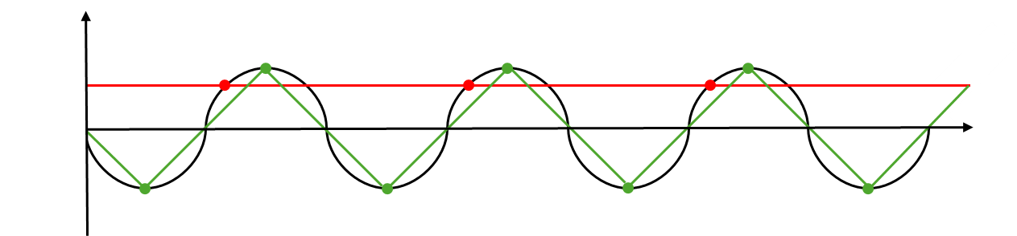
The oscillations are detected and measured as a DC signal; to reconstruct the signal as a digital oscillation the minimum sample frequency needs to be calculated If the sample rate is equal to the oscillation a DC signal forms as the digital reconstruction. To get a frequency back from the reconstruction the sample rate needs to be at least twice the maximum bandwidth (Figure 5). This can be calculated by using the Nyquist theorem [5] [6]. Its two times the max frequency that is in the sample.
Figure 5: Comparison of two sampling scenarios: (1) sampling frequency equal to the oscillation frequency, leading to aliasing (green), and (2) sampling frequency at twice the maximum bandwidth, ensuring proper signal reconstruction (red).
The spectrum of interest for determining the tune is typically between $0$ Hz and $f_{rev}/2f$, where $f_{rev}$ is the revolution frequency. The revolution frequency is defined as the point at which the observed frequency $f_{obs}$ ​ is twice the real frequency $f_{real}$​. Beyond this point, the observed frequency $f_{obs}$ ​ decreases instead of continuing to increase, marking the boundary where the expected behaviour of the frequency spectrum changes (Figure 6). [7]
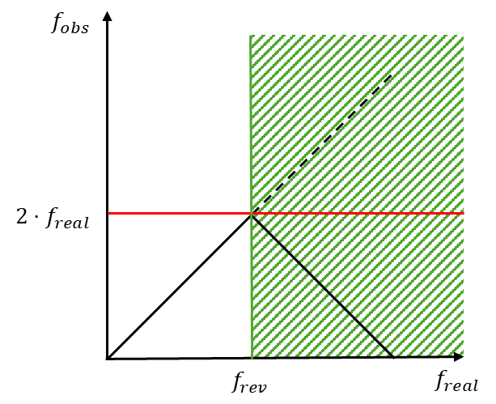
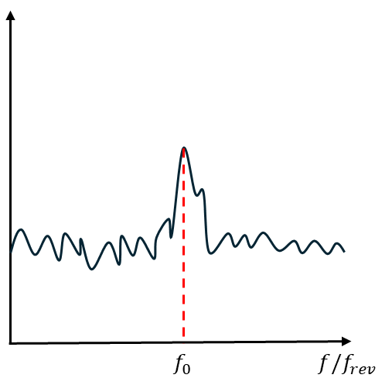
Once this relevant frequency range is identified, a Fast Fourier Transform (FFT) is applied to the reconstructed signal. To determine the tune, the peak frequency is located and then divided by the reference frequency. This ratio gives the normalized tune value. Ideally, the resulting spectrum should have a clear, distinct peak corresponding to the tune frequency of the beam (Figure 7). The reality is that frequency spectrum is pulled by a $50$ Hz harmonic. [7]
Figure 6: Illustration of the relevant frequency spectrum, highlighting the usable region for signal analysis, where the observed frequency increases up to the revolution frequency before it starts to decrease, compared to the real frequency.
Figure 7: Ideal frequency spectrum showing a clear, distinct peak representing the tune.

$50$ Hz Harmonics
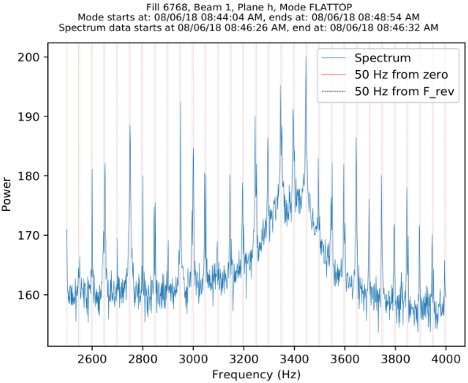
A persistent challenge in tune estimation arises due to unwanted $50$ Hz harmonics in the measured signal (Figure 8). The harmonic origin is unclear, but it introduces periodic interference in the BBQ spectrum. Since they appear near the betatron tune, they can distort the measured values, leading to instability in the tune feedback system [8] [9]. In some cases, the estimated tune locks onto a nearby harmonic or oscillates between neighbouring harmonics, compromising the reliability of the measurement.
Figure 8: Example of data pulled with the 50 Hz harmonics.
While existing filtering and signal processing techniques help reduce these effects, they are not always sufficient to prevent the tune algorithm from being affected by these disturbances. The original tune algorithm uses a sequence of filters and averaging techniques, which reduce the impact of the $50$ Hz harmonic on the final value. But the tune can oscillate between the neighbouring $50$ Hz, and the algorithm is not constructed for this. Thus, the algorithm is not ideal for finding the real value of the tune. [10]
To resolve this problem, two other algorithms were proposed. Both work on the same principle of cutting out the $50$ Hz harmonics but have a different technique to fill the created gaps. A Weighted Moving Average and a Gaussian Process have been tested. They were tested by using simulated data. The Weighted Moving Average performed the best, but the Gaussian Process also worked well enough that it could also implemented. [10]

Digital twin
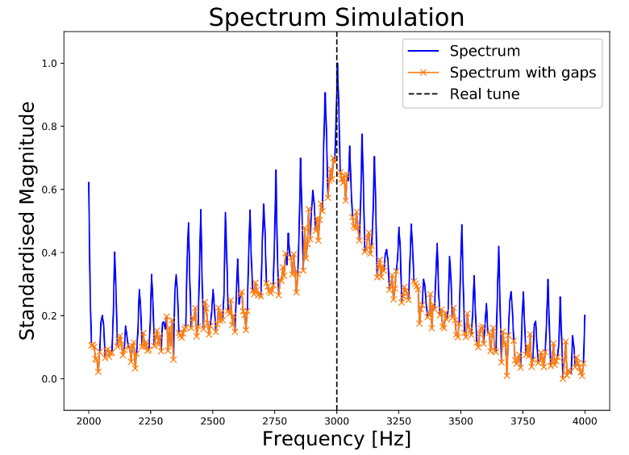
The exact value of the tune cannot be known when working with actual experimental data. To evaluate the accuracy of the data processing, simulation data is used. This data simulates the frequency spectrum of a second-order system, where the value of the tune is known. The spectrum has a resonant frequency and a damping factor that controls the width of the resonance. The resonant frequency corresponds to the tune value. To simulate the beam’s frequency spectrum, a Monte Carlo approach was employed to sample the resonant frequencies and damping factors. Artificial 50 Hz harmonics were then added to the spectrum (Figure 9). This simulation setup provides a controlled environment to test the accuracy of the processing before applying it to real data. [11]
Figure 9: Example of a simulated tune spectrum, with artificial added 50. Hz harmonics. [10]

Existing code
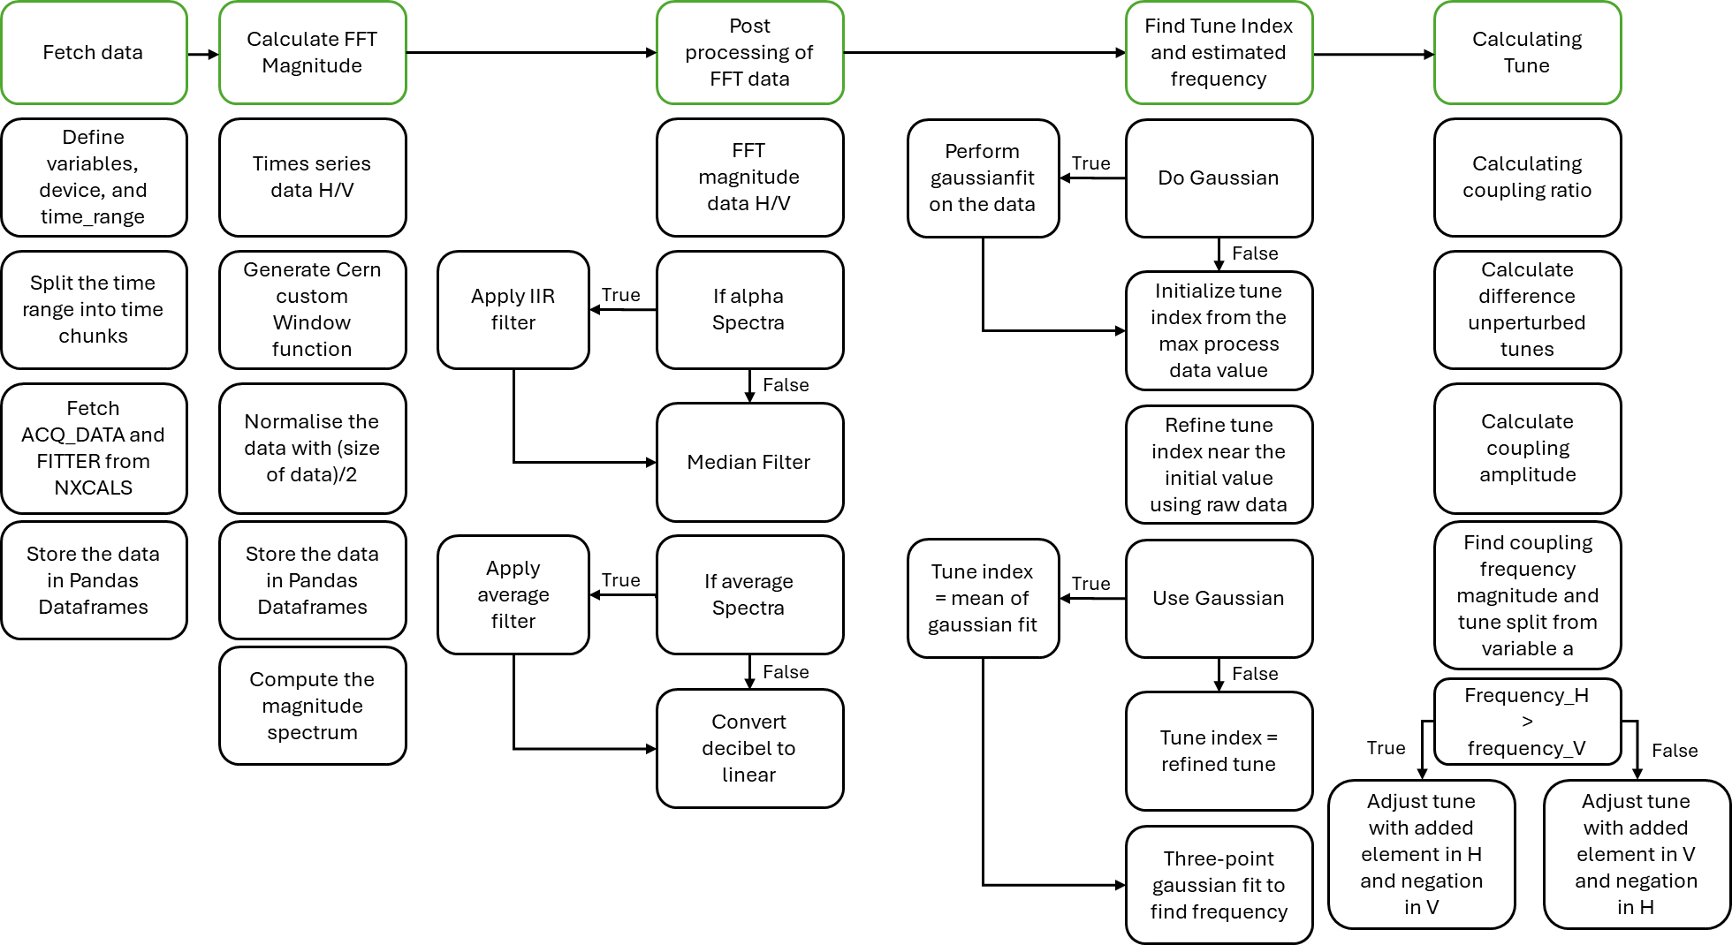
The flowchart (Figure 10) gives an overview of the current Python code's [12] workflow, which is focused on processing frequency data. The procedure starts with retrieving data and establishing relevant parameters, then segmenting the time range and storing it in an organized manner. It then computes the FFT magnitude using window functions and filtering methods. The post-processing stage involves further filtering and transforming the data to a more appropriate format. The code then determines the tune index using Gaussian fitting and refines the result depending on the processed data. Finally, the tune is determined, taking into consideration frequency components and coupling effects to ensure precise frequency estimates. [13]
Figure 10: Flowchart explaining the working of the existing Python code. [13]

Goal
The main objective of this internship is to optimize the offline Python script, which is based on the online processing of BBQ data. This includes recreating the filtering process, algorithms, and tune value calculation in an offline environment. This overall objective is broken down into three specific goals.

Streamlining
The first goal is to optimize the existing Python script by streamlining its functions and improving its accuracy. This includes removing unnecessary functions such as the conversion of decibel (dB) to linear, which applies a linear filter to the dB values of the frequency spectrum. These functions increase execution time without contributing to the tune peak determination. By cleaning up the code and eliminating inessential operations, the processing time will be reduced, and overall efficiency will be improved.
The modified Python script must outperform the existing code in determining the tune frequency with greater accuracy, when tested against known tune values. This accuracy will be tested using simulated data from the digital twin, where the tune values are already known. Additionally, an important part of this process will be optimizing the signal-to-noise ratio (SNR), ensuring a clearer and more precise tune peak for reliable data analysis.

Known issues
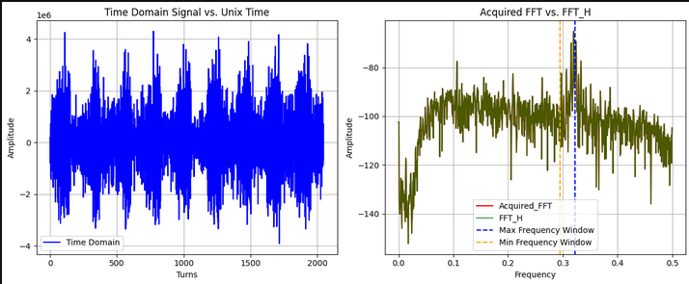
The current code uses a window to filter the frequency spectrum, focusing on the region where the tune peak is expected based on parameters from BBQ systems around the LHC and its booster accelerator. The window serves two purposes: speeding up the tune finding process by excluding unnecessary data and cutting out noise from certain regions of the spectrum where the tune cannot physically exist. However, the window algorithm is unreliable, sometimes including noise or filtering out the tune peak (Figure 11). The updated algorithm will refine the window placement to exclude noise while preserving the tune peak. The effectiveness will be tested using simulated data with known tune values to ensure the updated script outperforms the existing one.
Figure 11: Tune peak filtered out due to an error in the window algorithm. [13]

Comparison
Once the Python code has been optimized, the next step is to test the accuracy of tune determination by adjusting parameters in the non-feedback BBQ systems. This will involve modifying parameters in either the digital twin or the real LHC data from the 2025 run, which will begin shortly. By altering these parameters, the effect on the tune peak extraction process can be evaluated.
Unlike the previous two goals, this stage is exploratory and does not require the code to meet a strict accuracy threshold. Instead, the objective is to observe how variations in system parameters influence the tune extraction process.

Characterisation of BBQ systems

Research questions

Code optimization
"What modifications are required in the existing Python script to accurately replicate the online processing of the peak tune value in an offline environment using data collected by the BBQ system in the LHC?"

Sub-questions
To answer the main question, several steps need to be taken. These steps are outlined as sub-questions below, each accompanied by a hypothesis that should explanation of how they contribute to answer the main question:

- What improvements can be made to streamline the existing Python code for better efficiency?
By removing unnecessary functions (such as the dB to linear conversion) and optimizing the overall structure of the code, the execution speed of the Python script will improve, leading to a reduction in processing time and an increase in system reliability.

- How can the known issues in the existing code be corrected to improve its accuracy?
The existing code's issues, such as unreliable filtering and inaccurate placement of the window on the frequency spectrum, can be addressed by refining the window algorithm. By correctly identifying the BBQ system parameters and adjusting the filtering logic, the accuracy of the tune peak detection and SNR will improve.

- How does the improved Python script perform when tested on new data from the 2025 LHC run, with modified parameters in the non-feedback BBQ systems?
By testing the improved Python script on new data from the 2025 LHC run, where parameters of the non-feedback BBQ systems have been adjusted, its accuracy can be evaluated. This analysis assesses the effectiveness of the modifications and identify areas for further refinement.

BBQ characterisation
After addressing the main question and optimizing the code, the next step is to characterise the signal processing performance of the eight different BBQ systems, with the imporved. To achieve this, the following question has been formulated:
“How do the eight operational BBQ devices in the LHC differ in their signal processing performance, and what factors contribute to these differences?”

Methode

Numerical Method:
The first part of the work involves optimizing the existing Python script, which processes data from the BBQ system. The aim is to improve efficiency by removing unnecessary functions that slow down the execution without contributing meaningfully to the data processing. One such function is the linear filter applied to the dB spectrum, which will be removed.

Steps for Optimization:
The following steps outline the process for optimizing the Python script (Figure 12).
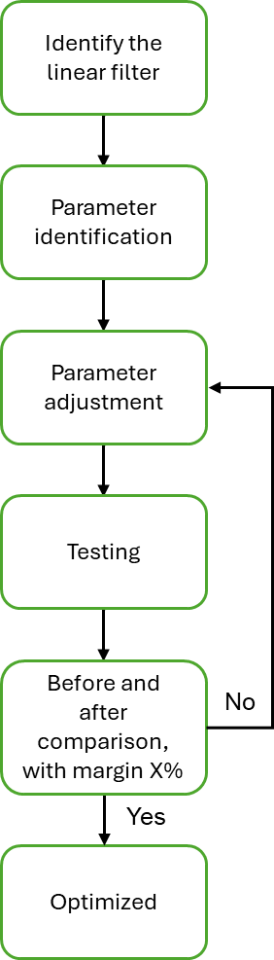
- Identify the dB to linear conversion: The function that applies a linear filter to the dB spectrum will be removed since it does not contribute to the accurate determination of the tune peak.
Figure 12: Flow chart numerical methode.
- Parameter identification: The sections of the code and the parameters dependent on the linear filter need to be identified. These parameters must be adjusted to ensure the script operates correctly after removing the filter.
- Before-and-after comparison: The performance of the optimized Python script will be evaluated using simulated data from the digital twin to determine its accuracy. Five random time samples from five randomly selected simulated data fills will be processed, and the results will be compared. If the extracted tune values fall within a predefined margin, the optimized script will be considered valid.
The SNR will be assessed using data from the LHC 2024 run. Five random time samples from five different LHC 2024 run fills will be analysed. If the signal-to-noise of the optimized script is equal to or lower than that of the original code, it will be considered an improvement.
- Review of the Window algorithm: After the linear filter removal, the window algorithm will be reviewed. The placement must also guarantee that the tune peak falls within the bounds of the window, preventing it from being filtered out. Once adjustments are made, the new code will be tested similarly to how the linear filter removal was tested.
These are the known issues at the time of writing, but new problems may arise during the optimization process. These will be addressed as they occur in consultation with D. Alves and others.

Experimental Method:
Once the Python script has been optimized, or if time constraints dictate, the next step will be to test the code using data from the LHC 2025 run. This experiment aims to validate the accuracy of the optimized script by adjusting the parameters of the non-feedback BBQ systems and observing their impact on the offline processing of the tune peak determination.

Steps for Testing:
- Test with Real LHC 2025 Data: After the code is optimized, the Python script will be applied to real data from the LHC 2025 run. During this phase, the parameters of the non-feedback BBQ systems will be adjusted, and the effect of these changes on offline tune peak detection will be observed.
- Accuracy Validation: The accuracy of the tune peak detection will be assessed by comparing the results from the offline optimized Python script to online processed, obtained from the LHC 2025 run. The comparison will help determine if the script is correctly identifying tune peaks after the parameter adjustments.

The goal is to ensure that the optimized Python code performs accurately when tested with both simulated and real-world data. If successful, this will confirm the improved performance of the script and its ability to accurately extract tune peak values, even after adjusting parameters in the non-feedback BBQ system.

Safety Measures:
Since this experiment is focused on data processing and will be conducted within the LHC control room, there are no direct physical risks associated with the work. However, precautionary measures will be taken to avoid interfering with LHC operations or other systems. Coordination with the control room team will be essential to ensure that the testing process does not disrupt the accelerator's functioning or data collection.

Characterisation
The goal of this method is to characterize the eight operational BBQ devices in the LHC, focusing on their signal processing performance. This characterisation will provide insights into how the devices differ in their ability to detect and measure the tune of the beam, and which factors contribute to these differences. The method for characterisation will be refined at a later stage. The process consists of the following steps:
- Data Collection: Data from each of the BBQ systems will be collected, focusing primarily on the LHC 2024 run. To ensure comparability, the data will be selected under similar beam conditions across all systems. Historical data from previous runs may also be analysed to observe any long-term performance trends or inconsistencies. This collection will include raw signal data and processed tune values.

- Tune Value Comparison: After collecting the data, the extracted tune values from each BBQ system will be compared. The percentage differences between the systems will be calculated and analysed to identify any systematic deviations. Particular attention will be paid to cases where discrepancies in tune estimation have been reported, such as the presence of $50$ Hz harmonics or other noise sources that may have interfered with the measurements. The comparison will allow us to determine whether any BBQ system consistently underperforms or shows notable discrepancies.

- SNR Analysis: The SNR of each BBQ system will be analysed in-depth to evaluate how well the systems filter out noise, especially from strong $50$ Hz harmonics. This analysis will identify which BBQ systems are more effective in isolating the tune peak from external noise, and which may have trouble with this due to their filtering capabilities or sensitivity to environmental factors. The SNR for each system will be measured to check if the system can maintain accurate tune detection despite noise interference.

- Examination of System Parameters: In addition to the tune value comparison, a deeper look into the individual parameters for each BBQ system will be conducted. This includes investigating calibration settings such as gain, phase response, frequency resolution, and sampling rate. These parameters can influence the accuracy of the tune measurements, so it is important to examine if any settings are miscalibrated or differently tuned in various BBQ systems. Additionally, external environmental factors such as temperature variations and electromagnetic interference will be considered as they may impact the consistency of the systems' performance.

- Characterisation Results: After analysing the tune value differences, SNRs, and system parameters, the differences in performance across the eight BBQ systems will be characterized. The results will highlight which factors contribute to variations in tune measurements, such as differences in the systems' configurations, signal processing abilities, or environmental influences.

Deliverables

Optimization
The deliverables for this project will include an improved Python script with full documentation. The documentation will detail all modifications made to the script, including the removal of the linear filter and adjustments to the window algorithm and how they have improved the accuracy in tune peak determination and the damping of the SNR.

After implementing improvements to the Python code, a comparison will be made between the extracted tune values of a dataset where the tune is already known for both the horizontal and vertical tune. This will help determine the accuracy of the improved code. The accuracy assessment will be performed after each major fix, including the removal of the linear filter and the optimization of the window algorithm. Additionally, a final comparison will be conducted between the original code and the fully improved version. These comparisons will contribute to answering sub-questions one and two by demonstrating the effectiveness of each modification.

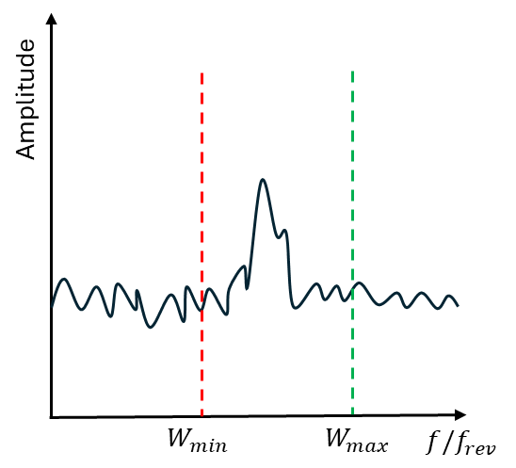
To further validate the window algorithm, an additional graph will be provided as an example of how the window is placed within the data (Figure 13). This will be followed by a table that quantifies the placement error of the window for both the horizontal and vertical tune. This analysis will illustrate the improvements in accuracy and reliability of the windowing method.
Figure 13: Example graph of window placement in the data, illustrating how the window is positioned to capture the tune peak.

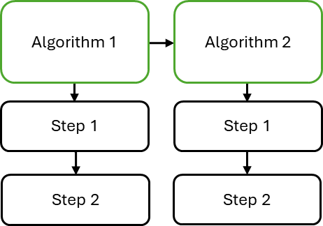
A flowchart (Figure 14) will be created to illustrate the functioning of the new and improved Python code. The flowchart will outline the different algorithms used in the script and explain the steps each algorithm follows. This visualization will provide the detailed information requested by CERN and will also contribute to answering sub-questions one and two by clarifying how the processing has been improved.
Figure 14: Example flow chart showing the workflow of the improved Python code, including the algorithms and their corresponding steps for processing data to extract the tune peak.

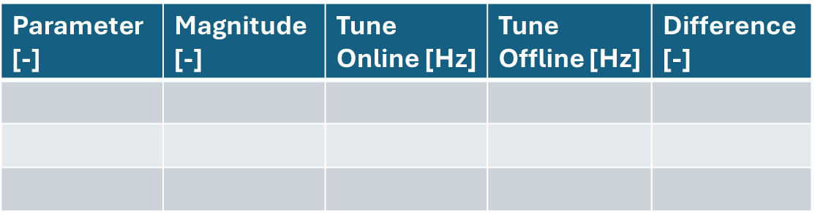
For the last sub-question, a table will be provided to show how the extracted tune peak changes when different parameters of the non-feedback BBQ system are modified. This table (Figure 15) will include the specific parameter that was changed, the magnitude by which it was adjusted, the resulting tune values from both the online and offline processing, and the difference between them. This comparison will highlight how well the improved offline processing aligns with the online system and will serve as a key validation step for the improved methodology.
Figure 15: Example table of comparison of online and offline processed tune values from LHC 2025 run with modified parameters of the non-feedback BBQ system.

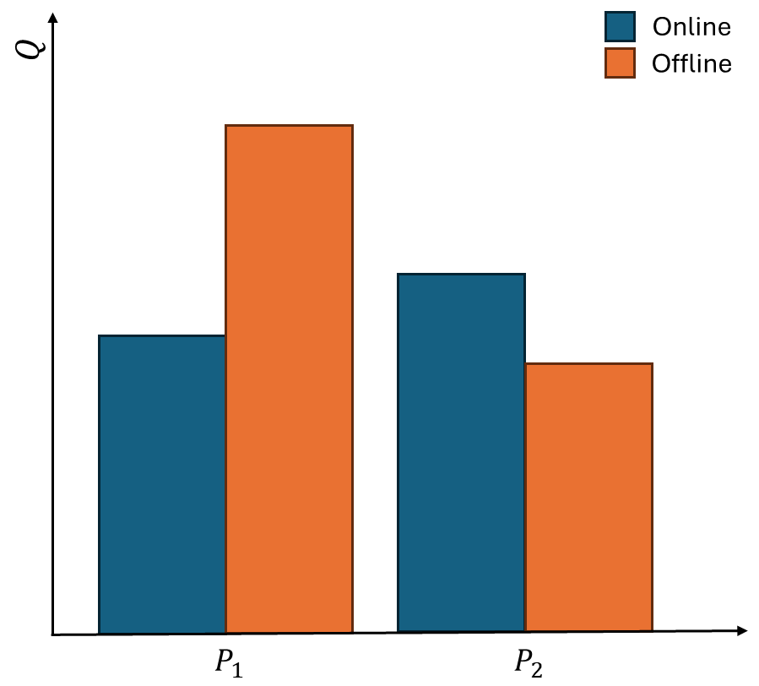
In addition to the table, a grouped bar chart will also be used to visually compare the tune peaks extracted from the online and offline processing systems. This chart (Figure 16) will display the tune values for each modified parameter, with distinct bars for the online and offline results. The X-axis will represent the different parameters that were adjusted, while the Y-axis will show the corresponding tune values. This visualization provides a clear and direct comparison, making it easier to identify how well the offline processing aligns with the online system. By using the grouped bar chart alongside the table, a more intuitive and comprehensive validation of the improved offline Python script is achieved, offering further insight into its effectiveness across various parameter changes.
Figure 16: Grouped bar chart comparing the tune values extracted from the online and offline processing systems for different parameter adjustments.

Characterisation
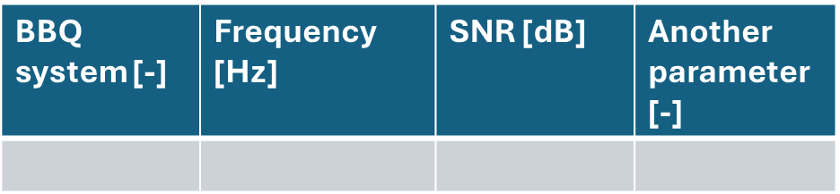
For the follow-up research, a Performance Comparison Table will be used to present the differences in the tune values extracted from each BBQ device. This table will display the tune values for each device, along with the calculated percentage differences between them. The purpose of this table is to clearly illustrate how the tune values compare across the different BBQ systems, highlighting any deviations or discrepancies that may exist. The table will focus on parameters such as the frequency of the tune peaks, allowing for a direct comparison between the systems under similar beam conditions. This comparison will help identify whether any BBQ system consistently underperforms or shows significant discrepancies in its measurements. By using this table, it will be able to compare the tune values across devices directly and identify any system performance issues, such as calibration errors or external noise interference. This method provides a precise numerical comparison and serves as a foundational component for analysing the BBQ systems' effectiveness.
Figure 17: Example table for characterisation of different BBQ systems.
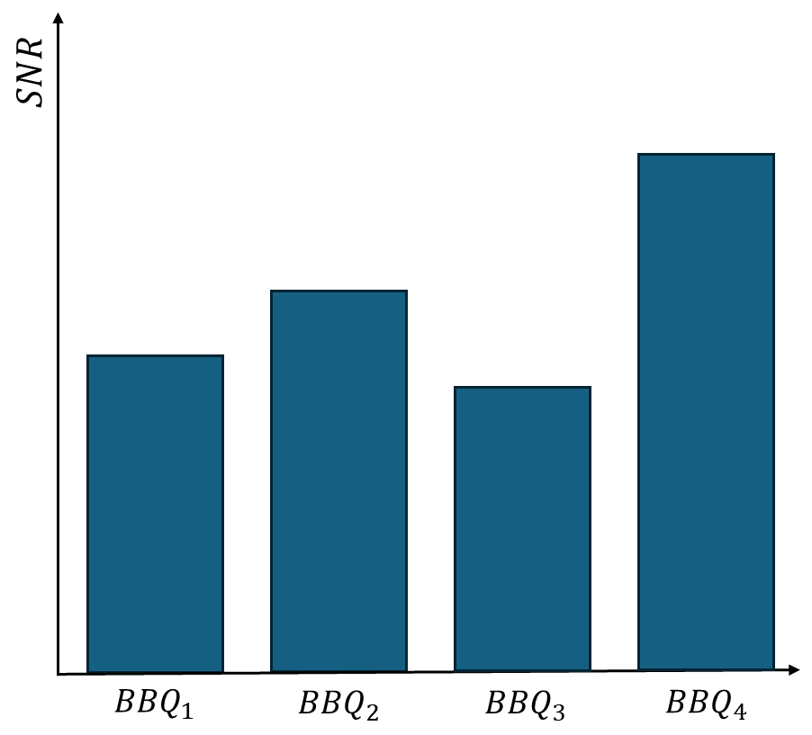
To complement the Performance Comparison Table, a grouped bar chart will be used to visually represent the SNR for each BBQ device. This chart will display the SNR values for each BBQ device, with distinct bars for each device. The X-axis will represent the different BBQ devices, while the Y-axis will show the corresponding SNR values (in decibels). Each group of bars will compare the SNR between different BBQ systems under the same beam conditions, providing a clear visualization of how effectively each device isolates the tune signal from external noise. This grouped bar chart will be valuable in assessing the noise-filtering capabilities of each BBQ system, especially in identifying devices that perform better in isolating the tune peak from harmonics or environmental interference. By using the grouped bar chart, the SNR differences across BBQ devices will be immediately apparent, allowing for an intuitive and direct comparison of each system’s performance in noisy conditions. This approach will enhance the understanding of how well the BBQ systems filter noise and identify any potential issues with environmental interference.
Figure 18: Example of the bar chart to visualize the SNR of each BBQ system

Bibliography

[1] | “LHC beams,” [Online]. Available: https://lhc-machine-outreach.web.cern.ch/beam.htm.
[2] | S. Baird, “Accelerators for pedestrians,” CERN, Geneva, Switzerland, 2007.
[3] | M. Gasior and R. Jones, “High sensitivity tune measurement by direct diode detection,” CERN, Geneva, Switzerland, 2005.
[4] | M. Gasior and R. Jones, “The principle and first results of betatron tune measurement by direct diode detection,” CERN, Geneva, Switzerland, 2005.
[5] | “Nyquist–Shannon sampling theorem,” Wikipedia, 18 02 2025. [Online]. Available: https://en.wikipedia.org/wiki/Nyquist%E2%80%93Shannon_sampling_theorem#External_links. [Accessed 19 02 2025].
[6] | “Nyquist Sampling Theorem,” GeeksForGeeks, 24 02 2024. [Online]. Available: https://www.geeksforgeeks.org/nyquist-sampling-theorem/. [Accessed 27 02 2025].
[7] | D. Alves, Interviewee, Signal reconstruction. [Interview]. 17 02 2025.
[8] | L. Grech, G. Valentino and D. Alves, “Application of reinforcement learning in the LHC tune feedback,” Frontiers in Physics, vol. 10, 2022.
[9] | R. J. Steinhagen, “LHC Beam Stability and Feedback Control,” CERN, Geneva, Switzerland, 2007.
[10] | L. Grech, G. Valentino and D. Alves, “An alternative processing algorithm for the tune measurement system in the LHC,” JACoW, Santos, Brazil, 2020.
[11] | L. Grech, G. Valentino and D. Alves, “A Machine Learning Approach for the Tune Estimation in the LHC,” Machine Learning and Accelerator Technology, vol. 12, no. 5, p. 197, 2021.
[12] | A. Lauritsen, “FFTDataProcessor,” CERN, Geneva, Switzerland, 2024.
[13] | A. Lauritsen, Offline Analysis of the Tune measurement, Geneva, Switzerland: CERN, 2025.
[14] | J. Pinson, “The power of attraction: magnets in particle accelerators,” Fermilab, 19 03 2020. [Online]. Available: https://news.fnal.gov/2020/03/the-power-of-attraction-the-use-of-magnets-in-particle-accelerators/. [Accessed 05 03 2025].

Appendix A: AI responsibility
For writing this Action Plan, AI, specifically ChatGPT, was used. It was applied in various ways, including checking spelling, grammar, vocabulary, and structure. Each heading was reviewed by ChatGPT to ensure that the text is written correctly, the word choice is appropriate, and the structure is clear and consistent.

Appendix B: Personal goals
- Goal: Improve Code Writing and Algorithm Development
Specific: Improve my Python coding skills by optimizing the BBQ data processing script, particularly focusing on refining algorithms such as the windowing algorithm and filtering techniques. Measurable: Successfully optimize at least 2 major algorithms (filtering and windowing) in the Python script, ensuring that the code processes simulated and real data with higher accuracy and efficiency. Achievable: Review existing code, understand the current algorithms, and research better alternatives for these processes. Test and validate the new algorithms using simulated data from the digital twin. Relevant: This goal will directly contribute to the internship’s main objective of optimizing the offline processing of BBQ data. Time-bound: Complete the optimization of the two algorithms and demonstrate improved results in simulated data processing within 2 months.

- Goal: Effective Planning and Time Management
Specific: Improve planning and time management to ensure timely completion of tasks and milestones for the project, including algorithm optimization, testing, and data analysis. Measurable: Break down the project into 5 major milestones (e.g., algorithm optimization, testing, validation) and achieve each milestone on time. Achievable: Use project management tools such as Trello or a Gantt chart to visualize the timeline and ensure that I’m meeting deadlines for each task. Relevant: Proper planning and time management are essential for ensuring that the project stays on track and meets its objectives, such as optimizing the code and testing it with real data. Time-bound: Complete all major milestones on time over the next 3 months, with weekly check-ins to review progress.

- Goal: Improve Communication with Supervisor
Specific: Enhance communication with my supervisor, D. Alves, by providing regular updates on my progress, asking for feedback on my work, and seeking clarification when needed. Measurable: Hold weekly meetings to discuss progress, receive feedback on deliverables, and ensure that any issues or questions are addressed promptly. Achievable: Schedule regular check-ins, prepare status reports, and maintain a clear list of tasks and challenges to discuss during meetings. Relevant: Regular communication with the supervisor will ensure alignment with project goals, help resolve any issues early and ensure that the final deliverables meet expectations. Time-bound: Hold weekly progress meetings with D. Alves throughout the internship period, starting immediately.

Appendix C: Planning
The planning has been added as an excel fill.

