Technical Infrastructure (TI)
Facility Coordinator last week |  | Ronan Ledru
Facility Coordinator this week |  | Ronan Ledru
Statistics
Alarms | 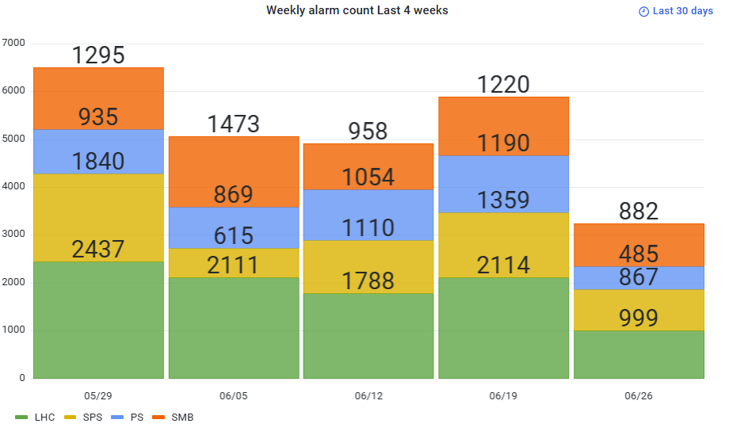
Phone calls | 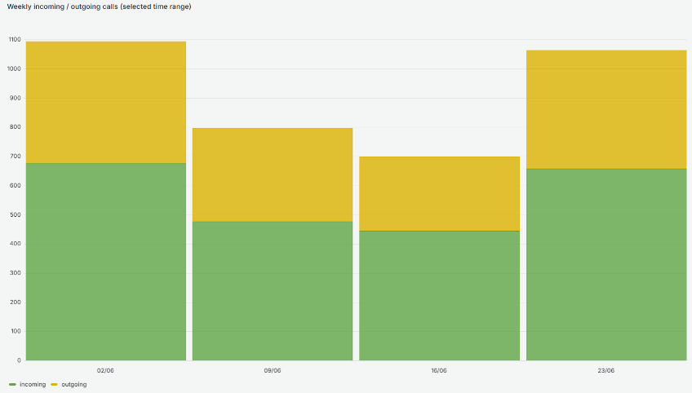  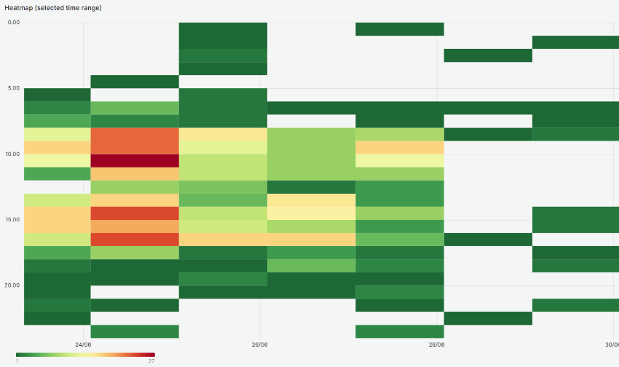
ODMs | 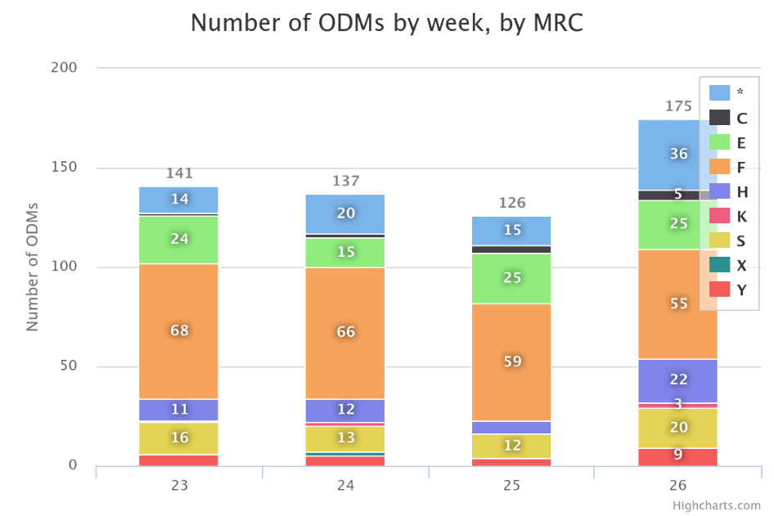
Facility Status
Summary | Technical stop week.  We add an operator during the morning and afternoon until Thursday.  Beginning of the week was busy but no major issue.
Issues | Mon 23/06/25  14:25  Loss of communication on the PLC APIMMD08  Cryo alarms, and technical alarms for fire and gas detection out of order for 45 minutes.  The breaker of the PLC was tripped.  Mon 23/06/25  The issue with the elevator displays in PM56 and PM85 has reappeared.  Fortunately, no one got stuck thanks to the recently installed cables between the call buttons and the machinery.  Investigations are still ongoing  Thu 26/06/25  UPS discharge test in RE22 RE18 for BE-ABP.  4 discharges of 2 minutes for BE-ABP study.
Plans

