Technical Infrastructure (TI)
Facility Coordinator last week |  | Gildas Langlois
Facility Coordinator this week |  | Clément Pruneaux
Statistics
Alarms | 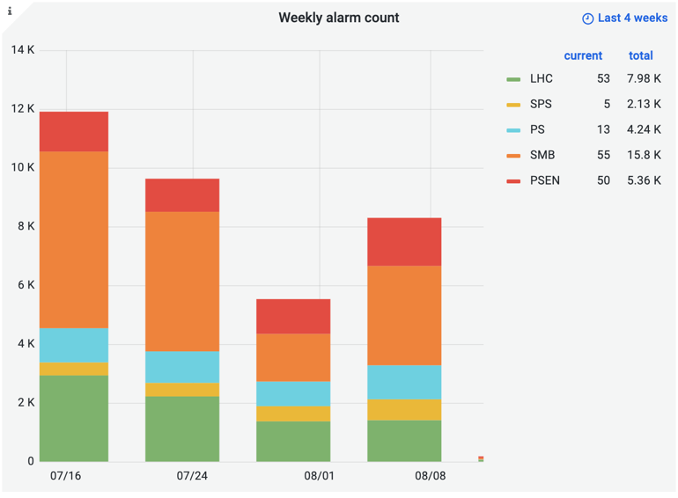
Phone calls | 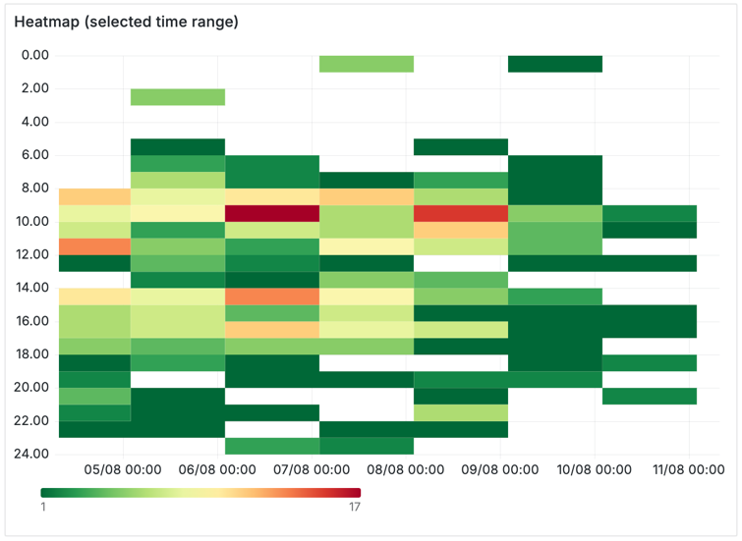  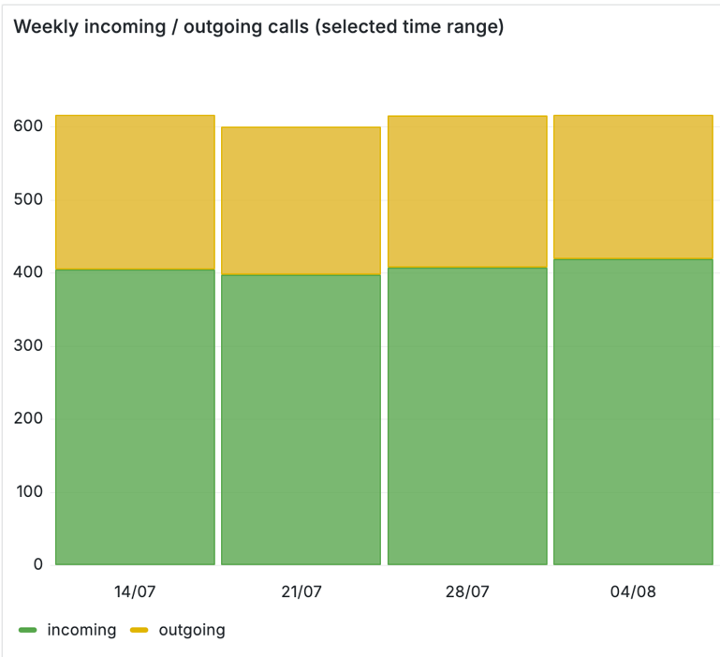
ODMs | 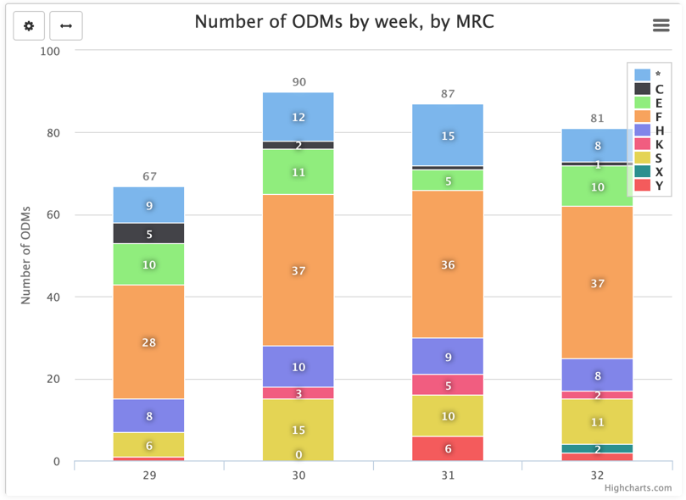
Facility Status
Summary | A week with quite a few events, shared mainly between LHC complex and North Area.
Issues | Tue 05/08/25 01:13: SF4 Cooling Tower trips on low level of the basin due to a faulty "doucet filter" washing valve. TI operator went quickly on site and turn off manually the valve while the picket restart the cooling tower from remote. No consequence on "client" like Cryo but really close to the trip threshold. ==> The problem stemmed from a damaged wire in the actuator. All cables will be replaced by flexible cables (which are now rigid).  Tue 05/08/25 05:43: Faulty rack temperature module trips NA62 GTK. The sensor erroneously made the DSS to send an interlock. The module has been replaced and this kind of problem is well known by the experience and is acceptable.  Wed 06/08/25 13:52: Fire detection in UXC55 stops CMS. CMS contacted TI to report that at 13:52 a fire alarm from sensor SFDEI-15356 triggered the DSS to send an interlock to rack X3E72 in UXC55.  An access has been made at 17:00 during the scheduled LHC beam dump. Nothing suspicious was found in the rack room. The smoke sensor had a lot of dust in it which could be the cause of the alarm and was replaced by a new one.  Thu 07/08/25 13:52: LHC beam dumped due to loss of cryogenics condition in 7-8 sector. The problem was a false contact on a "knife terminal" on the chain of local emergency stop buttons. Terminal replaced.  Sat 09/08/25 08:50: New occurrence of problem witch ODH sensor in ECN3. Sensor inhibited by piquet and access by Gaz specialist to fix it to be done later (probably Wednesday). To be noted that this weekend ECN3 operation team requested an access and due to the hazardous condition with ODH sensor, SPS operation proposed them to carry out an ODH portable as an extra safety element but they do not have appropriate training. Finally, fire brigade went to ECN3 to guarantee safe access but all this took a long time.
Plans

