Technical Infrastructure (TI)
Facility Coordinator last week |  | Clément Pruneaux
Facility Coordinator this week |  | Jesper Nielsen
Statistics
Alarms | 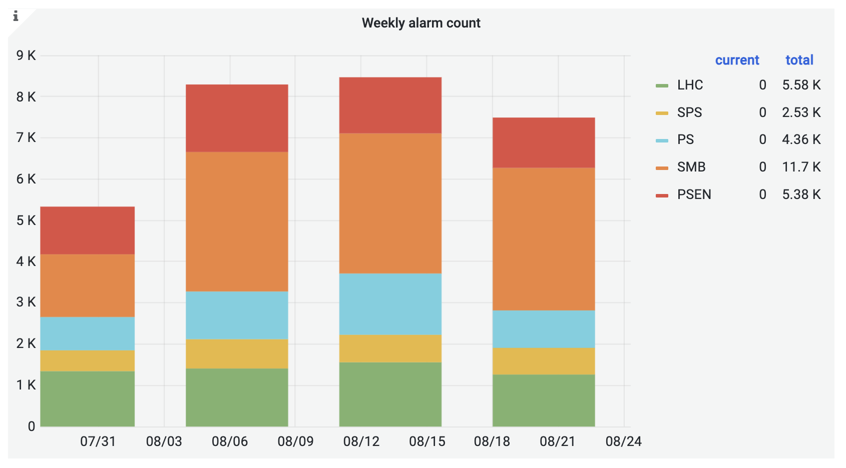
Phone calls | 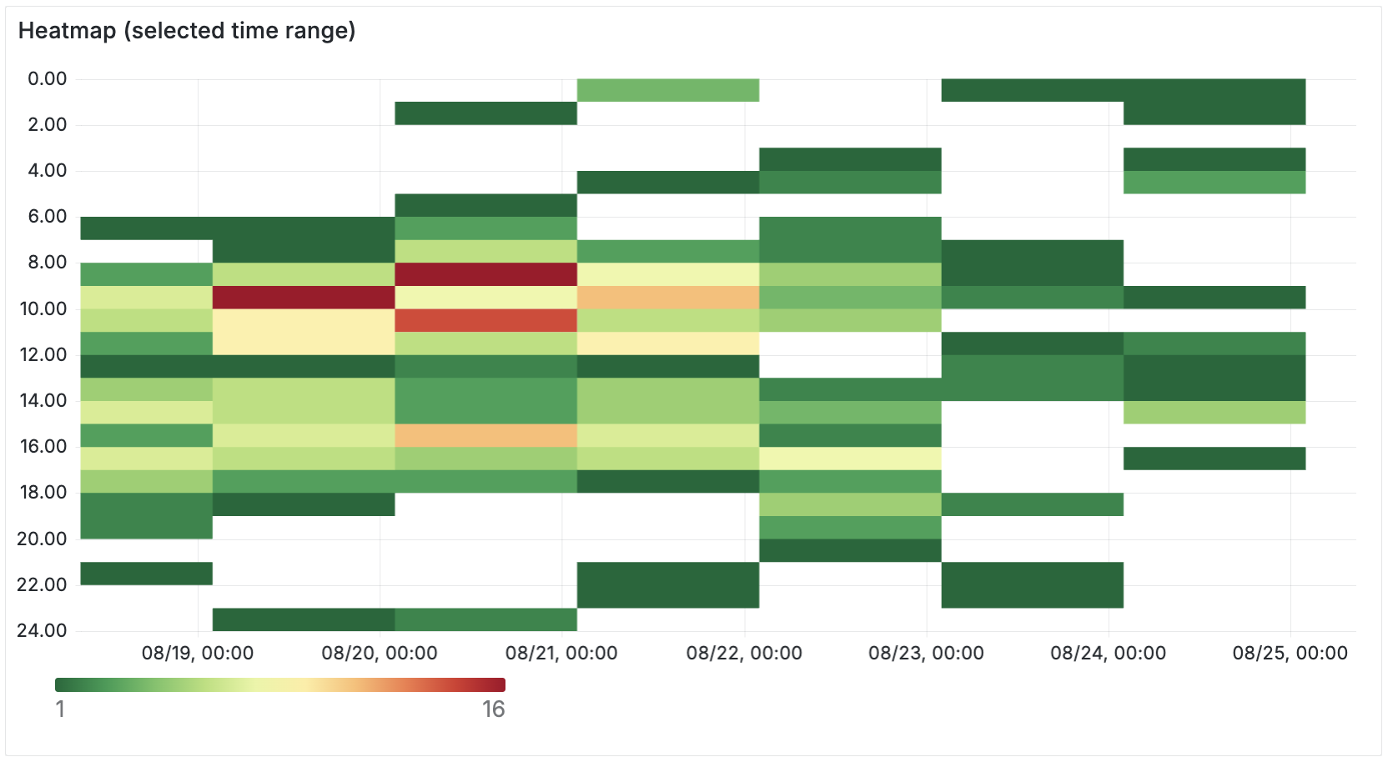  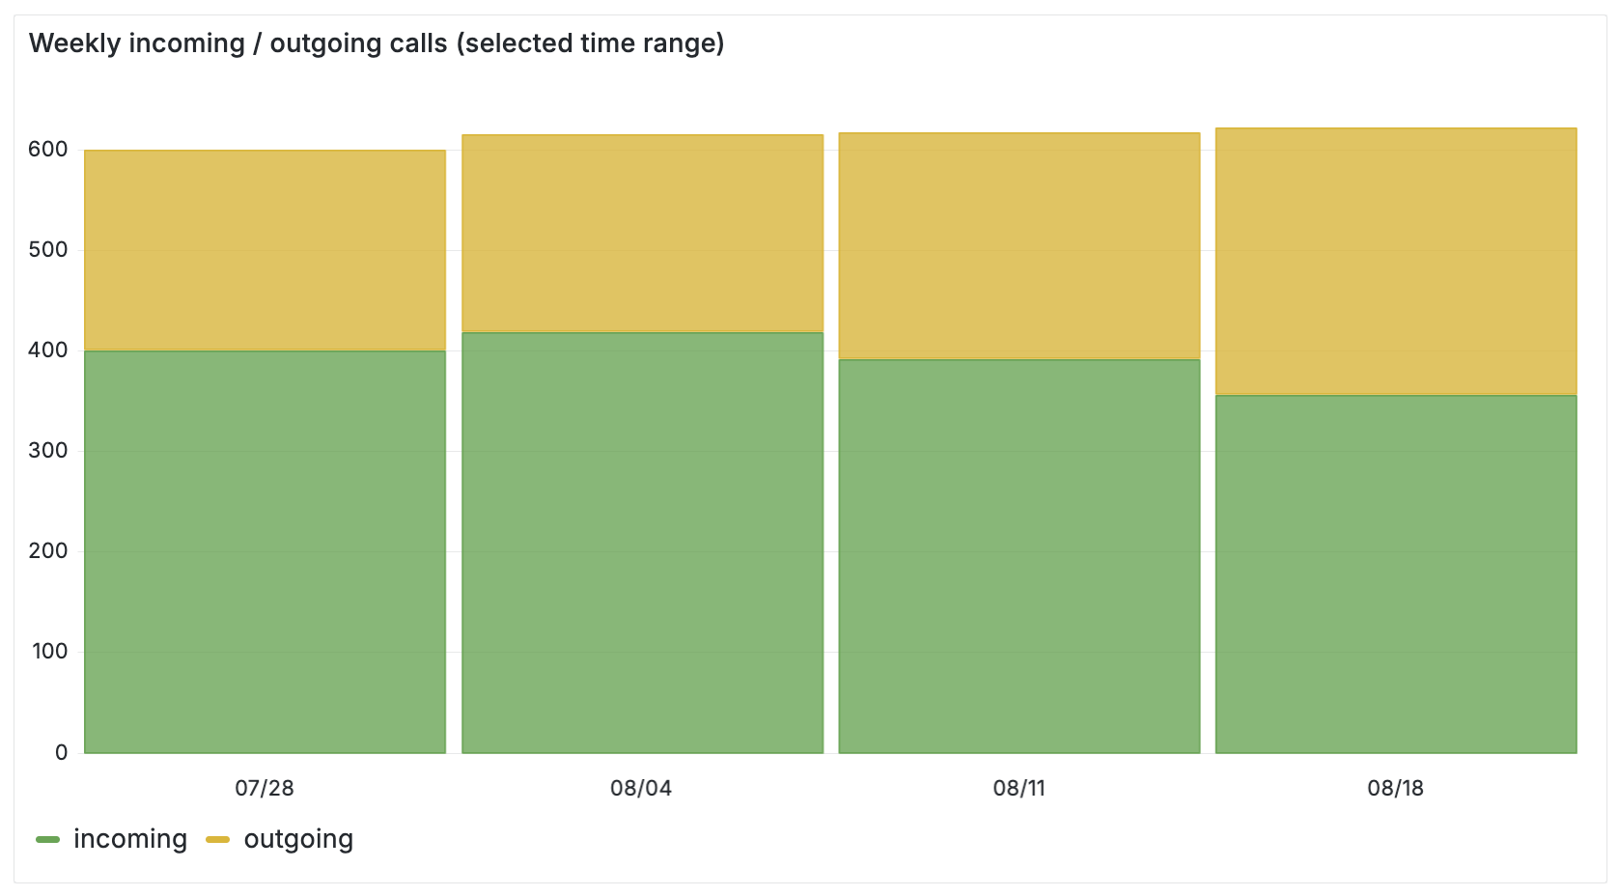
ODMs | 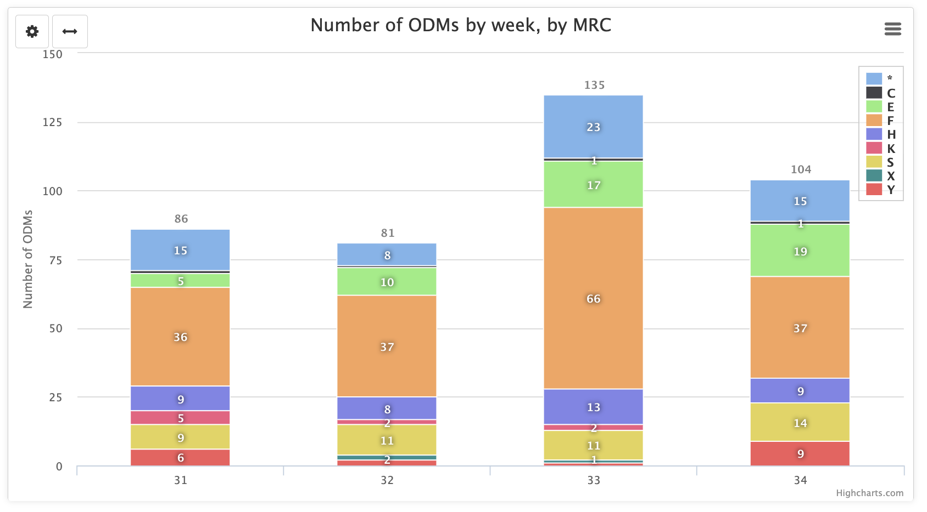
Facility Status
Summary
Issues | Thu 21/08/25 02:03  Trip of LHC power converter RB.A78 main dipole (earth fault alarm). After investigation on-site by EPC it was found that the power supply had tripped, EN-EL was contacted for intervention.  Thu 21/08/25 12:10  3 fire alarms in TDC2 (North Area) caused an interlock of the ventilation and stop of physics in North Area. Intervention was coordinated with TI, SPS, RP and CFRS. The alarms were reset by the CFRS, after which TI could restart the ventilation and give green light for beam again.  Sat 23/08/25 09:54  Nitrogen alarm in CLOUD experiment. TI coordinates with Zone responsible and Gaz on-call piquet. Decision to inhibit the sensor (false reading). There is no Nitrogen in the experiment at this time.
Plans | SIG is required to perform maintenance on the 130kV substation at MEYRIN (ME10). The intervention is scheduled from September 1st to 3rd.  A planned outage of 3 days will take place, with the possibility of power restoration within 3 hours in case of urgent operational needs.  During the outage, the safety network (supported by generator units) will remain fully operational to ensure continuity of service.  It should be noted that SIG is only providing the auto-transfer function and does not provide regular and/or emergency supply; their role is limited to acting as a "backup" system. IMPACT: https://impact.cern.ch/impact/secure/?place=editActivity:259867

