# Emittance Preservation in the LHC

V. Kain, G. Arduini, B. Goddard, B.J. Holzer, J. M. Jowett, M. Meddahi, T. Mertens, F. Roncarolo, M. Schaumann, R. Versteegen, J. Wenninger, CERN, Geneva, Switzerland.

Abstract

Emittance measurements during the LHC proton run 2011 indicated a blow-up of 20 % to 30 % from LHC injection to collisions. At the LHC design stage the total allowed emittance increase from SPS extraction to colliding beams was set to 7 %. This presentation will show the emittance preservation throughout the different parts of the LHC cycle and discuss the current limitations on emittance determination. Possible sources and cures for the observed blow-up will be presented. Possible improvements of emittance diagnostics and analysis tools together with a list of machine development tests in 2012 will also be shown.

## introduction

One reason of the remarkable performance of the LHC in 2011 was the extraordinary performance of the LHC injectors. Bunch intensities of 1.5 × 1011 protons with emittances of about 2 m were produced for the 50 ns beams. And the emittances could be kept below nominal until the start of collisions in the LHC. Blow-up is however apparent throughout the LHC cycle.

This paper analyses emittance preservation from SPS extraction to start of LHC collisions. The focus is on the blow-up under nominal 2011 run conditions, see Table 1. The behaviour of emittances with 25 ns beams as tested shortly in 2011, and the sudden blow-up of individual batches at injection are not discussed. Emittance growth with colliding beams is discussed elsewhere [1]. The analysis in this paper is based on data from SPS and LHC wire scan measurements (SPS wire scanners at positions 416 and 519), the LHC synchrotron light monitor and the luminosities of ATLAS and CMS.

Table 1: LHC run configuration after June 2011

|  |  |
| --- | --- |
| Total number bunches for fill | 1380 |
| Max number bunches injected | 144 |
| Bunch spacing [ns] | 50 |
| Intensity/bunch | 1.1 –1.4 ×1011 |
| Intermediate intensity [bunches] | 12 |
| Number of injections per fill and beam | 12 (+1 pilot) |
| Filling time | **~** 20 min |
| Number collisions (ATLAS+CMS/ALICE/LHCb) | 1318/39/1296 |
| Collision energy per beam | 3.5 TeV |
| Max. luminosity achieved [cm-2s-1] | 3.6 × 1033 |

### Limitations

The emittances of LHC 50 ns beams are routinely measured for the intermediate intensity of 12 bunches, which is injected first, and 144 bunches, the full 50 ns SPS batch, at the SPS flattop before an LHC fill starts. There are however no routine measurements for the LHC transfers. Comparisons of SPS and LHC emittances at injection are thus not necessarily comparing emittances of the same beam.

Especially in the injectors the required wire scanner settings for the PM and filters depend strongly on various parameters of the beam and need to be adjusted carefully. The fit quality also needs scrutinized before trusting the results. As a consequence fairly large shot-by-shot variations on the measured emittance results are observed which do not seem to correspond to the physical variations. An extreme example is shown in Fig. 1.

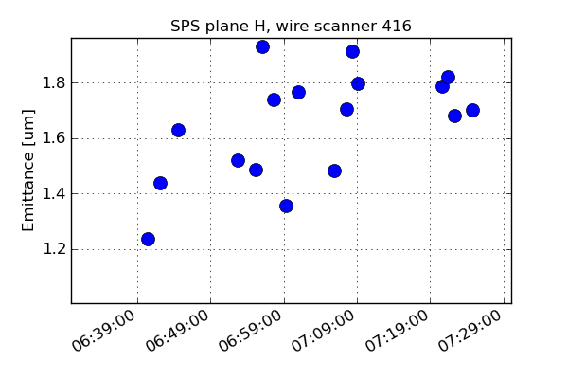

Figure 1: Emittance measurements in the SPS with 144 bunches, horizontal plane. Preparation of fill 2240. The spread of the obtained values is larger than 50 %.

For every fill the emittances of the first 12 bunch batch is measured with the LHC wire scanners. The first 144 bunch batch however is only rarely measured. Wire scans beyond an intensity of 2.5 ×1013 p+ are not allowed to protect the wires and avoid quenches. There are no LHC wire scan measurements for physics beams at 3.5 TeV.

The LHC synchrotron light monitor (BSRT) continuously measures bunch-by-bunch emittances. In 2011, integration times of 3 s per bunch were required for good quality data. Measuring the emittance of every bunch once for 1380 bunches took therefore 69 minutes. Obviously the scan time was too long to follow the emittance evolution of a single bunch through the cycle and associate growth with specific parts of the cycle. For example the LHC ramp in 2011 took 17 minutes. Dedicated fills with a limited number of bunches or the BSRTs gated over a few bunches were hence used to study emittance evolution with these devices.

Another issue with the beam size values obtained from synchrotron light monitors is the absolute calibration. The BSRTs are calibrated using lamps and calibration targets. Nevertheless energy dependent effects like aberration and diffraction make an absolute calibration difficult. Wire scanners are used to calculate calibration factors at a given energy. For the time being the BSRTs are mainly used for relative comparisons at constant energy. An example of the obtainable data during the LHC cycle is shown in Fig. 2.

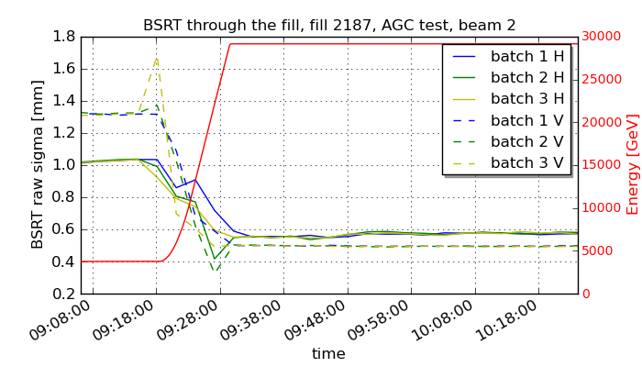Figure 2: If gated on a few bunches only the BSRTs can be used to study the evolution of the emittance through the cycle. The data during the ramp cannot be used.

An indication of the emittance at the end of the LHC cycle, the start of collisions, can be obtained from the peak luminosity published by the experiments CMS and ATLAS. The resulting emittance value is a convolution of the horizontal and vertical emittances for the two beams. This approach is based on several assumptions and uncertainties. The experiments must be fully optimized and the published luminosity values correct. Both conditions were not always fulfilled in 2011. Another assumption is that the transverse intensity distribution is Gaussian. Measurements indicate that the population of the bunch tails might be larger than for truly Gaussian beams [2].

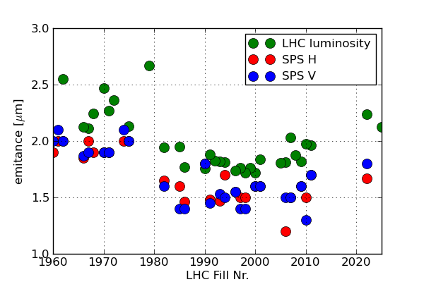

Figure 3: Comparison of the wire scan emittances of 144 bunch batches at the SPS flattop (blue, red) with emittances calculated from the LHC luminosity. Period: mid of July to mid of August 2011

## observation

60 LHC fills between mid July and mid August 2011 were analysed in [3]. The emitances from SPS wire scans with 144 bunches were compared with the emittances from LHC luminosity, see Fig. 3. A blow-up of 20 to   
30 % between SPS flattop and LHC collisions is apparent, Fig. 4.

In the following the contribution to emittance blow-up from the different phases of the LHC cycle will be analyzed.

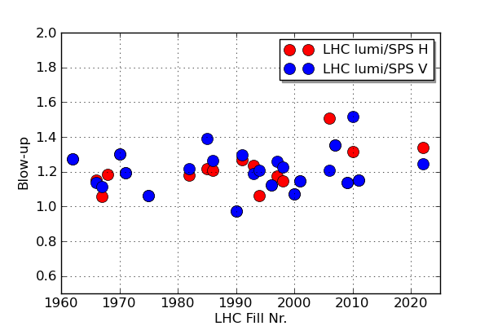

Figure 4: Blow-up between emittances of 144 bunch batches in the SPS and emittances from collision from Fig.3. Period: mid of July to mid of August 2011.

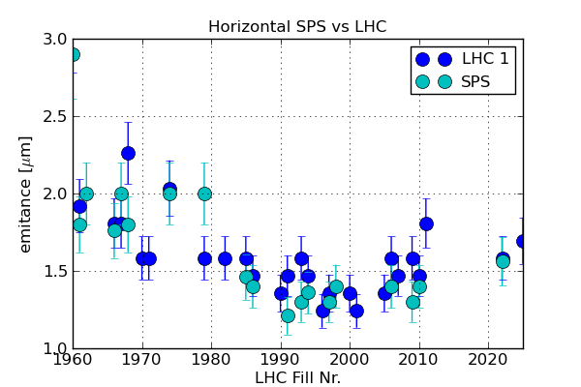

Figure 5: Comparison of horizontal wire scans of 12 bunches in the SPS and LHC.

## mismatch at injection?

For the same 60 fills as above the wire scanner data for 12 bunch batches at the SPS flattop was compared with the 12 bunch wire scan data in the LHC. Fig. 5 and Fig. 6 show the results of the measurements for the horizontal and vertical plane of beam 1. Within the measurement accuracy, the emittance values are the same. No significant growth can therefore be attributed to the injection process.

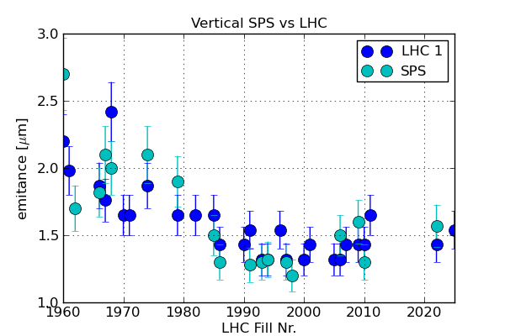

Figure 6: Comparison of vertical wire scans of 12 bunches in the SPS and LHC.

Fig. 7 and Fig. 8 compare the 12 bunch wire scan data of beam 1 and beam 2 at injection. Using the measured beta functions at the wire scanners beam 1 and beam 2 emittances are the same within the measurement accuracy.

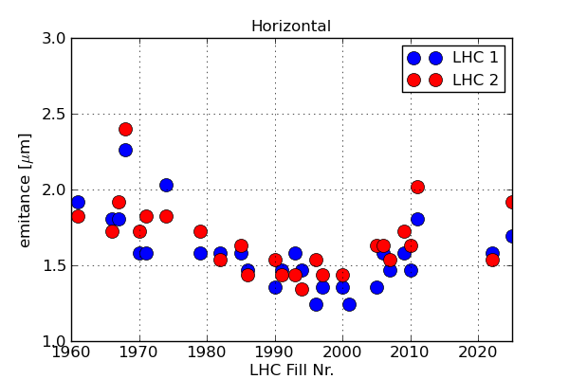

Figure 7: Comparison of horizontal wire scans of 12 bunches for beam 1 and beam 2.

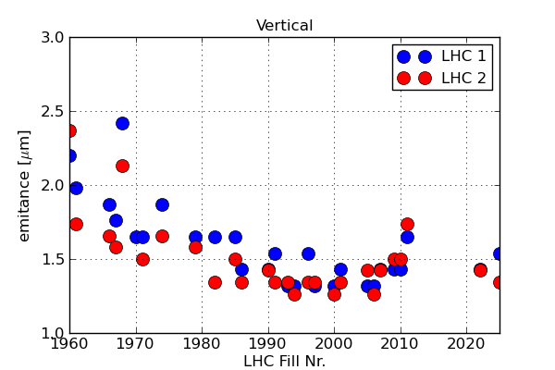

Figure 8: Comparison of vertical wire scans of 12 bunches for beam 1 and beam 2.

## emittance growth @ 450 GEv

The emittance evolution at 450 GeV was studied using the BSRTs gated on a single bunch or a few bunches only while waiting at injection of long periods (> 60 minutes). An example is shown in Fig. 9, Fill 2028. In this case the data was obtained while gating over a single bunch only. It is hence relatively noisy. The emittance in the horizontal plane grows by about 10 % in 20 minutes. The growth thereafter slows down as is typical for IBS

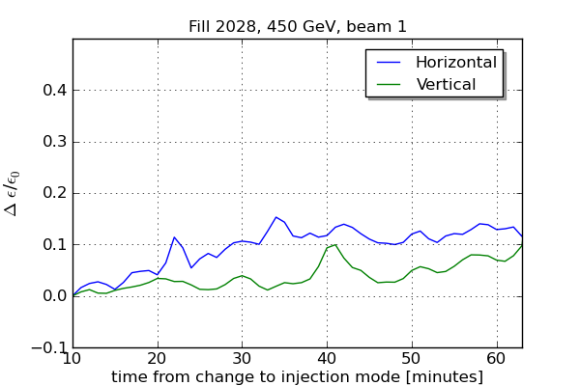

Figure 9: For fill 2028 the BSRT was gated over a single bunch. The measurement is noisy, nevertheless a growth in the horizontal plane of about 10 % in 20 minutes is apparent.

Simulations were carried out to find the origin of the emittance blow-up. In Fig. 10, IBS simulation results are compared with emittance measurements for Fill 1897. The BSRT had been gated over 12 bunches for this occasion. The horizontal emittance growth is reasonably consistent with the growth predicted by IBS. The simulations used measured parameters of initial emittance (wire scanner), emittance evolution (BSRT), bunch length (LHC BQM), bunch intensity (LHC FBCTs) and RF total voltage as input. Method and code are described in [4].

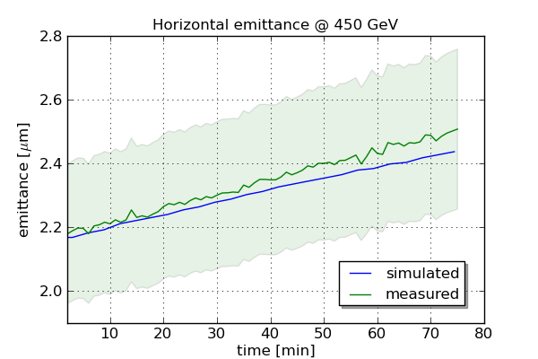

Figure 10: Comparison of measured horizontal emittance evolution at injection, green curve, with simulation of IBS (uncoupled), blue curve.

More studies will have to be carried out in 2012 to understand the nonetheless slightly faster growth in H than predicted by IBS and also the discrepancy between simulation and measurement of the bunch length evolution as shown in Fig. 11 for the same Fill 1897.

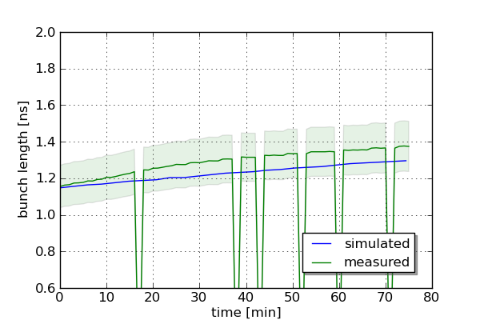

Figure 11: Comparison of evolution of measured bunch length with simulation of IBS. The discrepancy still needs to be understood.

The LHC filling (excluding the injection of the intermediate batch) takes about 30 minutes. This should be long enough to develop significant differences between the emittances of the first injected batch and the last injected one according to the growth rates seen in Fill 2028, Fig. 9. These differences should be visible in the specific bunch-by-bunch luminosity. And this is indeed the case as shown in Fig. 12. The difference in specific luminosity between the first and the last injected batches is about 10 %.

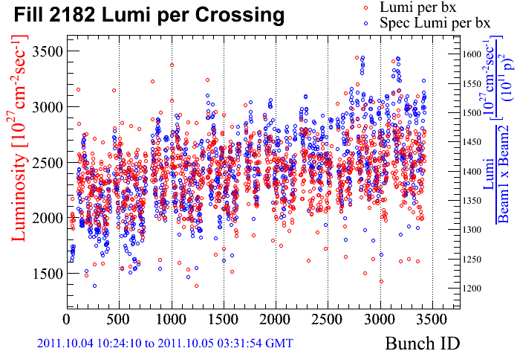

Figure 12: Bunch-by-bunch luminosity and specific bunch-by-bunch luminosity for fill 2182 at beginning of fill. There is a 10 % difference in specific luminosity for the first batches compared to the last injected batches. *Courtesy A. Ryd, CMS*

## Emittance growth during the ramp

As the LHC BSRTs do not produce useful data during the energy ramp and the Beam-gas Ionization Profile Monitors (BGI) were not commissioned, other methods had to be thought of to study emittance evolution during the ramp. In the end the wire scans were triggered several times during the ramp for dedicated fills with a low enough number of bunches.

Fill 2187 was an appropriate fill with only 36 bunches per ring in groups of 12 bunches spaced by 50 ns. The purpose of this fill was to study abort gap cleaning at flattop. The initial emittances from the wire scanners at 450 GeV for this fill are summarized in Table 2.

Table 2: Initial normalized emittances for abort gap cleaning test fill, Fill 2187.

|  |  |  |
| --- | --- | --- |
| 1H | [m] | 1.6 |
| 1V | [m] | 1.3 |
| 2H | [m] | 1.6 |
| 2V | [m] | 1.4 |

All wire scan measurements during the ramp were re-fitted offline and the measured beta functions at the wire scanners were used to calculate the emittance. Beta measurements are available at 450 GeV and 3.5 TeV. Linear interpolation for the beta function was used for any energy in between. Fig. 13 and Fig. 14 show the results of the emittance growth for beam 1 and beam 2. The measurements indicated an emittance blow-up of about   
20 % for both beams and both planes during the ramp.

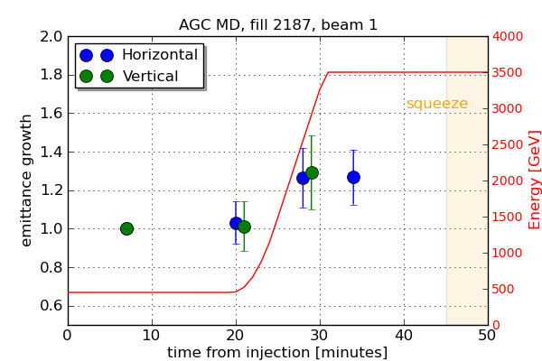

Figure 13: Emittance growth during fill 2187 measured with wire scanners for beam 1. 36 bunches per ring.

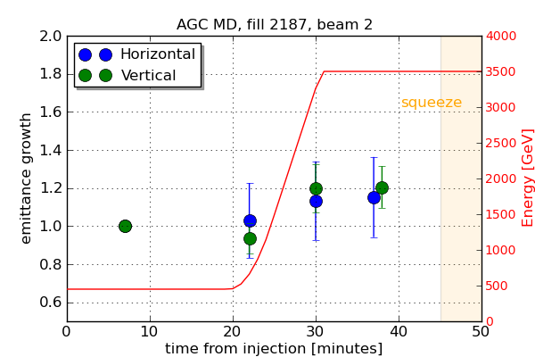

Figure 14: Emittance growth during fill 2187 measured with wire scanners for beam 2. 36 bunches per ring.

There was also another occasion where wire scans could be carried out during the ramp. During the BI MD of the last MD block in 2011, 4 bunches per ring were ramped with different emittances. 2 bunches had large emittances (> 3.5 m) and 2 bunches small emittances (~ 1.5 m). The larger emittances had been obtained by inserting screens in the SPS injection line. Unfortunately only data for beam 2 could be recorded. The beam 1 wire scanner had a timing issue. The results for beam 2 are shown in Fig. 15 and Fig. 16. Interestingly the relative growth for the different emittances is significantly different, however in absolute the emittances grow by the same amount. In the horizontal plane the emittances grew by about  ≈ 1 m and in the vertical plane the emittance grew by about  ≈ 0.7 m during the ramp.

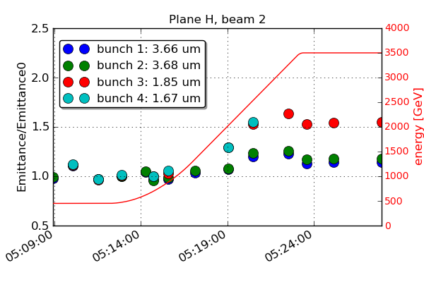

Figure 15: Relative emittance growth for different initial emittances for BI MD test ramp, beam 2 H.

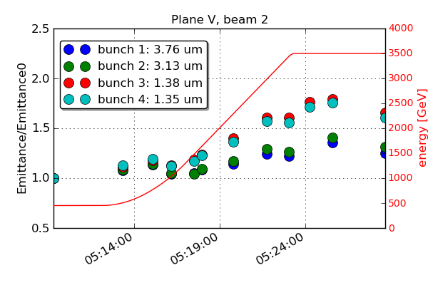

Figure 16: Relative emittance growth for different initial emittances for BI MD test ramp, beam 2 V.

## Emittance growtH at flattop

At flattop with constant energy, the BSRT is the obvious device to study the emittance evolution. Off-line the data of the abort gap test fill, Fill 2187, was averaged per batch (average over 12 bunches). The evolution of the average emittances per batch for beam 1 and beam 2 is shown in Fig. 17 and Fig. 18.

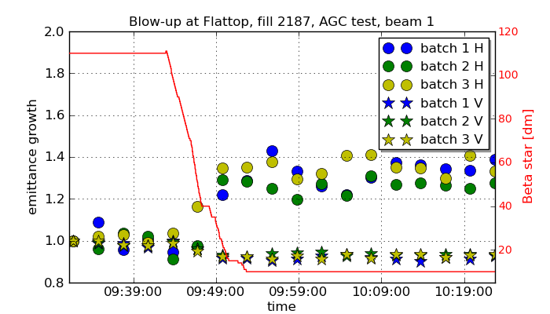

Figure 17: Relative emittance growth for different batches after ramp and during squeeze for Fill 2187, beam 1.

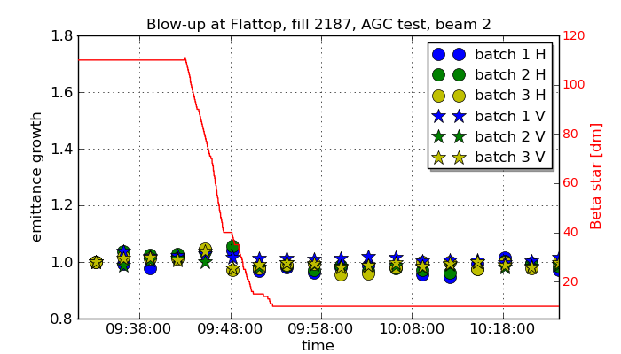

Figure 18: Relative emittance growth for different batches after ramp and during squeeze for Fill 2187, beam 2.

Whereas for beam 2, both planes, and beam 1, the vertical plane, the emittances remain constant within measurement accuracy after the ramp and during the squeeze, the horizontal beam 1 emittances show blow-up starting around 3 m *, see Fig. 17 and Fig. 18. The measured betas at theD3 were taken into account where available: at flattop, 3.5 m and 1 m *. It remains to be verified whether the emittances of beam 1 H systematically blow up during the squeeze or whether Fill 2187 was exceptional.

## possible sources for emittance growth during ramp

One of the parameters which were not fully optimized during the ramp commissioning of 2011 was the gain of the transverse feedback. No systematic scan of damper gain versus transmission or tune signal were carried out. It has to be reduced during the ramp to allow the operation of the BBQ based tune feedback [5]. The reduction of the gain takes place before the ramp starts, and is clearly visible as increase of the BBQ amplitudes, see Fig. 21. The larger oscillations measured by the BBQ could potentially lead to emittance blow-up.

|  |
| --- |
|  |
| Figure 21: Plot of the logged parameters of BBQ amplitudes (red) and damper gain (green) and beam energy (pink). At the moment of the reduction of damper gain in preparation of the energy ramp the BBQ amplitudes increase. *Courtesy W. Hofle* |

The effect of the damper gain change at 450 GeV on emittance growth was checked for Fill 2187. The evolution of the emittance and the damper gain is shown in Fig. 19. There is no clear indication of immediate emittance blow-up when reducing the gain.

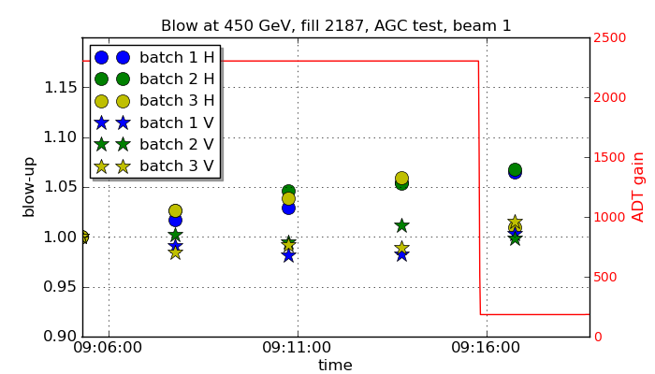

Figure 19: Relative emittance growth for beam 1, Fill 2187, at the injection plateau and the damper gain evolution. There is no immediate additional emittance growth apparent when the damper gain is reduced.

## Dependence on bunch intensity

The blow-up from the SPS to LHC collisions as function of bunch intensity was obtained by combining data from the summer period and October 2011, see Fig. 20. SPS wire scanner data with 144 bunches and emittance values from the luminosity data were used. Interestingly again the absolute value of emittance growth between SPS and LHC stays approximately constant for different bunch intensities.

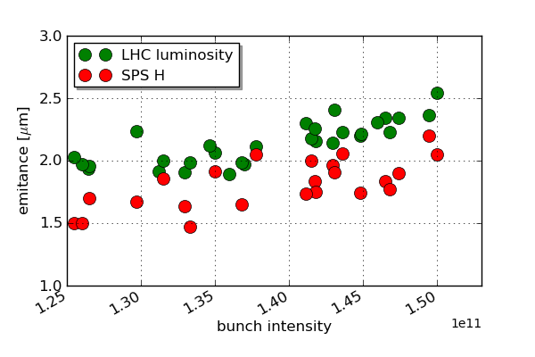

Figure 20: Comparison of emittance from LHC luminosity and emittance of 144 bunch wire scans in the SPS as function of bunch intensity. The absolute growth between SPS extraction and LHC start of collisions seems to be independent of bunch intensity.

Data with even higher bunch intensity than operationally used was delivered for the high pile-up MD fills such as Fill 2201, see Fig. 22. The absolute emittance growth during the ramp is similar as during the BI MD:   
 ~ 1 m in H and  ~ 0.6 m in V.

## ions

IBS has a much larger impact for ions at injection [4], and they also experience emittance blow-up during the ramp. As for protons, wire scans during the ramp for physics beams are not possible due to the intensity limitations. Wire scans during the ramp were carried out during the quench test fill on 7 December 2011. A single bunch was analyzed. The measured blow-up during the ramp is about 20 %, see Fig. 23.

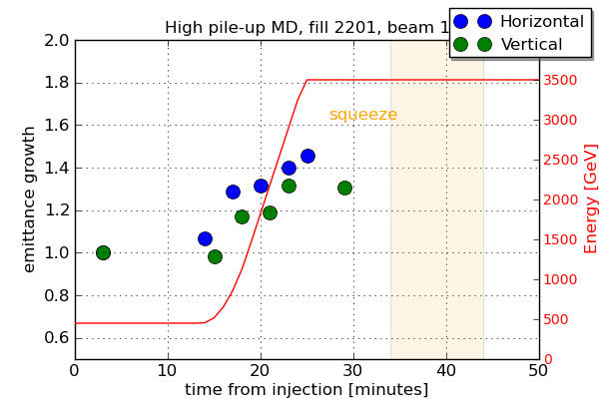

Figure 22: Emittance evolution during high pile-up MD for beam1. Bunch intensity: 2.4 × 1011. Initial emittances: H0 = 2.4 m, V0 = 2.2 m. The results are similar for beam 2.

## PLans for 2012

Many more studies are required to get a clear picture of the apparently additive source of emittance growth during the ramp. Several MDs are planned. Bunches with different intensities and same emittances and different emittances will be studied to check the effect on IBS at injection and the effect on emittance blow-up during the ramp. Also, the effect of different damper gains and working points (e.g. to avoid 50 Hz lines) will be investigated.

### Requirements

A number of additional studies and improvements of transverse profile diagnostics and analysis methods are required for 2012:

* Knowledge on beta-beat change over time
* BGI commissioned for protons
* Faster and better calibrated BSRTs. Work has already started on that subject.
* Automated wire scans during the ramp.
* Measured betas around the machine more easily available. Work has already started on that subject.
* More reliable wire scanner results for LHC and SPS, also bunch-by-bunch for the SPS: automated settings for given intensity, better fits,...
* Emittance measurements in the SPS for each LHC transfer.



Figure 23: Emittance evolution during ramp for ions. The emittances grow by about 20 %.

## Conclusions

The LHC transverse emittances grow by about 20 to   
30 % from SPS extraction to the start of collisions in the LHC. The collected data is consistent with no emittance growth from the injection process into the LHC. The emittances grow at the injection plateau (~ 10% in 20 minutes for the horizontal plane), reasonably consistent with IBS. Effort should therefore be put on minimizing the time spent at injection and dedicated LHC filling cycles could be re-investigated.

Wire scanner data indicates an emittance blow-up during the ramp. Measurements so far show a blow-up of more than 20 % for 50 ns trains in H and V, even more for single bunches. The emittances seem to grow by the same amount independently of the bunch intensity or initial emittance indicating an additive growth source like for example external noise.

More emittance evolution data during the squeeze is required. The data obtained from Fill 2187 indicates a blow-up of the emittances of beam 1 horizontal plane by more than 20 % at around 3 m *.

As expected, the emittance increase from IBS is faster for Pb beams. Moreover the spread of initial bunch intensities and times spent at the LHC injection plateau result in a spread of emittances going into the ramp and physics.

In general faster and better calibrated BSRTs, operational BGIs, better understanding of the wire scanners and reliable fits will be required in 2012. The data of dedicated fills and physics fills will be combined to get the full picture of LHC emittance preservation.

## References

[1] G. Papotti, “Luminoisty Lifetime - Protons”, these proceedings.

[2] F. Burkart, “Beam Loss and Beam Shape at the LHC Collimators”, Master thesis, to be published.

[3] V. Kain et al, “Emittance Preservation in the LHC”, IPAC 2011, San Sebastian, Spain.

[4] T. Mertens, “Intrabeam scattering in the LHC”, master thesis, CERN-THESIS-2011-042, CERN, Geneva, Switzerland.

[5] L. Ponce, “Orbit and tune feedback/diagnostics”, these proceedings.