Whenever relevant include EDMS or INDICO links and photos.
- General Info
  - Feedback from Composite Conference ICCM – R. Piccin
  - Update on coating characterization – F. Louka
- CERN Wide Service
  - STRING (SM18): Repair of Q3 bellow successful with Stycast 2850FT. Leak below background level/noise. See presentation indico
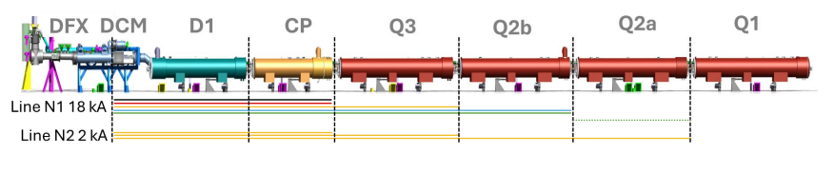
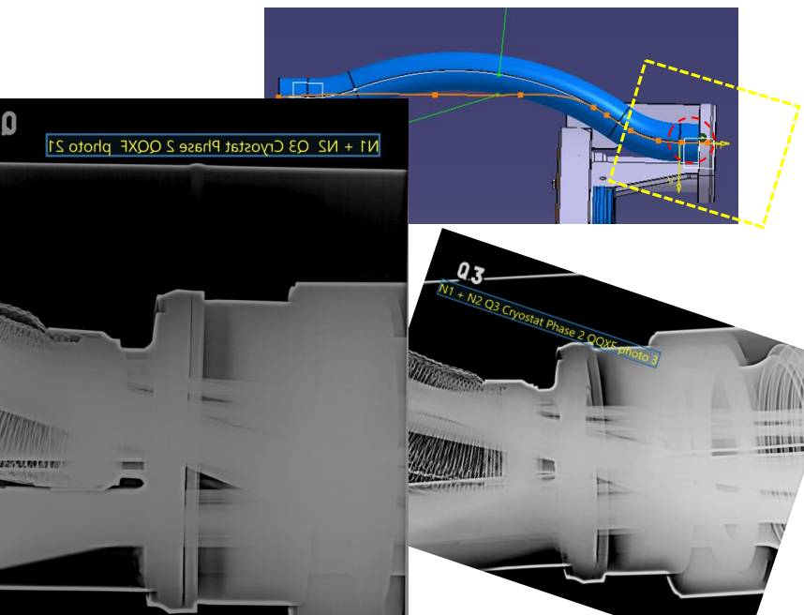

- TE-MSC-HSD Gluing of thermal sensor PT100 with stycast 2850FT for LHC 30/100 done
- TE-MSC-SMT 3D printing of spacer for Falcon D done
- TE-MSC-LMF 3D printing of one manchon in Ultem 6/8 done
- BE-ABP Molding of stamps in polyurethane for EBIS generator (ISOLDE) 7/13 done
- EN-MME-MA Impregnation test of Aerogel sample with CTD101K
- TE-VSC-SCC Gluing of membrane for permeation test
- SY-STI-RBS Boris tube, 3D printing test of Ultem/Accura parts for gluing insulation
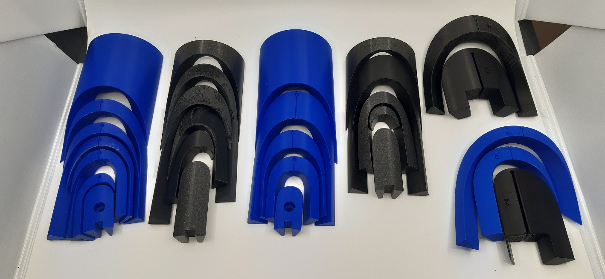3d printing of spacers for Falcon D

- Cable Insulation / CGP

Project | UL | Status | Delivery
M-Bond | C11uc0518A | Insulated, reception test ongoing | 927
CERN cable box | C06OC0492A Part 2 | Insulated, reception test ongoing | 927
PSI cable box | C06OC0492A Part 1 | Insulated, reception test ongoing | 927

- HFM activities
  - De-sizing: Reaction cycle completed on plasma-treated Nb₃Sn cable samples. Cables cut for SEM examination at MME. Preparation of 10-stack with double layer 636 sizing insulated cable, to undergo a reaction cycle.
  - Interlayer: DC breakdown tests of ceramic prepreg in liquid nitrogen to measure changes in dielectric strength after reaction cycle. Reaction cycle completed on samples with different fibre-binder combinations.
  - Radiation study: Paper “Processibility, Thermo-Mechanical Properties, and Radiation Hardness of Polyurethane and Silicone Resins” was published in Polymers (see https://www.mdpi.com/2073-4360/17/16/2240 )
  - SMC: preparation of next SMC coil that will be impregnated with filled wax, impregnation planned next week
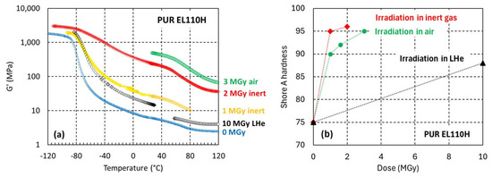
  - Ceramic coatings for Nb3Sn magnets: Characterisation of a set of SMC coil spacers and witness samples that were Al2O3 coated by reactive sputtering at Danish Technological Institute was controlled, see report https://edms.cern.ch/document/3333592/1.
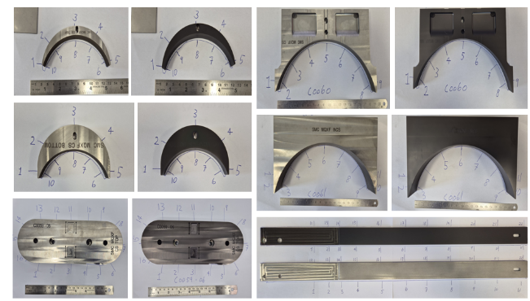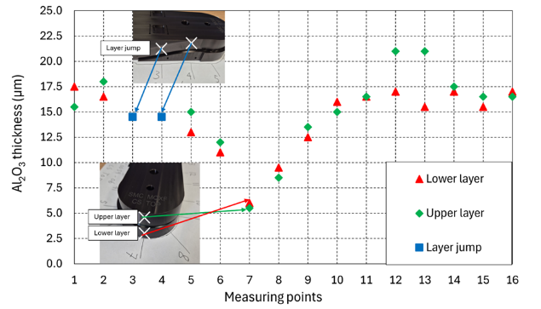

- Other R&D and projects
  - 3 reaction cycles for Al2O3 on stainless steel samples
  - Viscosity measurements of Araldite F (MBB project for NCM, resistive magnets) @60d using new accelerator Huntsman DY9577ES, see plot below
  - PU tensile samples aged for 6 months completed, shore A hardness test is ongoing, followed by tensile tests.
  - 3D-scanner from Creaform received, training and commissioning ongoing.
  - Aged Butyl sealant testing – ongoing: TGA 10/18, next: DSC
  - Telstar impregnation procedure to be finished with acceptable leak rate calculation
  - First attempt and project planning of SHIP putty experiment. Mix of MY750+D400 resin with Al2O3+Sil blend filler seems convincing (thixotropy, thickness, work time and temperature…). Thermal conductivity and fillers proportions to be calculated.

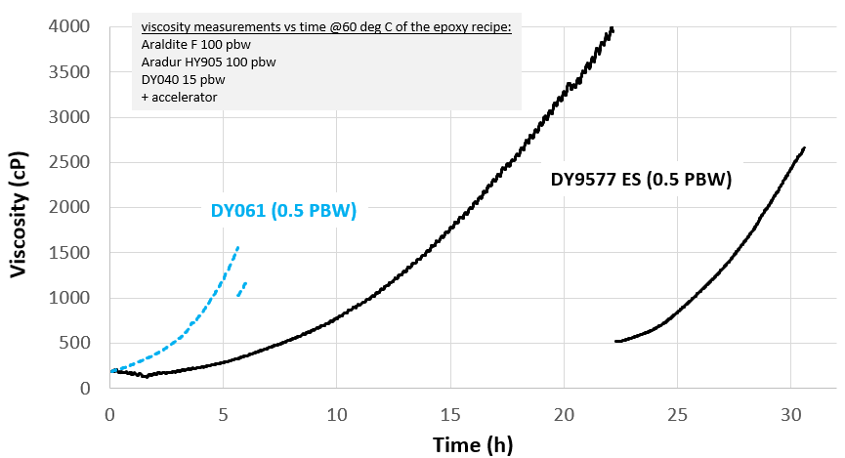
- Infrastructure
  - Braiding Machine: meeting with Herzog about commercial aspects, planning and new orders.
New delivery date: 1st week of April (W15)
New option ordered for the future braiding system:
- Suction system for fiber dust
- System to insert paper between 2 layers of cable on the drum
- System to insert a tape longitudinally like Mica on the cable before braiding

- Test and debugging of the new labview PLC to control 10 stacks measurement
- Telstar:
  - Heating tests @100d using empty SMC impregnation mold: to prepare first SMC impregnation in Telstar machine with 4 x cartridges. Control thermocouples 2 and 4 must be replaced.
  - General procedure of the machine is being written
  - New screen on the Telstar system
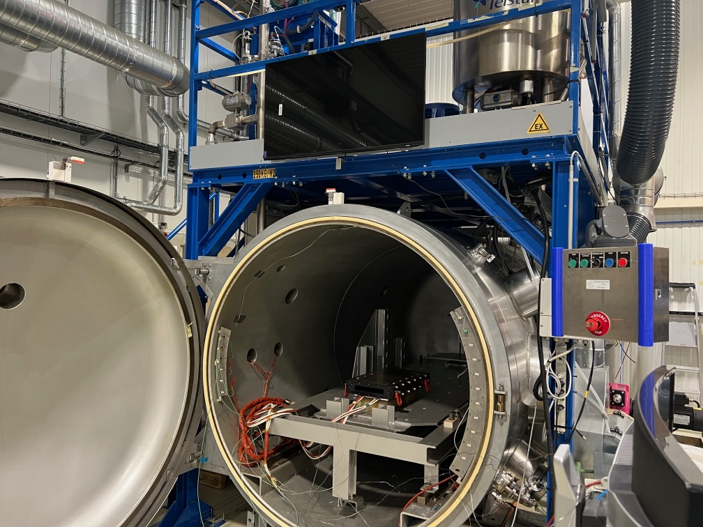

- AOB:

- Photos
