Whenever relevant include EDMS or INDICO links and photos.
- General Info
  - Presentation J. Osuna – De-sizing at MSC seminar https://indico.cern.ch/event/1480445/
  - Insulation for HV PCB boards. Kick-off new task for Hyperkamiokande. Presentation NASA in indico POLAB meeting https://indico.cern.ch/category/17517/

- CERN Wide Service
- EN-MME-MA Impregnation test of Aerogel sample with CTD101K
- EP-DT-CO Printing in Accura 25 of 50 Pre-heater Connector Clamps for CMS (50/50 done)
- TE-MSC-LMF 3D printing in Ultem 9085 of 8 manchon (7/8 done)
- EP-DT-DD: 3D printing in accura 25 supports samples for IRRAD (1/2)
- BE-ABP-HSL: mold of 13 stamps in polyurethane UR 3440 for ISOLDE (8/13 done)

- Cable Insulation / CGP

Project | UL | Status | Delivery
M-Bond | C11uc0518A | Insulated, reception test ongoing | 927
CERN cable box | C06OC0492A Part 2 | Insulated, reception test ongoing | 927
PSI cable box | C06OC0492A Part 1 | Insulated, reception test ongoing | 927
- For cable BOX, check the braiding parameters and compare them to the 1st cable BOX produced (it seems the glass fibre coverage is different).
- Meeting with VonRoll for cable insulation contract. Negative outcome. Not interested since require development/modification of their braiding machines for a relatively small production.
- HFM activities
  - Radiation study: MY740-DY906-TBv3 and MY740-DY906-TBv3-DY040 epoxy mixes irradiation at 10 MGy gamma completed. DMA and 3-point bending tests in progress.
  - SMC #110: impregnation done with filled wax. Some heating tests to smoother the upper surface.
  - De-sizing: impregnation of 10-stack MQXF 2 layers 11tex dummy cable / 636 sizing + electrical measurements

- Other R&D and projects

  - Viscometer: machine repaired, tests done to determine viscosity limits for filled mixtures: 100 - 20 000 cP (inside good torque range).
  - Viscosity measurements for NCM: Damisol 3420 fresh and aged resin ongoing (PS Booster) + Araldite F + DY 9577 completed (MBB project).
  - TE-MPE DQLPR capacitors: Butyl sealant ageing: DSC postponed
  - SHiP putty: Formula (MY750 + D400) proportions refinement and viscosity test tbd

- Infrastructure
  - Braiding Machine area: pending management decision on area.
  - 3D scan area
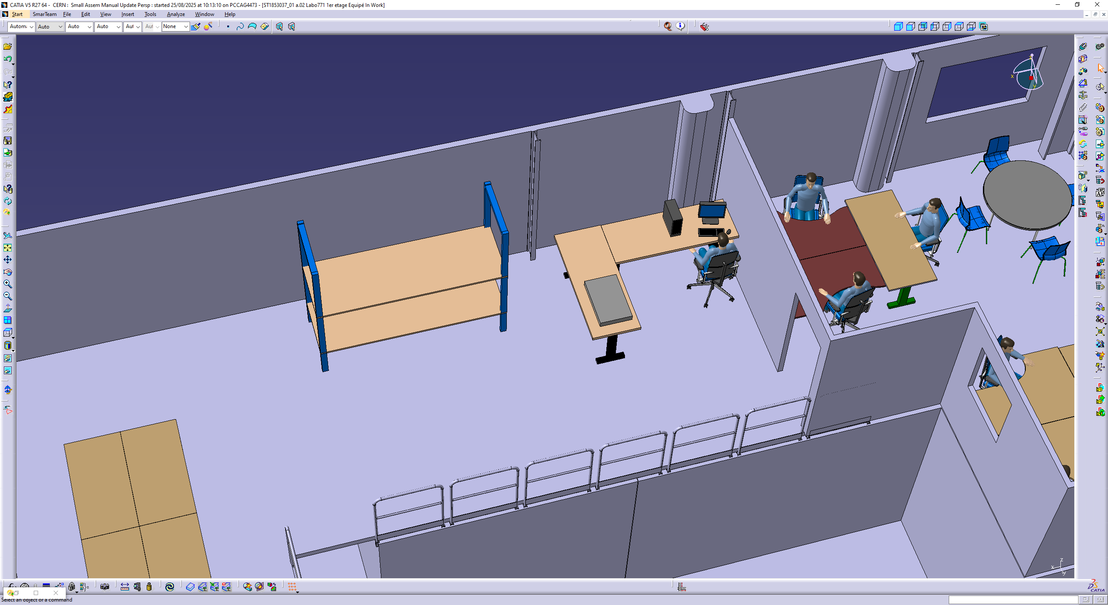
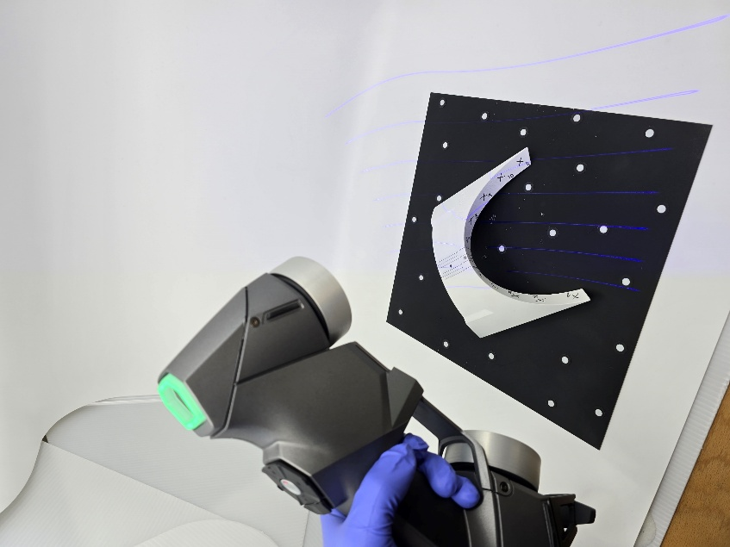

- AOB:
  - Evacuation of old equipment (2 pallets)

- Photos

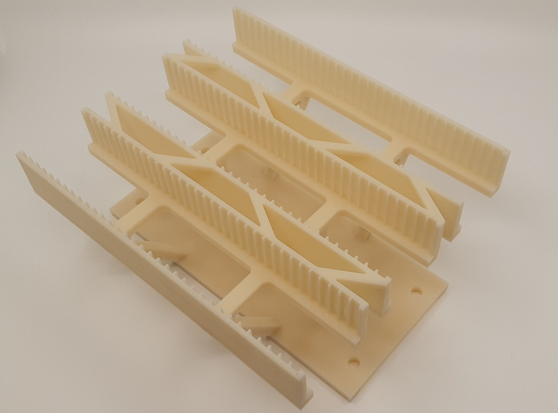
EP-DT-DD: 3D printing in Accura 25 supports samples for IRRAD

