Technical Infrastructure (TI)
Facility Coordinator last week |  | Jesper Nielsen
Facility Coordinator this week |  | Jesper Nielsen
Statistics
Alarms | 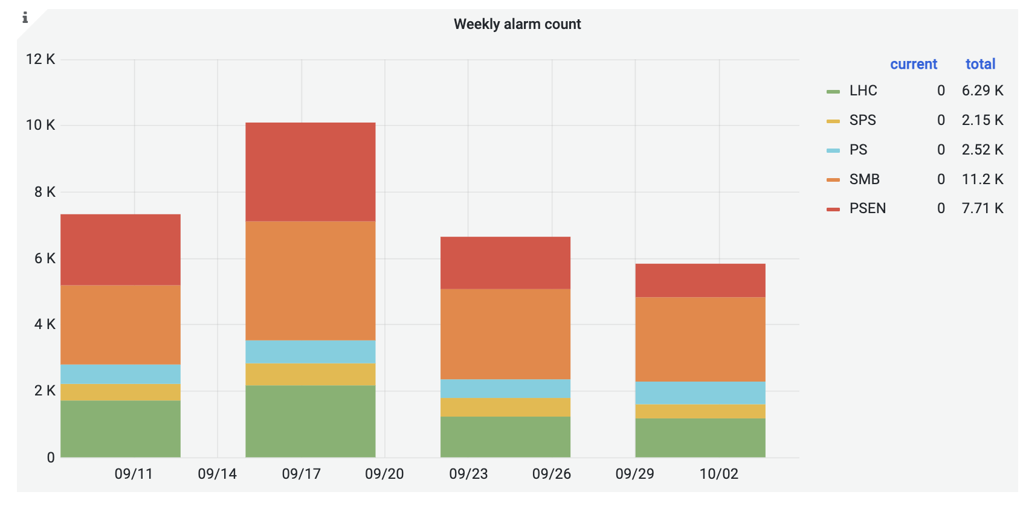
Phone calls | 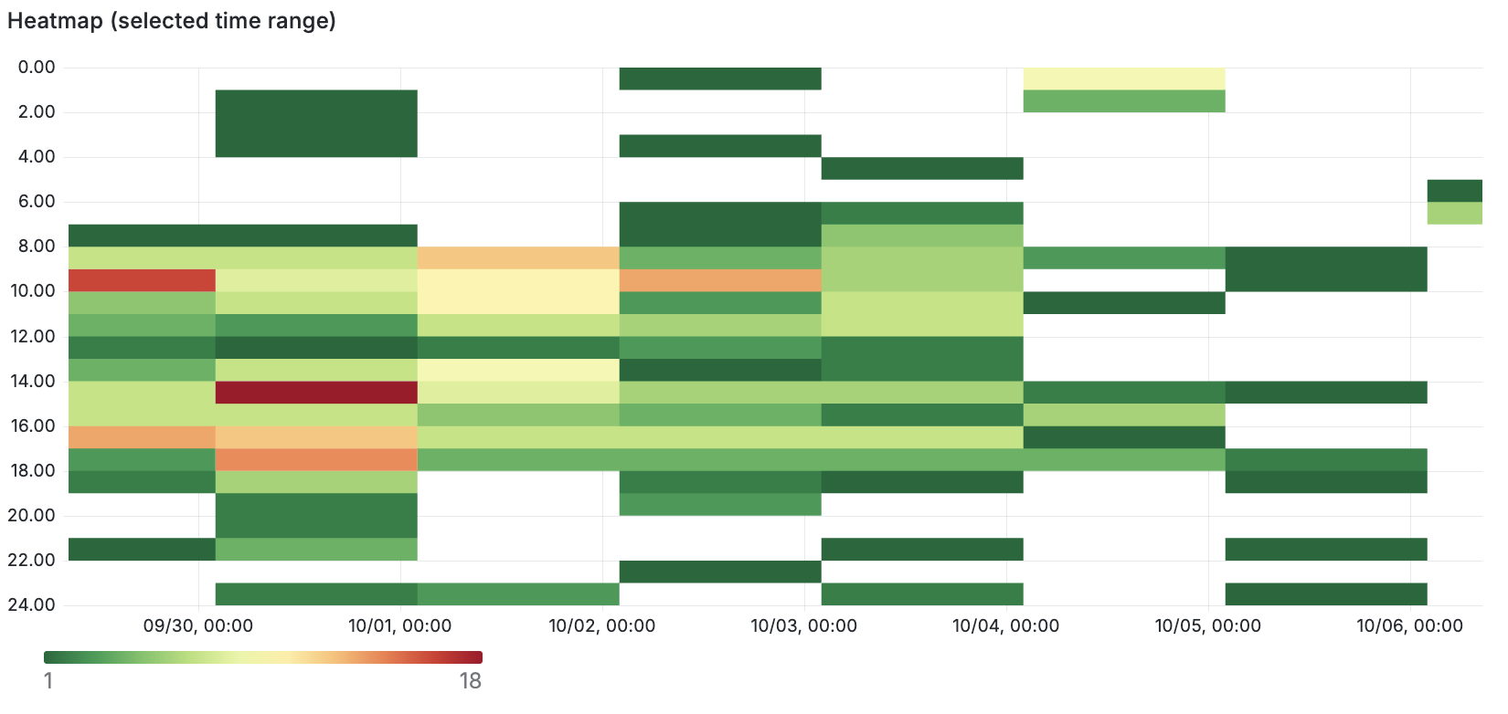  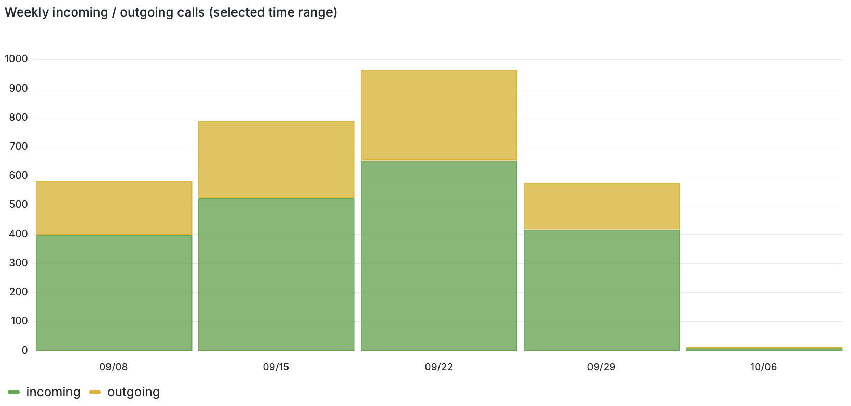
ODMs | 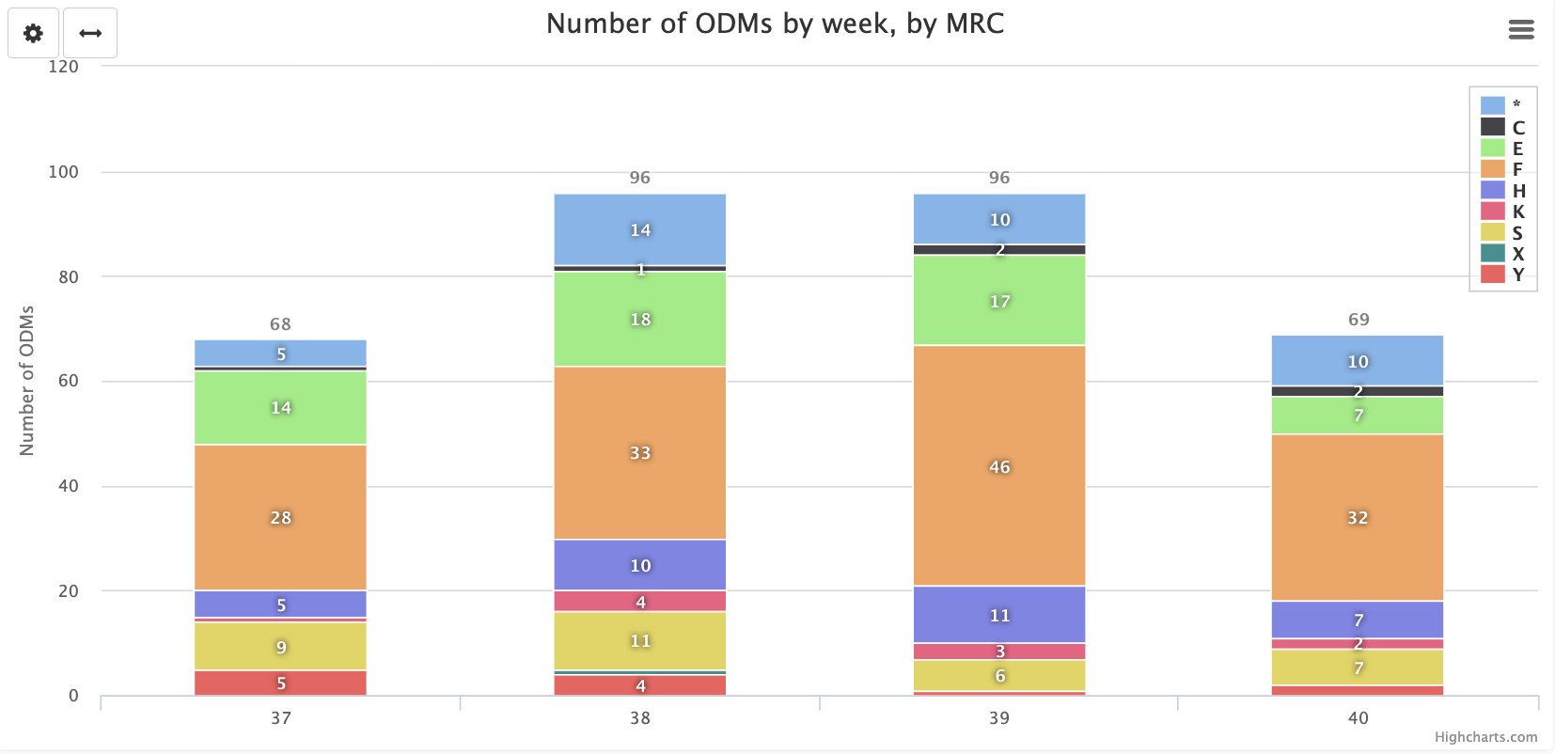
Facility Status
Summary | Quite a quiet week in TI, with only minor events recorded.
Issues | Tue 30/09/25 17:02  Toxic alarm received in LHC USC55. Piquet had to go on-site to reset the installation. The alarm was caused by a manipulation error in the experiment.  Sat 04/10/25 02:27  Alarm on FCUE-00002 Evaporative cooling installation for ATLAS tracker. Required an intervention on-site to restart the cooling station.

