Digital Radiation Tolerant Camera
Aiming At Beam Particle Imaging

BeamCAM

Document Title: | Test Plan and FDIR for Charm
Document N°: | MCSE-BCAM-PL-002
Issue: | 1.0 draft
Date: | 10.10.2025

Classification | Status |  | Export Control | Status
Public |  |  | Unclassified | X
Internal |  |  | EU / Switzerland | X
Proprietary | X |  | US EAR
Confidential |  |  | US ITAR

PROPRIETARY INFORMATION

 | Name | Function | Date | Signature
Prepared by | Quentin Bouille | HW Engineer | 10.10.2025
Verified by | Daniel Krähenbühl | Technical Manager | 10.10.2025
Released by | Marc Jeanmonod | Project Manager | 10.10.2025

Document Change Record

Issue | Date | Changes Description
1.0 | 10.10.2025 | Initial issue

Distribution List

Name | Organisation | Copies
S. Burger | CERN | 1x electronic copy

Content
1 Applicable and reference documents 5
1.1 Applicable documents 5
1.2 Reference documents 5
1.3 Norms, standards 5
2 Acronyms and definitions 6
2.1 Acronyms 6
2.2 Definitions 6
2.2.1 Data sizes 6
2.2.2 Data rates 6
3 Scope 7
4 Irradiation test presentation 8
4.1 Irradiation test objectives 8
4.2 Irradiation characteristics 8
4.3 Test main timeline 8
4.4 Test Sequences 8
4.5 Test SW operations flow 9
4.6 Keys monitoring parameters or data 9
5 Device Under Test (BeamCAM EBB) presentation and set-up 10
5.1 Description 10
5.2 Block Diagrams 10
5.3 Mechanical Information 10
5.4 Proof of concept evolution / Components improvements 11
5.5 Evolution of the power topology 12
5.6 BeamCAM EBB Connectors identification 13
5.7 Interfaces Connections at Camera level 13
5.8 Electrical schematic of specific connectors 14
5.8.1 Barrel HR10 (specific to BeamCAM EBB) 14
5.8.2 Trigger SMA 14
5.8.3 Power 4MM Plug Bananas 14
5.8.4 Ethernet RJ45 14
5.9 BeamCAM EBB HW settings 15
5.10 BeamCAM EBB FW settings 15
5.11 BeamCAM EBB identification 15
6 Test premises 16
6.1 CHARM Test Chamber CERN 16
6.2 Preparation room 157/1-N26 16
6.3 Beam area 17
6.3.1 Conveyor 17
6.3.2 Panels 18
6.3.3 Personnel preparation 19
6.3.4 Installation in the Beam Area 19
6.3.5 Precautions to be taken during the Beam test 19
6.3.6 End of the test 19
7 Test Set-up 20
7.1 Diagram Test Set-up 20
7.2 Test Equipment 21
7.3 Coax cable (item 11) solutions 21
7.3.1 Solution 1: SMA and 4mm to BNC 21
7.3.2 Solution 2: HR Barrel to 4mm then to BNC 21
7.4 As-run Set-up installation 21
7.5 Previous Test-Set-up Installation 21
7.6 Test set-up support for conveyer 22
7.7 External (MCSE) equipment needed in Control Room 23
8 FDIR during Test 24

List of figures
Figure 1: test timeline 8
Figure 20: Test SW operations flow 9
Figure 2: BeamCAM EBB 10
Figure 3: Power Path 12
Figure 4 Connectors IFs of EBBv4 13
Figure 5: J4 Schematic 14
Figure 6: J5 schematic 14
Figure 7: 4mm plugs schematic 14
Figure 8: ETH connector schematic 14
Figure 9: Top: CHARM facility irradiation layout, with the BeamCAM setup in location ’10’. Bottom: Two BeamCAM systems, each with a dedicated black-and-white target to probe visibility. 16
Figure 10: preparation room (general view) 17
Figure 11: preparation room data acquisition patch panel 17
Figure 12: preparation room irradiation panel 17
Figure 13: Overhead conveyor description 18
Figure 14: Data acquisition panel 18
Figure 15: Irradiation panel 18
Figure 16: test set-up in the Beam control room 20
Figure 17: test set-up in the Beam test room 20
Figure 18: Pervious test set-up 22
Figure 19: test support for conveyer 22

List of tables
Table 1: Changes / designs or PNs 11
Table 2: Connectors to be use 13
Table 3: Test Equipment 23

Applicable and reference documents

Applicable documents
Doc. Id. | Document Title | Document Nr, issue and date
 | CERN Technical Specifications | BTV-RTCAM-TS002 revision 0.4 (22.10.2024)
 | MCAMv4 Design Description | MCSE-MCAMv4-DD-001 issue 1.5 84.12.2024)
 | MCAMv4 Equipment ICD | MCSE-MCAMv4-ICD-001 issue 1.2 (9.09.2024)
 | Acronyms List | MCSE-MCAMv4-LI-004 issue 1.1 (5.02.25)

Reference documents
Doc. Id. | Document Title | Document Nr, issue and date
 | List of commands | MCSE-BeamCAM-CERN-TN-0001 issue 1.1 (14.06.2021)
 | PoC previous test:  SN01-SN02-CERN-CHARM-Test-Report : | MCSE-BeamCAM-RP-0014 :  BeamCAM_CHARM _Results_2022_12_02.pdf
 | Generic Test Setup Installation Guide | MCSE-BCAM-PR-002 issue 1.1 (9.10.2025)
 | CHARM Technical Meeting - CHARM team | EDMS 2721313
 | BOM updated | MCSE-BM4E-TN-001 1-0 issue 1.0 (13.11.2024)
 | MOSFET commercial plastic components survey and its SEE behavior | ALTER presentation version 3

Norms, standards
Doc. Id. | Document Title | Document Nr, issue and date
 | None

Acronyms and definitions

Acronyms
The definition of the acronyms used for the BeamCAM are given below. The other ones, related to the MCAMv4, are included in [AD04].
DUT | Device Under Test
GPI | General Purpose Input
HK | Housekeeping (TM containing DUT status information)
IF, I/F | Interface
MAIT | Manufacturing, Assembly, Integration and Test
TC | Telecommand
TM | Telemetry (answer to TC, containing data, as for instance image pixel values)

Definitions

Data sizes
- 8 bits = 8 b = 1 byte = 1 B;
- 1000 bits = 1 kilobit = 1 kb; 10⁶ bits = 1 megabit = 1 Mb; 10⁹ bits = 1 gigabit = 1 Gb
- 1000 bytes = 1 kilobyte = 1 kB; 10⁶ bytes = 1 megabyte = 1 MB; 10⁹ bytes = 1 gigabyte = 1 GB
- 1024 bits = 1 kibibit = 1 Kib; 1024² bits = 1 mebibit = 1 Mib; 1024³ bits = 1 gigibit = 1 Gib
- 1024 bytes = 1 kibibyte = 1 KiB; 1024² bytes = 1 mebibyte = 1 MiB; 1024³ bytes = 1 gigibyte = 1 GiB

Data rates
- 1000 b/s = 1 kb/s; 1000 kb/s = 1 Mb/s;
Example: 1 Kib of data to be transferred at 1 kb/s takes 1.024 s.

Scope
This document is the test plan for the evolution of the proof of concept of the BeamCAM to be tested at CHARM irradiation test chamber at CERN. It has been prepared by Micro-Cameras & Space Exploration SA (MCSE) in the frame of the development of a camera for CERN.
The new BeamCAM will be mainly based on the new generation of hardened, space grade micro-cameras currently developed by MCSE, which is called MCAMv4 (4th generation). Electronic and Electrical Elements on the BeamCAM prototype board are then the same as the ones embedded in the MCAMv4, with some CERN dedicated components, mainly in the power part.
The generic Test setup installation of the MCAMv4 / BeamCAM EBB is described in the dedicated document [RD03]. The present document contains the specific constraints to be followed for the Test Set-up at the CHARM facility in CERN premises.

Irradiation test presentation

Irradiation test objectives
The BeamCAM tests in CHARM facility is aimed to demonstrate that the overall HW design of the future BeamCAM is able to sustain the constraints which will be encountered in the different CERN scientific equipment, for example like in the current Large Hadron Collider (LHC) or the Future Circular Collider (FCC), a project currently in preparation.
Even if this test results could not directly be used by MCSE as a formal validation of the MCAMv4, it will also bring useful information in the frame of the MCAMv4 development and test.
To increase the test success chances, bring a certain redundancy and give more information, two BeamCAM prototypes (EBB, see a description in section 5) will be tested in parallel. To simplify the test set-up complexity and to allow an easier interpretation of the possible test failures, the complete test set-up will simply be completely duplicated : there will be two DUTs, two computers, two power supplies, two set of cables, etc. This document must be read in having this philosophy in mind.

Irradiation characteristics

The test will be performed in the CERN High energy AcceleRator Mixed field (CHARM) facility, which is a unique testing facility that completes CERN's radiation testing installations. It is located in CERN’s East Area where high-flux radiation testing on smaller experimental equipment takes place.
During experiments, the CHARM area receives Proton Synchrotron (PS) beam spills of up to 5e11 protons, 400ms long, at 24 GeV/c. The beam strikes a metallic target, producing a mixed radiation field—neutrons, protons, photons, electrons, and muons—via spallation. Resulting dose rates range from 10 µGy/h to 1 Gy/h, with fluxes up to 1e9 particles/cm2/s, enabling electronics testing in radiation conditions representative of accelerators, space, and nuclear facilities. More information can be found in [ref: https://charm.web.cern.ch].
The irradiation conditions for the BeamCam testing requested over 3 weeks at CHARM are the following:
- Total Ionizing Dose TID [Gy]: >400
- High-energy Hadron fluence, 𝐸 > 20MeV: Θ𝐻𝑒𝐻 [cm−2]: 2e12

Test main timeline
The CHARM test policy is to prepare each test within a dry run session, one week before starting the irradiation test. The CHARM provides facilities to test the equipment during the dry-run. The timeline is then as this :
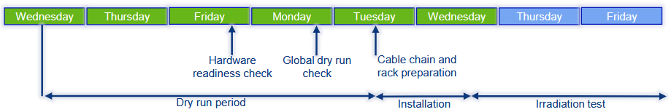
Figure 1: test timeline
Specifically, for the BeamCAM EBB test the foreseen dates are :
- Dry run start : Wednesday the 15th of October 2025
- Irradiation test start : Wednesday the 22nd of October 2025
- The irradiation test should last for three weeks. It could be interrupted sooner if the DUT is not able to work properly before having be submitted to the total irradiation dose foreseen, or temporarily in case of problems which could be fixed.

Test Sequences
Below agreed test sequences principles:
- Acquisition during the spill; ‘irradiated’ image acquired at start-up of Beam spill. That will be activated by a trigger provided by the CHARM equipment.
- Download and storage of the ‘irradiated’ image on the control computer. The image will be identified and time tagged.
- Acquisition after the Beam spill: ‘non-irradiated’ image acquisition is triggered also by the available trigger provided by the CHARM equipment. Neither the DUT FW or the test SW will perform any timing control, which will be given by the CHARM equipment.
- Download and storage of the non-irradiated image on the control computer. The image will be identified and time tagged.
- Loop to point 1.
- In parallel, check of the HK which will be send periodically from the DUT. If the HK flow is lost, a power cycle will be automatically generated after 10 minutes (TBC).
The images processing will be performed by an operator accessing remotely to the control computer, on a day-by-day basis.

Test SW operations flow
A dedicated test SW is needed to operate and control the test. It will run on a dedicated test computer, remotely accessible. The SW main functions will be according to the test sequence described in the previous section. Here below a description of the SW test flow :
TBW
Figure 2: Test SW operations flow

Keys monitoring parameters or data
Parameters and Data to monitor:
- Images acquisition when the beam is present
- Imagers Integrity
- Housekeeping data from Camera, As over-current protection counters on powerlines of sensor: Detection of Single event or latch-up / In case of OCP event, the FPGA power cycle the sensor.
- Voltage consummations
- Current consummations.

Device Under Test (BeamCAM EBB) presentation and set-up

Description
A development board (MCAMv4 Elegant Breadboard – EBB) was built by MCSE in the frame of the development of the 4th generation of the MCSE Micro-Cameras.
The BeamCAM, monitoring camera for CERN applications, will be developed in the future on the basis of the MCAMv4.
The EBB of the BeamCAM is a specific configuration of the MCAMv4 EBB. This configuration set all the needs for the BeamCAM design as components and functions. The generic test setup is described in [RD03] and sometimes in the present document when needed. All topics specific to the tests at CHARM are part of this document.
The components variations from the previous Proof of Concept board (see test report in [RD02]) are described in section 0.
Here below a picture of the BeamCAM EBB – actually the same as the MCAMv4 EBB.
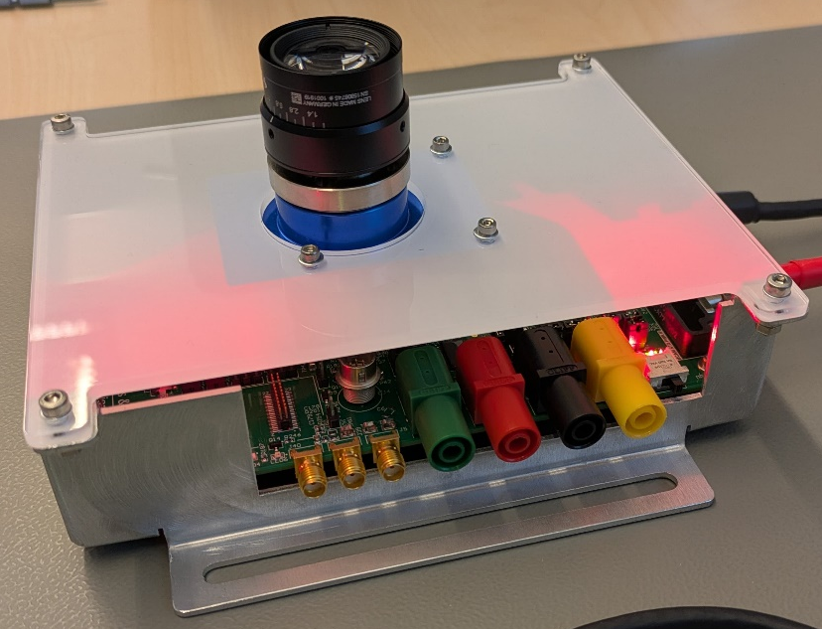
Figure 3: BeamCAM EBB
For the BeamCAM, EBB, the components adaptations are the followed:
- Rad-tolerant Clock
- 12v to 5v module: CERN DC/DC.

Block Diagrams
See in [RD03]

Mechanical Information
See in [RD03]

Proof of concept evolution / Components improvements
In the following table are listed the components changes between the prototype used during the first test in the CHARM facility (see [RD02]) and the new BeamCAM EBB. These changes are coming from the MCAMv4 design, which will be the basis for the future BeamCAM. The below information is also part of [RD05].
Table 1: Changes / designs or PNs
Elements or functions | Descriptions / Remarks
Transistor PMOS | - PN change for automotive grade from same techno and same manufacturer.  - Reduced package size.  - Radiation impact: No gate rupture expected (less than 4V operations).  Ref doc: see [RD06].
FPGA PN | - For integration purpose the FPGA is taking with smaller size (484 BGA with pitches of 0.8mm instead of 1mm previously).  - Power consideration to reduce SEE sensitivity: NO BANK powered at 3V3 -> Power topology design changes.  - Same die techno between COTS and RadTol
Power On Reset (IC and passives elements) | Removed: done by FPGA.  Present on EBB but as back-up.
Power topology Design | Major changes:  - All components were changed for having COTS/Automotive grade and Radtol equivalents counterpart that are packages and sizes similar. To allow easy swap for screen quality for any camera’s types.  - Following “new space plastic opportunity”  - Remove one FEAST for size purpose -> 5V to 1V  - DC/DC for FPGA power supplies to reduce power loss for conversion.  - LDO changed  - Sensors power topology optimization  - DC/DC changed  - Optional: added a Radtol Power E-FUSE IC from TI in power path (that is more for the space version of the camera) / Watch out: price by camera will be more expensive.
Trigger Input | Add a reverse diode on negative input line, to avoid damage when a wrong polarity connection is made.  Generic 1N4148. (see JAN level for more screening or databases for RT)
Clock | POC PN BeamCAM Radtol Clock will be use.  Another Radtol clock can be also used on the EBB as alternative.

Evolution of the power topology
Below Power Topology for Ethernet camera type Beamcam:

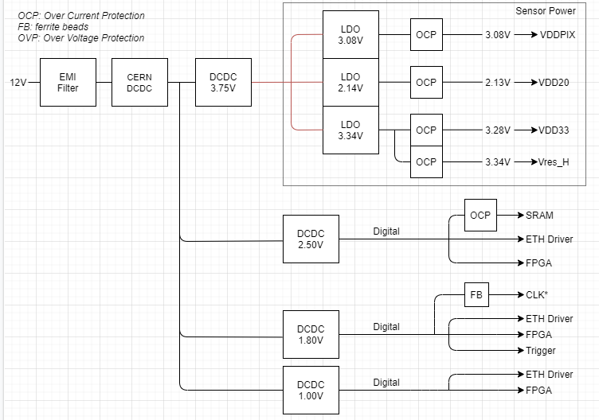
Figure 4: Power Path
Main changes:
- PN LDO converter changed
- Power converters for the sensors are reduces to 3x LDO instead of 4x.
- Power converters for the FPGA are changed for DC/DC’s types. NEW PN. Dual output ICs.
- No FPGA banks at 3V3 to reduce radiation sensitivity.

Latch-up protections
Some sensitives parts have their power supplies protect against latch-up events:
- All sensors supply
- SRAM supply
In Case of a detection of an over-current on the sensor or on the SRAM latch-up detection, the FPGA will process a restart and Reset of the sensor and SRAM.

BeamCAM EBB Connectors identification
Here below a description of the BeamCAM EBB connectors and interfaces:
J4

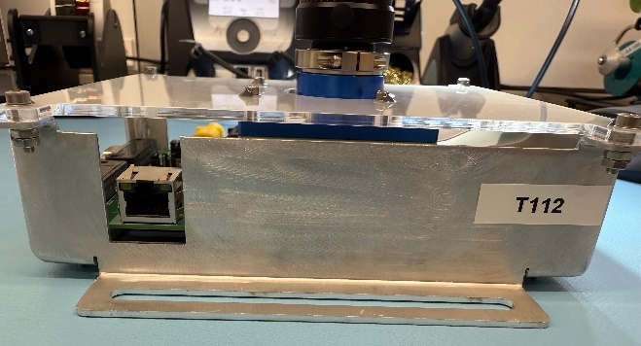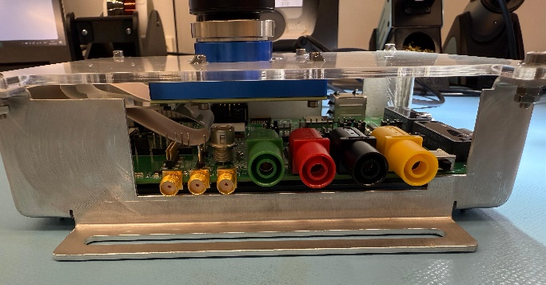
Switch left on ON position
J01E
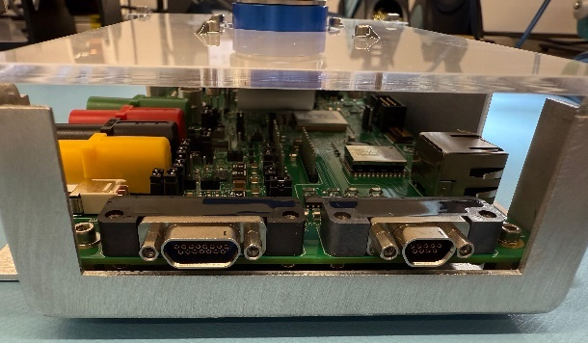
J9
J7
J8
J40
J39
J5
J10
J01
J02
Figure 5 Connectors IFs of EBBv4

Interfaces Connections at Camera level
Table 2: Connectors to be use
Designators | Type | Description | PN | Remarks / Notes
J01 | MDM9-Femal | SpW IF V4 | NA | NOT USED FOR BEAMCAM
J02 | MDM15-Femals | PWR IF V4 | NA | NOT USED FOR BEAMCAM
J01E | RJ45 | Ethernet IFs | 615008137421 | Note Ground connection to chassis: 2x 100pf 2kv.
J4 | Barrel Connector | BeamCAM IFs | HR10-7R-6PA(73) | All Beamcam IF integrated Power and trigger.Adaptor cable to banana 4mm shall be mounted before closing top panel of the mechanic
J5 | SMA Connector | Isolated Trigger Ifs | SMA-RA-E | Second option for Trigger IF for Beamcam
J7 | Black 4mm Plug Banana IF | GND Interface | FCR7350B | Ground connection for Power the camera
J8 | Red 4mm Plug Banana IF | +5vdc Interface | FCR7350R | NOT USED FOR BEAMCAM
J9 | Yellow 4mm Plug Banana IF | Chassis Interface | FCR7350Y | NOT USED FOR BEAMCAM
J10 | Green 4mm Plug Banana IF | +12vdc Interface | FCR7350G | +12V connection for Power the camera
J39 | SMA Connector | FPGA Live probe B | SMA-RA-E | NOT USED FOR BEAMCAM
J40 | SMA Connector | FPGA Live probe A | SMA-RA-E | NOT USED FOR BEAMCAM

Electrical schematic of specific connectors

Barrel HR10 (specific to BeamCAM EBB)
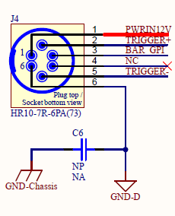
Figure 6: J4 Schematic

Trigger SMA
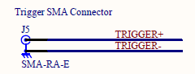
Figure 7: J5 schematic

Power 4MM Plug Bananas
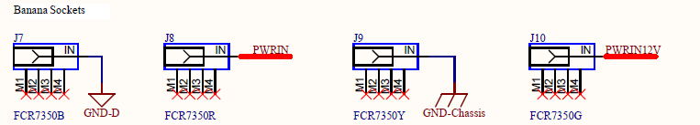
Figure 8: 4mm plugs schematic

Ethernet RJ45
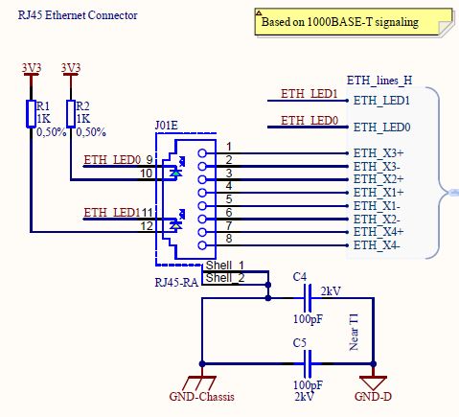
Figure 9: ETH connector schematic

BeamCAM EBB HW settings
The BeamCAM EBB will be tested according to the last HW definition coming from the MCAMv4 project (currently on-going), meaning all HW changes identified in the frame of this development project, as improvements or bugs fixing are implemented.
The tested HW is then in the last MCAMv4 Ethernet evolution and contains also the specific DC/DC and trigger IFs which are foreseen to be implemented in the future BeamCAM.
The BeamCAM EBB jumpers settings are according to the Ethernet configuration and specific power supply and trigger IFs. This is under MCSE responsibility.
The Power On switch (see in section 5.6) shall be always in ON position and shall never be switched OFF when the CERN DCDC is used.

BeamCAM EBB FW settings
Each MCAMv4 / BeamCAM image sensor shall be individually calibrated. Four parameters must be set-up at the beginning of a video or images capture session. The image sensor dedicated values are measured during camera manufacturing and provided to the customer.
In the frame of the CHARM test the dedicated MCSE test SW will be in charge to set-up correctly these values.
Concerning the image acquisition, it is foreseen to set a standard acquisition time between 10 and 20ms. It is possible that the internal gain must be adapted during the test, to consider image degradation.

BeamCAM EBB identification
As described in the test presentation, there will be two identical test set-up (meaning the list provided in section 7 must be prepared twice and the generic tests setup procedure followed two times (two reports to be provided).
The two DUT (BeamCAM EBB) will be :
- MCSE S/N T112 with a monochrome image sensor
- MCSE S/N T133 with a color image sensor
Note that, due to tight schedule in the FW development, the embedded FW of both DUT will be exactly the same. The HK and TM will indicate in a false manner that the image sensor is a b/w one, but that will not prevent to make images interpretation by a dedicated SW in a second step.
The optics will be provided by the CERN. The opto-mechanical I/F shall be C-Mount.

Test premises

CHARM Test Chamber CERN
The CHARM facility, located in CERN’s East Area, receives Proton Synchrotron (PS) spills of up to
5 × 1011 protons, 400 ms long, at 24 GeV/c. The beam strikes a metallic target, producing a mixed radiation field—neutrons, protons, photons, electrons, and muons—via spallation. Resulting dose rates range from 10 µGy/h to 1 Gy/h, with fluxes up to 1e9 particles/cm2/s, enabling electronics testing in radiation conditions representative of accelerators, space, and nuclear facilities.
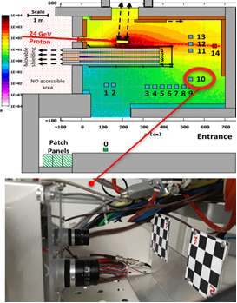
Figure 10: Top: CHARM facility irradiation layout, with the BeamCAM setup in location ’10’. Bottom: Two BeamCAM systems, each with a dedicated black-and-white target to probe visibility.

Preparation room 157/1-N26
The preparation room contains equipment (mainly the interfaces) which simulate the ones which are located in the irradiation test control room and the irradiation test room. It allows to prepare the irradiation test in an advance manner, in testing and validating the DUT and equipment provided by the customer (i.e. MCSE) in the same conditions than within the irradiation test control and test rooms.
Here below some pictures of the preparation room :
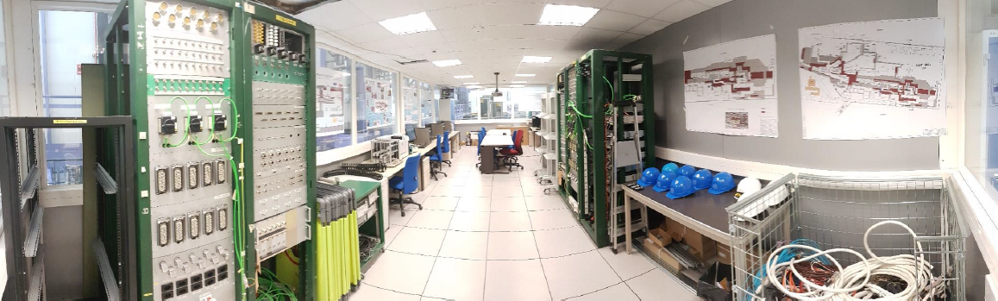
Figure 11: preparation room (general view)
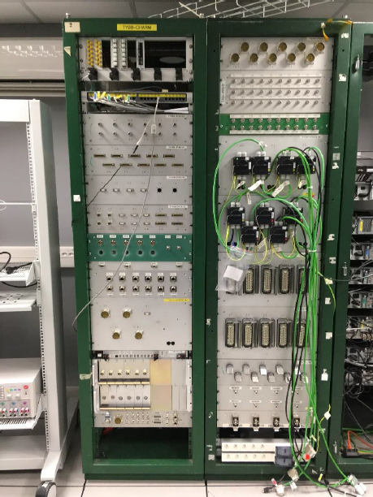  Figure 12: preparation room data acquisition patch panel | 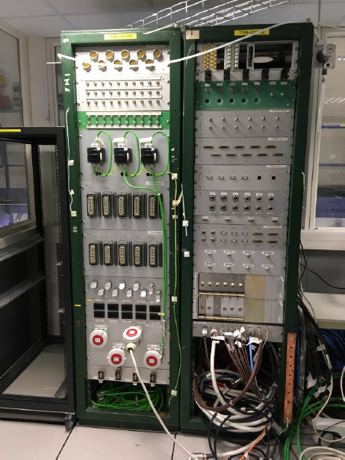  Figure 13: preparation room irradiation panel
Some recommendations from the CHARM Team :
- Cables must be properly labelled and as easy and fast as possible to connect /disconnect (no terminal screw)
- Cables used to connect the patch panels should be the cables that will be used for the irradiation test (already installed or not in the cable holder)
IT network (GPN and TN) is available in preparation and control rooms, allowing remote control of computers.
The length of the cables between the patch panels have been checked by MCSE and are compatible with the foreseen test set-up.

Beam area

Conveyor
The DUTs will be installed in a conveyor which is used to move them under the beam location. There are several of them of different sizes. For the BeamCAM test the Overhead conveyer (position G16) will be used, as during the previous test. The mechanical test set-up will also be the same, all needed mechanical parts are available.
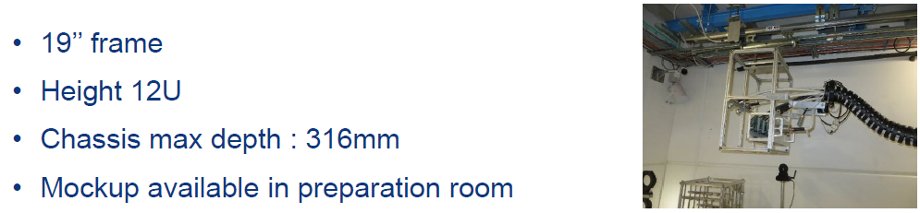
Figure 14: Overhead conveyor description

Panels
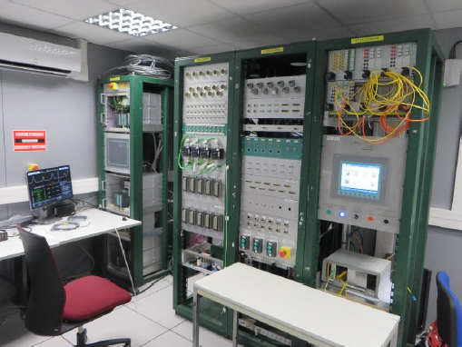
Figure 15: Data acquisition panel
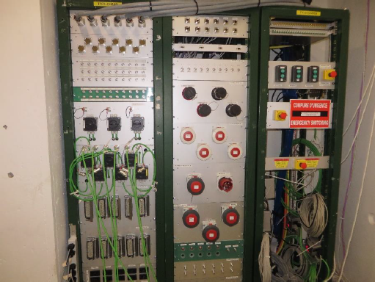
Figure 16: Irradiation panel

Personnel preparation
The people who will work in the CHARM facilities shall respect the following points :
- External users must be preregistered in order to be able to access to their CERN web account (in which most of the formalities could be done)
- Access rights required for the different rooms and locations
- Safety trainings to be followed

Installation in the Beam Area
The following operations are foreseen on Wednesday the 22nd of October :
- Access to beam area on Wednesday morning from 9h
- As soon as previous users removed their rack from control room 157-1-N28: installation of the new rack (not powered)
- Access in beam area on agreement with CHARM team
- Connection of the cables : patch panel + rack (1 team at a time)
- Powering and test of the setup (after confirmation of CHARM team)
- Transport of the rack to final test position
- End of access
- Beam expected usually in the afternoon

Precautions to be taken during the Beam test
The following precautions must be followed during the whole Beam Test :
- No access possible into the beam area for the whole week
- No restriction to access in preparation and control rooms
- Personal dosimeter mandatory. Preferably take active dosimeters (DMC) from bld 55 (some pool dosimeters available at CHARM)
- Shoes and helmets mandatory
- No drink or food
- Close the doors as often as possible (air conditioning)
- Inform CHARM team in case your setup fails or if you reached your target dose. We could anticipate the target removal in order to reduce the radiation doses during the next weekly access

End of the test
Activities to be performed at the end of the test :
- Access on Wednesday morning
- Disconnection patch panel + rack
- Protection of cables connectors for storage
- Material stored 1-2 weeks in internal buffer zone for cooldown
- User will be contacted few weeks later to retrieve their materials (TREC registration from RP buffer zone 157/R-O21)
- Material from the control and preparation rooms can be retrieved without any request.
- The facility can store the cables for later reuse
- Keep the control room tidy and clean

Test Set-up
In a general manner the instructions given in the Generic Test Setup Installation Guide [RD03] must be strictly followed. In this section 7 specific information for the test of the BeamCAM at CHARM are given.

Diagram Test Set-up
The following test diagram is the same as in the Generic test set-up [RD03] section 5.4, but consider the two rooms in CHARM :
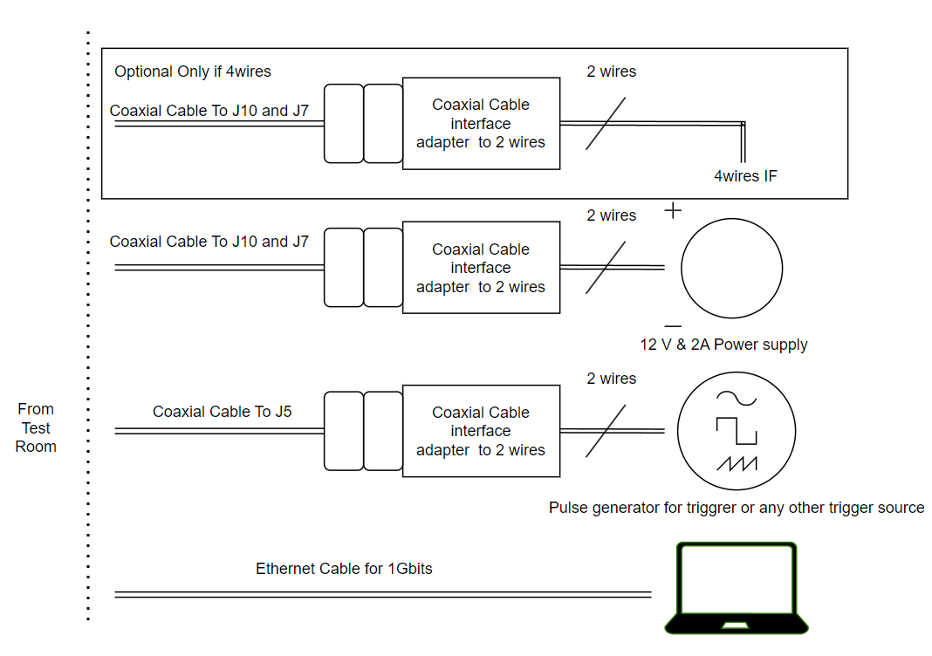
Figure 17: test set-up in the Beam control room
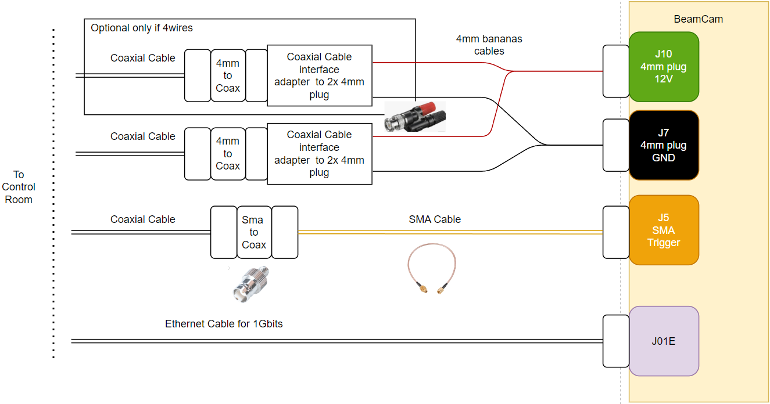
Figure 18: test set-up in the Beam test room

Test Equipment
Generally, the test Equipment listed in [RD03] must be used (see section 6.1.3 List of equipment).
However, the following list of equipment must be discussed with the CHARM Team before the dry run in order to be fully compatible with the CHARM test equipment:
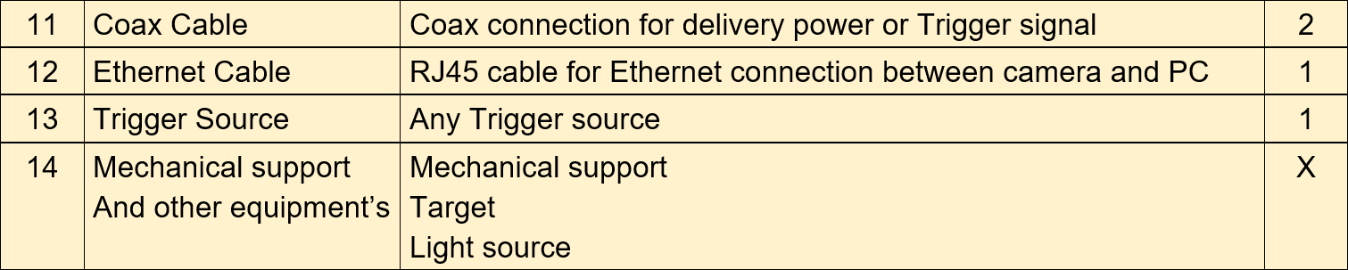

Coax cable (item 11) solutions

Solution 1: SMA and 4mm to BNC
Solution presented in sketch. TBD

Solution 2: HR Barrel to 4mm then to BNC
Back-up solution: MCSE to provide adaptor cable from HR barrel interface to 4mm plug adaptor or Coax interface. TBD.

As-run Set-up installation
The Generic Test Setup Installation Guide [RD03] contains an as-run test set-up installation in section 6.5, to be performed twice since there will be two identical test set-ups. Here below some notes about the specific installation in the CHARM facility :
- Step 4 : the remote access SW will be TeamViewer. Settings and access :
- TBD
- TBD
- Networks requests to be done ASAP (Dry run + control room)
- Step 5 : the dedicated list of equipment (number 11 in section 6.1.3 List of equipment in [RD03]) : the coax connection shall still be discussed between the CHARM team and MCSE, if possible before the dry test.
- Step14 (optional) : will not be done. It seems the final voltage in the accelerators facilities will be 10V. The DUT input DC/DC is able to accept as low as 5V.
- Step 15 (optional) : will not be done, the trigger is provided by the CHARM facility and the trigger I/F is already compatible.

Previous Test-Set-up Installation
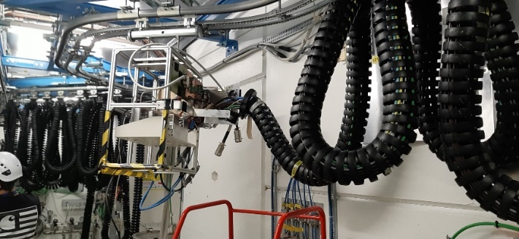
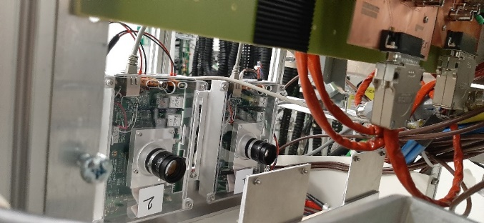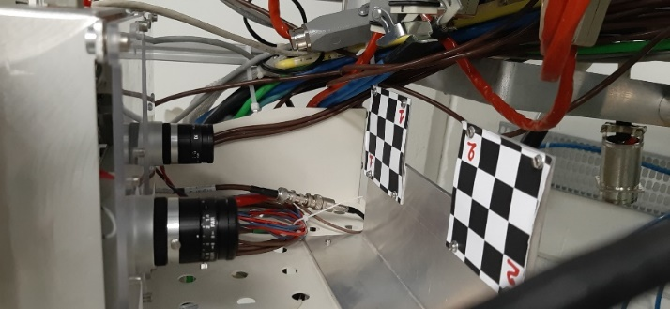
Figure 19: Pervious test set-up

Test set-up support for conveyer
Test support shall be the same as the one from the previous one. A sight shall be mounted in front of both DUT optics. .
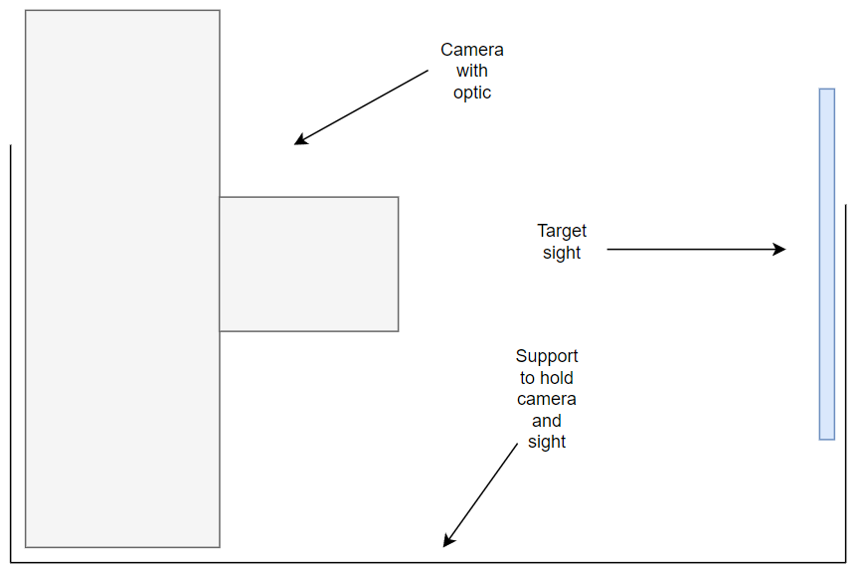
Figure 20: test support for conveyer
The CHARM team is responsible for the correct lightning of the two sights, which must be as uniform as possible.

External (MCSE) equipment needed in Control Room
The following MCSE equipment is needed in Control Room :
Table 3: Test Equipment
Type | Description | Remarks / Notes
PSU  Min: 12V 2 Amp. | Power supply for the camera | 4wires interfaces for the voltage level to guaranty the 12V at the DUT level is a plus! (Cables for power shall be the all the same length and gauge).  Current protection / limitation at 1.8A. TBD  Data to be monitor and log to a computer
Computer | Computer for safety | to log all data from PSU, Power cycling counter of the camera and trigger etc.  Manage Failures and event by power cycling unit.
Computer | Computer to operate the camera | software to control the camera; Test sequences; etc.  Log images and Housekeeping data
Computer | Computer storage | The computer shall have sufficient memory place to store all the data
Note : the trigger signal will come from the CHARM equipment.

FDIR during Test
Below descriptions of potential faults that may occurred during the irradiation test, with the potential causes and the recovery actions to apply if encountered
The software which controls the test will only check that the DUT is still functioning (see in section x). The below error’s conditions detection and recovery action need to regularly (ideal once a day) connect to the remote PC, download a few images from the saved ones and assess them. Power cycles will be done remotely as needed and new checks performed.
A decision to continue or stop the whole test session will be taken on a case-by-case basis, individually for each DUT.
ID | Name | Description of fault | Potential Causes | Recovery
1 | Image corrupted | Only noises in images are sent back from the camera | Sensor connection with FPGA is having an issue.  Single events on sensor-FPGA LVDs interfaces; FCC cable connection between sensor-FPGA is not properly connected | Power cycles the camera and resend a ping and wait for HKs and next images.  If persistent, the sensor is lost.  Continuing the test with the Image test acquisition.
2 | Image harshly under / over exposed toward ref image | Too much exposition or too lower exposition that cannot be related to the degradation from sensor because of irradiation accumulation dose. | Sensor signal conditioning of pixels may have suffered from single event (Sensor ADC, PGA, etc.).  Or corruption of sensor parameters | Send back to the camera, the sensor parameters.  If the fault is persistent power cycle the camera.  If it is still present the sensor is damaged
3 | Image pixels are mixed / lines, and columns, Splits of images | Lines and/or columns are mixed in the images received. | Issue on the ethernet link or in the ethernet driver.  FPGA lost a loop in Transmission. | Sent a HKs request or ping, and wait for next image, if persistent power cycle the camera.  If it is still present the camera FPGA and or Ethernet driver have a degraded mode in ethernet sub-function.
4 | Housekeeping  Data sensor counter OCP increased | HKs are sending back OCP counters with increments | The power supplies of the sensor have been in limiter mode for the current: latch up events on sensor powers supplies.  ------  FPGA is protected the sensor by a quick switch off of the sensor powers supplies. | The FPGA is power cycle the sensor, log the event, the image shall be corrupted.  If events of counter happen a lot the sensor is sensible of the intensity of the radiation cocktail.  If persistent power cycle the camera.  If still present and, no image can be acquired the sensor is probably dead
5 | No Ping feedback on ethernet | The camera doesn’t answer a ping from the control computer on ethernet | Loss of ethernet communication link on FPGA or Eth driver | Power cycles the camera and resend a ping and wait for HKs.  If persistent, the camera communication link is lost.
6 | Over current on PSU | Hight non-expected current happen on the PSU.  Current drawn maybe to Hight | Latch-up events in camera somewhere not expected in power supply path. | Power cycles the camera and resend a ping and wait for HKs.  If persistent, the camera is lost.
7 | Voltage drop on PSU | Hight non-expected current happen on the PSU. Voltage drops with current limiter | Latch-up events in camera somewhere not expected in power supply path. | Power cycles the camera and resend a ping and wait for HKs.  If persistent, the camera is lost.

------------------------------- End of document -------------------------------

