BOND-M: Eng. design activities 02

Attendants: N. Lusa, A. Temporal, N. Bourcey, N. Peray, Dimitris & J. Ferradas
Date: 10/10/2025

Minutes from the discussion:
- Nico P. shared with Alexandre the CATIA models for the first coil reference drawings:
  - 2D cross section with the definition of cable and insulation layers
  - 2D longitudinal cut with the definition of the coil end parameters
  - 2D cross section to check the minimum pole material thickness as a function of the coil end parameters

- For starting the coil design, the following values have been agreed:
  - Symmetric coil ends (as BOND)
  - 2 mm minimum material thickness in the pole
  - 8-degree angle (gentle flaring, same as BOND)

- The main parameters that remain to be agreed are the following:
  - Curvature radius:
    - For the moment = 750 mm (same as BOND & FRESCA)
    - BOND winding trials showed that 450 mm was feasible (https://indico.cern.ch/event/1458339/contributions/6144958/attachments/2938514/5162020/14T_Winding_Test_Sharing_Experience_Workshop_EFM.pdf)
    - It seems that we have margin here. Additionally, it depends on the cable width, which is significantly different for BOND and BOND-M
    - On the contrary, following HD experience the curvature radius was increased from 349 mm (HD2) to more than 1 m (HD3) to improve the instabilities seen in HD2 coils (https://ieeexplore.ieee.org/stamp/stamp.jsp?tp=&arnumber=6461063)
    - Proposal: Check how much we can gain in the end length by optimizing this parameter for BOND-M. Just to have an answer on what we’re talking about.

  - Distance from the exit of the layer jump to the beginning of the easy-way bend:
    - Option 1) 20 mm set in BOND based on winding tests
    - Option 2) 50 mm, ~½ of cable twist pitch based on MQXFB experience (keystoned cable, cos-theta geometry)
    - Proposal: Perform a winding test as done for BOND to determine if the stability of the 20 mm option is good.
      - Winding machine is not available at B.180. We will do it at B.927 by blocking the tilting of the mandrel.
      - Nico P. will share with Alexandre the 3D model of the BOND winding test tooling.
      - Check if we have an study of the minimum bending radius on soft-way and hard-way for MQXF.

Action items for next meeting:
- Alexandre:
  - TASK 1)
    - Start with the creation of the bare and insulated cable models.
  - TASK 2)
    - Inspired on BOND (using the files shared by Nico P) create the first reference drawings for BOND-M:
      - 2D cross section with the definition of cable and insulation layers
      - 2D longitudinal cut with the definition of the coil ends parameters
      - 2D cross section to check the minimum pole material thickness as a function of the coil end parameters
  - TASK 3)
    - 3D design of a quick mockup for winding trials, to be 3D printed.
      - Contains the layer jump geometry and coil end
      - BOND equivalent model has been shared by Nico P.
      - Mock-up to be compatible with 927 winding machines
      - Parameters:
        - 20 mm from the exit of the layer jump to the beginning of the easy-way bend.
        - 750 mm curvature radius

- Jose:
  - TASK 1)
    - Share with Alexandre the main coil and conductor parameters:
      - Cable dimensions
      - Interlayer thickness
      - Insulation layers

Supporting material:
FRESCA2:
- FRESCA2 curvature radius ~ 700 mm (https://link.springer.com/chapter/10.1007/978-3-030-16118-7_12)
  - “The minimum hard-way bending radius of the flared ends is set to 700 mm, based on experience from HD3, for which the bending radius was increased from 349 mm to 873 mm”
- Angle is 17 degrees (https://cds.cern.ch/record/1516045/files/CERN-ATS-2013-022.pdf)
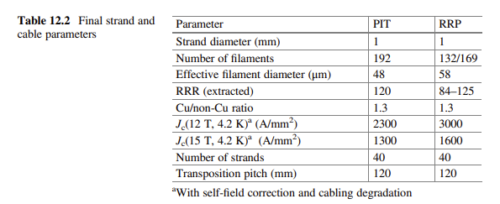

BOND:
- For BOND, although winding tests showed that 450 mm was feasible, we decided to align to FRESCA2 and HD experience and to increase it to 750 mm.
- (https://indico.cern.ch/event/1458339/contributions/6144958/attachments/2938514/5162020/14T_Winding_Test_Sharing_Experience_Workshop_EFM.pdf)
- Angle is 8 degrees
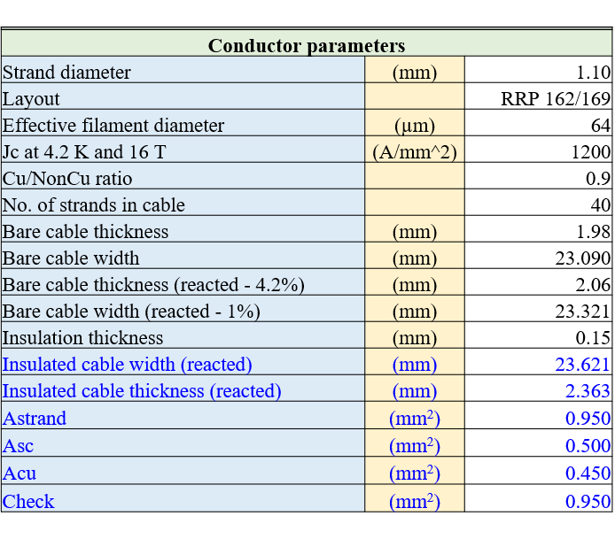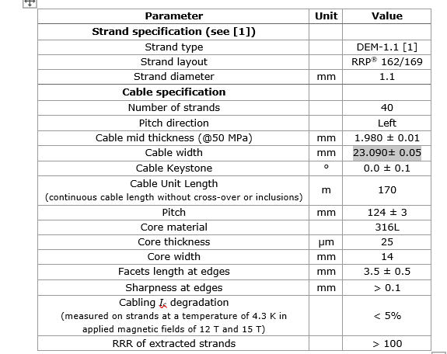

HD:
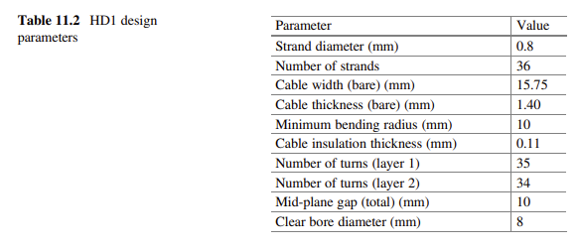
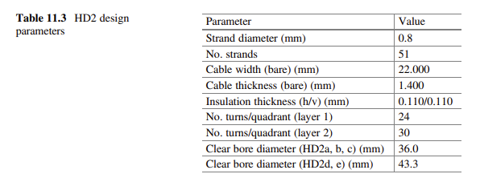
- HD2 curvature radius ~ 350 mm. Ugly transition in the ends when cutting the coils for inspection. Increased for HD3.
- HD3 and TFD hard-way curvature radius ~ 1m
- See: https://ieeexplore.ieee.org/stamp/stamp.jsp?tp=&arnumber=6461063

TFD:
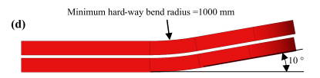
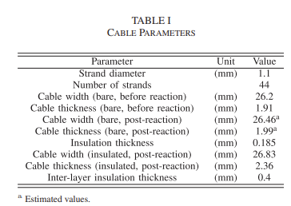
See: https://ieeexplore.ieee.org/stamp/stamp.jsp?tp=&arnumber=9733270

