MuCol Management Committee 07/10/2025
Date: 2025-11-05 | Project/Activity: MuCol

Attendees: Chris Rogers (Chair), Roberto Losito, Elias Metral, Bernardo Bordini, Steinar Stapnes, Nadia Pastrone, Massimo Casarsa, Anton Lechner, Federico Meloni, R. Taylor, Antoine Chance, Lucio Rossi, Sergo Jindariani, Mark Palmer, Tania Martucci
Total: 15

Description:
The meeting was held remotely on Zoom. The MuCol Management Committee (MC) members were invited to participate.

Chair: C.Rogers

Agenda: 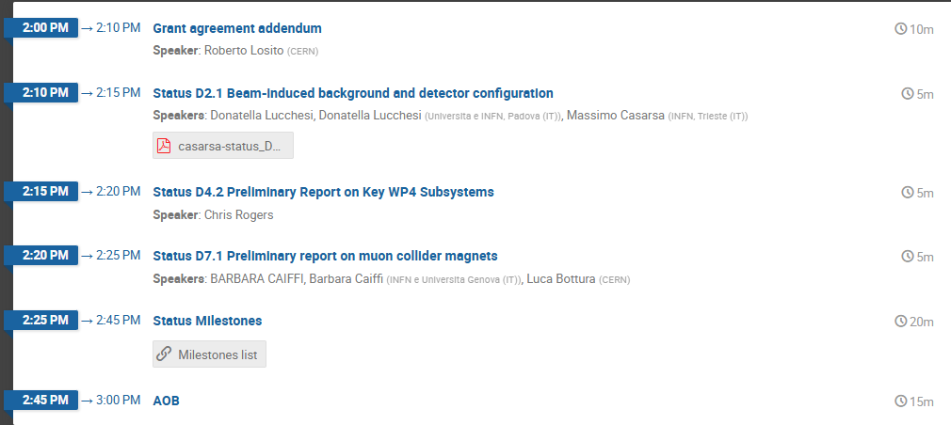

Indico page (including presentations): 27# MuCol Management Committee (October 7, 2025) · Indico
Other materials:

Prepared by: T.Martucci |  | Date: 2025-11-05
Revised by: MuCol GB |  | Date: 2024-11-XX
Approved by: MuCol GB |  | Date: 2024-XX-XX

Distribution List: Standing members of the meeting and participants

Decisions
No | ISSUE | DESCRIPTION | STATUS | VOTING

Actions
ISSUE | RESPONSIBLE | DEADLINE

DISCUSSION

Highlights during this MuCol MC meeting:
TOPIC | WP/ISSUE | COMMENT
Welcome (C.Rogers) |  | Chris Rogers opened the meeting and noted that Daniel Schulte was absent. The focus was on the MuCol project activities and upcoming deliverables and milestones.
1. Addendum to the Grant Agreement (R. Losito) | Project Administration | Following the positive midterm review, the EC requested a formal amendment to include updated Dissemination & Exploitation Plan (M32), revised Data Management Plan, and Policy Brief. The amendment has been submitted; feedback expected mid-November 2025.  R.Losito informed that he will take on new responsibilities at CERN starting January and will gradually hand over MuCol-related duties.  C. Rogers thanked Roberto for his major contribution to the success and smooth operation of the MuCol grant.
2. Status of Deliverables (C. Rogers) | WP | Chris Rogers reviewed ongoing deliverables and requested short status updates from WP leaders:  Deliverable D2.1 - Beam-Induced Background and Detector Configuration (M. Casarsa, on behalf of D. Lucchesi):  - Detector configuration completed: two detector concepts (MUSIC and MAYA), both publicly available on GitHub.  - Beam-induced background samples at 10 TeV (muon decay and incoherent e⁺e⁻ pair production) have been generated and used in studies.  - Work ongoing to define publication format and licensing of data.  - Data volume: ~2 GB; potential upload to Zenodo being evaluated.  Deliverable D4.2 – Preliminary Report on Key Work Methods for Subsystems (C. Rogers):  - Draft under preparation, with inputs from several contributors (target, cooling, demonstrator).  - First draft delayed but expected by mid-October; final version due end of November.  - Sections include: targets, cooling systems, magnetic shielding, demonstrator optics, and BDSim work.  - Authors to finalise sections within two weeks to allow formatting and review.  Deliverable D6.3 – Magnet Technology Report (B. Bordini)  - Deliverable due 30 November; document to be concise (approx. 10 pages).  - Structure based on European Strategy document; each task leader will provide a dedicated section.  - Will include latest results presented at MT Conference (Boston) and EUCAS (Porto).  - A Milestone Workshop on High-Field Solenoids will be held at the end of November, with international participation.
3. Status of Milestones (C. Rogers) | WP | Review of milestones due in the coming months:  M7 – Parameters Report (R. Taylor):  - Summary of parameters to be finalised by 10 October; draft in Overleaf by 13 October.  - Review by MuCol and approval planned by 27–31 October.  - U.S. colleagues (USMCC) to contribute to the review.  M19 – High-Field Solenoid Workshop  Workshop confirmed for end of November 2025; programme and invited speakers finalised.  M21 - Cooling Cell 3D Model (L. Rossi / R. Losito)  3D model being produced in Inventor, later converted to CATIA. Completion expected end Nov / mid-Dec 2025.
Any Other Business (AOB) |  | INFN School of Erice (L. Rossi)  School on Higgs-factory options (26–30 Nov 2025). Chris Rogers to circulate information and poster.  – Beam Dynamics Report access (R. Taylor / C. Rogers) WP4  Overleaf link to be re-shared with contributors; submission deadline end Nov 2025.
Closing |  | Chris Rogers thanked all participants for the progress and collaboration.  Next management meeting: to be announced.

