**Experiments expectations, plans and constraints**

B. Gorini, E. Meschi, CERN, Geneva, Switzerland

Abstract

The paper discusses the input from the experiments that is relevant to define the program for 2012.

It covers the target for integrated luminosity, for both p-p and Heavy Ion physics, the configuration for the Heavy Ion period (p-Pb, Pb-Pb or both) and the requests for special runs (high beta, VdM scan with un-squeezed beam, high or low pile-up runs…).

The impact of LHC parameters and conditions on the experiments is also discussed, including the effect of pile-up (would experiment performance be limited next year with 50 ns?), beam energy, bunch length, vacuum and background, etc..

Proposals for optimizations will also be discussed, including the use of satellite-main collisions to provide luminosity for ALICE and suggestions for reducing the overhead of ALICE and LHCb polarity reversals.

## Physics goals

### Proton-Proton physics

2012 is a crucial year for all LHC experiments, in particular considering the subsequent long shutdown. It is thus clear that few minimal results have to be achieved in 2012.

The major emphasis is of course on the search for the Higgs boson [1]. This year’s running period should provide enough statistics to either claim the discovery of the Higgs or exclude it to 95% confidence level down to a mass value of 115 GeV/c2 .

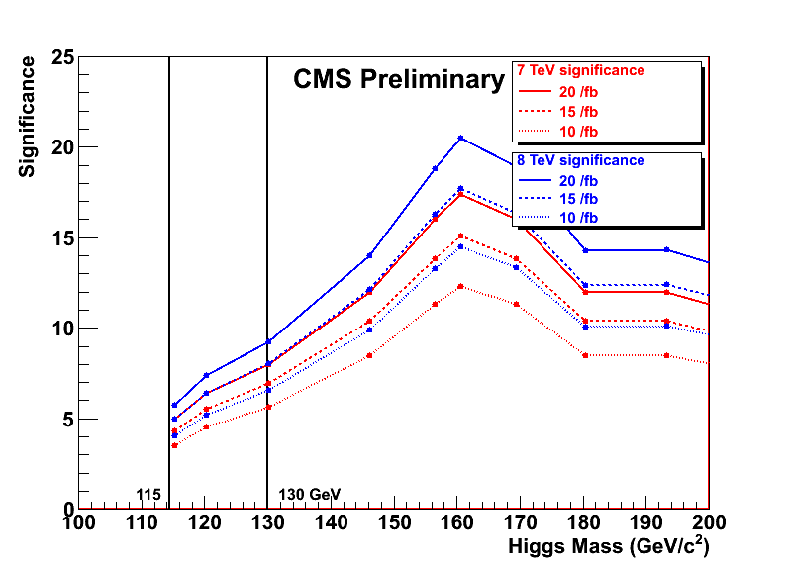

Figure 1: Montecarlo estimates of achievable sensitivity, expressed in number of σs, for Higgs discovery as a function of the Higgs mass and for different LHC center of mass energy and integrated luminosity.

Figure 1 shows an example of the Montecarlo predictions for the discovery potential as a function of the Higgs mass and the collected luminosity. One can deduce that, assuming a center of mass energy of 8 TeV for the LHC, about 15 fb-1 of integrated luminosity per experiment need to be collected before the shutdown, to ensure a sensitivity of 5 σ per experiment over the entirety of the Higgs mass range consistent with the Standard Model.



Figure 2: The amount of integrated luminosity at 8 or 9 TeV which gives the same median sensitivity as a function of Higgs boson mass as 1 fb−1 at 7 TeV.

It is important to note that the luminosity usable for analysis is only a subset of the total delivered by the LHC. Typically, extrapolations from the 2011 run indicate that about 15% of the delivered luminosity is not included in the analyses because of either data taking inefficiencies (causing the collision data not to be recorded on tape) or detector issues (causing the data to be rejected by quality checks).

In addition to these considerations, it must also be noted that the data from 2011 have been collected at a lower center of mass energy, resulting in a lower effective statistical power for Higgs searches than the 2012 data. Figure 2 shows the estimated effect of the increased center of mass energy on the statistical sensitivity, as a function of the Higgs mass.

These considerations lead us to conclude that an ideal target for total integrated luminosity collected before the first long shutdown would be 20 fb-1, which translates into a target of about 15 fb-1 for the 2012 data taking period alone.

The Higgs search is only one of the topics of the very rich physics program at the LHC. In particular searches for new physics beyond the Standard Model are of paramount importance for CERN and all the experiment communities. As a benchmark example one can consider the very sensitive probe that is the branching ratio of the $B_{S}→μμ$ decay [2]. Figure 3 shows the projected sensitivity of the LHCb measurement as a function of the total integrated luminosity, and the comparison with the prediction from the Standard Model. It is thus possible to derive a target for the total luminosity integrated by LHCb before the shutdown of about 2.5 fb-1, corresponding to about 1.5 fb-1 for the 2012 data taking campaign.

In addition to the low-beta program for proton-proton physics, very high * measurements have a potentially very interesting program. Its ultimate goal is the investigation of the diffractive cross section in the very large pseudo-rapidity region, as well as the measurement of the total cross section for p-p interactions at the LHC center of mass energy [3]. In particular, an independent measurement of the total cross section requires the ability to measure the elastic cross section for very low momentum transfer, up to the region where the well-understood Coulomb interaction contribution becomes dominant over the nuclear one. Figure 4 shows the relation between the beam optics and the distance of closest approach of the Roman Pots required to reach the region of interest.

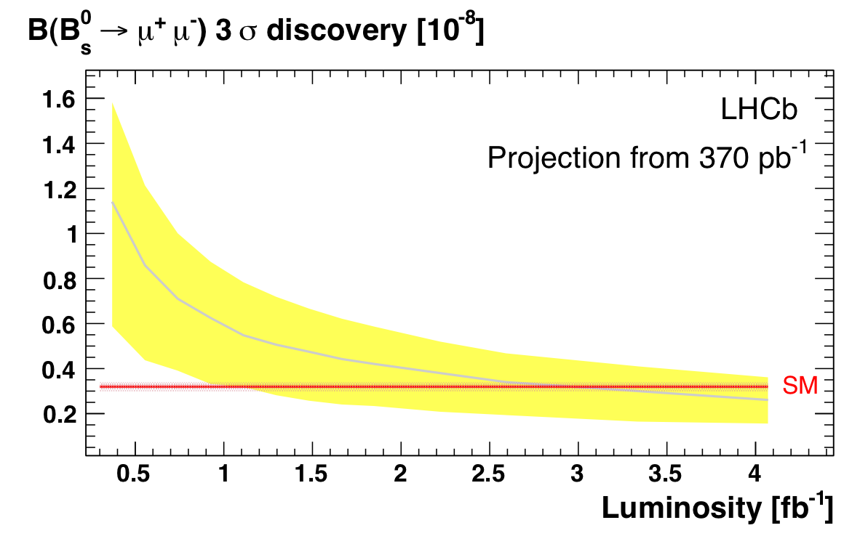

Figure 3: Interval for 3σ discovery of $B_{S}→μμ$ branching ration as a function of integrated luminosity and comparison with the Standard Model prediction.

### Heavy ions physics

After the success of Pb-Pb data taking in 2011, the main goal of the heavy ion run in 2012 will be to collect statistics in the more challenging p-Pb configuration.

Measurements in such a configuration will provide first of all a baseline comparison for Pb-Pb physics, but also potentially very interesting QCD probes, e.g. for the investigation of parton saturation at low *x.* Describing the complete physics program in any detail would go beyond the scope of these proceedings, but the interested reader can find an overview in [4].

Making estimates of achievable luminosities is subject to large uncertainties, due to the new machine configuration. Initial estimates indicate that a reasonable target for this year’s data taking would be to achieve 30 nb-1 of integrated luminosity.

Some data taking with proton-proton beams at different center of mass energy, to serve as a reference for Pb-Pb measurements, is also being considered for the Heavy Ions period, but a final program will only be agreed later in the year.

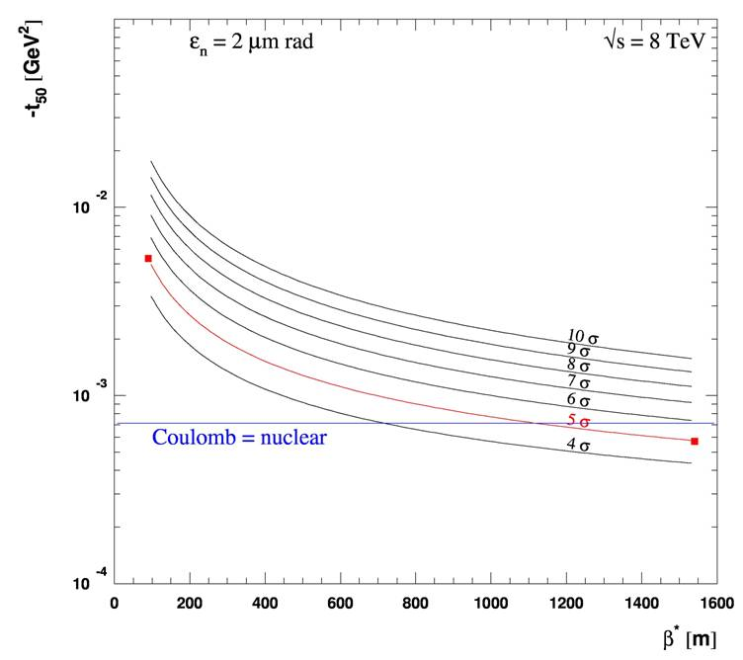

Figure 4: Reachable four-momentum transfer squared *t* as a function of β* and for different distance of approach of the Roman Pot detectors to the beam, expressed in beam sigmas. The blue line shows the value of *t* for which the Coulomb and nuclear components of the elastic cross section have the same value.

## Considerations about p-p beam parameters

The principal LHC configuration changes that are considered for 2012 are a possible increase in center of mass energy and a smaller * for the high luminosity experiments.

Figure 5 shows an estimate of the ratio of effective gluon-gluon luminosity [5], between different p-p center of mass energies as a function of the gluon-gluon invariant mass. It is clear that increasing the center of mass beam energy from 7 TeV to 8 TeV translates into a factor 2 to 4 increased reach for physics beyond the standard model. The benefit on sensitivity for the Higgs searches has already been discussed in the previous section. Taking all this into account the experiments have expressed a clear support for such an energy increase, under the assumption that the operational risks would not be significantly increased.

With respect to further reduction of *, or any other effort to improve the LHC peak luminosity, the main parameter to consider is the corresponding increase in pile-up level. In a configuration with 50 ns bunch spacing and β* of 0.6 m, the average number of p-p interactions per bunch crossing could reach a value of about 30 at the beginning of the fills. Despite the fact that ATLAS and CMS have been nominally designed for lower pile-up values, initial studies show no indication that the increased pile-up would prevent them from running. The effect of pile-up consists mainly of a progressive loss of efficiency, mainly due to the impact of the tracks from the additional collisions on the reconstruction algorithms. Some effects can possibly be mitigated by an appropriate optimization of the said algorithms, for example the loss in vertex reconstruction efficiency. Some other effects, like the degradation of the energy resolution of the calorimeters due to the additional fluctuations induced by the energy deposition of the products of pile-up events, cannot be corrected. In the end, all these effects result in some of the delivered luminosity being unusable. The studies suggest that, even for the highest possible pile-up values foreseen for 2012, the induced inefficiencies will be more than balanced by the increase in effective delivered luminosity. Under these assumptions ATLAS and CMS support modifications to the running parameters intended to maximize the peak luminosity. At the same tine it is recommended that some effort would be invested in commissioning a luminosity leveling mechanism that could be potentially deployed as a mitigation mechanism whether needed.



Figure 5: Ratio of parton luminosities as a function of the invariant mass. The solid lines are the luminosities for gluon-gluon fusion, which is the dominant process for Higgs production at the LHC.

It is however important to stress that both high luminosity experiments consider essential to operate the LHC at 25 ns after the first long shutdown (LS1), to mitigate an otherwise unacceptable pileup level. The experiments hence suggest that some studies be scheduled in the course of the year to identify potential limitations of the 25 ns setup, and be able to address them before the restart after LS1.

Concerning the running conditions for LHCb, it is mainly recommended that the external crossing angle be moved to the vertical plane, orthogonal to the internal crossing angle resulting from the experimental dipole field. This will result in a tilted net crossing angle whose absolute value will be independent of the dipole polarity, which needs to be frequently swapped to reduce the systematic error on the LHCb precision measurements.

Concerning the beam conditions at the ALICE interaction point during the p-p period, it is suggested to use as a baseline the filling scheme that provides only collisions between main and satellite buckets [6]. This scheme avoids large separations at IP2 (to keep the luminosity under control) as well as optimizing the number of collisions provided to the other experiments. The scheme has been successfully tested at the end of the 2011 data taking period, with the only limitation of providing slightly insufficient luminosity to ALICE. It is suggested to compensate this deficit by further squeezing the beams in IP2, to a value of β* of 3 m.

## Special Runs

The high * program for 2012 has been briefly outlined in a previous section. Both the TOTEM collaboration and the ATLAS ALFA spectrometer plan to take data at the largest reachable *. Based on current understanding [7], * values beyond 500m seem extremely difficult to reach in 2012, thus effectively limiting the access to the Coulomb-interference region. Compensating these limitations by scraping the beams to very low transverse emittance, thus allowing a closer approach of the RPs, is being considered. TOTEM also plans to collect data at an intermediate value of 90m, mainly for diffractive physics studies. Both optics need to be commissioned. The possibility of operating the two experiments with a mixed setup (500m for ALFA and 90m for TOTEM) has been considered, though its applicability is limited due to the very different beam intensities required for the two types of physics. Interest has been expressed by the TOTEM collaboration in collecting data, possibly in conjunction with CMS, with squeezed beams. A complete beam-based alignment of the RPs would be required.

Special runs are required by all four experiments to calibrate their luminosity measurement. At least one VdM scan with injection optics (β*=11m) is required to reach the ultimate precision. This will yield a mu of 1-2, sufficiently low not to mix VdM calibration with mu-dependent corrections. It is also speculated that larger transverse luminous region sizes will allow to investigate correlations between horizontal and vertical beam transverse profiles using reconstructed vertices. At low β*, the transverse size is comparable with the vertex position resolution, thus making these studies impossible. In order to quickly recalibrate the experiments’ luminometers under new energy and beam conditions, a first VdM at nominal β* is also envisaged early on during the intensity ramp-up.

Other special requests include dedicated data taking time with special low-pileup setups, based on beam separation in the non-crossing plane. In particular ATLAS will need to collect about 10 million events with a pileup of about 0.01 interactions per crossing.

CMS has requested dedicated mini VdM scans, to be scheduled at the end of few fills to continuously monitor the drift in the response of the forward calorimeter (HF), which is used for the online luminosity measurement.

Altogether a quota of about 8 days have been allocated for special runs during the proton physics period.

## AKNOWledgements

Many thanks to the experiments Spokespersons and Run Coordinators for withstanding the endless discussions that they have been forced to have with us.

A special thanks goes to our LHC colleagues for trying (hopefully with some success) to educate us on the difficult art of running a particle accelerator.

Finally we also want to warmly thank the former LPC Coordinator, Massimiliano Ferro-Luzzi, for his invaluable help and support at the beginning of our mandate.

## References

[1] S Kortner (ATLAS Collaboration), *XLVIIth Rencontres de Moriond, March 3-10 2012, La Thuile*. To be published in the proceedings.

M Pieri (CMS Collaboration) *XLVIIth Rencontres de Moriond*, La Thuile, March 3-10 2012. To be published in the proceedings.

[2] J A Hernando Morata (LHCb Collaboration), *XLVIIth Rencontres de Moriond, March 3-10 2012, La Thuile*. To be published in the proceedings.

[3] F Ferro, in proceedings *XXth Hadron Collider Physics Symposium November 16 – 20, 2009 Evian.* PoS (HCP2009) 023

ATLAS Collaboration, Nat. Commun*.* 2 (2011) 463

TOTEM Collaboration EPL 96 (2011) 21002

[4] C A Salgado et al., J. Phys. G: Nucl. Part. Phys. 39 (2012) 015010

[5] W.J. Stirling, private communication.

[6] M Ferro-Luzzi, these proceedings.

[7] H Burkhardt, *LHC Lumi Days Workshop*, CERN 29 February - March 1 2012, to be published in the proceedings