Performance Reach in the LHC for 2012
G. Arduini, CERN, Geneva, Switzerland

Abstract
Based on the 2011 experience and Machine Development study results the performance reach of the LHC with 25 and 50 ns beams will be addressed for operation at 3.5 and 4 TeV. The possible scrubbing scenarios and potential intensity limitations resulting from vacuum, heating will be taken into account wherever possible. The paper mainly covers the performance of the two high luminosity regions in IR1 and IR5.

2011 PEAK PERFORMANCE
Table 1 summarizes the main machine and peak beam parameters achieved at the end of 2011 and the corresponding peak performance. A peak luminosity of 3.6×10³³ cm⁻²s⁻¹ has been exceeded thanks to:
- the excellent quality of the beams delivered by the injectors with a brightness exceeding the nominal values by 75% allowing to inject beams with almost 1.5x10¹¹ p/bunch in transverse emittances of 2 μm [1];
- the large number of bunches with 50 ns spacing that could be accumulated as a result of the successful scrubbing run [2];
- the good control of the collective effects related to beam-beam, electron cloud and impedance [2,3,4];
- the reduction of β* down to 1 m in the high luminosity regions [5];
- the excellent performance of the collimation system allowing to handle safely the corresponding impressive beam energy of up to 115 MJ [6];
- last but not least, the good availability and reliability of all the machine systems [7].

The evolution of the transverse emittance in collision (estimated from the average peak luminosity data from ATLAS and CMS and from the average bunch population) as a function of the average bunch population is shown in Fig. 1 for the physics fills with 50 ns beams following the suppression of the controlled transverse emittance blow-up in the SPS.
A part from a few physics fills (red markers in Fig. 1) with larger transverse emittance coming from the injectors (resulting from the blow-up in the transfer from PSB and PS) the emittance of the beams in collision follows a linear trend as a function of the bunch population (blue markers). The transverse emittance in collision for a bunch population of 1.5×10¹¹ p is 2.6 μm to be compared with a transverse emittance of approximately 1.8 μm at extraction from the SPS. An important blow-up (35 to 40 %) is therefore taking place in the LHC. This is partly occurring at the injection plateau and during the ramp and squeeze [8]. The origin of the observed blow-up is not known. It must be noted that in the two fills (2030 and 2032) a reduction of the blow-up by almost 20% has been measured but no motivation could be found for that.
The linear fit to the data (blue markers in Fig. 1) is given by:

ε*_{coll} [μm]=1.900×10⁻¹¹ N_{b} - 0.2956 (1)

Momentum [TeV/c] | 3.5
β* [m] IP1/2/5/8 | 1/10/1/3
ε_{coll}*(start fill) [μm] | 2.6
Half Ext. Crossing angle θ_{cross} IP1/2/5/8 [μrad] | 120/80/120/250
Max. Bunch Population N_{b} [10¹¹ p] | 1.49
Max. Number of bunches | 1380
Max. Brightness [10¹¹/μm] | 0.64
Max. Number of colliding pairs | 1331/0/1331/1320
Full bunch length (4 σ)[ns]/ (r.m.s.) [cm] | 1.25 / 9.4
Max. Beam Current [A]/population[10¹⁴ p] | 0.37 / 2.05
Max. Stored energy [MJ] | 115
Peak luminosity L_{peak} [10³³ cm⁻²s⁻¹] in IP1/5 | 3.6
L_{peak}/coll. pair [10³⁰ cm⁻²s⁻¹] in IP1/5 | 2.7
Beam-beam tune shift ξ (start fill)/IP | ~0.007
Min. beam-beam separation d_{sepσ} [σ] | 9.3
Measured Luminosity lifetime [h] | 20
Average pile-up at IP1/5 (start fill) - <PU>_{peak} | 17/17
Table 1. Peak performance reached in 2011 with 50 ns beam.

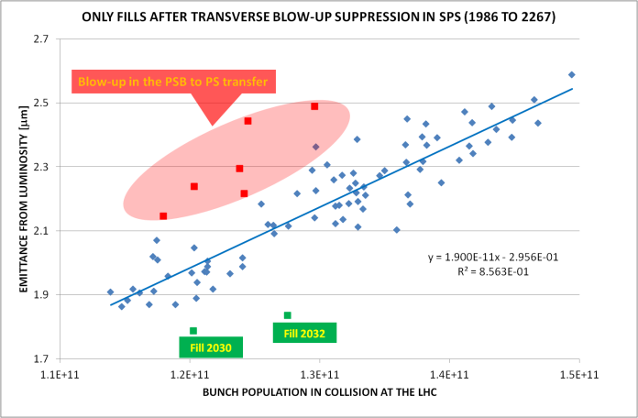
Figure 1. Transverse emittance in collision vs. bunch population for the physics fills with 50 ns beams from number 1986 to 2267 (included).

2011 INTEGRATED PERFORMANCE
Figure 2 shows the evolution of the peak luminosity and of the number of colliding bunches in IR1/5 during the run 2011.

Figure 2. Evolution of the peak luminosity and of the number of the colliding bunches in IR1/5 during the 2011 run.

The following operational phases can be identified during the run 2011:
- physics with 75 ns beams with up to 200 bunches (194 colliding in IP1/5) with a β* of 1.5 m in IP1/5;
- operation with 50 ns beams (β* of 1.5 m) and an increasing number of bunches (up to 768, 700 of which colliding in IP1/5) with population of ~1.2×10¹¹ p following the successful scrubbing run with 50 ns beams proposed in Chamonix 2011 [9];
- operation at high total intensity (up to 1380 bunches, 1318 of which colliding in IP1/5) and bunch population of ~1.2×10¹¹ p;
- adiabatic reduction of the transverse emittance by suppression of the controlled transverse blow-up applied in the SPS and increase of the bunch population up to ~1.3×10¹¹ p;
- reduction of β* to 1 m in IP1/5 and increase of the bunch population up to ~1.5×10¹¹ p.

The integrated luminosity during a given period is determined by the peak luminosity but also by other parameters like the efficiency for physics (i.e. the fraction of time spent in stable beams with respect to the corresponding scheduled physics time, in the following called Stable Beam fraction) and by the luminosity lifetime.
The convolution of the stable beam fraction and of the effect of the luminosity lifetime can be represented in the so-called Hübner factor. A “sliding” Hübner factor HF_{i} can be defined for every fill leading to stable beams as:

where L_{peak,i} is the peak luminosity for the i^{th} fill and ΔT_{i} is the time between the end of the (i-1)^{th} stable beam period and the end of the i^{th} one.
For each of the physics period above mentioned the following parameters have been estimated:
- HF_{peak}, a Hübner factor related to the peak luminosity of one period:
- <HF>, a average Hübner factor, that is the average of the “sliding” Hübner factors HF_{i} over one period,
- A LHCb Hübner factor where L_{levelling} is value of the luminosity at which LHCb was levelled during the period in consideration. .
Table 2 lists the values of the above parameters, the stable beam fraction, the average peak luminosity per colliding pair and the average beam brightness for each of the five operational periods with 50 ns beams above mentioned. The LHCb Hübner factor has been calculated for phase V assuming a luminosity levelling at 0.35×10³³ cm⁻²s⁻¹.

Period | Stable beam fraction  [%] | HF_{peak} | <HF> | <HF_{LHCb}> | Average peak luminosity per colliding pair  [10³⁰ cm⁻²s⁻¹] | Average brightness  [10¹¹/μm]
II | 32.8 | 0.14 | 0.32 | - | 1.07 | 0.43
III | 29.2 | 0.19 | 0.26 | - | 1.07 | 0.43
IV | 29.1 | 0.15 | 0.26 | - | 1.35 | 0.54
V | 32.8 | 0.2 | 0.26 | 0.31 | 2.41 | 0.58
Table 2: Evolution of the stable beam fraction, Hübner factors, average peak luminosity per colliding pair and the average beam brightness during the four operational periods with 50 ns beams above indicated.

The above Hübner factors can be used for the estimation of the luminosity evolution for 2012.
Differently from <HF>, the parameter HF_{peak} contains the information about the luminosity ramp-up (either in terms of number of bunches or bunch population or beam brightness). The lower values of HF_{peak} for phases II and IV are the consequence of the significant increase in peak luminosity during these periods (see Fig. 2) while the higher values in phases III and V are more typical of luminosity production periods with mild evolution of the luminosity. The average Hübner factor <HF> is approximately constant after an initial reduction from Phase II to Phase III due to the reduction in the stable beam fraction resulting from downtime due high intensity effects like SEUs, UFOs, vacuum activity. The slight increase in the stable beam fraction observed in Phase V as compared to IV is likely the result of the measures put in place during the previous phases to mitigate the impact of the high intensity effects above mentioned. No significant increase on the average Hübner factor has been observed and this could be due to a reduction of the luminosity lifetime following the increase in luminosity (faster burn-off) after the reduction of the β* to 1 m.
For the estimation of the performance reach in terms of integrated luminosity in 2012 the parameters corresponding to phase V will be considered for the following reasons:
- they have been obtained after the commissioning of the machine with a reduced β* (although more relaxed) and therefore in the conditions which are closer to those expected in 2012;
- in this phase the number of bunches was kept constant and equal to the value that could be used for operation in 2012 (at least for 50 ns operation);
- during this phase the emittance of the beam was the minimum that could be delivered by the injectors and no controlled transverse blow-up was applied in the SPS;
- machine parameters like β* and crossing angles were kept constant during this phase;
- bunch population was adiabatically increased from 1.2 to 1.5x10¹¹ p during this period (~1.5 months) and the emittance followed the evolution represented by Eq. 1;
- during this phase the highest bunch population and brightness (very close to the values expected for 2012 operation) as well as peak luminosity have been achieved;
- given the highest intensity and luminosity this period should be the most representative in terms of efficiency for physics for 2012 operation with respect to effects like SEUs and UFOs, also taking into account that some of the mitigation measures for these phenomena were already in place for this phase.

2012 expected peak PERFORMANCE with 50 and 25 NS beams

Emittance preservation in the Injectors and the LHC [8][1]
The experience in the injectors and the LHC with the LHC beams during machine development, operation and during the 25 ns beam tests has shown that for the 50 ns beams a bunch population up to 1.6×10¹¹ p can be delivered by the SPS in transverse emittances of 2 μm although this might be accompanied by a loss of reproducibility. Extrapolating the performance observed in the LHC up to 1.5×10¹¹ p (described by Eq. 1) we can expect the emittance in collision for bunch populations of 1.6×10¹¹ p to reach 2.8 μm.
For the 25 ns beam the SPS is expected to deliver a maximum bunch population corresponding to the nominal (1.15×10¹¹ p) with a transverse emittance larger than 3 μm. Assuming that an additive emittance blow-up of ~0.7 μm (observed for single bunch beams during dedicated machine development sessions [8]) is observed in the LHC the expected emittance in collision is equal or larger than 3.7 μm, very close to the nominal value.
For the evaluation of the peak performance in 2012 it seems reasonable to assume that progress will be made in the reproducibility of the parameters of the beam delivered by the injectors up to 1.6×10¹¹ p/bunch and in the understanding of the emittance blow-up in the LHC. Therefore, the peak beam parameters assumed for the LHC beams in collision are summarized in Tab. 3.

Bunch spacing  [ns] | Bunch population  [10¹¹] | ε*_{coll}  [μm] | Brightness  [10¹¹/μm]
25 | 1.15 | 3.5 | 0.33
50 | 1.6 | 2.5 | 0.64
Table 3. Peak beam parameters in collision in 2012.

Beam-beam effects [3]
For the peak beam parameters listed in Tab. 3 the head-on beam-beam tune shift ΔQ_{head-on}~N_{b}/ε* is equal or smaller than that achieved in 2011 and no hard limits have been observed so far. Operation with 50 ns beams with long range beam-beam separation down to 9.3 σ (for a normalized transverse emittance of 2.5 μm) has been demonstrated with bunch populations up to 1.5×10¹¹ p.
The expected dependence of the dynamic aperture on the long range beam-beam separation is shown in Fig. 3 [3] for the 25 (red) and 50 (green) ns beams and for a bunch population of ~1.2×10¹¹ p. The green vertical line corresponds to a separation of 9.3 σ. For this separation the expected dynamic aperture is close to 8 σ. The expected dynamic aperture for 1.6×10¹¹ p is close to 6 σ (larger than the primary collimator aperture with tight settings) given that the dynamic aperture for long range beam-beam effects is inversely proportional to the bunch population [3].
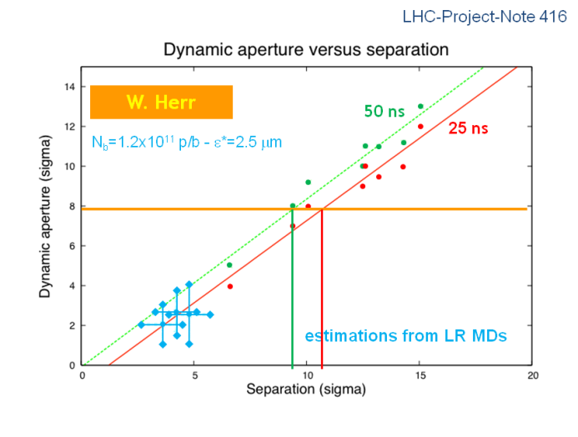
Figure 3. Dependence of the dynamic aperture on the long range beam-beam separation (in beam σ) for the 25 (red) and 50 (green) ns beam for a bunch population of 1.2×10¹¹ p [3].

For 25 ns spaced beams the number of long range collisions is 120 as compared to 64 for 50 ns beams. In order to get the same dynamic aperture the long range beam-beam separation (in σ) has to be increased by approximately 20% (to ~11 σ as indicated by the vertical red line) for the 25 ns beams at constant bunch population. In the following it has been assumed a long-range beam-beam separation of 12 σ for 25 ns beams and 9.3 σ for 50 ns beams for the beam parameters in Table 3. This assumption is rather pessimistic for the 25 ns beam given its lower bunch population and taking into account that the dynamic aperture resulting from long-range beam-beam encounters is inversely proportional to the bunch population.

β* reach [6][10]
The collimation system defines minimum aperture that can be protected and therefore the limits on the minimum β* that can be safely achieved taking into account the available aperture and the tolerances (e.g. β beating, orbit, etc.) and taking into account that the beta function at the triplets increase as we progress during the squeeze and we reduce the β*. Tight collimator settings have been tested during machine development studies [11] and are proposed for operation for 2012 with intermediate collimator settings (used in 2011) as back-up solution in case of issues with orbit control and/or impedance. The minimum β* achievable in 2012 at 3.5 and 4 TeV and the corresponding (half) crossing angle required to keep long range beam-beam separation to 9.3 σ for the 50 ns beam are listed in Table 4 [6] for different collimator settings. A scheme with a β* of 0.6 m can be also conceived assuming that the errors are not correlated among them and therefore can be added in quadrature instead of being added linearly.

β* [m] | θ_{cross} [μrad] @ 3.5 TeV | θ_{cross} [μrad] @ 4 TeV | Comments
0.6 | 155 | 145 | Tight collimator settings – errors in quadrature
0.7 | 143 | 134 | Tight collimator settings – linear error sum
0.9 | 126 | 118 | Intermediate settings – linear error sum
Table 4. β* reach for 50 ns operation for different collimator settings and tolerances [6].

For 25 ns beam a β*=0.8 m is achievable at 4 TeV with a half crossing angle of 190 μrad [6], providing a (rather conservative) 12 σ separation for long range encounters in the optimistic case in which the machine can be operated with tight collimator settings with a transverse emittance of 3.5 μm i.e. with the primary collimators at 4.3 beam σ.

Impedance effects [4][12]
Operation with tight collimator settings is expected to be possible for the beam characteristics listed in Table 3, provided the chromaticity is controlled and kept to approximately 1 unit. As a back-up solution operation with larger values of the chromaticity (2 units) is possible provided that the strength of the Landau octupoles is increased (corresponding current > 450 A) but this might entail a reduction of the beam lifetime at 4 TeV. Operation with 50 ns beam is expected to be more critical than that with 25 ns beam from the point of view of the beam stability related to impedance because of the larger bunch population.
Impedance and in particular longitudinal impedance can induce heating of the components responsible for the impedance. So far the following main issues have been identified although they do not represent a real show stopper and possible mitigation measures have been identified.
- TDI beam screen heating. The TDI gaps will have to be opened to parking position (110 mm) as soon as injection is stopped. This might slow-down filling during a scrubbing run;
- MKI heating remain one of the major potential limitations. This occurs during the ramp and in physics and it might impact the turn-around time as high intensity injection is not allowed if the measured kicker temperature exceeds the interlock level.

Bunch length increase and bunch shape tailoring [13] could help in reducing the TDI and MKI heating. It is planned to increase the bunch length to 1.35 ns (from the present value of 1.25 ns) during the run. This is going to increase correspondingly the length of the luminous region but it is considered to be acceptable by the experiments. The increase in bunch length will also reduce the peak luminosity by up to 3% as a result of the crossing angle. A possible reduction of the luminosity lifetime has been hypothesized and its extent must be assessed.

Vacuum effects and scrubbing [14][2]
During the 2011 run vacuum spikes have been observed in LSS2/5/8 during high intensity operation. The analysis of the data and the investigations performed during the Christmas stop have revealed that this behaviour was related to non-conform RF fingers and not, as initially suspected, to electron cloud. The non-conform RF fingers have been replaced and no limitation is expected from vacuum within the envelope defined in Tab. 3 [14].
Suppression of the electron cloud effects with 50 ns beams at 4 TeV requires [2]:
- Secondary Electron Yield (SEY)< 2.1 in the arcs;
- SEY<1.6 in the uncoated/unbaked straight sections.

These values were achieved at the end of the scrubbing run in April 2011 (5 days with 50 ns beam). Lower values were achieved during dedicated 25 ns beam tests in fall 2011.
During the winter stop the LHC arcs have been kept at temperatures below 80 ºK and care is going to be taken to cool down the magnets preventing condensation of gases released from the cold bore on the beam screens. It is therefore hoped to find the same SEY as at the end of 2011 but this needs to be confirmed and if this is not the case it is expected that scrubbing of the surface should be fast.
The long straight sections around points 2/5/8 have been vented and high vacuum activity is expected during the start-up with high intensity beams. Scrubbing with 50 ns beams will take ~15 h of effective beam time at high intensity (~1000 bunches circulating with bunch population >1.4×10¹¹ p). With 25 ns beams (~2000 bunches per beam circulating with bunch population >1.15×10¹¹ p) few hours will be required.
It is proposed to precede any significant beam intensity ramp up with 50 ns beams with 1 day of scrubbing with 25 ns beams (composed by trains of 72 bunches). The scrubbing should be preceded by approximately 1 day for the setting-up of the 25 ns beam and 1 day should be added as reserve in case of problems during the setting-up or scrubbing. This short scrubbing run would:
- allow verifying the conditions of the beam screen surface (in particular in the arcs) after the winter stop providing important input for future operation at 25 ns and for the requirements for the recovery after a winter stop;
- create clean conditions for operation with 50 ns beams with intensities above those reached in 2011 in the arcs and in the straight sections;
- possibly mitigate (by conditioning) other effects like UFOs during operation.

Operation with 25 ns at 4 TeV would require lower SEY values [2]:
- SEY<1.35 in the arcs;
- SEY<1.2 in the uncoated/unbaked straight sections.

In the following an attempt is made to estimate the amount of machine time required to achieve the above conditions with a dedicated scrubbing run.
At least 20 hours of beam time at 450 GeV/c [2] are estimated to be necessary to approach the above values. Accumulation of up to 2100 bunches with trains of 72 bunches would be followed by accumulation of larger number of bunches with trains of 144, 216 and 288 bunches. During the last 25 ns test (which was preceded by 3 machine development sessions with 25 ns beams) on 24th-25th October 2011, 2 hours of beam time with 2100 bunches (on beam 1 only) were accumulated in ~14 h of machine time. The low efficiency (~14%) was due to the losses (affecting mostly the trailing bunches of each bunch train) and the beam dumps triggered by the LSS6 BPM when the population of the trailing bunches decreased below ~0.3×10¹¹ p. The vacuum activity at the injection kickers MKI and in particular at those located in point 8 also contributed to increase the filling time. It must be noted that during that test the machine availability was close to 100% and furthermore the TDI was left in injection position during the whole session. This will not be possible in 2012 if we want to minimize the heating of the TDI beam screen and the movement of the TDI before any injection could add additional inefficiency to the scrubbing.
Assuming the above efficiency (14 %) 140 hours (~6 days) of machine time are required to delivered the required electron dose at 450 GeV/c. 1 day of setting-up of 25 ns beam (injection of trains of 72 bunches) and 2 shifts of commissioning for each additional step in the injected number of bunches (144-216-288) must be added, for a total of 3 days.
In order to achieve the above mentioned SEY for the operation at 25 ns some time must be devoted to dedicated ramps starting with a reduced number of 25 ns trains for scrubbing/operation at 3.5-4 TeV with increasing number of bunches to validate operation at high energy.
A total of 11 days of machine time with very good machine availability and no contingency is therefore required for creating the conditions necessary for operation with 25 ns at 3.5-4 TeV, therefore a scrubbing run of 2 weeks is a realistic estimate for operation with 25 ns beams.

Peak performance for 50 ns beam
The expected peak parameters for operation at 3.5 TeV with 50 ns beams for the three values of the β* presented in Table 4 are listed in Table 5.

Momentum [TeV/c] | 3.5
β* [m] IP1/2/5/8 | 0.6/3/0.6/3 | 0.7/3/0.7/3 | 0.9/3/0.9/3
θ_{cross}IP1/2/5/8 [μrad] | 155/90/  155/250 | 143/90/  143/250 | 126/90/  126/250
ε_{coll}*(start fill) [μm] | 2.5
N_{b} [10¹¹ p] | 1.6
# bunches | 1380
Max. Brightness  [10¹¹/μm] | 0.64
# coll. Pairs in IP1/2/5/8 | 1331/0/1331/1320
Bunch length (4 σ)[ns] / (r.m.s.) [cm] | 1.35/10.1
Beam Current [A]/  population [10¹⁴ p] | 0.4 / 2.2
Stored energy [MJ] | 124
L_{peak}[10³³ cm⁻²s⁻¹] in IP1/5 | 6.0 | 5.4 | 4.5
L_{peak}/coll. pair [10³⁰ cm⁻²s⁻¹] in IP1/5 | 4.5 | 4.1 | 3.4
ξ (start fill)/IP | 0.007
d_{sepσ} [σ] | 9.3
<PU>_{peak} IP1/IP5 | 29 | 27 | 22
Table 5. Peak parameters for the 50 ns operation at 3.5 TeV

The expected peak parameters for operation at 4 TeV with 50 ns beams for the three values of the β* presented in Table 4 are listed in Table 6.

Momentum [TeV/c] | 4
β* [m] IP1/2/5/8 | 0.6/3/0.6/3 | 0.7/3/0.7/3 | 0.9/3/0.9/3
θ_{cross}IP1/2/5/8 [μrad] | 145/90  /145/250 | 134/90  /134/250 | 118/90  /118/250
ε_{coll}*(start fill) [μm] | 2.5
N_{b} [10¹¹ p] | 1.6
# bunches | 1380
Max. Brightness  [10¹¹/μm] | 0.64
# coll. Pairs in IP1/2/5/8 | 1331/0/1331/1320
Bunch length (4 σ)[ns] / (r.m.s.) [cm] | 1.35/10.1
Beam Current [A]/  population [10¹⁴ p] | 0.4 / 2.2
Stored energy [MJ] | 142
L_{peak}[10³³ cm⁻²s⁻¹] in IP1/5 | 6.8 | 6.2 | 5.1
L_{peak}/coll. pair [10³⁰ cm⁻²s⁻¹] in IP1/5 | 5.1 | 4.7 | 3.8
ξ (start fill)/IP | 0.007
d_{sepσ} [σ] | 9.3
<PU>_{peak} IP1/IP5 | 35 | 31 | 26
Table 6. Peak performance for the 50 ns operation at 4 TeV

Peak performance for 25 ns beam
The expected peak parameters for operation at 4 TeV with 25 ns beams are listed in Table 7.

Momentum [TeV/c] | 4
β* [m] IP1/2/5/8 | 0.8
θ_{cross}IP1/5 [μrad] | 190
ε_{coll}*(start fill) [μm] | 3.5
N_{b} [10¹¹ p] | 1.15
# bunches | 2760
Max. Brightness [10¹¹/μm] | 0.33
# coll. Pairs in IP1/2/5/8 | 2662/0/2662/2640
Bunch length (4 σ)[ns] / (r.m.s.) [cm] | 1.35/10.1
Beam Current [A]/population [10¹⁴ p] | 0.57 / 3.2
Stored energy [MJ] | 203
L_{peak}[10³³ cm⁻²s⁻¹] in IP1/5 | 3.8
L_{peak}/coll. pair [10³⁰ cm⁻²s⁻¹] in IP1/5 | 1.4
ξ (start fill)/IP | 0.007
d_{sepσ} [σ] | 12
<PU>_{peak} IP1/IP5 | 10
Table 7. Peak performance for the 25 ns operation at 4 TeV

2012 expected integrated LUMINOSITY with 50 and 25 NS beams

Operation with 50 ns beams
Based on the present machine schedule an estimate of the integrated luminosity has been made in case of operation of the machine with 50 ns beams. For the estimate the following assumptions have been made:
- 147 days of physics;
- 22 days of MDs
- 21 days of commissioning with beam (small number of bunches);
- 20 days of Technical Stops;
- 6 (2x3) days of recovery after Technical Stops;
- 8 days of special physics runs;
- 3 days of scrubbing with 25 ns beam including setting-up and 1 day of contingency. To be planned as soon as possible before any significant intensity ramp-up.
For the intensity ramp-up the scheme proposed in [15] has been considered:
- 3 fills and 6 hours of stable beams operation for each of the configurations with 48, 84, 264 and 624 bunches/beam (a stable beam fraction of 25% has been assumed);
- 3 fills and 20 hours of stable beams operation for each of the configurations with 840, 1092 and 1380 bunches/beam (a stable beam fraction of 28% has been assumed).

Approximately 2 weeks would be needed for validating the machine with the maximum number of bunches after commissioning at low intensity and the scrubbing run.
The integrated luminosity evolution obtained considering the Hübner Factor HF_{peak}=0.2 and the peak luminosity L_{peak} corresponding to the scenarii described in Table 6 for 4 TeV is shown in Fig. 4. No hypothesis is made on the actual luminosity ramp-up except for the initial evolution of the number of bunches described above.

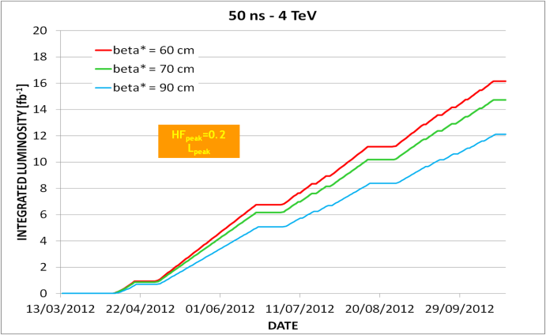
Figure 4. Integrated luminosity evolution for operation with 50 ns beams at 4 TeV.

A similar estimate can be done considering the average Hübner Factor <HF> and making the following hypothesis on the evolution of the luminosity after the initial ramp-up in the number of bunches with a bunch population of 1.4×10 ¹¹ p (see Fig. 5):
- Phase I (between the first and the second Technical Stops): linear increase of the bunch population from 1.4 to 1.6x10¹¹ p with emittance determined according to the fit given in Eq. 1. This would imply a linear increase of the luminosity from ~80 to 90 % of the peak value assumed for 2012 in 51 days;.
- Phase II (between the second and third Technical Stops – 44 days): linear increase of the brightness from 90 % of its peak value to the peak value by reduction of the transverse emittance achieved by mitigating the sources of emittance blow-up in the LHC.
- Phase III (from the third Technical Stop to the end of the run): operation at peak performance.

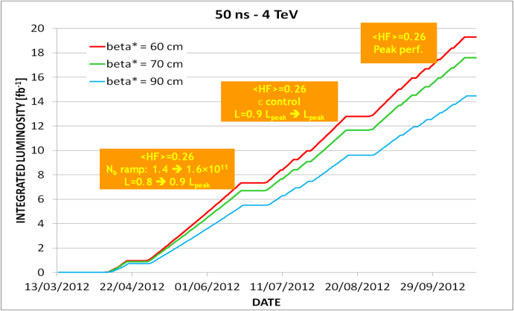
Figure 5. Integrated luminosity evolution for operation with 50 ns beams at 4 TeV.

This estimate provides very likely an upper value for the expected integrated luminosity as it assumes constant operation to peak performance in the last part of the run and does not take into account:
- any significant reduction of the luminosity lifetime due to the increased peak luminosity per colliding pair as compared to Phase V of 2011 operation;
- any reduction in machine availability as compared to Phase V of 2011 due to intensity effects like UFOs and SEUs.

Similar estimates have been done for operation at 3.5 TeV and are presented in Fig. 6 and 7, respectively.

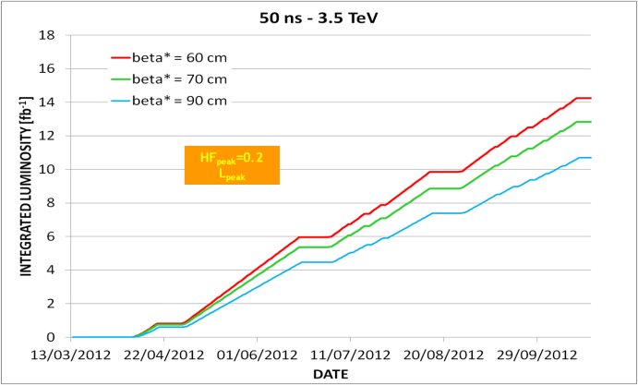
Figure 6. Integrated luminosity evolution for operation with 50 ns beams at 3.5 TeV.

Operation with 25 ns beams
Operation with 25 ns beams will require a dedicated scrubbing run. This will have an impact on the machine schedule and in particular on the total number of days scheduled for physics. For the estimate of the integrated luminosity the following assumptions have been made:
- 137 days of physics;
- 22 days of MDs;
- 21 days of commissioning with beam;
- 20 days of Technical stops;
- 6 (2x3) days of recovery after Technical Stops;
- 8 days of special physics runs;
- 13 days of scrubbing (including setting-up and 2 days of contingency).

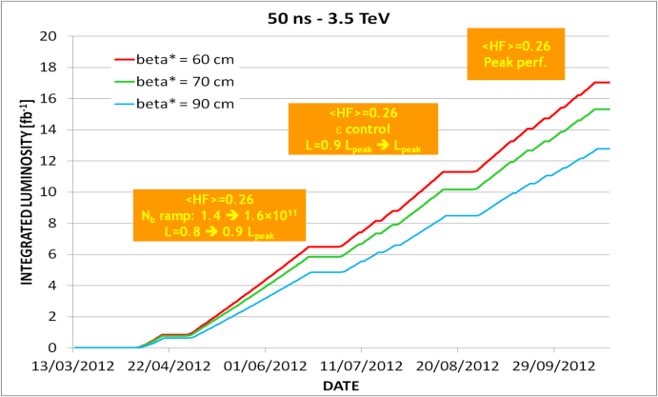
Figure 7. Integrated luminosity evolution for operation with 50 ns beams at 3.5 TeV.

The same intensity ramp-up rate (in terms of number of bunches) as for 50 ns beam has been considered during the initial phase of operation. That is optimistic taking into account that the peak total current for 25 ns beams is by 42% higher than the peak total current assumed for 50 ns beams.
In the estimation of the integrated luminosity the peak Hübner factor of 0.2 has been optimistically assumed. This value has obtained during the 2011 run when operating with a constant number of bunches. It must be noted that no operational experience exists with 25 ns beam and therefore a higher uncertainty exists on the luminosity evolution. The same value was used at the beginning of 2011 to evaluate the expected performance for the 75 ns beam during the 2011 run (while for 50 ns a Hübner factor of 0.15 was considered). The expected performance is presented in Fig. 8.

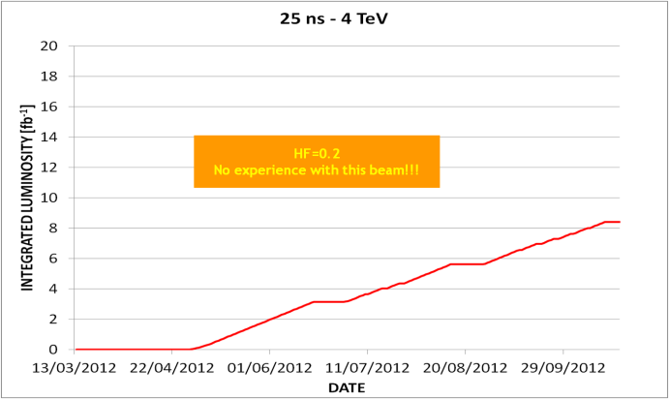
Figure 8. Integrated luminosity evolution for operation with 25 ns beams at 4 TeV.

SUMMARY AND CONCLUSIONS
The expected integrated luminosity for the operation with 25 and 50 ns beams as discussed above is summarized in Table 8, listing the expected integrated luminosity range, peak luminosity and average pile-up at peak luminosity for the different values of the β* and for 3.5 and 4 TeV.
For LHCb, ~1.5 fb⁻¹ are expected for 50 ns operation (147 days of physics) and close to 1.4 fb⁻¹ for 25 ns operation (137 days of physics) assuming <HF_{LHCb}>=0.3 and L_{levelling}= 0.4x10³³ cm⁻²s⁻¹. The value for 25 ns operation might suffer from lower machine availability due to the higher total beam current.

 | 3.5 TeV |  |  | 4 TeV |  |  | Comments
 | ∫Ldt  [fb⁻¹] | L_{peak}  [10³³ cm⁻²s⁻¹] | Average  pile-up  at L_{peak} | ∫Ldt  [fb⁻¹] | L_{peak}  [10³³ cm⁻²s⁻¹] | Average  pile-up  at L_{peak}
50 ns - β*=0.6 m | 14.3-17 | 6.0 | 29 | 16.2-19.3 | 6.8 | 35 | Tight collimator settings – errors in quadrature
50 ns - β*=0.7 m | 12.8-15.3 | 5.4 | 27 | 14.7-17.6 | 6.2 | 31 | Tight collimator settings – linear error sum
50 ns - β*=0.9 m | 10.7-12.8 | 4.5 | 22 | 12.1-14.5 | 5.1 | 26 | Intermediate settings – linear error sum
25 ns - β*=0.8 m | - |  |  | 8.3 | 3.8 | 10 | Tight collimator settings – errors in quadrature
Table 8. Expected performance for the 2012 run.

Operation at 50 ns clearly provides a higher integrated luminosity than 25 ns operation, furthermore the longer scrubbing time required for 25 ns operation reduces significantly the integrated luminosity that can be collected in time for the summer conferences.
The high level of event pile-up that will be observed at the beginning of the fills with 50 ns beams is certainly an issue but levelling can be used to reduce it at the beginning of the fill.
25 ns is a new mode of operation with more unknowns and likely surprises and for that reason a more conservative approach has been used in the estimation of the integrated luminosity. 25 ns operation would imply larger beam current and therefore, potentially, a larger stress on equipment and collimation that could result in lower machine availability and lower efficiency for physics. From the above analysis 50 ns operation appears to have the largest potential of delivering the highest integrated luminosity in 2012.
The highest integrated luminosity values are obtained with tight collimator settings allowing to reach β* values below 0.7 m. Although no show-stoppers have been identified, this mode of operation will require a tighter control of the machine parameters (e.g. orbit, chromaticity, etc.).
A realistic, although challenging, ramp-up phase in number of bunches and luminosity has been assumed for the estimation of the upper range of the integrated luminosity, nevertheless operation at peak luminosity with <HF>=0.26 implies mastering high intensity and blow-up at peak performance in the whole chain of accelerators before the last third of the run in a consistent and reproducible way. Furthermore the expected lower luminosity lifetime (due to the lower burn-off lifetime resulting from the larger luminosity per colliding pair expected in 2012 as compared to 2011) has not been taken into account.
In the estimations it has also been assumed that 4 TeV operation will not reserve significantly more difficulties than 3.5 TeV operation (e.g. in terms of UFO, SEU, …..) and will not imply additional commissioning time.
An integrated luminosity of 15 fb⁻¹ is within reach but it heavily relies on the successful commissioning and operation at high intensity with tight collimator settings at 4 TeV. This mode of operation should be therefore commissioned and tested as early as possible in the run. 20 fb⁻¹ seems out of reach even for very optimistic scenarios. Operating at β*=0.6 m would allow approaching this value.
In spite of the optimistic scrubbing plan, 25 ns cannot compete with 50 ns operation. A mini-scrubbing run at 25 ns before any significant intensity ramp-up with 50 ns is strongly advised as it would allow a fast intensity ramp-up with 50 ns minimizing potential vacuum activity in the experimental straight sections that have been vented during the winter stop and it would provide an important input for future operation at 25 ns (model and cool-down procedure validation).

APPENDIX
In this appendix the models used in the estimation of the integrated luminosity evolution for 2012 are verified with 2011 data and some additional constraints to the model, based on 2011 experience, have been added after the workshop.
The accuracy of the representation of the dependence of the emittance as a function of the bunch population presented in Eq. 1 and used in the estimation of the peak luminosity evolution in 2012 for the data presented in Fig. 5 and 7 are compared with the measured peak luminosity evolution during the fills with 50 ns beams from number 1986 to 2267 when the controlled transverse emittance blow-up in the SPS was suppressed. The comparison is presented in Fig. 9. The agreement is rather good.

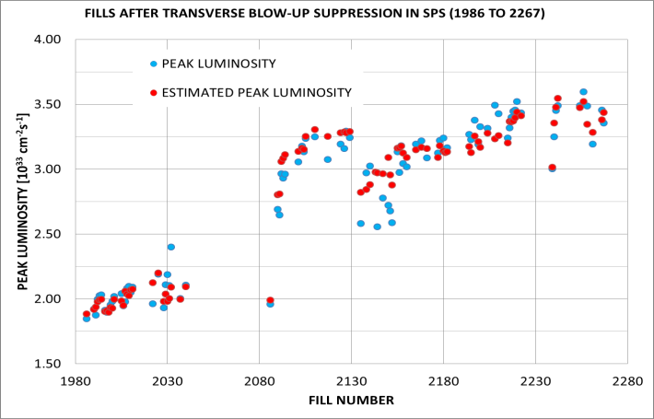
Figure 9. Measured (blue) vs. estimated (red) peak luminosity for the physics fills with 50 ns beams from 1986 to 2267.

The evolution of the integrated luminosity as a function of the fill number during Phase V of the 2011 operation is compared with the expected integrated luminosity evolution based on the estimated peak luminosity shown in Fig. 9 and assuming an average Hübner factor <HF>=0.26 calculated for this period. The results are shown in Fig. 10. It must be noted that the ramp-up phase after the commissioning of the optics with β*=1 m in IP1 and 5 is included in the comparison. The estimation is slightly (by 4 %) higher than the measured value at the end of the period.
The presented model does not include any dependence of the sliding Hübner factor on the luminosity lifetime. This should decrease with increasing luminosity per crossing pair (assuming constant machine availability and turn-around times) at least to account the dependence of the burn-off lifetime on the luminosity per crossing pair.
That dependence can be inferred by plotting the sliding Hübner factor HF_{i} normalized to the stable beam fraction SB_{i} as function of the luminosity per colliding pair where:
t_{stable i} is the length of the i^{th} stable beam period and ΔT_{i} is the time between the end of the (i-1)^{th} stable beam period and the end of the i^{th} one.
Fig. 11 represents the above dependence for all the fills with 50 ns beams in Phases II to V. It must be noted that the dependence is small and the linear correlation coefficient is low although a mild trend seems to be visible. The linear fit to the data is:

(2)
where n_{coll} is the number of colliding pairs in IP1/5.
Fig. 12 shows the evolution of the integrated luminosity as a function of the fill number during Phase V of the 2011 operation and the expected integrated luminosity evolution based on the estimated peak luminosity shown in Fig. 9. The dependence of the ratio HF/SB on luminosity per colliding pair given in Eq. 2 is taken into account and an average stable beam fraction of 32.8% calculated for this period has been assumed. The estimation is slightly (by 4 %) higher than the measured value. The discrepancy in the integrated luminosity at the end of the period is reduced to 3%.

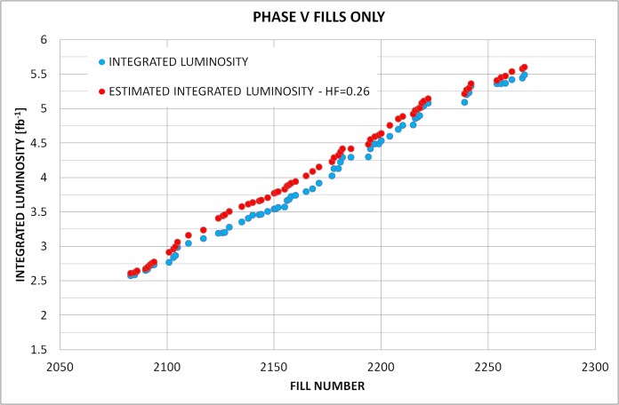
Figure 10. Measured (blue) vs. estimated (red) integrated luminosity for the physics fills in Phase V.

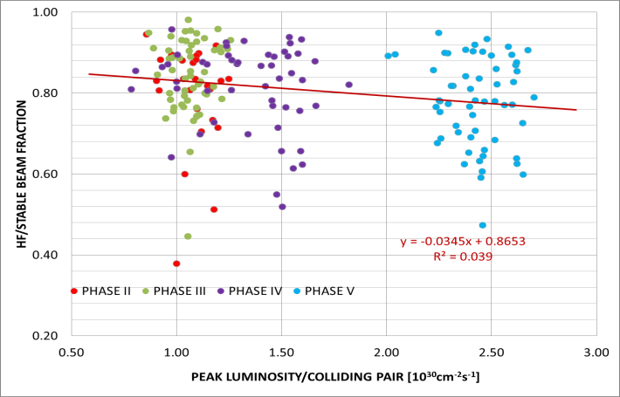
Figure 11. Sliding Hübner factor normalized by the stable beam fraction vs. peak luminosity per colliding pair.

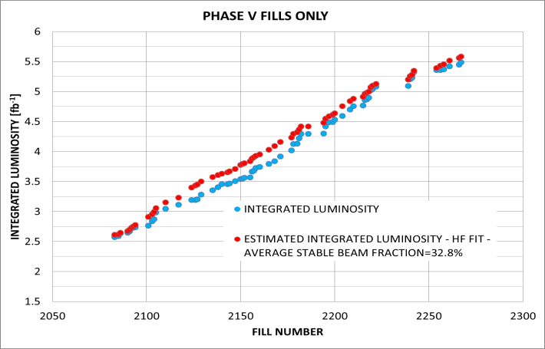
Figure 12. Measured (blue) vs. estimated (red) integrated luminosity for the physics fills in Phase V, taking into account the dependence presented in Eq. 2.

This dependence must be taken into account for the extrapolation to 2012 to account for the expected reduction in lifetime due to the increase by almost a factor two of the peak luminosity per colliding pair.
The expected evolution of the integrated luminosity for 50 ns operation at 4 TeV is presented in Fig. 13 and the expected integrated values at the end of the 2012 run for 50 ns operation are listed in Table 9 for 3.5 and 4 TeV.

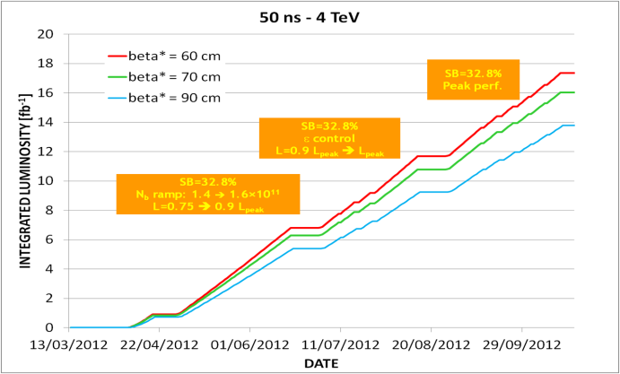
Figure 13. Integrated luminosity evolution for operation with 50 ns beams at 4 TeV including the extrapolated dependence of luminosity lifetime on peak luminosity per colliding pair.

 | ∫Ldt [fb⁻¹]
 | 3.5 TeV | 4 TeV | Comments
β*=0.6 m | 15.6 | 17.3 | Tight collimator settings – errors in quadrature
β*=0.7 m | 14.4 | 16 | Tight collimator settings – linear error sum
β*=0.9 m | 12.3 | 13.8 | Intermediate settings – linear error sum
Table 9. Expected performance for the 2012 run taking into account the dependence of the luminosity lifetime on the peak luminosity per colliding pair resulting from the 2011 data..

A reduction by 4 to 10% can be observed with respect to the most optimistic values above estimated and the projected values lie within the range previously indicated in Table 8.
It must be noted that this could imply a better performance for the 25 ns beam given the lower peak luminosity per colliding pair.

Acknowledgements
The estimation of the integrated luminosity in 2012 is largely based on models and considerations already developed by S. Myers whom I thank sincerely for pointing me to his analysis.
The input provided by R. Bruce, S. Gilardoni, M. Giovannozzi, W. Herr, G. Iadarola, J. Jowett, V. Kain, M. Lamont, E. Métral, G. Rumolo, R. Steerenberg, J. Wenninger and the LHC Machine Coordinators is gratefully acknowledged.

References
[1] R. Steerenberg, “Performance reach of the injector complex”, these Proceedings.
[2] G. Rumolo, “LHC experience with different bunch spacings in 2011 (25, 50 & 75 ns)”, these Proceedings.
[3] W. Herr, “Observations of beam-beam effects in MDs in 2011”, these Proceedings.
[4] E. Métral, “Beam-induced heating/bunch length/RF and lessons for 2012”, these Proceedings.
[5] J. Wenninger et al., “Commissioning of the betatron squeeze to 1 m in IR1 and IR5”, CERN-ATS-Note-2012-005 MD.
[6] R. Bruce, “Collimation settings and performance”, these Proceedings.
[7] A. MacPherson, “2011 availability analysis”, these Proceedings.
[8] V. Kain, “Emittance Preservation”, these Proceedings.
[9] G. Arduini et al., “Beam observations with different bunch spacings and overall synthesis”, Proceedings of the Chamonix 2011 workshop on LHC Performance, C. Carli ed., CERN-2011-005, p. 63-69.
[10] M. Giovannozzi, “Optics Options”, these Proceedings.
[11] R. Assmann et al., “Tests of tight collimator settings in the LHC”, CERN-ATS-Note-2012-022 MD.
[12] N. Mounet et al, “Impedance Effects on Beam Stability”, to be published in the Proceedings of the LHC Beam Operation workshop - Evian 2011.
[13] P. Baudrenghien, “Running the RF at higher beam energy and intensity”, these Proceedings.
[14] V. Baglin, “Vacuum performance and lessons for 2012”, these Proceedings.
[15] M. Zerlauth, “Intensity ramp-up: 2011 experience - Limitations, mitigation, risks, strategy, pushing it in 2012, 1380 in 3 weeks?”, to be published in the Proceedings of the LHC Beam Operation workshop - Evian 2011.

