# LHC TRANSVERSE FEEDBACK

W. Höfle, G. Kotzian, T. Levens, D. Valuch, CERN, Geneva, Switzerland

Abstract

The LHC Transverse feedback system (ADT) is undergoing a major upgrade during LS1. In an effort to further reduce the noise floor of the system, the total number of pickups has been doubled. New beam position electronics are being designed using current, state of the art components. An upgrade of the digital signal processing system accommodates all of the extra functionality that had been introduced during the LHC run I. Use of the most recent FPGAs will allow more sophisticated signal processing algorithms to be deployed for run II.

The upgraded ADT will also feature multiple, fully dedicated signal paths with independent gain and bandwidth control for treatment of witness bunches, the abort/injection gap cleaning pulses, and for the main feedback. The cleaning process will be fully automated. An additional, alternative data processing algorithm can detect anti-symmetric intra-bunch oscillations. An instability trigger network is being deployed in LHC point 4 to interconnect systems and instruments which can detect instabilities and those which can provide observation buffer data. Feasibility of an external “observation box” to record transverse and longitudinal data from the RF and ADT systems has been demonstrated and work has started on its implementation.

The current status, readiness for restart and beam commissioning plans will also be presented.

## ADT pre-LS and Motivation FOR UPGRADE

Initially conceived for damping injection oscillations and providing stability for coupled bunch dipolar oscillations the LHC transverse feedback system (ADT) [1] has found after initial commissioning [2,3] many applications far beyond what the electronics were designed for [4,5]: Abort gap cleaning [6,7], although originally envisaged [8], has been extended to so called “injection gap” cleaning [9]; beam observation of oscillations with unprecedented precision, bunch by bunch, are complementary to LHC beam instrumentation capabilities; and the injection of noise for the purpose of loss maps [10] have become indispensable for efficient collimation set-up [11]. Moreover, excitation for tune measurement [12] and quench tests [11,13] with the possibility of modulating the excitation strength and feedback gain around the circumference of the LHC have proven to be essential for studies and operation and should be further developed for the case of the tune measurement.

Limitations of the system, both in terms of performance (noise level) and suitability of the hardware and software for the many different applications have also become visible during run I. A major upgrade program is under way during LS1 which will permit the system to be better adapted to the various applications that the ADT is now used for, to provide more functionality for beam observation, and to reduce the noise floor. The main modifications are:

* Doubling the number of pick-ups to reduce the level of noise; re-cabling of pick-ups with higher performance smooth wall coaxial cables
* Redesign of the analogue and digital signal processing hardware to have independent gain control for feedback, abort gap cleaning, and excitation
* Improved frequency response by new cabling and analogue and digital correction of the frequency response aimed at 25 ns bunch spacing and improved pulse shape for abort gap cleaning
* An external “observation box” for bunch by bunch data collection
* A triggering network linking RF, ADT and BI observation to acquire data synchronized with occurring instabilities on the beam

The new digital hardware is going to be tested in the SPS during the run in 2014. After these successful SPS tests, the new hardware will be deployed in the LHC. The new hardware will also be controlled using the latest FESA 3 middleware.

## HARDWARE AND NEW FEATURES POST-LS1 FOR RUN II

### Power System

Maintenance on the power system is being carried out with refurbishment of the water cooling system and interlocks as well as the installation of additional vacuum gauges for improved robustness with respect to false interlocks. Careful measurements of the transfer functions of the power system are planned at re-start and these will permit to optimize the signal processing for best phase compensation and bunch-by-bunch operation.

### Pick-ups and Cabling

Following an agreement with the Beam Instrumentation Group the number of pick-ups used for the ADT system will be doubled with optimal positions of the pick-ups for the ADT at high beta function values. Table 1 and Table 2 summarize the ADT pick-ups left and right of IP4 together with expected values for the beta functions. The necessary swap of pick-ups with BI is detailed in an ECR [14].

Table 1: ADT pick-ups left of IP4 with beta functions for respective plane used (pick-ups added for run II in *italic*)

|  |  |  |  |  |
| --- | --- | --- | --- | --- |
| **Beam/plane** | ***Q10L*** | **Q9L** | ***Q8L*** | **Q7L** |
| B1.H |  | 111 m |  | 106 m |
| B1.V | *175* m |  | *155* m |  |
| B2.H | *158* m |  | *96* m |  |
| B2.V |  | 160 m |  | 167 m |

Table 2: ADT pick-ups right of IP4 with beta functions for respective plane (pick-ups added for run II in *italic*)

|  |  |  |  |  |
| --- | --- | --- | --- | --- |
| **Beam/plane** | **Q7R** | ***Q8R*** | **Q9R** | ***Q10R*** |
| B1.H |  | *133 m* |  | *153 m* |
| B1.V | 161 m |  | 142 m |  |
| B2.H | 150 m |  | 101 m |  |
| B2.V |  | *151 m* |  | *180 m* |

The doubling of the number of pick-ups has already been proposed in the past as one of the options to increase the signal-to-noise (S/N) ratio [15]. Assuming that noise is not correlated from pick-up to pick-up, but signals are, the S/N improvements with respect to a single pick-up, scales with the square root of the number of pick-ups *N* used. As signals also scale with the square root of the -function and assuming noise does not scale with , the improvement of the S/N in dB with respect to the use of a single pick-up with design =100 m can be expressed as

Table 3 compares the improvement for run I (two pick-ups per plane and beam) with respect to a single pick-up and for run II with four pick-ups per plane foreseen and the relative improvement from run I to run II that is expected.



Table 3: Improvements in signal-to-noise ratio with respect to single pick-up at design beta of 100 m.

|  |  |  |  |
| --- | --- | --- | --- |
| **Beam/plane** | **Run I dB** | **Run II dB** | **Run I 🡪 II dB (relative)** |
| B1.H | 3.8 | 7.0 | 3.2 |
| B1.V | 4.2 | 8.0 | 3.8 |
| B2.H | 4.4 | 8.0 | 3.6 |
| B2.V | 4.9 | 8.2 | 3.3 |

The expected improvement from run I to run II of more than 3 dB in S/N is also due the overall increased values of the beta functions at the pick-ups, a result of an optimization by the LHC optics team.

The new cabling has been carried out using smooth wall coaxial cables which have less dispersion of group velocity for high frequencies than the previously used corrugated cables. Moreover, careful cable pulling together with rigorous quality control during cabling ensured that reflections due to bends and deformation of the cable during pulling and attachment are minimised. All previously used pick-up cables that were part of the damper system for run I have also been changed. Consequently at start-up length matching of cables has to be check as part of a full setting-up procedure.

### Signal Processing Hardware

Fig. 1 shows the layout of the new digital signal processing. The new digital hardware will be able to treat the complete set of four pick-ups per plane and generate the analogue output signal for one ADT module. Eight such digital cards are needed to drive the eight kicker modules (two per beam and plane).



|  |
| --- |
|  |
| Figure 1: Layout of Signal Processing for ADT hardware after LS1. |

The three output DACs permit the combination of the principle feedback control signal and the signals for excitation and abort gap cleaning, each with independent gain control. Fast bunch-by-bunch diagnostics on board is possible and is principally planned to be used for setting-up, RF group internal purposes, and in a limited capacity for fixed displays and logging as in the past. A separate hardware platform based on PCs will receive the digital data streams for storage, and on- or offline processing and is described in more detail below.

Figure 2: Signal Flow for ADT pick-up electronics frontend. Four signals are digitized, the in-phase (I) and quadrature (Q) components of the  and  signals with respect to the RF signal at 400.8 MHz.

## ADT DATA for observation and analysis

### ADT Pick-up Signal Processing and Head-Tail Oscillations

The transverse feedback system is targeted to damp dipole oscillations, i.e. the centre of gravity of the oscillation. Fig. 2 shows the signal flow of the analogue part 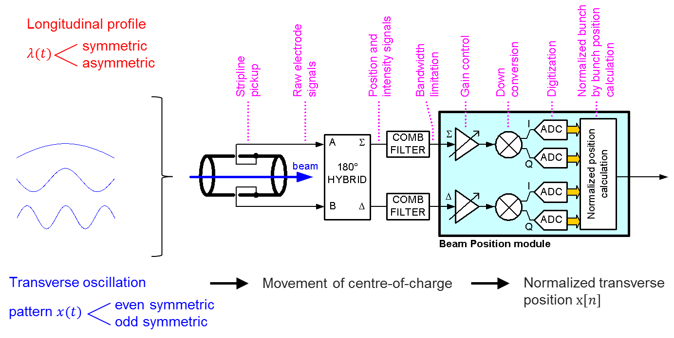of the pick-up signal treatment electronics up to the digitization [16]. Four signals, the I (in-phase) and Q (quadrature) components of the pick-up sum and difference signals are digitized. The algorithm first rotates vectors of sum and delta (I,Q) pairs to align them (Fig. 3) and then computes the normalised position from [16-18]

,

Fig. 3: Vector diagram of (I,Q) vectors of  and  at 400 MHz with respect to RF at 400.8 MHz. During calibration the angle  is determined.

whereby the (I,Q) vectors of  and  have been assumed to have been rotated to align in (I,Q) space beforehand, see [17].



Fig. 4: Sensitivity of the computed position to *symmetric* intra bunch motion, mean (red) – weighted with bunch line density, – and actually used (I,Q) algorithm (blue) [18].

Fig. 4 shows the sensitivity of the computed position to symmetric intra bunch motion and compares it with the weighted position



where *(t)* is the bunch line density. In Fig. 4 the bunch shape has been assumed to be cos2 shaped with a length of 4* =*1.2 ns corresponding to measured profiles at 6 MV RF voltage and zeros in the spectrum at 1.5 GHz [19]. For any *symmetric* bunch profile the algorithm is only sensitive to *symmetric* bunch oscillation patterns within the bunch and perfectly rejects the anti-symmetric part if present (head-tail oscillation). An alternate processing of the (I,Q) samples can be used to quantify the *asymmetric* part assuming a symmetric bunch profile [18]



This asymmetric oscillatory part is *rotated* by /2 with respected to the longitudinal signal component, i.e. appears in quadrature with the longitudinal signal. It is most sensitive to oscillations just below 1 GHz as shown in Fig. 5 as a result of the combination of bunch shape and frequency used to down convert the signals (400.8 MHz). It can be viewed as a parameter characterising head-tail activity on the bunch and any higher-order asymmetric intra-bunch transverse oscillations.



Fig. 5: Sensitivity of the computed position to *asymmetric* intra-bunch motion using alternate algorithm from (I,Q) samples [18].

This new alternate algorithm has not been explored during the LHC run I, but for run II can turn out to be essential in identifying the presence of intra-bunch motion up to 2 GHz. As the information is available bunch-by-bunch recording these signals is complimentary to the planned multi-band instability monitor (MIM) [20] which will not have full bunch-by-bunch capabilities and (I,Q) processing in the initial phase, but with many frequency bands and high sensitivity can better identify the frequency band of any instabilities. In fact the ADT front-end electronics can be viewed as a single band of the MIM with full (I,Q) demodulation and bunch-by-bunch capabilities and as such can demonstrate a way to upgrade the MIM at a later stage.

### ADT – RF Observation Box

The “Observation Box” is a PC based gateway to present data from both the ADT and the LLRF system to users. It was launched as a development to overcome the limitations of data transfer in the VME based hardware that is used for both the ADT and LLRF systems in the LHC. The observation box will receive digital bunch-by-bunch data streams from the VME hardware over optical serial links using a proprietary protocol. The observation box will be able to:

* transfer data in blocks using a standard FESA interface, to users or application software
* acquire on demand following the reception of an instability trigger
* process data for tune and instability analysis, issue triggers and present processed data using standard FESA based interfaces
* eventually, store data locally, in the spirit of “take home your MD data on a hard disk”

A total for four operational observation boxes will be deployed for ADT (one per plane) plus one development system.

The wealth of the data available and its usefulness have been previously described. In particular for monitoring injection oscillations with 25 ns bunches there is a need to make bunch-by-bunch oscillations visible at injection. As an example Fig. 6a and Fig. 6b compare the oscillation amplitudes at a vertical ADT pick-up as recorded for a batch of 144 bunches at 50 ns spacing and half of a nominal batch at 25 ns bunch spacing (also 144 bunches) as recorded during MDs in 2012 in the LHC [21]. Such displays will become possible online following the commissioning of the observation boxes and development of the application software needed.

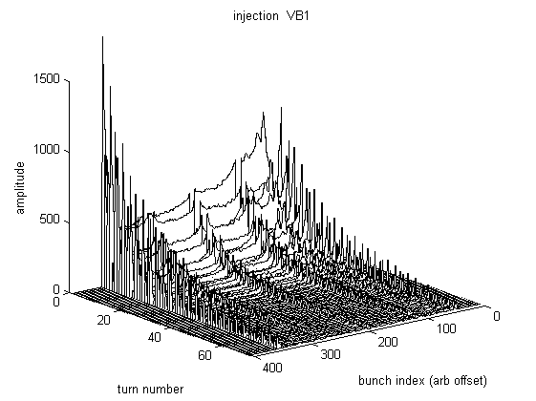

Fig. 6a: Injection oscillations in vertical plane for beam 1 (absolute value) for 144 bunches at 50 ns spacing; spikes of large oscillation amplitudes can be seen due to the kicker rising and falling edge (standard ADT bandwidth settings [21]).

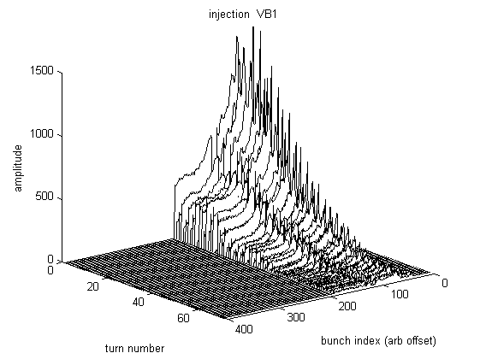

Fig. 6b: Injection Oscillations (a.u., vertical beam 1) for 144 bunches at 25 ns bunch spacing during 25 ns tests in 2012; spikes visible at the batch limit due to the kicker rise time are rapidly damped thanks to the enhanced bandwidth settings [21].

More sophisticated analysis such as for tune diagnostics, using the ADT can be realised on the same platform but perhaps call for a separate instance of the observation box. Using GPUs for parallel processing of bunch data is foreseen with the observation boxes and has previously been considered for the purpose of tune analysis [12].

Using the ADT data for instability diagnostics will heavily rely on the successful deployment of the instability triggering network described in the next section.

### ADT and the Instability Trigger Network

A project has been launched to install an *Instability Trigger Network* [22]. This network is based on *White Rabbit* technology [23] and will link clients via a central hub to permit them to exchange trigger information for data acquisition across different systems and instruments. It addresses the need of synchronised acquisition in case of instabilities across a wide range of devices spread geographically around the LHC. In the first stage RF and BI systems in point 4 of the LHC will be connected to the central node in the CCC. The system can later be extended across the LHC to other users.

Fig. 7 shows as an example the signal flow after an instability is detected by the horizontal ADT system. The trigger is time-stamped and sent via the White Rabbit network. Depending on a pre-configured mask all subscribed clients can trigger *synchronously* after a pre-defined delay. In the example of Fig. 7, the configuration leads to triggers being generated for the ADT system for beam 2 (all planes and observation box), the APW, and the MIM. The trigger system is easily scalable so that other instruments can be connected by adding new nodes to the White Rabbit network.



Fig. 7: Example of signal flow with the LHC instability trigger network (explanations, see text).

The synchronism in the White Rabbit network ensures that all data is frozen at the same moment and correctly time stamped for later reference. Storage of the data in the Measurement data base or – a clearly defined, limited amount – through the infrastructure of the post mortem system is being considered.

## STATUS AND COMMISSIONING PLANS

### Status of LS1 Works in Summer 2014

As of summer 2014 the power system modifications have been completed and re-commissioning of the kickers, power converters and power amplifiers is well advanced and on schedule. Infrastructure for the new pick-ups and the instability trigger has been prepared, namely all cabling to the tunnel has been completed. New LLRF electronics for the damper is being designed and fabricated with series production starting after full validation in the SPS, foreseen at the start-up in autumn 2014.

### Commissioning Plans

As additional pick-ups will be available and cabling and electronics will have been changed a full re-commissioning and set-up has to be carried out. The commissioning will include preparations for the 25 ns run with improved choices for the flattening of the frequency response and automatic adaptation to bunch intensity and spacing. The redesign of the controls software for FESA3 and new hardware will represent a significant workload for the software team yet to be accomplished.

## Summary

Substantial modifications have been undertaken in the ADT during LS1. These comprise doubling the number of pick-ups and a re-design of the electronics to better match the evolved requirements. All modifications are aimed at improving flexibility, reducing noise, and optimizing for the 25 ns bunch spacing, the baseline for LHC run II. The instability trigger network and the planned observation system will permit a better use for operations, in MDs and for diagnostics, of all the data available inside the ADT system.

## acknowledgment

We would like to thank the members of the BE-RF-CS and BE-RF-PM sections for continuously upgrading and maintaining software and power systems needed for ADT and the preparation of the related works foreseen during LS1. For collaboration on the Instability Trigger network we thank the BE-CO and BE-BI groups. Beam commissioning in 2015 will be a challenge and efforts of all team members involved for the timely completion of the LS1 works are highly appreciated.

## References

[1] W. Hofle et al., *Transverse Damping System for the Future CERN LHC*, PAC’01, Chicago, Ill, USA (2001), TPAH004, 1237-1239.

[2] V. Zhabitsky et al., *LHC Transverse Feedback System: First Results of Commissioning*, presented at RuPAC 2008, Zvenigorod, Russia (2008), CERN LHC Project Report 1165, CERN, Geneva (2008).

[3] W. Hofle, G. Kotzian, M. Schokker, D. Valuch, *LHC Damper Beam Commissioning in 2010*, IPAC’11, San Sebastian, Spain, September 2011, MOPO012, 505-507.

[4] F. Dubouchet, W. Hofle, G. Kotzian, D. Valuch, *“What You Get” – LHC Transverse Damper*, LHC Beam Operation Workshop - Evian, December 2012, CERN-ATS-2013-045, CERN Geneva (2013), 73-77.

[5] W. Hofle, *LHC Transverse Damper*, LHC Performance Workshop (Chamonix 2012), February 2012, CERN-2012-006, CERN-ATS-2012-069, 157-162.

[6] E. Gianfelice-Wendt et al., *LHC abort gap cleaning studies during luminosity operation*, IPAC’12, New Orleans, LA, USA (2012), MOPPD058, 496-498.

[7] J. A. Uythoven et al., Abort Gap Cleaning for LHC run 2, IPAC’14, Dresden, Germany (2014), MOPRO031, 138-140.

[8] W. Hofle, *Experience Gained in the SPS for the Future LHC Abort Gap Cleaning*, EPAC’04, Lucerne, Switzerland (2004), MOPLT019, 575-577.

[9] B. Goddard et al., *Controlling Beamloss at Injection into the LHC*, IPAC’11, San Sebastian, Spain, September 2011, THPS055, 3553-3555.

[10] W. Hofle, R.W. Assmann, S. Redaelli, R. Schmidt, D. Valuch, D. Wollmann, M. Zerlauth, *Controlled Transverse Blow-Up of High-energy Proton Beams for Aperture Measurements and Loss Maps*, IPAC’12, New Orleans, LA, USA (2012), THPPR039, 4059-4061.

[11] B. Salvachua et al., *Handling 1 MW Losses with the LHC Collimation System*, IPAC’14, Dresden, Germany (2014), MOPRO043, 174-177.

[12] F. Dubouchet, W. Hofle, G. Kotzian, T. E. Levens, D. Valuch, P. Albuquerque, *Tune measurement from transverse feedback signals in LHC*, IBIC’13, Oxford, UK (2013), TUPF29, 579-582.

[13] M. Sapinski et al., *Beam Induced Quenches of LHC Magnets*, IPAC’13, China (2013), THPEA045, 3243-3245.

[14] D. Valuch, *Pickup Swap between ADT and BI at 8L4 and 8R4 in the LHC*, LHC-BPMC-EC-0001, ECR EDMS 1386392, CERN, Geneva (2014)

<https://edms.cern.ch/document/1386392/0.1>

[15] W. Hofle, *Transverse Feedback Systems in the LHC and its Injectors: Projected Performance and Upgrade Paths*, 3rd CARE-HHH-APD Workshop, Valencia, October 2006, CERN-2007-002, CERN, Geneva (2007), 177–179.

[16] P. Baudrenghien, D. Valuch, *Beam phase measurement and transverse position measurement module for the LHC*, LLRF’07, Knoxville, TN, USA (2007),

<https://edms.cern.ch/document/929563/1>

[17] H. Bartosik, W. Hofle, *Analysis of bunch by bunch oscillations with bunch trains at injection into LHC at 25 ns bunch spacing*, CERN-ATS-Note-2012-027 MD (LHC), CERN Geneva (2012).

[18] G. Kotzian, W. Hofle, D. Valuch, *Sensisivity of LHC ADT to intra-bunch motion*, presented on 22.01.2014, CERN-ABP-HSC Meeting, CERN (2014), EDMS 1404633, <https://edms.cern.ch/document/1404633/1>

[19] P. Baudrenghien, T. Mastoridis, *Longitudinal Emittance Blowup in the Large Hadron Collider*, Nucl. Instr. Methods A, vol 726, Oct. 2013, 181-190.

[20] R.J. Steinhagen, M.J. Boland, T.G. Lucas, *A Multiband-Instability-Monitor for High-Frequency Intra-Bunch Beam Diagnostics*, IBIC’13, Oxford, UK (2013), TUBL3, 327-330.

[21] W. Hofle, F. Dubouchet, G. Kotzian, D. Valuch, *Performance of the LHC Transverse Damper with Bunch Trains*, IPAC’13, Shanghai, China (2013), WEPME043, 3022-3024.

[22] T. Wlostowski, *LHC Instability Trigger Distribution project (LIST)*, Functional Specification, CERN, June 2014, EDMS 1377705,

<https://edms.cern.ch/document/1377705/3>

[23] J. Serrano et al., White Rabbit Status and Prospects, ICALEPCS’13, San Francisco, CA, USA (2013), THCOA02, 1445-1448;

see also [www.ohwr.org/projects/white-rabbit](http://www.ohwr.org/projects/white-rabbit)