Experiments expectations
B. Gorini, E. Meschi, CERN, Geneva, Switzerland

Abstract
In this paper the experiment expectations for the 2015 data taking period, including the period of commissioning with beam and the initial phase of collisions with 50ns bunch spacing are discussed. Experiments views concerning various beam parameters for the p-p period, beam energy, maximum pileup, bunch spacing and luminosity limitation in IP2 and IP8, are presented, as well as the physics goals and the constraints of the 2015 program, including the heavy ions period as well as special running conditions.

Standard p-p running conditions
The principle guideline for the discussion on beam conditions from the physics standpoint is the maximization of the total integrated luminosity usable for physics. On the one hand, conditions for the 2015 data-taking period should be analyzed in view of the integrated luminosity reach of the whole Run 2; on the other hand, considering machine performance, reaching ultimate peak luminosity may not be the optimal choice in terms of commissioning time and machine availability, as well as e.g. pileup. It is important to note that especially an excess of the latter could dramatically degrade the data taking and analysis efficiency of the experiments.

Energy and bunch separation
Any increase in beam energy will significantly improve the potential for discovery of new physics even with moderate luminosity (figure 1). This augmented reach must however be weighted against the need of fixing the energy early enough to allow MC production. The experiments assume hereafter that 6.5 TeV will be defined as the initial energy (after the Chamonix final decision) and NOT changed in 2015. Results from late quench tests could force to run at lower energy and that is considered an unavoidable risk. In the course of Run 2, in general, small step increases towards ultimate energy during the year should be avoided wherever possible in favor of a single change applied during the end-of-the-year technical stop.
As always stated the most critical parameter for the high luminosity experiments is the number of interactions per crossing. A higher level of pileup has negative implications on several aspects of the experiments, and ultimately affects the experimental accuracy of the results. These include the readout capability, because of increased occupancy, the trigger efficiency, the reconstruction and analysis efficiencies, as well as the systematic uncertainties. Higher pileup also demands larger online and offline computing resources.
ATLAS and CMS have studied carefully several effects and agree that a maximum level of pileup of about 50 would be manageable in Run 2, and would not require the introduction of any mechanism for luminosity leveling. 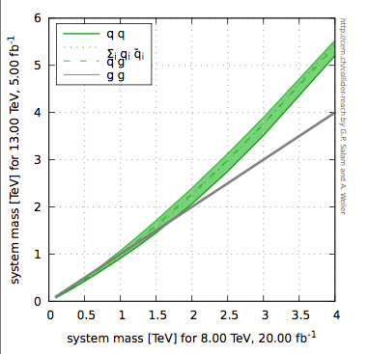
Figure 1: Discovery potential comparison: profiles of equal statistics as a function of the parton-parton system mass for 5 fb⁻¹ delivered at a center of mass energy of 13 TeV with respect to 20 fb⁻¹ at 8 TeV [1].

It must be made clear though that handling such a level of pileup is challenging and it is hence only considered acceptable as an initial fill value, assuming the natural luminosity decay. Values of acceptable constant pileup in the case of luminosity leveling range between 30 and 40.
Effects of pileup are not linear, and depend of the specific physics channel considered; there is therefore no sharp threshold below which pileup has no effect and above which the experiments would stop working. Rather, pileup should be considered as the key parameter to optimize the physics yield of LHC in conjunction with all other relevant machine parameters.
Running the LHC with a bunch spacing of 25 ns is considered of maximum importance to maximize the ultimate physics reach of the machine. It is accepted by all experiments that 25 ns bunch spacing will require a longer commissioning period and could result in lower integrated luminosity delivered in 2015 with respect to 50 ns, but it is still considered as the supported scenario in view of the longer term scientific goals. It is also understood that a phase of machine re-commissioning with 50 ns spacing will be needed, but it is expected to be limited to what is required for establishing the machine conditions.

Luminous region and optics
At constant total pileup, the density of collisions in the luminous region is of particular relevance for the efficiency of the reconstruction of the primary vertex in the tracking detectors. Considering that the luminous region in Run 2 will be smaller due to larger crossing angles, the experiments would prefer to have bunch lengths at the beginning of the fill yielding a luminous region not significantly shorter than those of Run 1. Decreases and increases of the order of about 10% would be acceptable, while larger changes will require further study.
There is no major concern with adjusting the bunch length or the crossing angle as a proposed mechanism to reduce the luminous region during the fill, in view of moderating the luminosity decay.
It is to be noted that lengthening the luminous region may also reduce track reconstruction efficiency in ATLAS and CMS, as well as the LHCb VELO acceptance for long-lived B mesons. As a general remark, it would be important for the experiments to know the expected beam parameters as early as possible for MC production.
ATLAS and CMS express no specific concern with respect to the choices of optics at the IP. Injecting at lower β* would not be a problem as the Van der Meer scan campaign will anyway require ad-hoc optics. Even the possible adoption of flat optics is not seen as a problem, at least up to a β_{x}/β_{y} ratio of 2-3.

Filling schemes
The only constraint with respect to filling schemes for physics data taking is that they should include few bunches not colliding in IP 1 and IP5, for both beam 1 and beam 2. These bunches have proven to be essential to background studies, as otherwise the experiments would have no direct way to evaluate the level of beam-gas interactions (figure 2).
It is proposed to shift, for one of the two beams only, the initial injection of 12 bunches, required for machine protection checks. Despite the fact that the non-colliding bunches should be as similar as possible to the colliding ones, it would be acceptable to inject lower charge to mitigate potential instabilities due to lack of Landau damping.

Leveling and crossing in LHCb
Analysis of the LHCb’s Run 1 data did not show a significant improvement of systematic uncertainties from the tilted crossing angle scheme. This requirement is thus relaxed for Run 2. Differences between the crossing angles for the two experiment’s magnet polarities should anyway be minimised. Regular polarity swaps will still be necessary about every 100 pb⁻¹ delivered to LHCb.
In 2015 LHCb will need luminosity leveling at 4-6 10³² cm⁻²s⁻¹in IP8. Leveling by separation is assumed as the default. All experiments agree that commissioning the leveling based on modulation of β* in IP 8 could prove useful in case such a mechanism should need to be deployed at a later stage in IP1 and IP5. Hence it is supported, if seen as beneficial, only if not significantly affecting physics time.
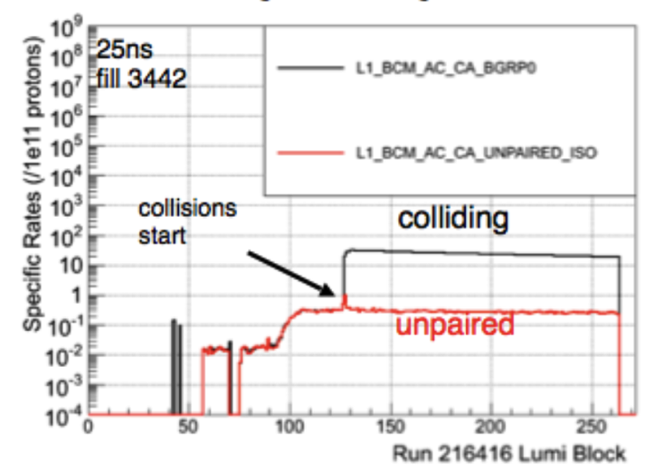
Figure 2: Rates from beam monitors for paired and unpaired bunches. The rate from unpaired bunches is and indispensable tool to evaluate the beam-gas background

ALICE conditions during the p-p period
The ALICE experiment needs to collect data in minimum-bias conditions during the whole p-p data taking period. This means that the luminosity in IP 2 should be leveled in a range between 5 10²⁹ cm⁻²s⁻¹ and
2 10³⁰ cm⁻²s⁻¹. With 25 ns bunch spacing most bunches collide head-on in IP 2 and the required reduction of luminosity must be achieved mostly by beam separation. Looking at beam profiles measured in Run 1 during Van der Meer scan campaigns (figure 3) one concludes that a separations of 5-6 σ will be needed.

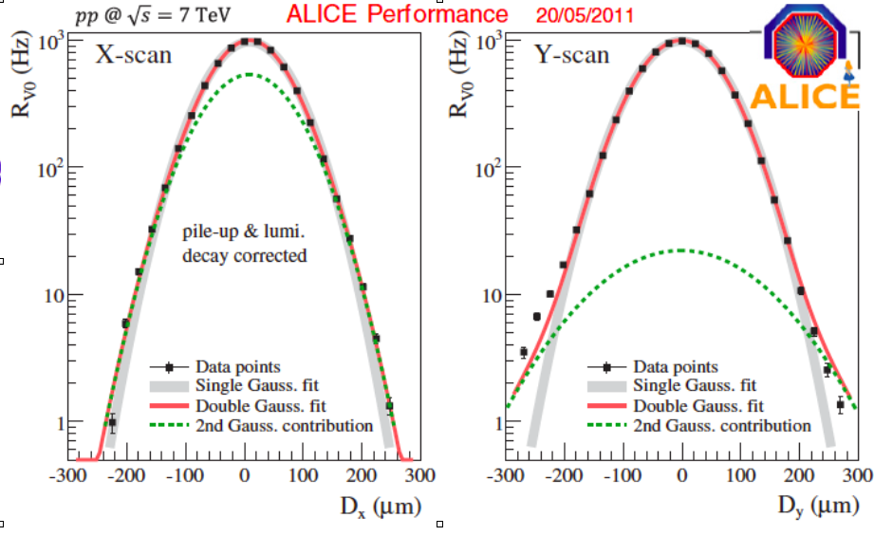
Figure 3: Beam Profiles at IP2 in a 2011 Van der Meer scan. Rate drops at the limit of the scan range are only 300 (Y), and 1000 (X), respectively

Dedicated studies must be carried on early on to assess the feasibility and the stability of such conditions. In particular the stability of luminosity conditions at such extreme separations should be addressed, as well as the operational procedure to bring ALICE into collisions with a large enough separation, to avoid the risk of a beam dump when removing the separation bump, as ALICE BCMs are currently set at a dump threshold estimated to correspond to about 6 10³¹ cm⁻² s⁻¹ [2].
ALICE requires to have few bunches colliding in IP 2 during the 50 ns period. An ad-hoc filling scheme with few head-on collisions would be preferable given the relative instability of conditions achieved with the main-satellite collisions approach followed in Run 1.

Heavy ions conditions
Four weeks of Heavy Ion collider operation are assumed in 2015. It has been decided to run with Pb-Pb collisions. The equivalent nucleon energy should be 5.1 TeV. A value of 5.02 TeV would be considered preferable but only if the additional cost in commissioning is negligible.
Since luminosity is expected to exceed the maximum value acceptable by ALICE of 3-4 10²⁷ cm⁻² s⁻¹ [3], a leveling mechanism will have to be set up at least in IP 2. Due to the importance of burn-off in heavy ion collisions, alternative leveling scenarios including the 3 experiments are under evaluation, based on the machine potential for peak luminosity and turnaround times. Despite being not directly needed by ATLAS and CMS, these are meant to limit the performance penalty in ALICE.
ATLAS and CMS require a reference sample of p-p collisions at the equivalent proton energy with an integrated luminosity given by
∫Ldt (pp) = 3-4 104 × ∫Ldt (PbPb)
The actual extent of this data taking period, as well as its detailed schedule are still being discussed in the LPC meetings, but it is required that the necessary commissioning is carried out before the start of the Heavy Ions period.

Early commissioning period
At this moment the only specific request from the experiments for the initial machine commissioning period is to deliver about 20 beam splashes per beam in both IP1 and IP 5 as well as few TED shots, during the sector tests of sector 78, for LHCb alignment studies. It is also expected that stable beams conditions will be established as soon as possible to allow detectors and triggers commissioning. Some data taking in stable beams conditions will be regularly requested during the phases of intensity ramp up.
Unsqueeze for VdM scans and the LHCf special run are expected to be part of the initial commissioning as needed (see below). Performing ALFA and TOTEM alignment and loss maps for Roman Pots as part of the initial commissioning should also be considered.
Dedicated runs with low or very low pileup are not requested at the moment as these are expected to be collected parasitically during the special run for LHCf.

Special Runs
Given the shortness of the 2015 data taking period and the extent of the commissioning campaign, it has been decided to limit the program of special runs to a minimum. The only exceptions foreseen at this moment are special runs for LHCf and an high β* period for diffractive physics in ALFA and TOTEM, as well as two Van der Meer scan campaigns.

LHCf run and VdM scans
The LHCf run with special optics for low luminosity and pileup (µ<0.01) is expected to be scheduled in the very first days of the 2015 physics production (within about a week of data taking). LHCf also requires large bunch separation (>2µs) and a half crossing angle of 145 µrad. The goal for the LHCf run is to collect approximately 10 nb⁻¹ of integrated luminosity.
An early VdM scan is necessary to provide initial calibration of the luminometers at the new beam energy. Due to the increased beam energy and the subsequent natural reduction of the beam size, it is established that the VdM scan will need to be performed with un-squeezed optics in order to keep the luminous width significantly larger than the vertex resolution, to study the non-linear x-y beam correlations that are a dominant source of uncertainty for the luminosity calibration (figure 4).
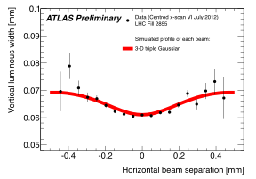
Figure 4: Nonlinear x-y correlations can be studied quantitatively by fitting the evolution of the beamspot position and luminous width during scans. This is only possible if the vertex resolution does not dominate the luminous width.
The LHCf run must be scheduled before about 500 pb⁻¹ of luminosity are delivered to IP 1, to prevent significant degradation of the LHCf detector due to radiation damage. For the VdM scan ATLAS requires a minimum of 5 pb⁻¹ delivered in order to condition their luminometer. Thus, it is proposed to combine the two special runs using ad-hoc optics to accommodate both programs. The requested values of β* are 19 m for IP 1 and IP 5, while LHCb would benefit from a larger value, between 30 and 40 m.
The luminosity per bunch requirements are significantly different for the two programs, hence it is considered acceptable, if it can save setup time, to use similar bunch intensities for the two programs, of order 7 10¹⁰ protons, ideal for the VdM scans, and reduce the pileup in IP 1 by separation when providing data to LHCf.
It is foreseen to start this special run campaign with the VdM scans in the four interaction points and then proceed with the LHCf data taking. LHCf will ideally start collecting data during the scan in IP 5. It is still unclear if a filling scheme can be established to allow LHCf to also take data parasitically during the scans in IP 2 and IP 8 and yet have a total current compatible with operating the DCCT detectors in their preferred range.

High beta runs
Both ALFA and TOTEM have requested data taking with β* of 90 m for diffractive physics studies. TOTEM in particular has requested a joint data-taking period with CMS with the target of collecting about 10 pb⁻¹ of central diffractive event data. Given the need for low pileup conditions, it is foreseen to inject bunches with a charge of about 7 10¹⁰ protons. To maximize total luminosity and yet respect the minimal bunch separation requirements of TOTEM, an ideal setup would require a filling scheme with about 1000 bunches and 75 ns of bunch spacing. This requires the development of a machine setup with a crossing angle.
It is important to state that even in those ideal conditions one would only reach a luminosity of about 10³¹ cm⁻²s⁻¹, making the TOTEM statistics goal quite difficult to reach in an already tight schedule. In addition, ALFA, even with an upgraded trigger, can only take data with up to 700 bunches.
Insertion of the Roman Pots with standard optics is envisaged for TOTEM in the context of the CMS/PPS program. It is suggested that end of fill studies be scheduled to test the mechanism during the machine commissioning and intensity ramp-up.

acknowledgment
We wish to thank in particular the Run Coordinators of ALICE, ATLAS, CMS, LHCb, LHCf and TOTEM for their essential input as well as our colleagues working on the LHC and injectors operations for countless explanations and discussions about machine parameters and constraints.

References
[1] G. Salam, A. Weiler, Collider Reach webpage; http://collider-reach.web.cern.ch/collider-reach/
[2] A. Di Mauro, presentation to the 91st
LHC Machine Protection Panel Meeting; https://indico.cern.ch/event/318640/contribution/0/material/slides/1.pdf
[3] J. Jowett, M. Schaumann, LBOC Meeting No 17; https://indico.cern.ch/event/311453/contribution/2/material/slides/1.pdf

