The time synchronization of CSNS neutron Instrument

Jian ZHUANG^{1,2}, Jiajie LI², Yichao MA³, Yi LIANG⁴, Haofu LIU⁴, Lei HU², Lijiang LIAO²
State Key Laboratory of Particle Detection and Electronics¹, Beijing, P.R.China
Institute of High Energy Physics², Beijing 100049, P.R.China
Shaanxi University of Science and Technology³, Xi'an 710021, China
GDWave Technology Co.,Ltd⁴, Guangzhou 510655, P.R. China

Abstract–In Chinese Spallation Neutron Source(CSNS), proton beam is used to strike metal tungsten target, and the target generates high flux neutron for experiments on neutron instruments. The precise time and beam current of proton hitting the target need to be measured. Then this time is broadcasted to the target station and the neutron instruments to work collaboratively. To calculate the neutron energy, this time is also needed to measuring the neutron time of flight(TOF).The beam current of proton is sent to physical analysis software to normalize neutron flux.
The time synchronization technology based on WhiteRabbit, can achieve high precision time synchronization with a large range of nodes. A synchronization system is built in CSNS with WR nodes composed of signal acquisition, time synchronization and data packing-sending. The proton beam current is monitored with timestamp, for physical analysis software. And more, in CSNS, a real-time control system based on WR is built for measuring the proton hit time, broadcasting to the electronics system of detectors, and calculating TOF of neutrons.

INTRODUCTION
N
eutron scattering is a powerful method to probe the structure of the microscopic world, becoming a complementary technique to x-ray in the advanced researches in physics, chemistry, biology, life science, material science, new energy, as well as in other applications. To meet the increasing demands from user community, China decided to build a world-class spallation neutron source, called CSNS. It can provide users a neutron scattering platform with high flux, wide wavelength range and high efficiency. The pulsed-beam feature allows studies not only on the static structure but also the dynamic mechanisms of the microscopic world.
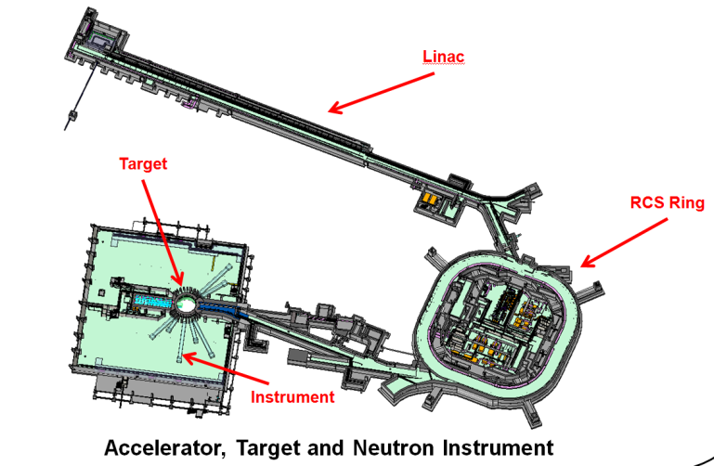
Fig.1. Overall construction of CSNS
CSNS mainly consists of an H-Linac and a proton rapid cycling synchrotron. It is designed to accelerate proton beam pulses to 1.6GeV kinetic energy at 25Hz repetition rate. Proton pulses strike a solid metal target to produce spallation neutrons. The facility of CSNS is shown in figure Fig.1.
White Rabbit system based on synchronous Ethernet and IEEE-1588 protocol extension can achieve high precision time synchronization with large capacity and long distance transmission. It can provide accurate time synchronization in the sub-nanosecond level, also can provide real-time Ethernet. WR switches can be cascaded and supports timing tens of thousands of nodes using single-mode optical fiber link. So it can be used to build high precision time synchronization and communication network of tens of kilometer level.
In CSNS, the proton current needs to be measured, to normalize neutron flux by the physical analysis software. If the proton beam bunch can be measured with timestamp, neutron flux can be normalized bunch by bunch. Furthermore, if each value in sample environment system can be measured with timestamp, the variable temperature experiment is also possibly supported in future. In CSNS, time synchronization nodes based on WR were combined with general equipment to achieve measuring with timestamp.
When the time of the proton beam bunch hitting the target is measured, the time is broadcasted to the neutron electronics to measure TOF of neutron. The time of proton hitting target is call T0. Neutron chopper, target imaging system and neutron related equipment need to work collaboratively by T0. At present, CSNS uses the T0-fanout system to constantly broadcast the time of proton hitting target. If taking advantages of the real-time extension of the WR network synchronization and data communication abilities, CSNS can implement a real-time control system, to achieve real-time event broadcasting, records of events in real time, and equipment of real-time control function. This system can replace T0-fanout system, to achieve a unified time synchronization network and real-time command network.
In this paper, we introduce the design and construction situation of time synchronization system based on WR in CSNS. And then, we carry out the basic performance testing for real-time data transmission. According to the results, we designed a instruction format for real-time command system.

DESIGN OF TIME SYNCHRONIZATION
In the first stage of CSNS, three neutron instruments, serval test instrument and white light neutron source were built. Shown as figure Fig.2, GPS receiver, rubidium clock and WR grandmaster switches were deployed in the central control room. Slave WR switches were deployed in the HighBay, the experiment hall and neutron instruments. In proton flux monitoring station, neutron instruments, test instrument and white light neutron source, WR nodes were deployed.
In the CSNS, the measurement resolution of TOF is 1us. Considering the requirements of the neutron beam in the future, as well as the requirements of the Fermi neutron chopper, the time precision of T0 is better than 10ns. The precision of time measurement better than 1ns is enough to meet the requirements of the time accuracy of the neutron instrument.
The WR system uses PPS pulse provided by GPS receiver. This PPS pulse is acclimation by rubidium before being sent to WR system. And WR system use UTC time provided by the GPS receiver. In order to synchronize the computers time in control system, the NTP server synchronized to this UTC time is also deployed in the EPICS control network.
Fig.2. Overall plan
.
In neutron instrument, main detector electronics are synchronization to WR nodes by PPS pulse and UTC times pulse. This means clock upon second generated by WR system, and clock within second is generated by the crystal on the main detector electronics board.
At the end of RTBT of the accelerator, a NI PXI station with WR nodes is deployed to acquire proton flux and proton hit time. This station acquires proton flux by data acquisition card and improved SPEXI card to mark timestamp. The sequence No. of proton bunch can also assign by SPEXI card. In the current engineering plan, the proton flux data is transmitted to the proton flux recording server through the EPICS control network, for neutron instruments and the white light neutron source. Then this data is submitted to history database based on MySQL. The physical analysis software can acquire the data with last one minute by network. The average flux per 4 seconds is also calculated and provided for simple computation via EPICS PV. The block of the proton current query system is shown in figure Fig.3.
Fig.3. Proton bean query and storage system

The trigger time of proton flux pulse, can be used as proton beam hit time for neutron instrument after the amendment. If in the SPEXI card, at the time marking timestamp on the proton flux, Ethernet packets including proton hitting time can be generated, and then broadcasted to all neutron instruments and white light neutron source within the specified time delay. Thus a substituted T0 signal can be generated by WR nodes to the equipment. Furthermore, if we can cache neutron data in a buffer for a certain time, the TOF is calculated of neutron by timestamp subtraction. Consider most demand of CSNS instruments, the delay of 5us can be accepted.

REAL TIME TRANSMISSION PERFORMANCE TEST
In order to design a real-time control system which meets the requirements of the CSNS spectrometers, the system should transmit data packets to the nodes in real-time, we build an experimental network for testing. The experimental system topology is shown in Figure Fig.4. In order to verify the influence of the length of the data frame on the real-time performance, the transmission delay jitter of a number of different length data frames were sampled and analyzed.
Fig.4. Topology of real-time control system
According to the experimental network, the cycle experiment of different data length for the performance of the system is carried out. The length of the packet is increased from 60 bytes to 1512 bytes. In each frame length, 1000 times the cycle of experiments were done. The mean delay is shown in Fig.4.
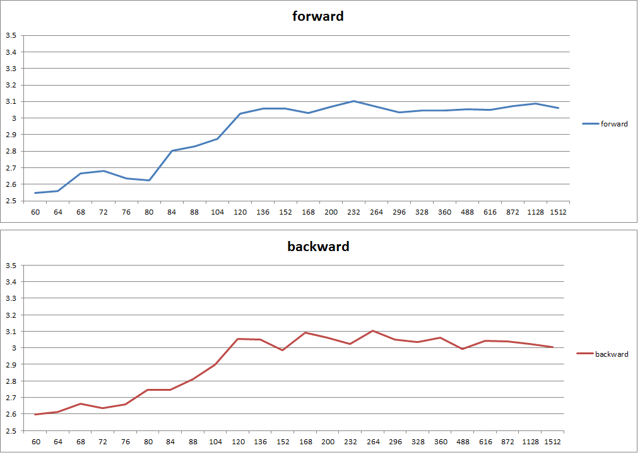
Fig.5. Data frame transmission of various lengths of the experimental mean value

As shown in Figure Fig.5, while the length of the data packet is more than 104 bytes, the transceiver time will be convergence to about 3us. So, there is little of effect on delay by the frame length from 104 bytes to 1512 bytes. So the short frame, about 64 bytes can be taken for fast control in real-time control system based on the WR. A long length frame can be taken for complex control. For the convergence transmitted delay, the step of length can be designed to big. Even for the maximum length package, the delay is less than 5us. The requirement of CSNS can be met.

INSTRUCTION FORMAT DESIGN
In CSNS, a real-time control package format based on the WR system is designed. In this real-time control system, event source node or master node send instructions using UDP broadcast packet. Then target nodes receive instruction packet as silent mode or response to the source node with a reply packet. The format of instruction is shown as Figure Fig.6.
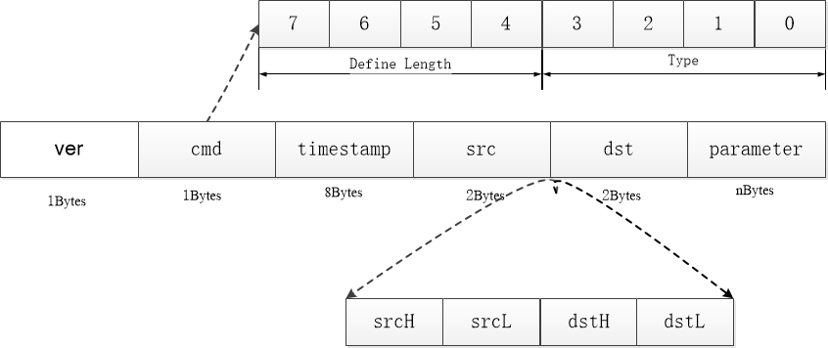
Fig.6. Instruction format
Each field in the instruction is defined as the table Tbl.1.
Name | Length  （Byte） | Definition
ver | 1 | Define the command system version number for compatibility design.
cmd | 1 | Consists of two parts:  - 1 frame length type, high 4 bits, 0x0~0x4, step 4 bytes; 0x5~0xA, step 32 bytes; 0xB~0xF, step 256 bytes;  - command type, low 4 bits, the first edition of the protocol includes three kinds of instructions:  A) events broadcast;  B) response messages;  C) commands with parameter.
Timestamp | 8 | The time stamp of a marked source event or instruction;
src | 2 | The source node address, big endian mode;
dst | 2 | The target node address, main mode;
Parameter | N | Defined by the field ‘CMD’, packing another CMD is available.
Tbl.1. Fields Description
The instruction system uses the length-mapping-table algorithm, which can be used in the parameter field to make the steamed stuffed instruction in a recursive way. So as it can be done to expand the capacity of the instruction information. The command system is currently implemented in the first version, used in the laboratory for internal validation.

INSTRUCTION DELAY TEST
In order to test the delay of this instruction, more delay test, for the size of 60 bytes, 416 bytes and 1512 bytes, were done. The result of 10000 times test is shown in figure Fig.7. According to the result, small length packets to send and receive will produce some more jitter. For the 10000 tests on 60 bytes, the histogram shows bimodal distribution for long data packets, the delay performance is relatively stable.
According to the experimental results, it can be concluded, regardless of the minimum message or the long message, there is low delay of transmission in this system with the instruction we designed. The delay is less than 5 us, and the jitter less than 500 ns. All this can meet the requirement of neutron instrument.
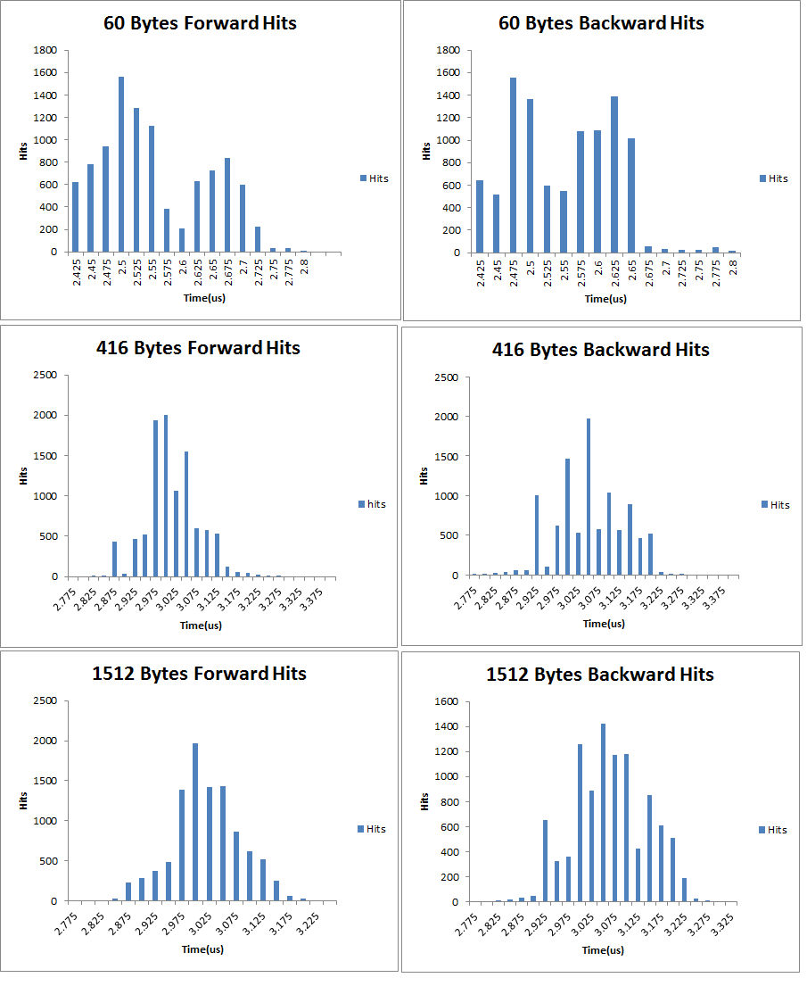
Fig.7. Histogram of transferring jitter

CONCLUSION
In the Chinese Spallation Neutron Source, we validated the feasibility of high precision timing in WR system and design the time synchronization. Then, the extended feasibility of real-time command and control system was validated, and design an instruction set for CSNS.

References
- Wei Jie et al, China Spallation Neutron Source - An Overview of Application Prospects, Chinese Phys. C, Volume 33, 2009.
- http://www.aps.anl.gov/epics/
- Extreme Fast Control Technology, BECKHOFF Company, http://www.beckhoff.com/english.asp?highlights/xfc/technology.htm
- Lei Hu, Jian ZHUANG, et al, Design of Interface between EPICS system and device driver of Beckhoff PLC
- Eidson John C. (April 2006). Measurement, Control and Communication Using IEEE 1588. Springer. ISBN 1-84628-250-0.
Martin R. Krainmer et al, EPICS Application Developer's Guide, http://www.aps.anl.gov/epics/base/R3-14/12-docs/AppDevGuide/

Jian ZHUANG(1976.10- )， male, received his doctor's degree in computer applied technology from University of University of Chinese Academy of Sciences. He current works as associate professor at Institute of High Energy Physics in China. His research interest includes control system, real-time system and DAQ.( e-mail: zhuangj@ihep.ac.cn) Corresponding author: Jian ZHUANG, (e-mail:zhuangj@ihep.ac.cn)

