Beam Transport System of ALPI-PIAVE Accelerator’s Complex at LNL EPICS Based

M. Montis, M. Giacchini, INFN - LNL, Legnaro, PD, ITALY

Abstract– The beam transport system of ALPI-PIAVE accelerators has been recently upgraded by migrating the control software to EPICS. The field systems is based on diagnostic and magnets. To reduce the upgrade costs the first system re-use the existing VME hardware used for data acquisition, while the motor controllers only have been replaced by new units developed in house. The second system is based on embedded linux boxes. The control software has been rebuilt from scratch using EPICS tools. The operator interface is based on CSS; a Channel Archiver Appliance has been installed to support the analysis of transport setup during tests of new beams. The whole Epics network is monitored using open sources tools, either various services, like deploy, automatic backup, log centralization relay on open sources linux project customized as necessary to our requirements.

INTRODUCTION
T
he beam transport system is a critical task for managing the accelerator complex, because it is the first stage where scientists and operators understand machine status and execute the operations required to provide the desired beam. It is composed by interceptive diagnostics based on VME hardware and lens (magnets and steereres) which are managed by embedded PCs; more than this it relays on other essential control system tools: archiving, backup/restore configurations etc. (Fig 1)

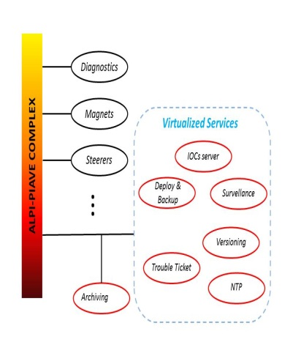

Fig 1: PIAVE-ALPI complex.

The beam diagnostics system for ALPI-PIAVE accelerators has been upgraded two years ago by migrating the control software to EPICS[1]. The system has based on 40 modules, where each module inclues a Faraday cup and a beam profiler. The device's insertion is controlled by stepper motors in ALPI and by pneumatic valves in PIAVE. To reduce the upgrade costs the existing VME hardware used for data acquisition has been left unchanged, while the motor controllers only have been replaced by new units developed in the laboratory.
The previous lenses system (magnets power supplies, steerers etc.) was based on terminal servers: power supplies were connected to the terminal server through serial interfaces to the central control workstation server. In this last machine, a C program run to manage the communications, and made available the Graphical User Interface (GUI) to the operators. This architecture forced users to operate only one GUI interface per time. The communication interface itself realized sub-groups connected on terminal servers with RS422 protocol. This configuration suddenly provided communication problems in case of faults of only one power supply on the chain. Basing on this experience and using the features provided by an EPICS based architecture, the new system should have a great granularity, where, the communication shouldn’t be concentrate, and the GUIs could be duplicated and distributed without effort on the entire facility.
The control software for both systems, has been rebuilt from scratch using EPICS tools. The operator interface is based on Control System Studio (CSS) while a Channel Archiver based on PostgreSQL[2] relational database has been installed to support the analysis of transport setup during tests of new beams.
A giant monitor based on 52” TV, resumes the status of overall machine and has been placed in the control room (Fig 2).
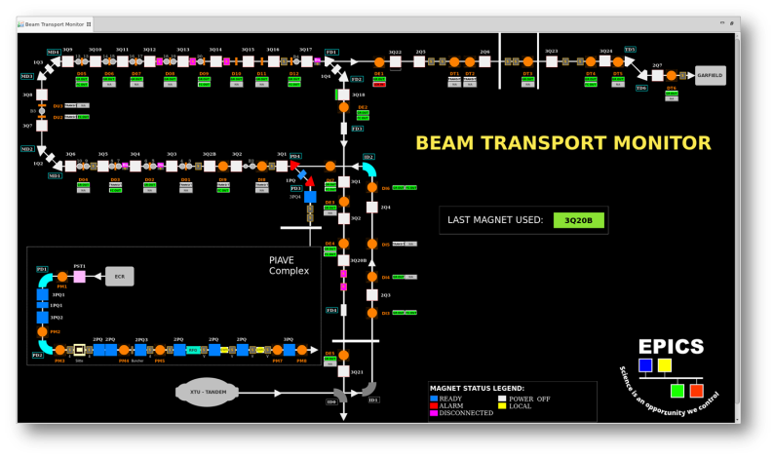

Fig 2: Beam Transport monitor.

diagnostic system
The ALPI-PIAVE diagnostics environment is composed by 48 diagnostics boxes installed along the apparatus containing, each one, a faraday cup and a couple of grids (horizontal and vertical) where every single grid has made of 40 wires. To avoid white noise inducted by cables, current signals are converted to voltage next to the diagnostics box.
After the conversion step, grid signals are multiplexed and serialized before the transport to the acquisition system composed by an ADC card installed in VME crates. The multiplexer is driven by a counter whose clock is generated by the ADC itself, in order to provide a signal synchronized with the conversion operation.
The VME CPU runs a VXWorks operating system, which is supported by EPICS since its origin; therefore VME systems has been used in the following configuration: the VME processor implements an Input/Output Controller (IOC) providing the acquisition of grid signals and faraday cups. The EPICS Databases loaded in the IOC are not very complex, due to simplify the maintenance, and provide minimal processing on raw data.
Signal from beam profilers and faraday cups are acquired by XVME566 board produced by XYCOM: this kind of hardware provides 12 bit resolution and support a conversion rate up to 100 KHz in streaming mode. As indicated in Fig 3, a dedicated EPICS Device Driver realized by M. Davidsaver implements the software interface between the field and the EPICS server host.

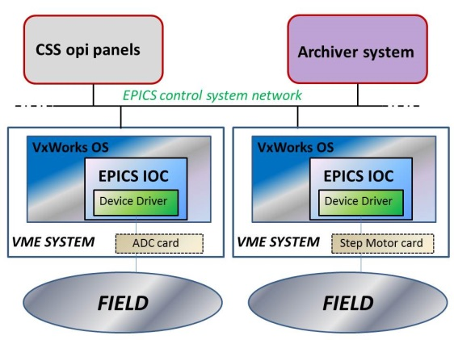
Fig 3: Software schema

Steppers motor controllers for collimator position are VME cards built inside the LNL, together with the associated power drivers. The crate controller is an Emerson MVME3100 based on the PowerPC8540 equipped with 256MB RAM and every single controller is able to manage up to 8 motors.
Also this host runs under VxWorks OS which provides an EPICS IOC properly configured to manage the devices connected and provide a set of basic functions:
• acquisition of collimator position from linear encoders;
• control of step motors used to synchronize the collimator motion with the grid signal acquisition.
Due to realize this functionality, a dedicated Device Driver has been developed by D. Chabot to control motor position and provide feedbacks.
The entire diagnostics system results composed by 1600 record, counting both records managing raw and elaborated data.

lenses system
The EPICS Input Output Controller (IOC) selected to this application is a low cost embedded PC. The power requirements necessary to this object is low enough to use the Power Over Ethernet technology in order to minimize power consumption. This solution makes extremely cheap the cabling, but requires the sufficient power on the Ethernet switch. We are evaluating various kind of embedded PC which could play this role and the final decision has not been done, but we have already done tests on ARM embedded PC.
The power supply for the magnets driver cards can use two kind of serial communications: RS232 and RS422. The previous system has used the second one: the pros of that choice were the reduction of the amount of the lines, the reduction of the cabling and, as consequence, a final reduction of the total cost, but the cons was quite bad in terms of reliability and availability: if just only one element of the chain goes on communication fault state, all the controllers on that line are not controllable until the fault was fixed.
The new system makes all the communication independently using the RS232 connection, which realize a point to point connection between the controller and the embedded PC. Later we could move back to the RS422 protocol, which is more strong in front of noises; in any case we would maintain the point to pint connection in order to guarantee the system robust as much as possible.
The core of the software, the device communication layer, has been accomplished by using ASYN[3] and has been based on basic version used on other sites: particular customization has been required in order to fit the requirements of our site.

central control system human machine interfaces and services
Different tools and applications are available in the EPICS environment to create dedicated control panels for managing the facility and the Linac apparatus and every single tool provides particular features.
Following the line defined for the SPES Project, Control System Studio (CSS) has been chosen as common layer to realize Human-Machine Interfaces (HMI), in order to have an integrated environment where the user (scientist or operator) can use different tools (such as control panel, archiver viewer and alarm handler) in the same main application.
As consequence, a dedicated set of control panels has been developed in CSS inheriting as starting point the layout used until now with the previous control system.
The whole HMI for the ALPI-PIAVE lenses system is composed by a main panel representing the map of the linear accelerator (Fig 4) and an area where user can interact with a particular lens box.
The beam transport system, was used as test bench for the EPICS Archiver service. Preliminary basic operations related to data storing and retrieving have been performed between this sub-system and the archiver machine in order to verify the correct communication in both sides and, at the same time, define the common standard configuration which will be used for all the other sub-systems. The data acquisition performed now is used to estimate the hardware requirements (disk space, etc.) needed by the archiver service in production. In these tests both raw and elaborated data are stored, due to understand the best sampling configuration for archiver acquisition with different type of data. 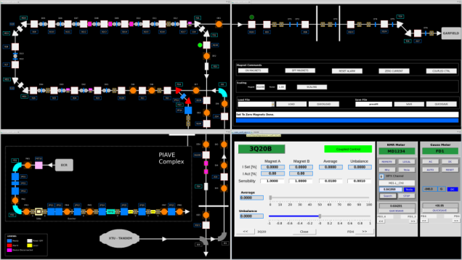
Fig 4: Lenses HMI interfaces

For the ALPI diagnostics system, archiving all the information provided by this system requires about 70 GB/day; obviously this is the worst case and optimization is required, but this information can be used as upper bound for design data archiving for the diagnostics.
For bringing in production the beam transport system, all the necessary services have been provided from the architectural point of view: NTP server, NFS server, versioning system, IOC server, machine deploy system.
Particular studies and design have been put for the last one service in order to provide an optimized disaster recovery strategy: using the machine deploy system with the regular backup service let us be able to replace a system (in particular the EPICS IOCs) from a bare-metal installation in few hours, minimizing the machine stop.

conclusions

The beam transport system has been a great playground to verify and improve the initial design and overall architecture. After a first archiving system based on PostgreSQL we are moving on most powerful and simple to maintenance new Appliance archiving control system.
A good backup and restore system has been realized using the cloud technology [5].
All this architecture should be the base environment to move on and integrate other control systems composing the machine in the next future, in order to provide a real distributed control system for the SPES project.

Acknowledgment
This works leveraged of years of experience on EPICS use from good engineers of other laboratories around the world: great acknowledgments to them.

References
- EPICS website: http://www.aps.anl.gov/epics/
- M. Montis et al., “New Data Archive System for SPES Project Based on EPICS RDB Archiver with PostgreSQL Backend”, PCAPAC’14, Karlsruhe, Germany (2014)K. Elissa, "Title of paper," unpublished.
- G. Bassato et al., “A Beam Profiler and Emittance Meter for the SPES Project at INFN-LNL”, MOPMS035, Proceedings of ICALEPCS2011, Grenoble, France (2011)
- ASYN : synchronous Driver support module to EPICS control systems (www.aps.anl.gov/epics/modules/soft/asyn/)
- Owncloud: Open source, self-hosted file sync and share app platform (https://owncloud.org)

