WLCG Resource Reporting

V1.0

Introduction
This document explains the purpose of resource reporting within WLCG and the need for the inclusion of clouds. It proposes a technical solution so that cloud resources can be reported and provides an analysis that identifies the missing components.

Requirements
The WLCG collaboration is supported by MoUs which represent a commitment to support WLCG. Pledges are a renewal of that commitment and define its level. To ensure that sufficient resources are in place, a yearly pledge gathering exercise takes place and the result is compared to the needs from the VOs. Monthly reporting of resource usage is monitored to verify that the resources pledged are delivered. Cloud resource usage must therefore also be reported so that they can be offset against the pledges. This capability needs to be in place for clouds to be considered in production as sites will rightly not divert hardware to clouds if it is not acknowledged as part of their pledge contribution.
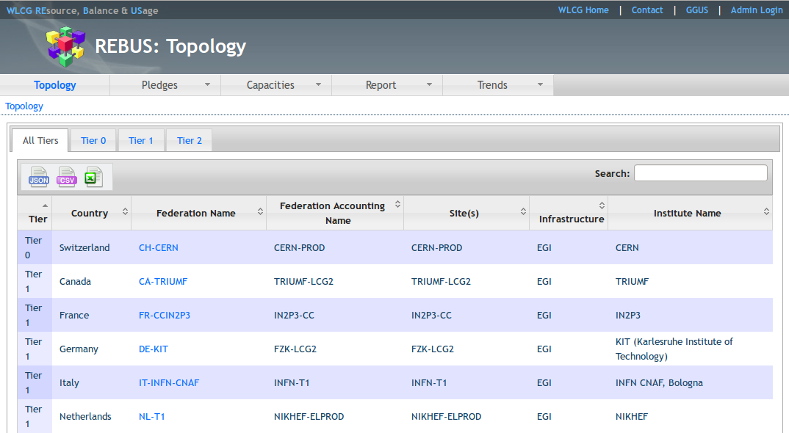
Figure 1: REBUS Topology View
The Resource Balance and Usage (REBUS) service is used to implement the related workflow. Once a Federation has signed the MoU, the Federation is added to the Topology in REBUS as shown in Figure 1. This defines the official list of WLCG Federations, the Sites belonging to that Federation and to which Tier they belong. Each year the VOs (ALICE, ATLAS, CMS and LHCb) define their expected resource needs for CPU, Disk and Tape in HEP-SPEC06 hours and TB respectively. Similarly each Federation provides pledges for the resources that they expect to deliver. These two values can be compared for each resource type to see if the anticipated resources to be delivered match with the needs of the VOs as shown in Figure 2.
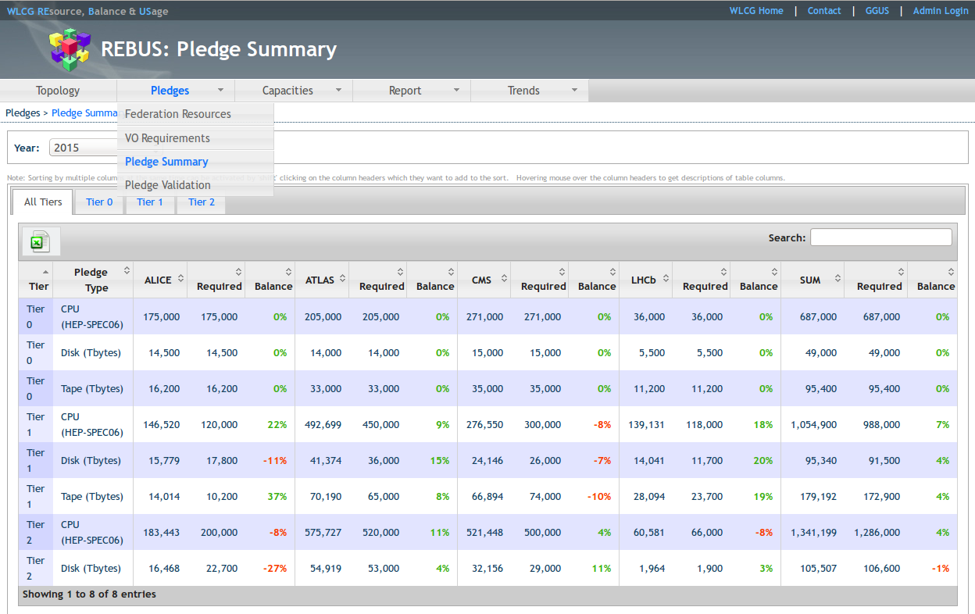
Figure 2: Comparison of Pledges with the Requirements
Every month the Tier 0/1 sites submit a report on their use and a similar one for the Tiers 2 is created automatically and sent to the Tier2 site managers for verification. The values for the CPU and Wall time used in HEP-SPEC06 are automatically obtained from the relevant view in the EGI Accounting Portal as shown in Figure 3. The underlying source for these values is the APEL accounting system. The accounting publisher obtains the CPU and Wall times from the relevant log files. CPU and wall clock times are normalised to HEP-SPEC06 using benchmarks performed by the site. In some cases the scaling factor is provided per job by the batch system based on the power of the node where it ran. For this case the benchmark units of the normalization are also provided. The batch normalization factor is also reported in the BDII. For cloud resources similar HEP-SPEC06 values are required per WLCG Federation to allow comparison with the pledges.

Proposal
The solution for cloud resource reporting in WLCG will build upon the existing APEL cloud accounting work. It will follow the same approach as for Grid resources where an accounting publisher extracts the required information from the cloud resource, sends the result to the accounting database and the EGI Accounting Portal is used to provide an aggregated summary. The information on cloud resources should be shown separately from Grid resources as this itself is interesting information. The information will need to be merged for comparison with the pledges. Sites that have a cloud resource and publish cloud accounting information should register this service (eu.egi.cloud.accounting) in the GOC DB. Automated monitoring can then verify that records are being published. The information provided by the summary view in the EGI Accounting Portal should be cross-checked using external information sources such as the job result metric held by the VOs. A HEP-SPEC-06 normalization factor for the VM will be published in the usage record. The methods used to select the appropriate benchmarking value for a VM will need to be documented. OSG resources should be able to send accounting summaries from their Gratia accounting tool similar to how this is done for Grid resources. So far NorduGrid resources are publishing directly using SSM.
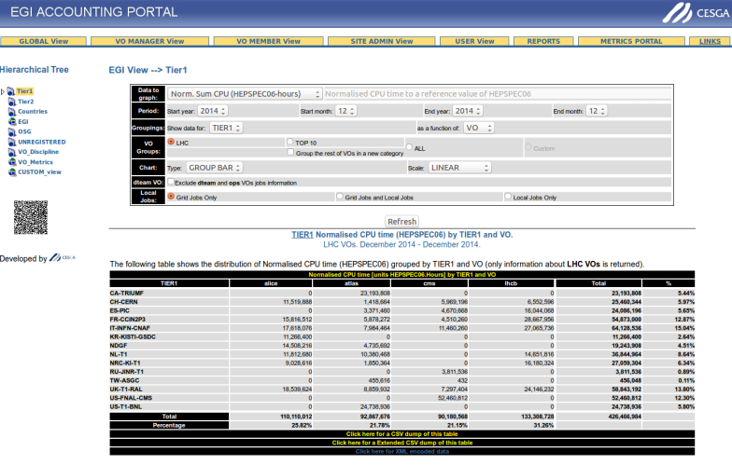
Figure 3 Tier 1 view in the EGI Accounting Portal

Analysis
Many clouds are already publishing accounting information using APEL and a list of sites can be seen in the service view of the GOCDB and usage in the EGI Accounting Portal. This information provides the CPU and Wall time in seconds per site and VO. As already happens for Grid accounting, this data could be viewed in the portal by the T1/T2 structure as given by REBUS. Once this view is in place, the REBUS service can be extended to include cloud accounting values and hence the final resource reporting reports will contain information about cloud usage. The details on what changes are needed for REBUS can be discussed once the cloud accounting information is available in the EGI Accounting Portal.
Current reporting assigns the usage to the Starting timestamp of the VM. While this is probably fine for current LHC use cases, if long running VMs become the norm then it will be more useful to report the usage of a VM split across the months during which it runs.
The following work remains to be done:
- Implement planned changes to the cloud accounting record including a normalisation factor
- Agree on a normalisation method
- Develop a method of splitting the usage reported across calendar months
- Implement T2 view in Cloud Accounting Portal
- REBUS to pull data from T2 reports to report alongside grid usage

https://goc.egi.eu/portal/index.php?Page_Type=Services&serviceType=eu.egi.cloud.accounting

