LHC operation and efficiency in 2015
M. Solfaroli Camillocci, CERN, Geneva, Switzerland

Abstract
With the restart at a record energy level, 2015 has been a challenging year for the LHC. An analysis of the performance through the investigation of each phase of the nominal cycle will be presented. The possibility and different scenarios to potentially increase efficiency will also be discussed.

INTRODUCTION
2015 has been a special year for the LHC. The machine has been commissioned to a higher energy level with many system upgrades implemented during the Long Shutdown 1. Some conditions have also been changed during the year, as for example, the bunch spacing. The first part of the year the machine has been operated with 50 ns, then with 25 ns. The change of bunch spacing impacts quite strongly machine operation. For this reason it is important, while analyzing the LHC efficiency, to distinguish between the two phases and considering the second one (25 ns) as representative for 2016 projections.

The LHC turnaround
The LHC turnaround is defined as the time between two consecutive stable beams. Namely, the time between a beam dump (in stable beams) and the moment the stable beams mode is declared again. A histogram with these times for 2015 operation can be found in [1]. This analysis can be fine tuned, eliminating from the histogram all occasions when studies or scheduled access were done. These situations, in fact, are not representative of the operational time needed to cycle the machine. The results are shown in Fig.1 for all 2015 fills (red) and for only 25 ns fills (blue).

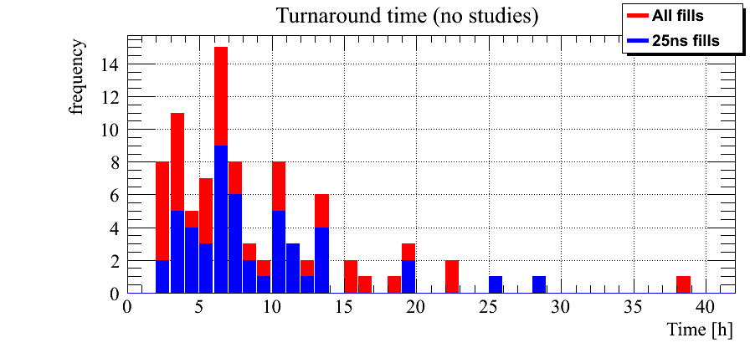
Figure 1: LHC turnaround without studies and scheduled accesses

The average time needed to turn the machine is 9.0 hours (8.8 hours if only 25 ns fills are considered).
A further analysis was done, removing from the previous set of values the occasions were an access is given or a very long fault occurred. In this way we can obtain what could be defined as operational turnaround, in other words the time needed to operate the machine in absence of mayor unexpected events. These results can be found in Fig.2.

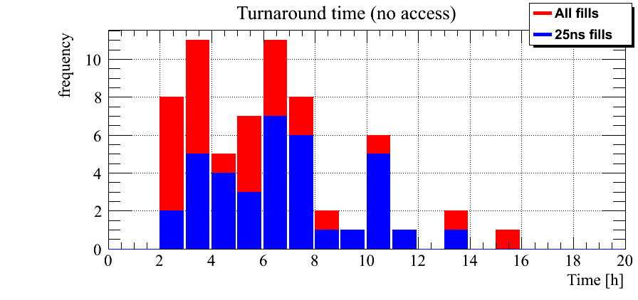
Figure 2: LHC turnaround time in absence of mayor faults

The average time goes down to 6.3 hours and 6.8 if only 25 ns fills are considered; this difference is mostly due to the higher heat load generated by the 25 ns beam. These results are very important not only for optimization of LHC efficiency, but also for design of future accelerators.

The LHC EFFICIENCY
The start of machine operation can be considered as the moment the first stable beams was declared (June 3th). This moment marks the end of beam commissioning. On November 4th the LHC entered a period of machine development, followed by a technical stop to prepare Ions operation. Taking the time between these dates and dividing all possible operational conditions into four categories, the graph in Fig.3 is obtained. The time LHC was undergoing technical stops was removed. The category NO BEAM includes accesses and long period without beam due to faults, while BEAM IN includes all conditions of beam operations that are not stable beams (included in the category STABLE); finally SETUP represents the time spent in precycling and preparing the systems for beam operation.

Figure 3: LHC efficiency in 2015

Taking into account the considerations made in the introduction, it is important to calculate the LHC efficiency considering only the 25 ns fills. This distribution is, in fact, more representative for 2016 estimates. The result for 25 ns period can be found in Fig.4.

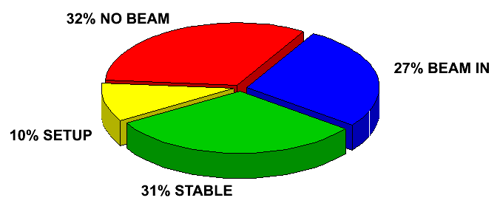

Fig.4 LHC efficiency (25 ns fills only)

More than 50% of the time the LHC is operated with beam and a large fraction (31%) is devoted to physics production.

Analysis of the operational cycle
To better understand the LHC efficiency, it is very important to split the analysis into the different phases. Each of them, in fact, has its own peculiarity and the higher granularity would allow identifying possible improvements. The details of such analysis can be found in [1]. A summary table is presented in Tab.1.

Beam mode | AVG₂₀₁₅ – AVG₂₀₁₂ | Comment
Injection | + 5 min | 25 ns beam (higher complexity)
Pre-ramp | + 5.2 min | cryo stabilization (heat load)
Ramp | + 6.5 min | Higher energy (longer settings)
Flattop | - 0.9 min | Q change (previously done during squeeze), but no systematic check of Q corrector currents
Squeeze | - 2.9 min | Higher energy (shorter settings) and no Q change
Adjust | + 4.7 min | Slightly shorter settings
Table 1: 2015/2012 beam mode time comparison

Table 1 shows the average time spent in each beam mode compared to the time spent in 2012. The first conclusions that can be taken from this analysis is that 2015 operation performance is comparable with 2012. This, considering the commissioning after LS1 and the new energy level adding a high level of complexity, it is a great success.
Looking more into the details, the different phases can be divided into two main categories. The first one, including Ramp, Flattop and Squeeze contains those phases that are essentially driven by the settings length and no improvement can be made unless combination of some of them. The second category includes those phases (Injection and Adjust) where operation is not reproducible (large distribution of time spent in each phase), therefore improvement is possible.
As previously mentioned the impact of 25 ns beam is not negligible and results in heating of some systems, thus requiring pauses in the injection process. For this reason the higher average (5 minutes) of time spent at injection in 2015 with respect to 2012 can be considered a good result. Despite that, there are still several things that can be improved to make this phase more efficient. About five minutes more than in 2012 are also spent in average in Adjust, despite the settings being slightly shorter. A more detailed discussion about these two phases will be done in the next chapter.
To complete the efficiency analysis a check of average time spent in stable beams is also presented in Fig.5. The peak of the distribution below 3 hours that is visible for all fills becomes very small when only considering 25 ns fills. This is mainly due to the early dumps generated by the non-radiation hard components of the QPS that were replaced during TS#2.

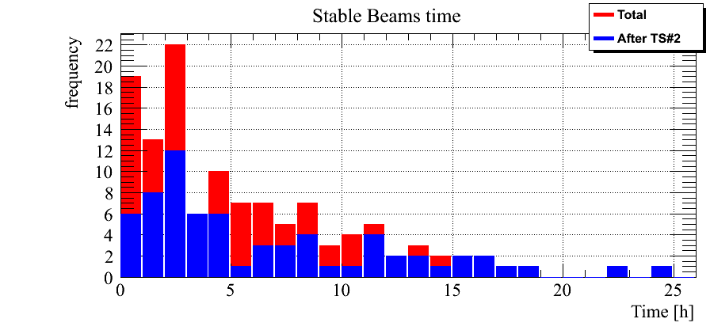
Figure 5: LHC Stable Beams time in 2015

The reason of early dumps has been analyzed to identify possible systematic problems. As it can be seen in Fig.6 no specific reason has been found and the fault distribution for early dumps (<3 hours) reflects the one for all fills dumped in stable beams.

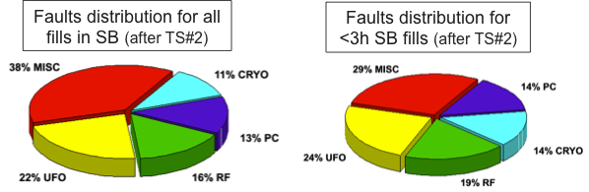
Figure 6: Fault distribution for stable beams fill

A more complete analysis of LHC faults is reported in [2].

2016 possible changes
Thanks to the analysis carried out on 2015 data, three major sources to improve LHC efficiency have been identified:
- Reduction of time spent at Injection and in Adjust
- Combination of Ramp and Squeeze
- Change of the precycle strategy

Cycle optimization
Looking at the data in Tab.1 and more in details at the operational cycle analysis [1], it is clear that Injection and Adjust phases are not optimized.
A dedicated analysis [3] has been carried to identify the possible improvements on the injection phase. The time spent to fill the LHC strongly depends on the filling scheme (number of injections and type of beam), the SPS supercycle length, the beam quality, the time spent to measure and tune the LHC parameters and the reaction of the cryo system to the beam induced heat load. Each of those factors plays an important role on the global time needed and their optimization should be discussed. As example it can be consider the increase of the interlock threshold for the beam screen that was decided during the run. The higher margin on the heat load on the cryo system resulted in the possibility to perform closer (in time) injections, thus in a much quicker filling time. All different ingredients of the injection process will be further studied with the aim of diminishing the global time.
The other candidate for improvement is the Adjust phase, when the beams are put into collisions. The separation is first collapsed in the high luminosity points then collisions are optimized before collapsing separation in IP2 and IP8. Finally, all points are optimized and the orbit feedback is switched ON. Two critical points have been identified. The optimization done after collisions are set in the high luminosity points (requiring about 3 minutes) is meant to maximize the landau dumping, but it is not strictly needed if the beams are already “sufficiently centered”. A value should be defined below which IP2 and IP8 collisions can be set without the need of previous optimization of IP1 and IP5. The other possible gain comes from the definition of a clear strategy on when the declaration of stable beam has to be done. Whether it is a requirement from the experiments to complete the optimization or not is an important ingredient for this decision to be made. The definition of these two strategies could potentially allow diminishing the time spent in Adjust by about 4 minutes per cycle. This would have resulted in 2015 in about 8 hours gain of time (that would directly result in ~8 hours more of stable beams).

Combined Ramp & Squeeze
The possibility to combine the energy Ramp and the betatron Squeeze has been addressed through systematic studies at CERN since 2011 [4]. With increased maturity on beam operation, it was decided in 2015 to make an attempt with beam during the MD phase 1. The test was successful and both beams were brought to 6.5 TeV while squeezed up to a beta star of 3 meters in IP1 and IP5. Following these good results [5], it was decided to use Combined Ramp and Squeeze (CRS) in operation in the more relaxed conditions of the intermediate energy run. CRS was then generated to 2.51 TeV and 4 meters (in IP1 and IP5). This configuration was used in operation for the whole intermediate energy run, including five fills used for physics (stable beams). The operation team has now acquired enough knowledge on this technique to use it as baseline for 2016 operation. The details have still to be defined and the optics distribution has to be optimized according to aperture availability, flexibility of the operation and power converter performance. Presently two scenarios seem to be realistic for the squeeze:
- 3 meters beta star: this is the standard value used during the MD. It is an historical value, as at three meters optics corrections are needed.
- 1.2 meters beta star: more aggressive scenario, as it was demonstrated that optics can be measured during the ramp [5][6][7], then corrections implemented.
The time gain of such an operation obviously depends on the choice of betastar, but it is calculated to be up to ~600 seconds per fill (~33 hours in 2015).

Precycle strategy change
In 2010 a study was done to define a strategy [8] for precycling the LHC magnets when a fault occurs; the LHC precycle in Run1 was designed following this strategy. Coming out of LS1 the change in energy would have resulted in a large increase precycle time [9][10]. A campaign of review of the method used to ramp down the magnets was done and a new method was approved [11]; this change allowed to reduce the rampdown time of the LHC and consequently the precycle time. It is estimated that a gain of about 5 days was reached in 2015. Despite this, the large number of precycle (230) performed in 2015, suggested a review of the global strategy. A precycle is needed, after the current of the magnets went to zero, for two main reasons:
- To bring the field on the right branch of the magnetic hysteresis (static component)
- To allow reproducibility of the harmonic decay, which depends on powering history (dynamic component)
The idea of precycle the LHC at a lower energy (i.e. 2 TeV) is under study. Magnetic measurements performed in SM18 indicate that the magnets would be on the correct hysteresis branch, while the harmonic decay would be different but smaller and easier to control. More complete studies have to be done, before implementing this change, to avoid spoiling the magnetic reproducibility of the machine, which is a crucial ingredient of its performance. The importance of such an operation is in the potential gain; a reduced precycle at 2 TeV would take about 50% of the time of the present precycle, which would have resulted in a further gain of about 4.8 days in 2015.
A parallel study is also being done to understand the criticality of precycle for the quadrupoles in the matching sections. These cryogenic sectors, in fact, are more sensitive to heat load and the cryogenic conditions are often lost. In 2015 about 30 precycles of matching section have been done; the possibility to inject without precycling these magnets would have resulted in 15 hours gain in 2015. As for the global precycle it has to be demonstrated that this would not affect the magnetic quality of the machine. The results of these studies, conducted with the FIDEL team, will be presented at the LHC Beam Operation Committee.

conclusions
The analysis carried out on the LHC efficiency in 2015 can be summarized in two main conclusions.
The first one is that the LHC operational performance has not been affected by LS1. The analysis presented, in fact, shows results similar to those of 2012, despite the challenging energy level at which the LHC has been operated in 2015.
The second conclusion is that despite the excellent results, there is still some room for efficiency improvements in the LHC. The main possibilities have been identified in:
- Review the injection process
- Define a strategy for stable beam declaration
- Use combined Ramp and Squeeze as baseline for 2016 operation
- Review the precycle strategy

acknowledgment
The author wishes to express his sincerest gratitude for the useful discussions to all people involved in LHC operation and in particular to A.Apollonio, S.Redaelli, R.Tomas and all members of LHC/OP section. A special thank goes to the FIDEL team (in particular to L.Bottura and E.Todesco), responsible of the magnetic accuracy of the LHC; some studies presented in this paper are the result of a very close collaboration with them.

REFERENCES
[1] M.Solfaroli “Cycle”, Proceedings of the 6th Evian workshop
[2] A.Apollonio “LHC availability – status and prospects”, these proceedings
[3] D.Jacquet “Injection”, Proceedings of the 6th Evian workshop
[4] N.Ryckx “Combined energy ramp and betatron squeeze at the large hadron collider”, CERN-THESIS-2012-004
[5] J.Wenninger et al. “First beam test of a combined ramp and squeeze at LHC”, CERN-ACC-NOTE-2015-0023
[6] M.Kuhn et al. “Origin of transverse emittance blow-up during the LHC energy ramp”, CERN-ACC-2014-0158
[7] A.Lagner et al. “Optics measurement algorithms and error analysis for the proton energy frontier”, Phys. Rev ST Accel. Beams 18, 031002
[8] L.Bottura et al. “Pre-cycles of the LHC magnets during operation”, CERN-ATS-2010-174
[9] J.Wenninger et al. “The LHC nominal cycle, precycle and variations in 2015”, Proceedings of the 5th Evian workshop pp. 43-48
[10] M.Solfaroli et al. “Nominal cycle and options”, Proceedings of the 2014 Chamonix workshop pp.119-121
[11] M.Solfaroli “Rampdown optimization”, LMC 209 on March 18th 2015

