Stack of three plates
There are two consequences of the magnetic stray field to take into account when considering a stack of three plates:
- While a current of 3 kA is sufficient to achieve a magnetic field of the order of 1.5 T in a single Armco plate; to obtain the same magnetization in a stack of three Armco plates the current needs to be increased to 3.5 kA.
- While the magnetization of the central plate is perfectly symmetric with respect to a vertical axis passing through the center of the plate (see Figure 1), the magnetization of the outer plates shows the asymmetric pattern illustrated in Figures 2 and 3 below. The asymmetric pattern is due to the layout of the turns in the so-called sewed coil design where the two halves of each turn are slightly shifted so that the conductors do not overlap in the slits. The lower the number of turns, the more visible is the effect. However, using a very large number of turns is impractical from the manufacturing point of view and it must also be noticed that:
  - The minimum magnetization in the center of the outer plates is in any case at least 1.45 T;
  - The pattern reverses between the front and back plates of the stack. Therefore, a particle crossing the three plates will experience the same field integral irrespective of whether it travels on the left or right of the central vertical axis of the plates.
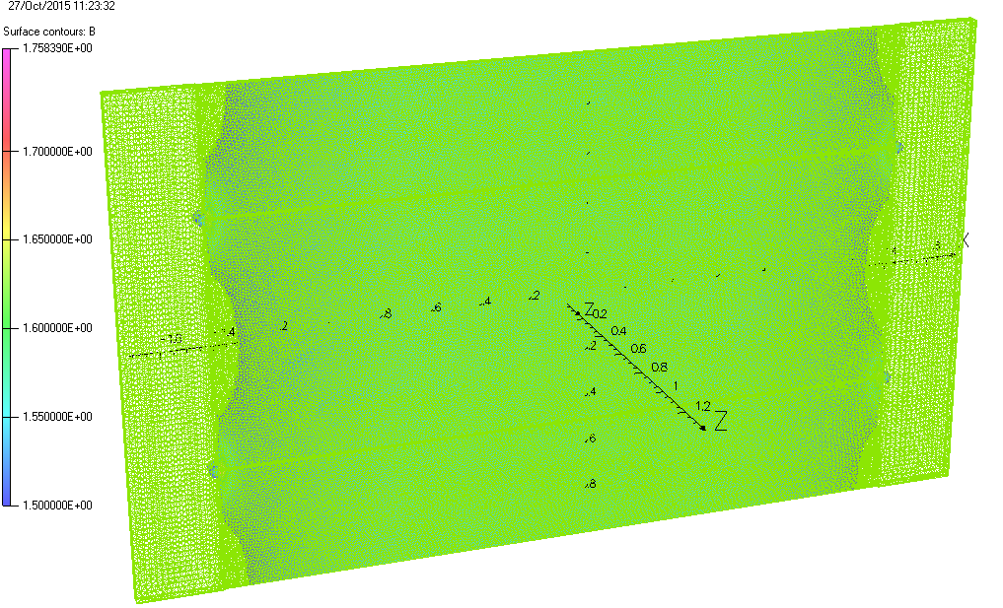
Figure 1 Total magnetic field distribution in the center of the central plate of a stack of three plates, showing the regions above 1.5 T.
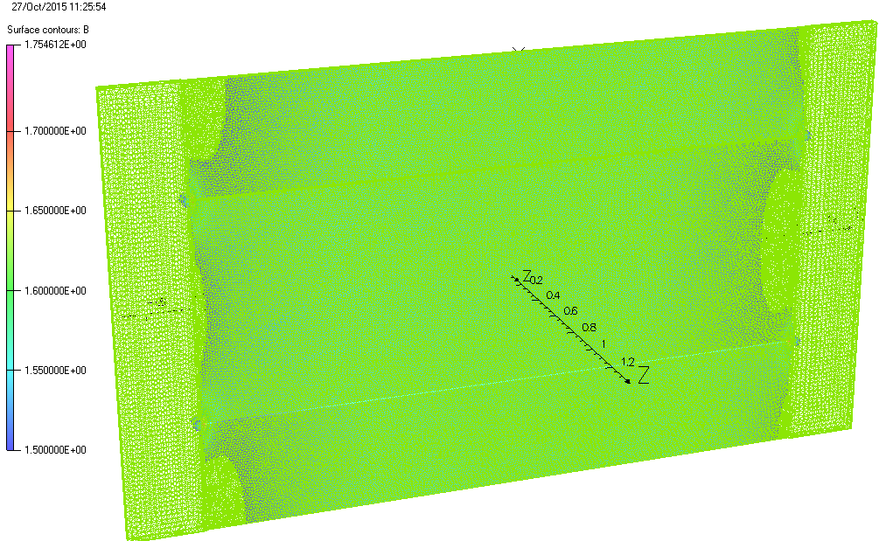
Figure 2 Total magnetic field distribution in the center of the front plate of a stack of three plates, showing the regions above 1.5 T.
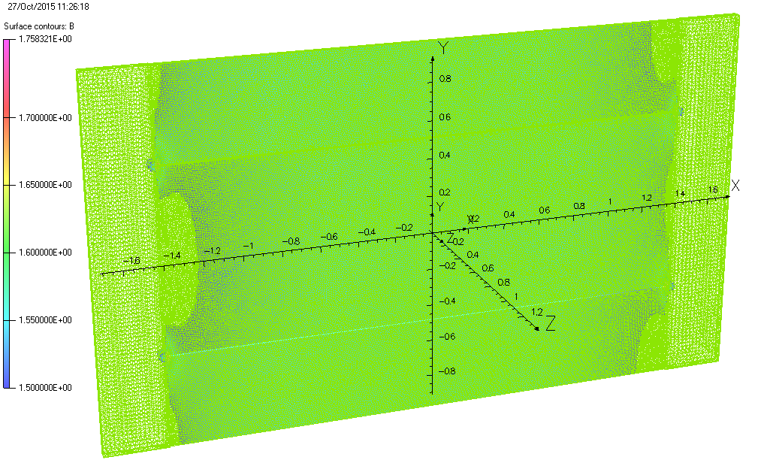
Figure 3 Total magnetic field distribution in the center of the back plate of a stack of three plates, showing the regions above 1.5 T.

