Feynman inspired art

a construction manual

Andy Charalambous in collaboration with CERN HST Programme 2017

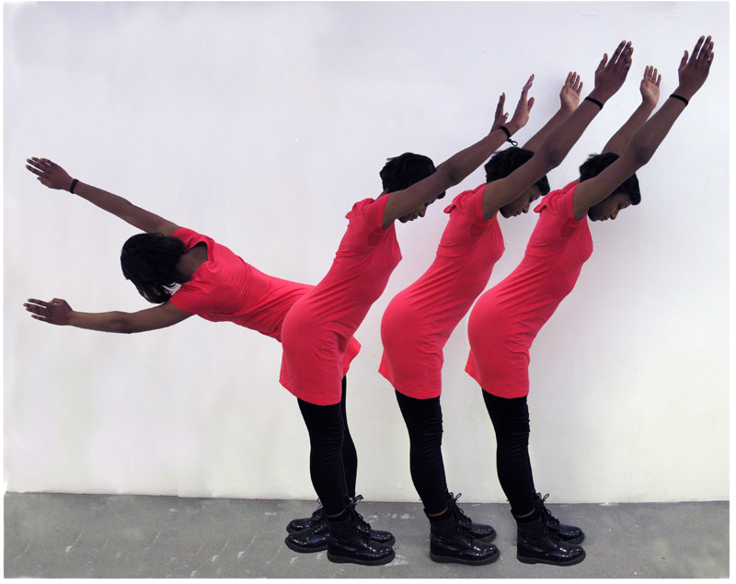
Fig.1: Coreen, 2012
- Introduction
When I left school I went to work as a technician for the Physics and Astronomy department at a university in London. I trained as an engineer and spent many years designing and building equipment for the research groups there. My interest in science grew as I worked with these groups and got a better understanding of the science they were researching. I loved my job because it gave me so much insight into the science involved.
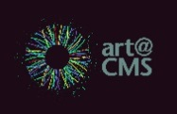
When I left that job and started as an artist I found that the excitement of science was something I didn’t want to move away from. So, I decided to use science as the inspiration for my art. Most of the art I make comes from some bit of science that has seeded an idea. Science is a tool for letting us see our world more clearly, and for me it also inspires my work. By the way, I have not moved very far from the university I worked at. I am Artist in Residence for the Astronomy group and the High Energy Physics groups there, as well as being part of the art@CMS project run by Michael Hoch at CERN.
- Artist statement
Physics can be a very difficult subject to master. Like most sciences, even when you have understood the broader concepts, you often need to work with involved mathematics and terminology to get into the subject.
Feynman diagrams are a very useful way of communicating in particle physics, and are used at all academic levels from school science to high level research. They provide a graphic language which defines complex particle processes in a visually simple way.
This visual language is not dependent on the spoken language of the user. It is therefore a very powerful tool in communicating these complex concepts to people from different countries. Being a visual artist I was impressed by the simplicity of the symbols used and saw beauty in the patterns and shapes formed in each diagram.

- Inquiry questions

- How can we convey meaning in a visual form?
- Why is the concept of change important in challenging ideas?

- Scientific background
Feynman diagrams are used in subatomic particle physics. They give a simple visualization of the interaction between subatomic particles. Therefore you could imagine a time-space-diagram (unfortunately there is no set rule for which axis is for what, let`s make it simple and say in the following explanation the time-axis moves from left to right and the space is going from the bottom to the top). Now we need a few simple drawing rules, which must be strictly adhered to.
The Representation of the lines:
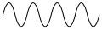
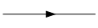
- Fermion : straight line ( )
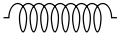
- Photon, W-, Z-Boson : wave line ( )
- Gluon: curled line ( )
- Higgs Boson: interrupted line ( )
Drawing Rules:
- The direction of an incoming particle is towards the vertex, for outgoing particles away from the vertex.
- The direction of antiparticles are reversed (incoming -> away from vertex, outgoing -> towards the vertex)
- At every vertex there is one incoming and one outgoing line attached.
So let`s do an example:
Collision of two electrons (Fermion):
Real movement: Feynman-diagram:
space
time

e⁻

e⁻

e⁻

e⁻

e⁻

e⁻

Decay of a Higgs-Boson:
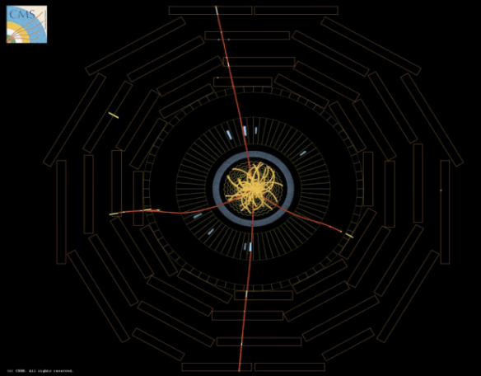
Seen in a detector: Feynman-diagram:
H
Z⁰
Z⁰
µ
µ
µ
µ

For more detailed information see the references.

- Art background - What are you seeing?

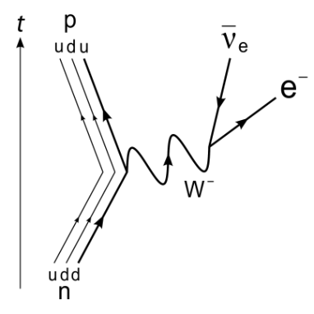
Early on when I was exploring Feynman diagrams and trying to understand the science behind them I found the beta decay diagram particularly interesting and memorable and especially liked its lack of symmetry. Watching television one evening I happened to see a music video where the dancers (for a brief moment) posed in a way which looked like the shape of this diagram. I decided to explore this further and started to photograph people in different positions. From these came the series of 4 photographs here, which are fundamentally about body shapes, but inspired by Feynman diagrams.
Hopefully you will find these ‘body shapes’ interesting to look at. If you know about Feynman diagrams you may get an additional satisfaction from realising the source of these shapes. Coreen was the first image I made, and used a friend to pose in different positions in front of a plain white wall. I then used Photoshop (an image editing software) to cut and paste these images into the one you see. Claudia is not edited in any way. I see the shapes I want in her very gymnastic pose. Coreen and Claudia were based on the Beta Decay diagram. Elena and The Boys are based on other Feynman diagrams. A challenge for you later is to see if you come across these.
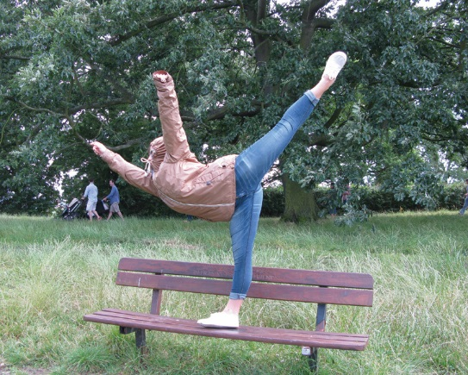
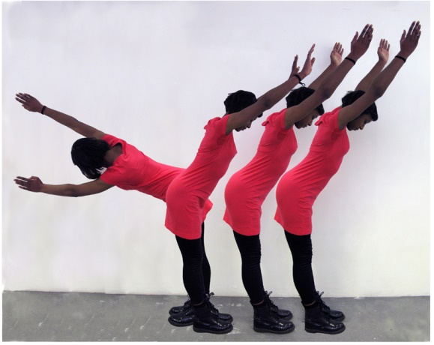
fig 2:Coreen fig 3: Claudia
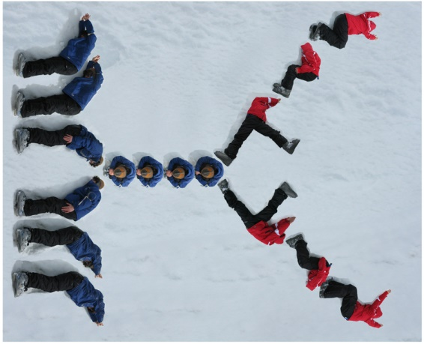
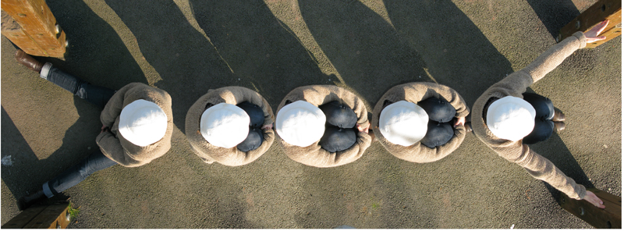
Fig 4: Elena

Fig 5: The Boys

- How can you make your own image?
To produce your own images I suggest you do the following:
- Look through images of Feynman diagrams and become familiar with the shapes that are used to construct each one. Learn what the symbols mean. There is a brief guide in a later section, and also links to further information.

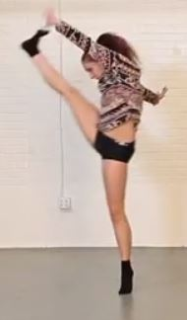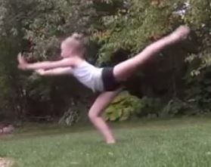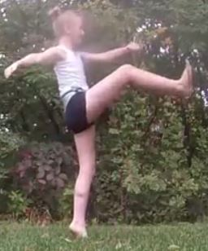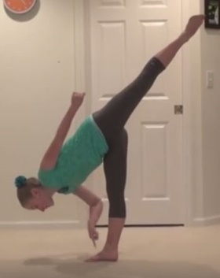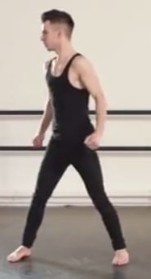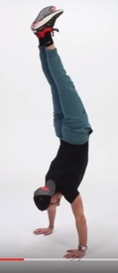

- Choose a diagram you like.
- Work with friends in a small group, exploring body positions and poses which look like the diagrams or bits of the diagrams. Be adventurous and see how different bodies or parts of the body can form shapes. Keep thinking of what might be useful to you later on.
- Use cameras or mobile phones to take pictures of these poses. It is better to take lots and then reject the ones you don’t want. Tip: Think about the background of your photos. A plain background will make it easier to do your editing later.
- Combine images or parts of images together such that the shapes form your chosen Feynman diagram.
  - You can use image editing programmes to do this. There are many available, like Photoshop or Gimp (which is an Open Source programme and free to use).
  - Alternatively, print the images and cut out the bits you want. Glue them together to form a collage.
- Once you start working on your image you might wish you had posed differently or think of a better pose. If you need to, go and take more pictures.
- Keep a record of all you do, even when you are editing or sticking pictures down. Photographs are great for this, and fun to go through afterwards.
- Remember that there are no rules to what you are doing. I did my work one way, and this guide is based on that. I am sure many of you can come up with more creative ideas. Use them and see what you can come up with!
Further Ideas:
- Try to compose a song or write a poem
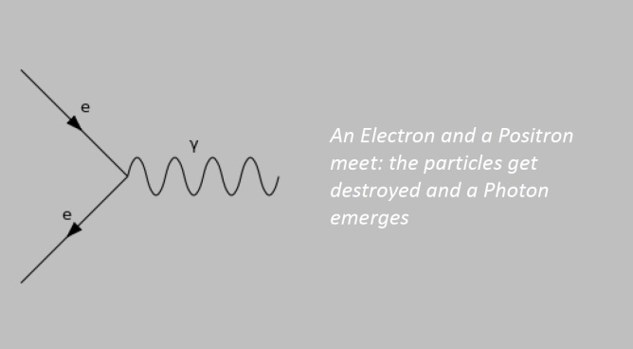
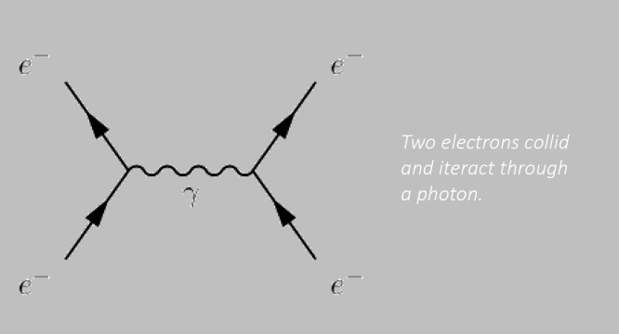
- Use other “material”, for example …
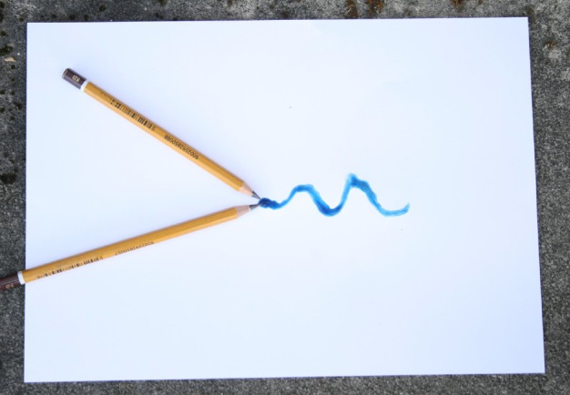
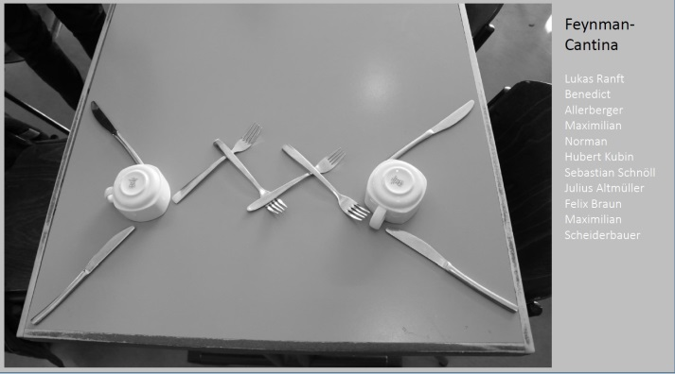

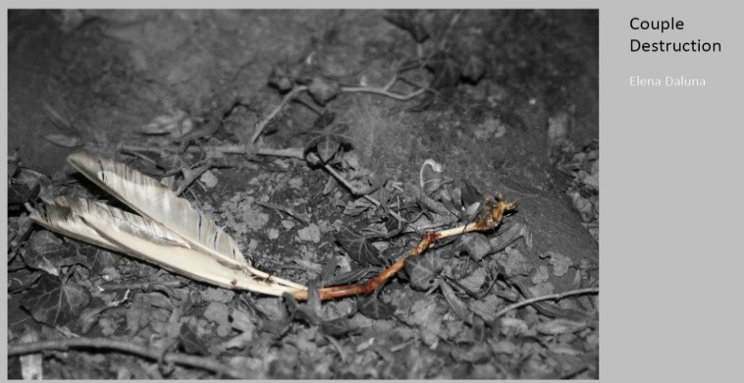
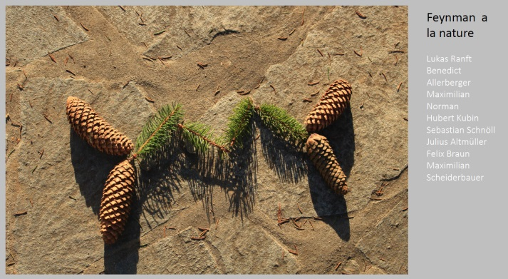

- Evaluation
Demonstrating an understanding of the concepts covered across disciplines and reflecting on one’s own performance and learning are essential components of sciART activities. The students need to be aware that it was the process that is important more so than the outcome. The criteria below are a model outline for an approach to evaluating a sciART project and can be adapted to suit the particular needs of the students involved.

Project Portfolio
The project portfolio is meant as a tool that the students use throughout the project, updating as they go along with any relevant information, and is the main focus for the evaluation of the students work. Relevant information could include, but is not limited to;
- Planning stages (sketches, initial ideas, background research, design process etc.)
- How they are applying skills and knowledge from science and art
- Challenges and how they are overcome
- Changes from the initial design with reasoning

The portfolio could take on many forms; a sketchbook, a presentation, poster, performance etc. and should be an original piece of work by the students to show their engagement with the project.

Evaluation Criteria
Each of the evaluation criteria should be assessed using a rubric, which depending on the level, can be adjusted to provide more or less guidance for the students.
Subject specific content
The depth that this is assessed is dependent on the level of ability of the students and should arise from the particular concepts and understandings coming from the each subject specialist involved in the project (science and art). This could be assessed collectively by both teachers, or individually through formative assessment, the project portfolio and the final artwork produced.
Reflection
Reflection is an essential component of the evaluation. Students must ensure that they have identified and explicitly explained the necessary relevant links between the two disciplines. This criterion would also include identifying changes that the students would make in future if they were undertaking a similar project. Evidence of regular reflection should be present throughout the project portfolio, and directly link to the inquiry questions. Identifying and discussing strengths and limitations of each discipline in the context of the individual project should also be a major component of the reflection.

- Reference Material

- Useful Diagrams of Top Signals and Backgrounds. Fermi National Accelerator Laboratory. http://www-d0.fnal.gov/Run2Physics/top/top_public_web_pages/top_feynman_diagrams.html
- Feynman Diagrams - a beginners guide. youtube. https://www.youtube.com/watch?v=HaWhWeBxQRQ
- Feynman Diagrams - Sixty Symbols. youtube. https://www.youtube.com/watch?v=3bbJeMBHq0g
- The structure of matter. slideplayer. http://slideplayer.com/slide/9026005/
- Let's draw Feynman diagrams. quantum diaries. http://www.quantumdiaries.org/2010/02/14/lets-draw-feynman-diagams/
- The Fantastic Mr Feynman. Youtube. https://www.youtube.com/watch?v=LyqleIxXTpw
- Andy Charalambous artist and ingenieur web page www.andycharalambous.com
- web pages for art@cms. http://artcms.web.cern.ch/artcms/

Andy Charalambous; art@andycharalambous.com artist and trained engineer based in London UK, HEP Artist in Residence, Astronomy Artist in Residence and Honorary Research Fellow Physics and Astronomy University College London http://www.andycharalambous.com

art@CMS_sciARTbooklet: web page : http://artcms.web.cern.ch/artcms/
A tool to support students with their research on various scientific topics, encourage an understanding of the relevance of expression through the arts, a manual to recreate the artwork and enable students to define and develop their own artistic inquiry in the creation of new artworks.

The art@CMS sciART booklet series directed by Dr. Michael Hoch, michael.hoch@cern.ch scientist and artist at CERN, in cooperation with the HST 2017 participants (S. Bellefontaine, S. Chaiwan, A. Djune Tchinda, R. O’Keeffe, G. Shumanova)
_________________________________

