Orders of Magnitude – Potato Powered Cosmos

a construction manual

Rachael Nee in collaboration with HST Programme 2017

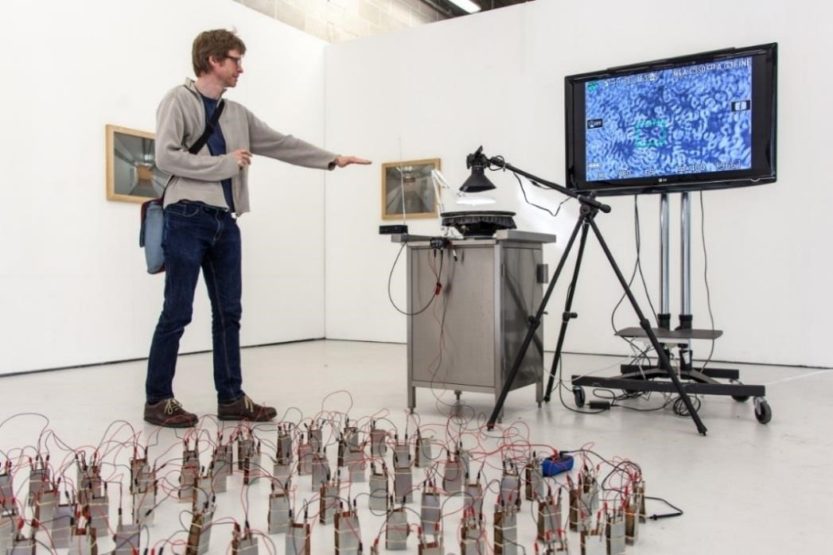

- Introduction

This booklet is written for science and art teachers with the aim of interdisciplinary learning. It assumes no knowledge of the other disciplines subject. In it you will read about the art installation from both the science and art viewpoints and how to reconstruct it. This becomes a jumping off point for the development of new artworks by High School students, with questions along the way.

Science and contemporary art have different end goals; however, they also have a lot in common. Both contemporary art and science have similar methodologies involving; investigation, research, testing out of ideas and theories through experiment. They share imagination, curiosity, quest for knowledge and are forms of inquiry. When successful both allow the world to be seen in new ways.

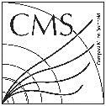

- Artists Statement - Potato Powered Big Science

Scale is unavoidable in CERN; scales at the extremes of space, time, knowledge, collaboration, finance and energy. The CERN website states that “CERN uses 1.3 terawatt hours of electricity annually, enough power to fuel 300,000 homes in the UK.”
Is there not a cheaper, more sustainable and renewable energy source to probe the fundamental structure of the universe?
A published research paper posits the idea of using boiled potatoes as an alternative, off-grid energy source. I built on this hypothesis with The Large Potato Field Array experiment and offer the suggestion of planting up the countryside around CERN.
The experiment produced 5 volts and 40 milliamps for one hour during observer-activated tests. These tests revealed several key events indicating that fundamental forces were seen; from this we can extrapolate that the universe can indeed be observed in a potato powered puddle.
Further research into feasibility requires scaling up the Array. Evidence suggests that 11.13 x 10⁹ kg of potatoes could fuel CERN for one hour.
Alternatively, if eaten, the experiment’s potatoes would power 6.3 average-sized scientists for a day.

- The Hot Potato Inquiry Questions.

- How Can Energy Fuel Innovation?
- Why Is Scale Relevant?

- Science Background

You can produce electricity from a “cell”, which is made of two different metals where the different reactivity of the metals creates a difference in potential. This difference in potential causes chemical energy to be converted to electrical energy.
The essential features of a simple cell are that:
- there are two different metals
- the metals are separated from each other by an electrolyte (a solution containing ions, which are charged atoms or molecules, that can conduct electricity)
- the metals are connected by wires through which electrons can flow (this flow is a current)
Let's look at the example of zinc and copper being used to make a cell using a potato:
The difference in reactivity means that the zinc will push electrons to the hydrogen ions through copper electrode. The hydrogen ions will accept the electrons. The potato contains phosphoric acid and other organic acids which will act as the electrolyte and allow ions to flow from the copper electrode to the zinc electrode.

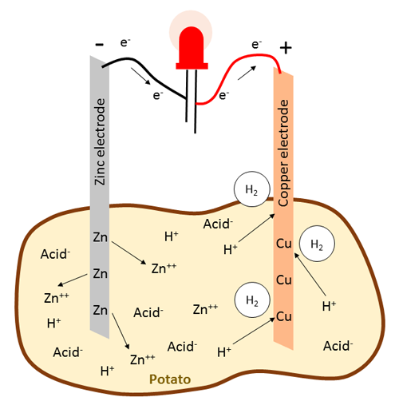
Image credit: Sciencebuddies.org
The zinc and copper ions would still react if they touched within the potato but they would only generate heat. Since the potato keeps them apart, the electron transfer has to take place over the copper wires of the circuit.
If the potatoes are boiled, the cells of the potato can burst which means the ions can move more easily through the potatoes and the reaction can happen faster, generating more current in the wire connecting the metals.
Multiple cells connected together will make an electrochemical battery, which can produce a specific voltage.
If you add voltage to a speaker, it will create sound by vibration converting the electrical energy to kinetic energy. Different voltages will lead to different vibrations. If you put a latex rubber sheet filled with water on a speaker the water will start to swing like a wave in a lake. The overlapping of the waves (interference) lead to a special pattern. So if the voltage is changed the pattern produced will also be changed. One way to change the pattern is to use a theremin, a musical instrument which changes the frequency of sound by the distance of players.

- Art Background

Energy, Machine, People, Experiment.
Potato Powered Cosmos is an interpretation of CERN as a complex and interrelated system that includes; energy, people, machine and experiment whose combined aim is to search for the fundamental structure of the universe. The theme of energy runs through the installation its many forms and transformations.
Why is the kitchen unit important?

Why is the installation incomplete without the presence of a human and what purposes do they serve?

Why is the audience encouraged to look at the standing waves indirectly through the TV monitor?

The artist statement finds that the “universe was seen in a puddle” this is a reference to William Blake and the first stanza of his poem, Augeries of Innocence 1803
To see a world in a grain of sand
And a heaven in a wild flower,
Hold infinity in the palm of your hand,
And eternity in an hour.
The role of imagination is important in the artwork, it is a mix of fact and fiction, you are invited to look at the results of the experiments to see the cosmos within the images. To Imagine a universe in a puddle created by standing waves or see galaxies in a potato battery cell, creating a small scale sense of wonder.
The potato becomes, literally, food for thought.

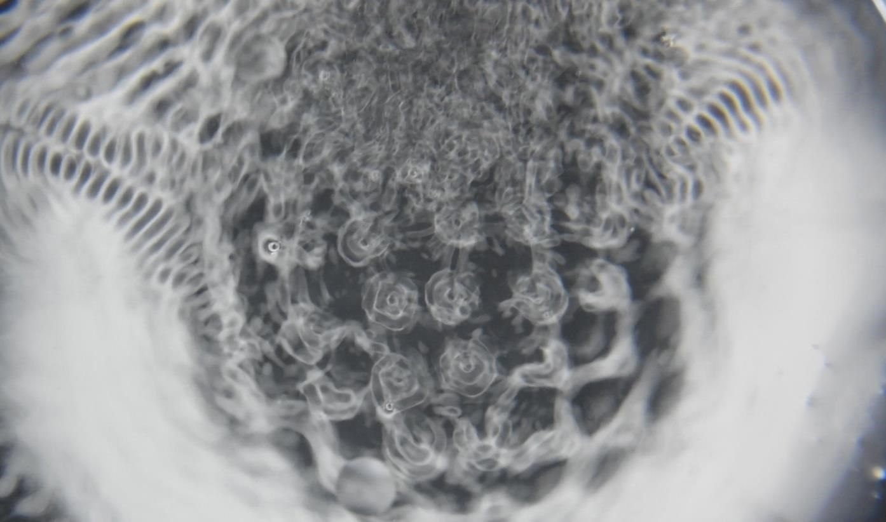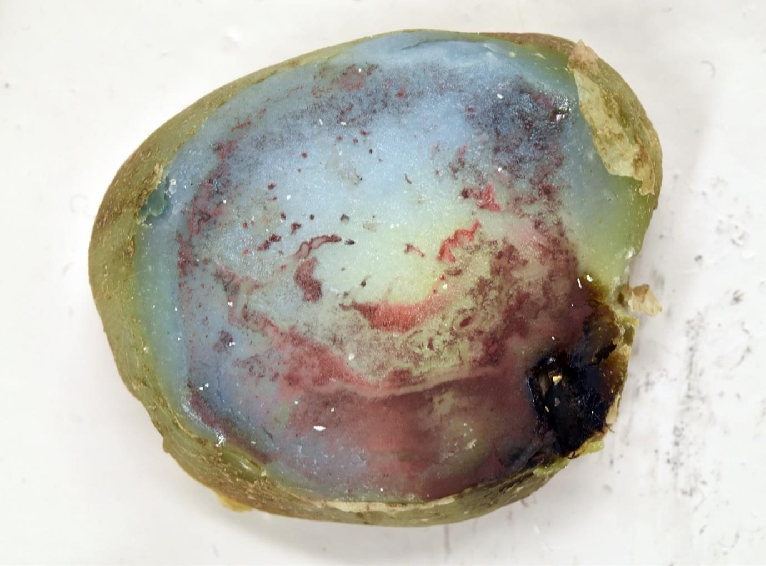
Puddle Universe Potato Hubble

Key Artists and Concepts.

The following are key art concepts illustrated with contemporary artists who collaborate with scientists and whose work has influenced the installation.

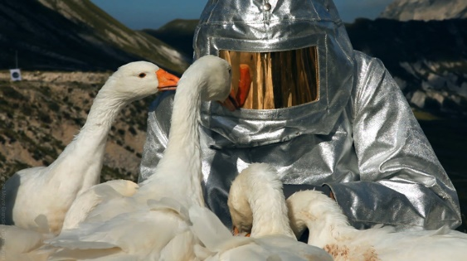
AGNES MEYER-BRANDIS
Moon Goose Colony, 2011

Combining Fact and Fiction. Tapping into the imagination and story-telling to form a complex and large scale project.

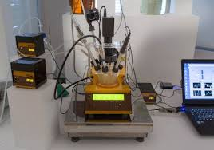
PHILIPE PARRENO – AnyWhen, 2016
Used science experiment to control a video installation

CONTEMPORARY ART - Refers to art of the present day. It aims to be innovatory in nature and reflects on contemporary society and its issues.

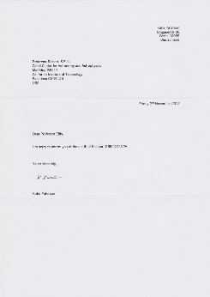
KATIE PATERSON - Dying Star letters 2011 – ongoing
Often uses humour to investigate her subjects of Time and Scale

CONCEPTUAL ART - Conceptual art is where planning and decisions for the idea (or concept) are made beforehand and the finished artwork may be of lesser importance.

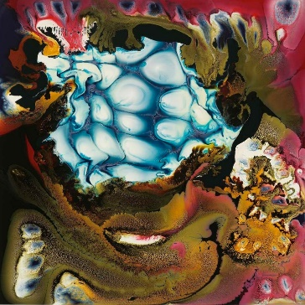
KEITH TYSON - Mathematical Nature Painting 2008.
The process of experimenting with the agency of materials is placed to the fore in these system based paintings.

PROCESS ART - where the process of making is an important aspect of finished artwork and is prominent, not hidden.

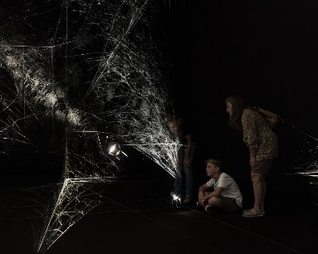
TOMAS SARACENO – How to Entangle The Universe in a Spider’s Web, 2017
Audience is vital component in creating the artwork with movement that resonates through webs to create music.
INTERACTIVE ART - Describes art that relies on the participation of a viewer or audience as an integral part of the artwork.

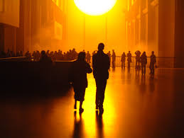
OLAFUR ELIASSON – THE WEATHER PROJECT, 2004
Collaborative and interdisciplinary artist, inspires ‘wonder’ often with a sense of theatre.

INSTALLATION ART - Installation art is used to describe large-scale, mixed-media constructions, often designed for a specific place or for a temporary period of time.

- Assembling
Materials List:

Potato Battery
- Copper sheet
- Galvanized zinc sheet
- Alligator clips
- Wire – red and black
- Elastic bands
- Potatoes (other fruit and vegetables ie. Lemons)
- Soldering iron and solder
- Wire cutter/stripper
- Pliers
- Multimeter

Speaker Assembly
- Kemo DC amp (6V– 12V)
- Cable with 1/4in jack plug and phono connector (amp to theremin)
- Theremin
- Loudspeaker
- Optional - Signal or tone generator can be an ‘app’ downloaded to a mobile phone.

- 9v batteries, snap battery clip
- Latex rubber sheet (enough to cover speaker so it overlaps at least 5cm)
- Water and other materials with different viscosities, for instance; runny and solid jelly, oil, fine-grained sand.
- Ear protectors (for high frequency)

Observation
- Magnifying lamp
- Camera with ‘live view’ or camcorder.
- Monitor/TV
- AV cable
- Stainless steel kitchen unit.
- Human

Assembling the installation:
- Cut the zinc and copper metal plates to size (10 x 5cm)
- Assembling the individual cells
  - Cut the ends of the potatoes off along the longer side (you can use several small instead of one large also)
  - Sandwich between one plate of zinc and one plate of copper
  - Wrap elastic bands around as tightly as possible top and bottom.
  - Make sure the ‘cell’ stands upright firmly.
- Wiring
  - Crimp or solder alligator clips to both ends of red and black wires of at least 20cm
- Arrange the potato battery array in configuration of series and parallel already worked out.
- Put speaker, theremin and amp onto kitchen unit.
- Attach latex sheet to speaker with elastic bands around circumference, manipulate it to make as taut as possible (this is easier with two people)
- Connect amplifier to speaker
- Use the cable with phono and ¼ in jack to connect theremin to amplifier
- Attach the magnifying light to the unit.
- Set up the tripod with the camera or camcorder facing down to look through the magnifying lamp.
- Connect the camera or camcorder to the TV monitor and so there is a ‘real time’ view of the latex speaker surface
- Put a small amount water of on the latex so it reached about 5cm from the edge.
- The theremin will need calibrating so it works at the correct distance with a hand, this can only be done through trial and error.

Further Ideas:
Further Ideas
- Use other media instead of potatoes such as lemons, oranges, tomatoes etc.
- Set the experiment to measure the voltage and current from potato cells
- Use various arrays of potato batteries, for example series, parallel or a combination
- Vary the number of potatoes and measure the voltage changed
- Change metals used for electrodes
- Change type of liquid on the latex sheet, for example jelly, sand, alcohol etc.
- Vary sheet properties, such as tension or material
- Work with the concept of ‘energy’
- Work with the concept of ‘interrelated systems’
- Work with the concept of ‘scale’
- Collaborations between two or more students on one artwork.
- Work with Sound; pitch, volume, frequency, scale, voice.
- Film, use phones to make and edit short films of standing waves through different media.
- Performance – dance, spoken word, poem interpretations of the concepts.

- Evaluation

Demonstrating an understanding of the concepts covered across disciplines and reflecting on one’s own performance and learning are essential components of sciART activities. The students need to be aware that it was the process that is important more so than the outcome. The criteria below are a model outline for an approach to evaluating a sciART project and can be adapted to suit the particular needs of the students involved.

Project Portfolio
The project portfolio is meant as a tool that the students use throughout the project, updating as they go along with any relevant information, and is the main focus for the evaluation of the students work. Relevant information could include, but is not limited to;
- Planning stages (sketches, initial ideas, background research, design process etc.)
- How they are applying skills and knowledge from science and art
- Challenges and how they are overcome
- Changes from the initial design with reasoning

The portfolio could take on many forms; a sketchbook, a presentation, poster, performance etc. and should be an original piece of work by the students to show their engagement with the project.
Evaluation Criteria
Each of the evaluation criteria should be assessed using a rubric, which depending on the level, can be adjusted to provide more or less guidance for the students.
Subject specific content
The depth that this is assessed is dependent on the level of ability of the students and should arise from the particular concepts and understandings coming from the each subject specialist involved in the project (science and art). This could be assessed collectively by both teachers, or individually through formative assessment, the project portfolio and the final artwork produced.
Reflection
Reflection is an essential component of the evaluation. Students must ensure that they have identified and explicitly explained the necessary relevant links between the two disciplines. This criterion would also include identifying changes that the students would make in future if they were undertaking a similar project. Evidence of regular reflection should be present throughout the project portfolio and should directly link to the inquiry questions. Identifying and discussing strengths and limitations of each discipline in the context of the individual project should also be a major component of the reflection.

- Reference Material

Science:
https://www.sciencebuddies.org/science-fair-projects/project_ideas/Energy_p010/energy/potato-battery.shtml?from=GO#background
http://www.bbc.co.uk/bitesize/standard/chemistry/metals/making_electricity/revision/3/
http://www.kidzworld.com/article/4726-how-potato-batteries-work

Art:
- Golberg, H. D. Rabinowitch, and B. Rubinsky, Zn/Cu-vegetative batteries, bioelectrical characterizations, and primary cost analyses, J. Renewable and Sustainable Energy, 2 033103 (2010).
- ‘Powers of Ten’ – Charles and Ray Eames, 1977 – (about orders of magnitude) https://www.youtube.com/watch?v=0fKBhvDjuy0
- Cymatics – Bringing Matter to life with sound; (c.1970) Dr. Hans Jenny - https://www.youtube.com/watch?v=05Io6lop3mk
- CERN, energy consumption - https://home.cern/about/engineering/powering-cern

Relevant artists websites.
- Olafur Eliasson -http://www.olafureliasson.net/
- Tomas Saraceno - http://tomassaraceno.com/
- Agnes Meyer Brandis - http://www.blubblubb.net/
- Katie Paterson - http://www.katiepaterson.org/
- Keith Tyson - http://keithtyson.com/
- Philipe Parreno - http://www.tate.org.uk/whats-on/tate-modern/exhibition/hyundai-commission/philippe-parreno-anywhen

Bibliography
- Colliding Worlds: How cutting-edge science is redefining contemporary art; Arthur I Miller, W. W. Norton & Company, (2014)
- Art and Science Now: How scientific research and technological innovation are becoming key to 21st Century aesthetics; Stephen Wilson, Thames and Hudson, 2010
- Experiment: Conversations in art and Science – Edited by Bergit Arends and Davina Thackara, The Wellcome Trust, (2003)
- Seen|Unseen – Art, Science, and Intuition from Leonardo to the Hubble Telescope; Martin Kemp, Oxford University Press (2006)
- Art and Science - Sian Ede, I.B Taurus (2005)

Websites of interest
- art@CMS - http://artcms.web.cern.ch/artcms/
- Leonardo – The international Society for the Arts, Science and Technology http://leonardo.info/index.htmlJournal
- Science Gallery, Dublin, Ireland - https://dublin.sciencegallery.com/events
- Science Museum, London - http://www.sciencemuseum.org.uk/
- Wellcome Collection, London - https://wellcomecollection.org
- Arts Catalyst - http://www.artscatalyst.org/
- Super/Collider - www.super-collider.com

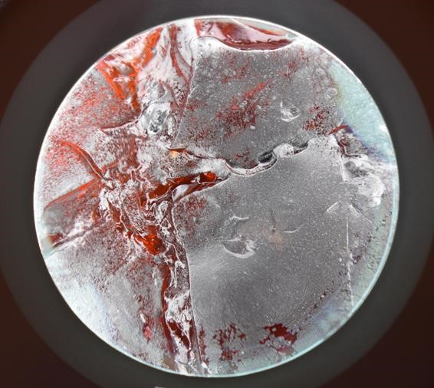

Rachael Nee rachaelnee@gmail.com graduated from MA Fine Art at Chelsea College of Arts, UK with Distinction in 2015, her art practice is concerned with energy, entropy and matter. www.rachaelnee.com

art@CMS_sciARTbooklet: web page : http://artcms.web.cern.ch/artcms/

A tool to support students with their research on various scientific topics, encourage an understanding of the relevance of expression through the arts, a manual to recreate the artwork and enable students to define and develop their own artistic inquiry in the creation of new artworks.

The art@CMS sciART booklet series directed by Dr. Michael Hoch, michael.hoch@cern.ch scientist and artist at CERN, in collaboration with the HST 2017 participants (S. Bellefontaine, S. Chaiwan, A. Djune Tchinda, R. O’Keeffe, G. Shumanova)

