CNGS electronics parasitic test facility Logbook
Planning as approved before the CNGS restart in 2009 (RADWG 3 April):
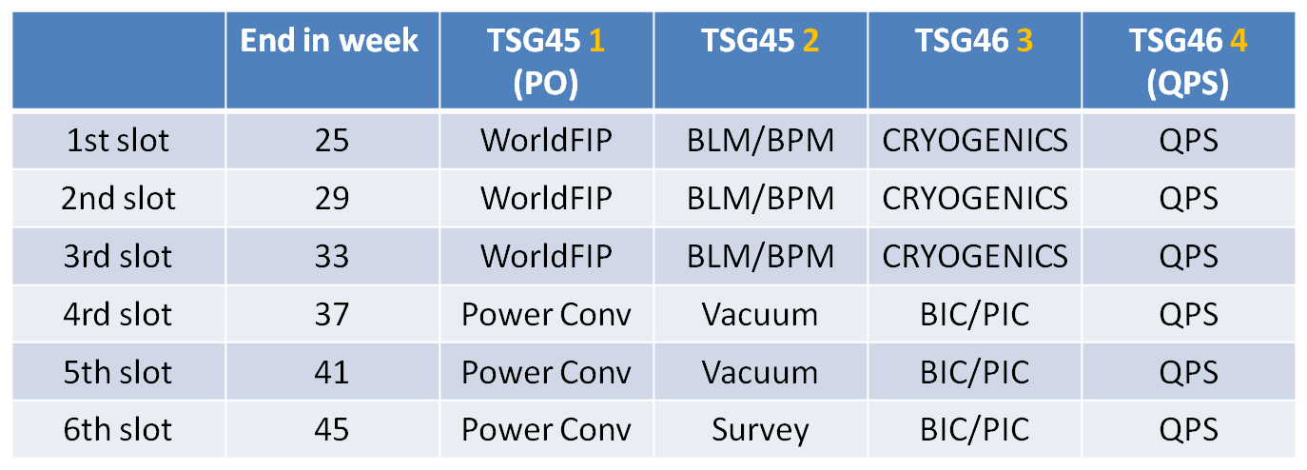
Initial installation for Slot 1: 29 April 2009 (W18) non beam, DUTs displaced from Dry Run
Final installation for Slot 1: 14 May 2009 (W20) Placement into the final positions
- RadMon7 box – under Station 1 [5V]
- RadMon7 remote – on BPM crate, behind the corner left of TSG45
- RadMon8 box – under Station 4 [3V but DB setting as 5V]
- RadMon8 remote – between QPS and HTS CL heaters ~2.5m from TSG46

Access for Slot 2: 17 June 2009 (W25)
- RadMon7 box – former BPM crate position, behind the corner left of TSG45 [5V]
- RadMon7 remote – on BPM crate, middle of TSG45, 5cm above ground
- RadMon8 box – under Station 4 [5V]
- RadMon8 remote – between QPS and HTS CL heaters ~1m from TSG46

Access for Slot 3: 15 July 2009 (W29)
- RadMon7 box – under Station 1 [3V]
- RadMon7 remote – on CRYO crate behind BLM, 10cm above ground, TSG45
- RadMon8 box – between QPS and HTS CL heaters ~1m from TSG46 [5V]
- RadMon8 remote – former CRYO position, 10cm above ground, middle of TSG46

Access for Slot 4: 13 August 2009 (W33)
- RadMon7 box – under Station 1 [3V]
- RadMon7 remote – on the fence at the WFip location, 1.5m? above ground, TSG45
- RadMon8 box – at the QPS slot 1 position ~2.5m from TSG46 [5V]
- RadMon8 remote – ~2m further in the duct from the former CRYO position, 10cm above ground, 1mfrom tunnel edge, middle of TSG46

