SYSTEMs performance: circuits
A. Antoine, M. Bednarek, Z. Charifoulline, G.J. Coelingh, G. D’Angelo, R. Denz, V. Montabonnet, J. Nielsen, D. Nisbet, B. Panev, F. Rodríguez Mateos, I. Romera Ramírez, H. Thiesen, S. Uznanski, CERN, Geneva, Switzerland
Abstract
The performance of the LHC magnet circuits for the proton physics run in 2017 is evaluated. This contribution focuses on the availability of magnet powering (PC) and protection systems (QPS, EE, FMCM and Interlocks) and evaluates the impact of the new deployments, mainly the FGClite and RPADO power converters, on the overall performance of the machine. Finally, a comparison with 2016 availability is presented.

CIRCUITS aVAILABILITY
Operational statistics in 2017 show that 211 fills, out of a total of 762 fills, reached Stable Beams. About 20 % of the fills (i.e. 160 fills) were prematurely aborted by magnet powering and related protection systems, which contributed with 169.5 hours to the total downtime (out of a total of 800.7 hours). Figure 1 illustrates the distribution of fault duration in 2017 on the various root causes and provides a comparison with faults in 2016. Quench protection systems and power converters appear as one of the main contributors, while the impact on availability from magnet circuits and machine interlocks remains residual.
The increase on the power converter fault duration with respect to 2016 can be explained by an increment of the R2E suspected events in the RRs and several interventions on the RB.A12 power converter to fix a leak on the water-cooled busbars. The Quench Protection System was also penalized by lengthy interventions on the RQD.A12 Energy Extraction system and a main quadrupole acquisition system. The contribution from magnet circuits was drastically reduced as a lot of time was dedicated in 2016 to localise the inter-turn short in RB.A12.

POWER CONVERTERS
Table 1 shows the breakdown of the power converter faults classified per circuit type. The main contributors to the availability are the 600A-10V, main dipole and 120A converters which represent 75 % of the fault time. The number of R2E events on the 120A and 600A PCs located in the RRs increased in 2017.

600A Power Converters
The RPMBA/B – LHC600A-10V converters are the worst PC-type in terms of reliability as 10% of the power modules had to be replaced in 2017. 5 out of the 44 faults were allocated to R2E effects as a consequence of the new TCL6 settings [1]. The radiation-induced failures are expected to drop after LS2 thanks to the deployment of R2E-600A converters and FGClite controls in the RRs. During LS3, the 600A power converters in the UAs will also be replaced.

Main dipole Power Converters
The main contributor to the fault time was a leak on the water-cooled busbars of the RB.A12 power converter [2], which required 3 interventions and 20 h to be fixed. A consolidation of all busbars is envisaged in LS2.

120A Power Converters
Faults were dominated by R2E effects (5 out of 8), which occurred in power converters located in radiation exposed areas such as the RRs around IR1 and IR5. A consolidation campaign to deploy FGClite on the 120A power converters is planned during LS2.

Table1: Power Converter faults per circuit type

Classification | Number of installed PC |  | Number of faults |  | R2E | Fault duration (h)
RPMBA/B - LHC600A - 10V | 394 | 44 |  | 5 |  |  | 42.1
RPTE – Main dipole | 8 | 7 |  | 0 |  |  | 26
RPLB - LHC120A | 291 | 8 |  | 5 |  |  | 15.7
RPHF/G/H – IPD, IPQ, IT | 188 | 6 |  | 0 |  |  | 12
SATURN_2s | 4 | 3 |  | 0 |  |  | 8.9
RPLA – LHC60A | 750 | 10 |  | 0 |  |  | 5.3
RPMC – LHC600A - 40V | 38 | 3 |  | 0 |  |  | 0.3
RPTF – Warm Quadrupole | 4 | 2 |  | 0 |  |  | 2.7
∑ | 1677 | 84 |  | 10 |  |  | 113.7

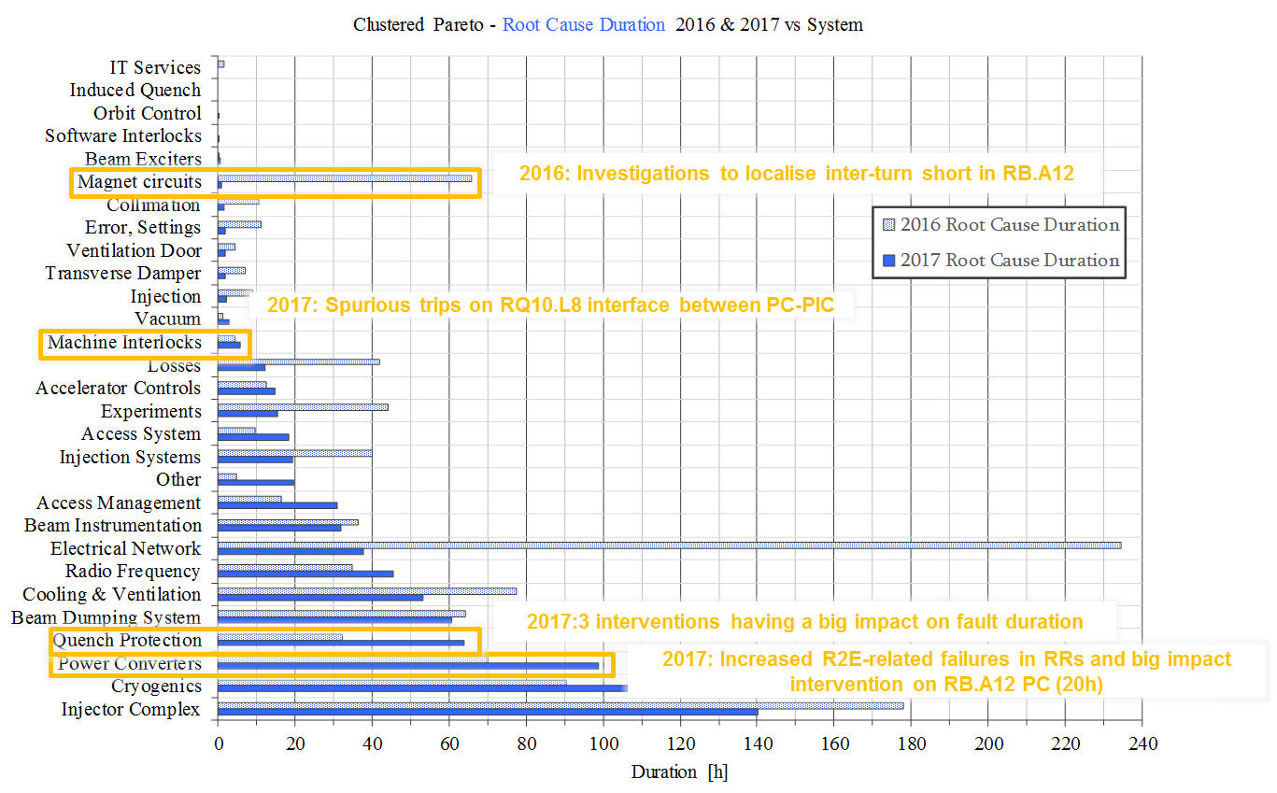
Figure 1: Root cause duration per system as observed in 2017 vs 2016

SATURN Power Converters
Four new power converters powering the RD1.LR1/5 and RD34.LR3/7 were deployed during the YETS 2016-17 to mitigate electrical network disturbances coming from the 18 kV grid [3]. An early life failure was observed in one of the control chassis.

60A Power Converters
A few communication issues were identified during the commissioning period following the deployment of the FGClite during the YETS 2016-17 and solved before starting the proton physics run.

QUENCH PROTECTION SYSTEM
A total of 55 faults had their root cause in one of the more than 4000 QPS electronics boards deployed in the LHC. The fault duration was dominated by 3 long interventions on the RQD.A12 Energy Extraction system (14 h) and on MQ8.L7 to replace a faulty DQAMC board (8h).
The consolidation efforts have very efficiently mitigated the R2E effects and only 1 SEU affecting the QPS electronics for the RB circuits caused a dump. Non-blocking SEUs were reset in the shadow of operations. Several trips of the QDSIPQ electronics were observed following electrical perturbations during thunderstorms, which used to be in the shadow of FMCMs before consolidation of the RD1 and RD34 power converters.

Table 2: Classification of QPS faults per type

Classification | Units | Faults | R2E | Duration(h)
QPSRB | >2000 | 6 | 1 | 6.4
QPSRQ | >2000 | 5 | 0 | 17.8
QDSIPQ | 76 | 8 | 0 | 4.2
QDS600 | 114 | 24 | 0 | 3.7
nQPS | 436 | 4 | 0 | 5.5
EE13kA | 32 | 5 | 0 | 14
EE600A | 202 | 2 | 0 | 7.8
DQHDS | 6084 | 1 | 0 | 2.5
Σ | >8900 | 55 | 1 | 61.8

MAGNET CIRCUITS

Earth faults
A short circuit appeared after the TS2 when powering the magnet at 10.5 kA [4]. The initial diagnostics with the QPS voltage feelers suggested that the earth fault was located in the first part of the positive busbar of the circuit. The root cause was finally identified and traced back to a crocodile clamp which was used for grounding the circuit during the technical stop and not completely removed. After correction and replacement of the earth fuses in the power converter, the circuit was revalidated.

Current lead heating system
A faulty regulator provoked 1 beam dump. Another 5 regulators were preventively replaced during programmed stops.

Zero voltage crossing
The power converters generate some distortion when crossing through zero voltage with current in the load. This behaviour is specific for the 4-quadrant power converters which result in a voltage spike that can trigger the QPS. In 2017, 10 trips were observed during the precyle or ramp-down and dominated by RQTL11.L5B1 (8 occurrences).

13kA EE resistors temperature interlock
In case of quenches, the cool-down of 13 kA EE resistors remains in the shadow of the cryogenics recovery, however in 3 occasions, the EE exceeded the recovery time of the parent fault by up to 2 hours.

Fast Magnet Current CHANGE Monitors
Fast Magnet Current change Monitors (FMCM) are designed to detect unacceptable current changes in normal conducting magnets. In 2017, 15 electrical perturbations resulted in protective dumps triggered by the FMCMs, which represent a significant improvement with respect to the 23 electrical disturbances observed in 2016 leading to 22 FMCM dumps. This reduction comes from the replacement of the thyristor power converters RPTG (for the RD1 and RD34 warm magnet circuits) by new switch-mode power converters during the YETS 2016-17. A potential availability gain could be easily achievable by improving the rejection against electrical glitches on RMSD and RQ5 circuits.

MAGNET INTERLOCKS
Magnet interlocks were identified as the root cause for 9 premature beam dumps. This includes 7 spurious triggers of the RQ10.L8 electrical circuit, due to glitches on the interface between the power converter and the PIC. Several mitigations actions were put in place, without success (e.g. current source, patch panels, FGC and PC chassis replacement). In addition, a PLC installed in UL14 suffered from a memory corruption that led to a loss of communication and dumped the circulating beams. This event was classified as radiation-induced, as similar events occurred in the past on different PLCs in the UL14/16. Furthermore, a wrong manipulation of the Controls Configuration Database provoked a CMW communication issue with the PIC WinCC Servers that led to a premature dump.

CONCLUSIONS
The performance of the LHC circuits, powering and protection systems was remarkable in 2017 and the overall fault time was slightly reduced with respect to 2016 (169 h compared to 174 h last year). The consolidation efforts to deploy new power converters and FGClite controls for the 60 A circuits payed off. Further R2E mitigations will be put in place in LS2, with the deployment of the FGClite in the 120 A converters in the RRs, together with R2E-600A and R2E-4-6-8kA converters also in the RRs.

acknowledgment
The data presented on this report were kindly provided by A. Antoine, M. Bednarek, Z. Charifoulline, G. J. Coelingh, G. D’Angelo, R. Denz, V. Montabonnet, J. Nielsen, D. Nisbet, B. Panev, S. Pemberton, F. Rodríguez Mateos, H. Thiesen, S. Uznanski.

References
[1] R. G. Alía, “Summary of 2017 LHC radiation levels with a focus on IP7 losses scaling”, 331st LMC
[2] V. Montabonnet, “Water leak on RB.A12 power converter”, 308th LMC
[3] M. Aru, “Change of RPTG Power Converters: LHC Warm Magnet Circuits RD1 and RD34”, EDMS 1534654
[4] M. Zerlauth, “Earth fault on RB.A12”, 2017 September, https://twiki.cern.ch/twiki/pub/MP3/RBA12/RB_A12_Short.pptx

