Means to limit the collateral damages in the beam vacuum chambers
J.M. JIMENEZ, CERN, Geneva, Switzerland
Technology Department, Vacuum, Surfaces & Coatings Group

Abstract
The incident in the sector 3-4 has pointed out the need to limit whenever possible the propagation of the contamination by soot, multi-layer insulation (MLI) and other debris to an entire bending section (arc). Indeed, the subsequent endoscopic inspection and cleaning imply about 6 months of shutdown and requires opening the interconnections every 200 m.
Following a brief review of the 3-4 incident, the impact of a similar event at other locations in the LHC ring will be discussed together with the expected impact onto the upstream and downstream vacuum sectors. Expected pressure profiles will be presented. Some proposal to limit the induced overpressure and the propagation of dusts will be discussed.
Their feasibility and drawbacks as well as the prerequisite and time required for their implementation will be discussed and compared to solutions implemented in other accelerators. The applicability to the recently defined maximum credible incident (MCI) will be commented.

introduction to lhc beam vacuum sectorisation
The LHC beam vacuum sectorisation has been defined to limit, whenever possible, the impact of air or helium leaks due to failing welds and seals, corrosion problems in feedthroughs and beam screen capillaries. The beam vacuum was sectorised as follow (Fig.1): 8 bending sections (arcs) and 8 long straight sections (LSS) in which cold and RT vacuum systems can always be decoupled using sector valves. This sectorisation aimed also to create vacuum sectors in long and fragile RT zones for example for the equipment which need an ex-situ conditioning (RF cavities and kickers) and at the experimental areas.
By construction, the arc insulation vacuum was sectorised every 204 meters by vacuum barriers and two spring relief valves (DN90) aimed to avoid their pressurisation. Following the incident in sector 3-4, additional exhausts were added, DN200 safety relief valves and/or declamped DN63 and DN100 flanges. By-passes were installed across all vacuum barriers (5/8 arcs completed).
The pressurisation of the arc beam vacuum was prevented using rupture disks (30 mm aperture) available at each arc extremity (~3 km); the arc beam vacuum is not sectorised.
The standalone magnets (SAMs) and inner triplets (ITs) have similar configurations both for the insulation and beam vacuums.
The Experimental areas were not protected at the exception of LHCb (rupture disk at the Velo detector) from an internal pressurisation. In spring 2009, all four (4) Experimental areas were equipped with rupture disks (30 mm aperture) installed on the pumping ports close to the Q1 quadrupoles. Since the central beam vacuum sector could not be equipped with rupture disks, the two central sector valves are locked in an open state during the hardware commissioning and operation with beams. If required, these valves can be remotely closed during accesses.

BEAM VACUUM Failure modeS
The beam vacuum can be affected directly or indirectly (collateral effect) and the amplitude of the incident will depend on the type of failure and on its localisation: warm or cold sectors, interconnection or cold mass.
The direct failure modes are: air and helium leaks, electrical arcing in the cold mass (liras or coils) and accidental beam losses. The first type is assimilated to a “natural” incident as the two others are “provoked”.
“Natural” (not triggered by another incident) air or helium leaks were taken into account at the design stage and were included in the risk analysis [LHC Project Note 177]. These leaks often result from corrosion (bellows, feedthroughs, beam screen capillaries) and/or fatigue (bellows and beam screen capillaries). The development of these leaks is expected to be slow and the venting should be limited to the beam vacuum sector (entire arc if happening in the arc) by triggering the closure of the vacuum sector valves.
“Provoked” helium leaks resulting from accidental beam losses and/or electrical arcs (liras and coils) will lead, if the cold bore is perforated, to a fast venting and later internal pressurisation of the beam pipes as the cold helium warms-up. This type of failure mode is the most severe since it will damage the magnet, induce a huge contamination (soot, Kapton and metallic debris) and buckle the beam pipe bellows (PIMs and nested) in case of excessive internal pressurisation (3.5 bars for PIMs, 5 bars for nested).
The indirect failure modes are collateral effects of incidents occurring in the cryomagnets insulation vacuum. The beam vacuum can only be affected in case of a simultaneous failure of the bellows (nested and PIM) between the insulation vacuum and the beam vacuum.
Only two events have been identified as potentially dangerous for the integrity of the beam vacuum bellows: a mechanical displacement of the magnet cryostat or cold mass and an electrical arcing inside the interconnections (busbars). The expected consequences are a brutal venting and the injection of MLI debris into the beam vacuum. If associated to an electrical arc in the busbars, the incident becomes more serious as observed in sector 3-4, the beam vacuum will, in addition, get contaminated by soot and an internal pressurisation shall be expected (Fig.2).
The installation of additional spring relief valves prevents, for the fully consolidated sectors, that the pressurisation exceeds 1.5 bars, 3.5 bars for the partly consolidated sectors. Associated with the reinforcement of the supports of the quadrupole magnets with vacuum barriers, the displacement of the magnets is excluded.
Only in presence of the maximum credible incident (MCI) which corresponds to the damage of all three (3) cryolines passing through an interconnection (Fig.3), the internal pressurisation could lead to buckling of the bellows in the beam vacuum. In all other cases, the spring relief valves installed on the magnet cryostats will prevent the buckling of the beam vacuum bellows.

Expected consequence

Accidental venting of beam vacuum
As expected, the more brutal is the venting and the more damages and collateral effects are expected. For the beam vacuum, the effects of an air or helium leaks are drastically different.
An air leak is expected to develop slowly and since it can only take place at extremities, it should be detected by the vacuum instrumentation. In terms of collateral effects, it implies the warm-up of the cold sector (arcs, SAMs and ITs) if the leak is big enough (>10⁻⁴ mbar.l/s) and safety precautions due to the condensation of oxygen on the cold surfaces. In the LSS RT sectors, it will require a bake out and activation of NEG coatings i.e. requires several months in the Experimental areas.
Two types of helium leaks are expected, with and without pressurisation and contamination by dusts.
A helium leak without pressurisation has as origin, a leak on the beam screen capillaries. In this case, no dust contamination is expected but it will require the warm-up of the cold sectors (arcs, SAMs and ITs) and the removal of at least one magnet. In case the upstream or downstream RT vacuum sectors are partly vented, a pump down should be sufficient to recover the initial performances since dry helium does not saturate the NEG coatings.
A helium leak with pressurisation results from a brutal rupture of the cryolines or of the magnet cold bore. The resulting external or internal pressurisation is accompanied by dust and/or soot contamination. As in the previous case, a warm-up is required followed by a cleaning of the beam lines [see talk V. Baglin].

Mechanical damages to Beam vacuum
The following damages will be considered as mechanical damages: buckling and rupture of the bellows due to both internal and external pressurisation (insulation and beam vacuum respectively), rupture of the bellows induced by a mechanical displacement of a magnet cryostat or cold mass, hole induced by accidental beam losses.
In the arcs, SAM and ITs, it will require a total warm-up and a removal of all damaged magnets and replacement of other damaged components. In case of an internal pressurisation, the damages could expand far away from the incident areas (Fig.2). The buckling of the nested bellows is critical since welded to the beam screen and its replacement implies the removal of the magnet from the tunnel. The internal buckling pressure for the PIMs and nested bellows is respectively 3.5 and 5 bars.
In the Experimental areas, many components are critical: bellows, chambers and supports. The later could fail resulting from the build-up of longitudinal forces not considered during the design of the supports. Some components are extremely fragile like thin-wall beam pipes, aluminium bellows, VELO detector and LHCb aluminium window.
In the LSS warm sectors, the damages will be fixed by replacing all damaged components. This operation requires a bake out but will still stay in the background of magnets exchange in the arcs, SAM and ITs or for any intervention in the Experimental areas.

Contamination
The contamination is expected to expand very quickly (several hundred of meters per second) to the upstream and downstream beam vacuum pipes. Similarly to other damages, the consequences are more critical in the arcs (warm-up and cleaning) and in the Experimental areas (cleaning, bake out). The type of contamination will depend on the origin of the failure.
If the failure originates from the insulation vacuum, the contamination has to be injected through the damaged interconnection e.g. PIMs and/or nested bellows. MLI debris will be injected into the beam vacuum. The bellows can also fail due to an electrical arc in the busbars. Then, a contamination by soot, MLI and metallic debris is expected. Heavy soot contamination of cold bores and beam screens implies the exchange of the magnet. Light contamination can be cleaned in situ. However, the removal of all dust is not granted.
If the failure occurs in the cold mass (beam losses, lira or coil shorts), the cold bore has to be perforated to inject contamination in the beam vacuum. Kapton and metallic debris as well as soot are expected to propagate upstream and downstream. Faster is the venting, bigger will be the quantity of cold helium injected, higher will be the pressurisation and more contaminant will be injected into the beam vacuum.

Mitigation solutions
To limit the effect of the previous failure scenarios, new mitigation solutions are presented together with their expected efficiency and feasibility.

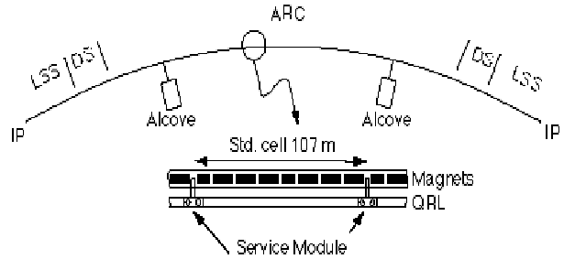
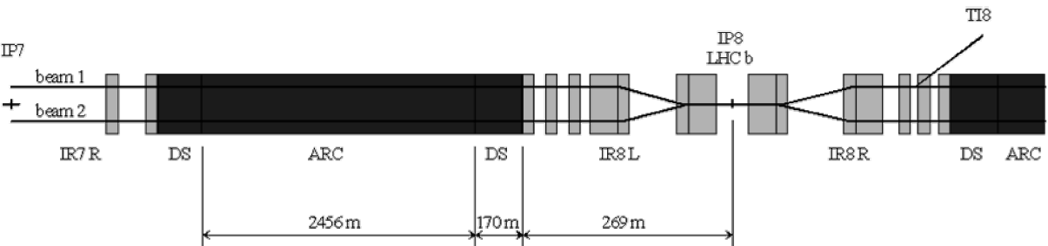
Fig.1: Picture of an LHC arc and of the LSS regions.

Table 1: Expected protections from all mitigation measures implemented or proposed for the LHC beam vacuum.

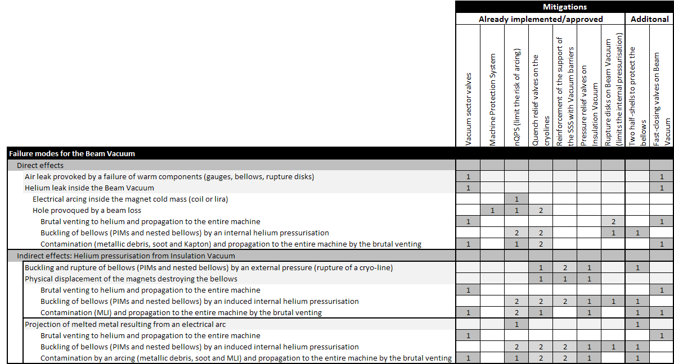
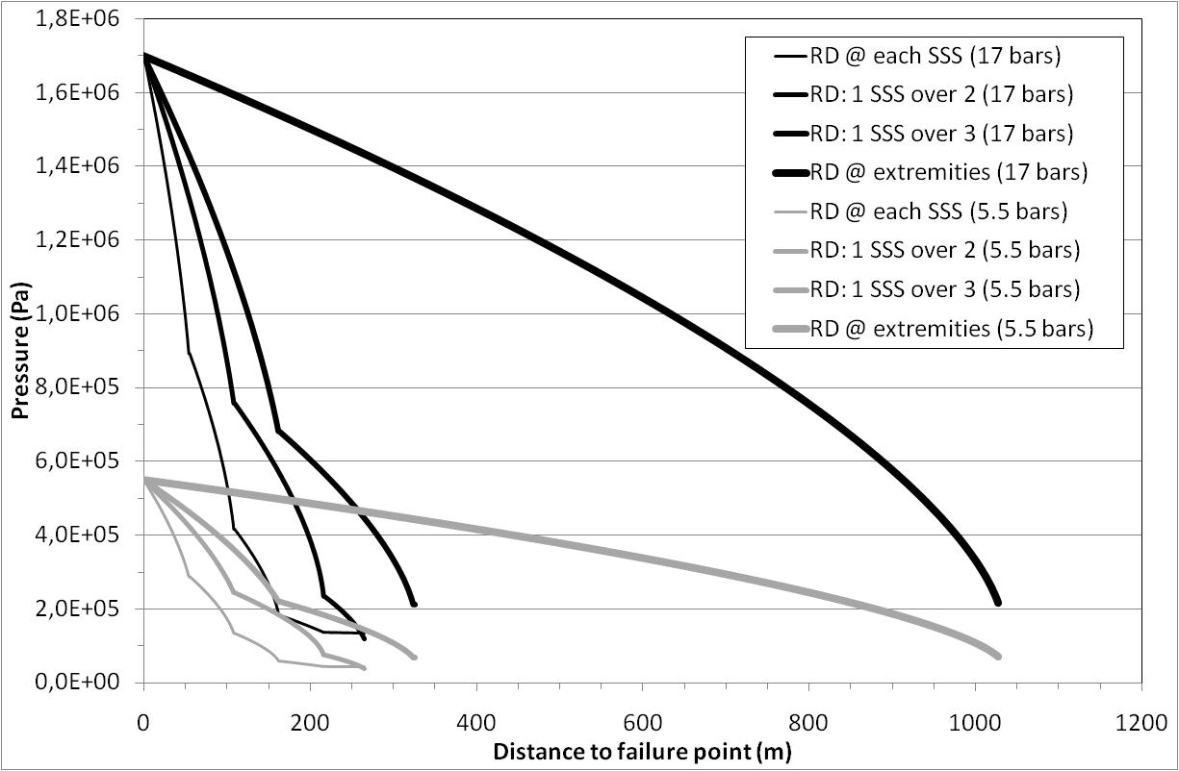
Fig.2: Calculated pressure profiles in case of an internal cold bore pressurisation. Two cases are represented, for 17 bars and 5.5 bars pressurisation and assuming only rupture disks at extremities, 1 over 3 quadupole (SSS) and at each quadrupole (SSS).

Protective half-shells on bellows
During the incident in sector 3-4, it appeared that the fragility of the bellows acted as a worsen factor. The proposed protection, to be applied on all bellows of an interconnection (PIMs and nested beam vacuum bellows and cryolines bellows), consists in two half-shells made out of insulation material, Vetronite or equivalent to reduce the arcing risk. This solution cumulates many advantages: easy to retrofit in all cryomagnet interconnections, provides a higher resistance to plasma discharge (high temperature resistance) and to projection of melted metal.
In addition, the screening effect will limit the injection of MLI in the beam vacuum as the “guiding” effect (no lateral deformation of the bellows) shall improve the resistance to internal and external buckling.
Opening the interconnections requires a total warm-up. Therefore, these half-shells can be easily retrofitted during the consolidation of the splices.

Fast-closing valves
To be successful, the fast-vales shall close within 20-30 ms while being highly reliable to reduce beam downtime due to inopportune closures.
Usually, the fast-closing valves are also vacuum leak tight. For the LHC, the priority is to limit the propagation of the contamination, in particular to protect the injection kickers, RF cavities and Experimental areas. The accidental venting of the beam vacuum by dry helium gas from the cryolines does not permanently degrade the beam vacuum quality even for the NEG coated beam pipes as seen in sector 3-4. Therefore, the leak tightness is no longer mandatory and a more adapted and audacious design can be envisaged.
Low-Z material (Carbon-Carbon or equivalent) will be used for the fast-valve sealing plates to limit the collateral damages in case the beam accidentally intercepts the sealing plate. Indeed, the material will be transparent to beams. The use of low-Z material has another advantage; its low weight will favour a faster actuation which can be spring or pyrotechnic based.
As always with fast-valves, the triggering is the key issue: in presence of beams, beam loss monitors can be associated to pressure signals. In the absence of circulating beams, nQPS signals could be used (not studied yet).
The development and validation of this non- leak tight fast-valve is expected to take about 1 year. In parallel, the triggering signals for the closure of the fast-valves will be studied as well as studying their possible implementations in the arcs of the LHC.

Rupture disks
The present protection scheme is based on one rupture disk at each extremity of the cryomagnet assemblies (arcs, SAMs, and ITs) and Experimental areas. Adding more rupture disks in the arcs was considered after the 3-4 incident but finally postponed. The present design could induce major damages in case of accidental depressurisation resulting from a failure of the sealing metallic membrane.
An upgraded solution is being studied to mitigate the effect of the membrane rupture. The rupture disks, which industrial design will not be modified (years of experience gained in Industry) will be equipped with a head including a spring-based cap. A pin, actuated by the pressure difference, will indicate when the membrane has failed. This head can be retrofitted to the rupture disks already installed.
The basic principle is the following. In case of internal pressurisation, the membrane will break and the spring-based cap will open to reduce the internal overpressure. Once completely depressurised, the spring-based cap will close to prevent retrodiffusion of atmospheric air. In case of failure of the metallic membrane, the spring-based cap will remain closed and will ensure the tightness, preventing the catastrophic depressurisation of the beam vacuum. The pin indicator will allow detecting visually which of the rupture disk membrane has failed.
Fig.2 shows the expected buckling of the bellows in case of an internal pressurisation. Increasing the number of rupture disks will allow decreasing the collateral damages to the magnets. Indeed, the nested bellows, welded to the cold bore and beam screen can only be replaced at the surface by opposition to the PIMs which can be cut and replaced in the tunnel. Therefore limiting the number of damaged nested bellows is a priority.
The installation of additional rupture disks in the arcs of the LHC requires the warm-up of the cryomagnets. An alternative, more risky, consist in a venting of the beam vacuum lines (both V1 and V2) using dry Neon and then proceed with the installation of the “Te” piece and rupture disk while keeping a small internal overpressure to prevent the back streaming of air. Any mistake will imply a warm-up of an arc to RT.
This alternative solution has to be used for the Experimental areas since a venting would imply a bake-out of the Experimental beam pipes, a non-acceptable option.

Closing Remarks
The LHC cannot profit from protection measures implemented in other accelerators World-wide. None of the US accelerators has means to limit the accidental internal pressurisation or the propagation of contamination. Therefore, all above mentioned solutions will be used for the first time and need a careful evaluation before being implemented.
The LHC being in operation, the prerequisites and required time for implementation are taken into account.
The installation of the half-shells on all bellows in the interconnections is an easy task but requires warming-up of all arcs and the opening of the W bellows (cryostat interconnection). The installation can be coupled to the consolidation of the electrical splices.
In case of an internal pressurisation of the beam vacuum, the number of buckled beam pipes bellows can only be limited by installing more rupture disks. However, in case of an MCI, about one period (two half-cells, 8 magnets or 108 metres of machine) could be damaged. This option is being studied and will be considered once their reliability and compensatory measures to limit the collateral damages in case of a membrane failure will be technically validated.
The installation of a large number of rupture disks in the arcs of the LHC requires the warm-up of the cryomagnets but no mechanical modification. The alternative solution using a Neon venting at cold is an option only for the Experimental areas and to install a few units in the arcs.
As the rupture disks are not expected to help against the propagation of the contamination, the use of fast-closing valves is being considered. A new design, not necessarily leak tight and with a sealing plate which uses low-Z material will be studied. The best options for triggering their closure will also be studied.
These additional protections shall be implemented in complement of the other already decided measures: nQPS, pressure and quench relief valves, rupture disks. Then, it is expected that the collateral damages to the beam vacuum will be limited, even in case of an MCI (40 k/s of cold helium). But, it is still delicate to see them as primary machine protection systems.
The impact of the contamination is difficult to predict, it will strongly depend if the primary incident takes place inside or outside the cryomagnet cold masses.

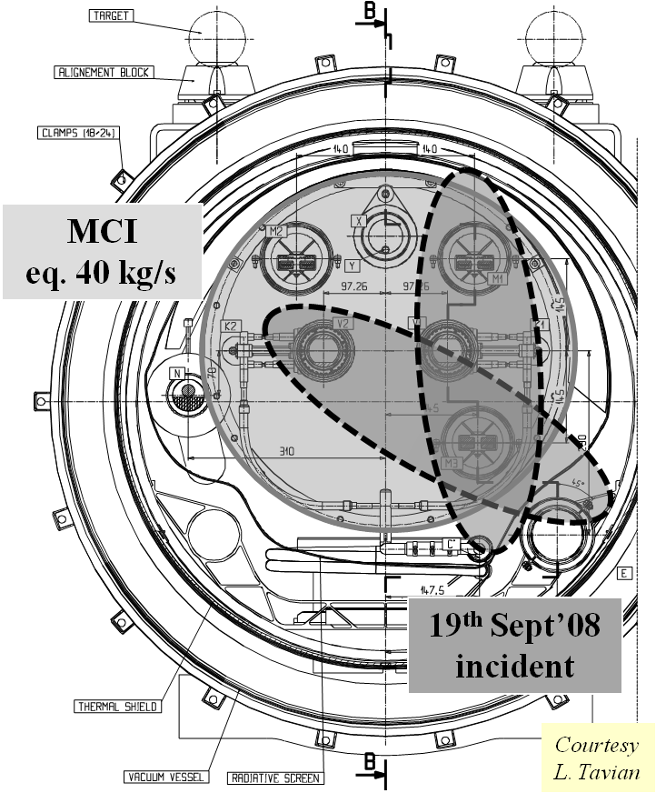
Fig.3: Illustration of the maximum credible incident (MCI) as compared to the sector 3-4 incident.

Conclusions
Together with the consolidation of the splices, many actions can be taken to reduce the contamination and to prevent the internal pressurisation of the beam vacuum, responsible for the buckling of the beam pipe bellows.
While waiting for this consolidation, all measures already taken have increased the safety margin i.e. nQPS, pressure relief valves, and reinforcement of the supports of the quadrupole with vacuum barriers. The case of an internal helium leak is still critical (Table 1).

Acknowledgements
The author would like to thanks V. Baglin, P. Coly,
P. Cruikshank, C. Garion, J. Strait, L. Tavian, R. Veness and R. Van Weelderen for their help.

