JUAS 2020 – Computer Exercices
F. Caspers

Multipactor exercises

Consider a notch filter in vacuum for a 200 MHz accelerating cavity. This filter is realized as coaxial structure of λ/4 length and 10 cm outer diameter of the inner conductor and 15 cm inner diameter of the outer conductor.
Use a travelling wave model and set different power levels, i.e. 10 Watt, 100 Watt , 1 KW and 10 KW

For the structure: take the user defined coax.

Your startup screen looks (similar) to this

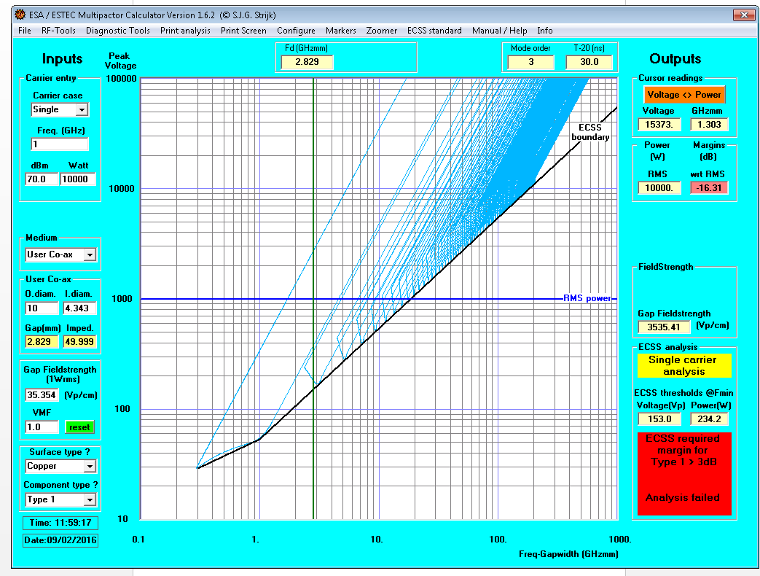
You see that with 100 watt travelling wave power you are still safe, but 100 Watt traveling wave power are just 1 Watt input power on a resonator with a Q of 100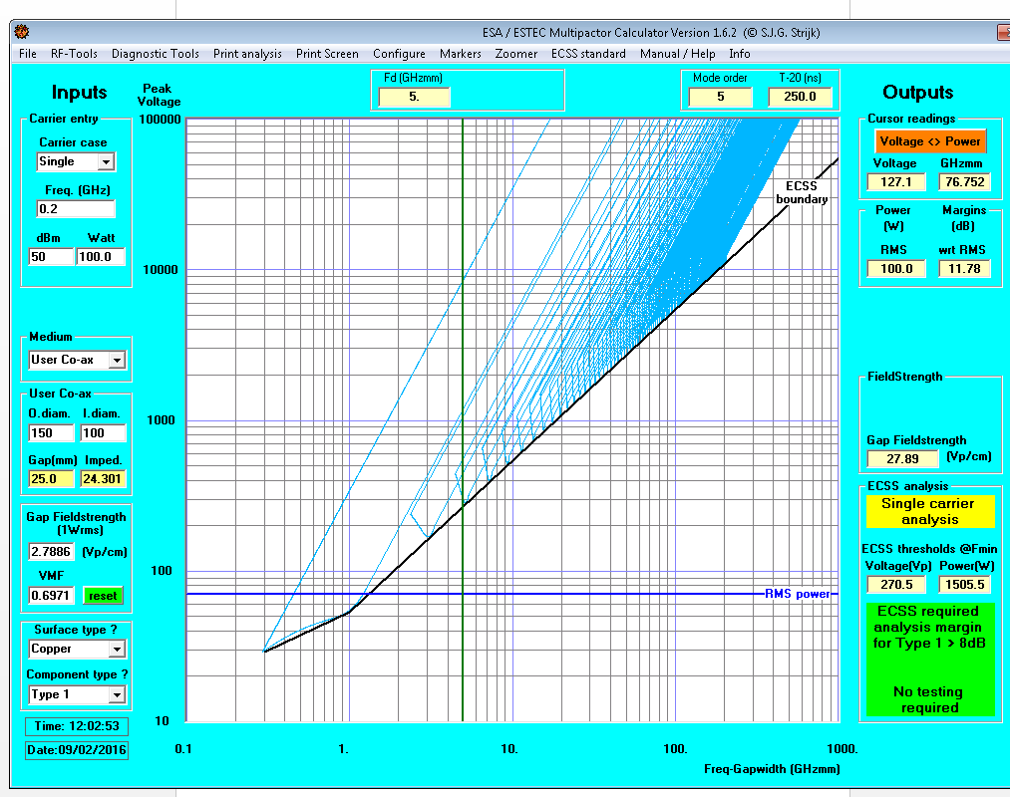
With 1000 Watt you are at the multipactor edge…(very close to the boundary), as defined by the ECSS (European Cooperation for Space Standardization)

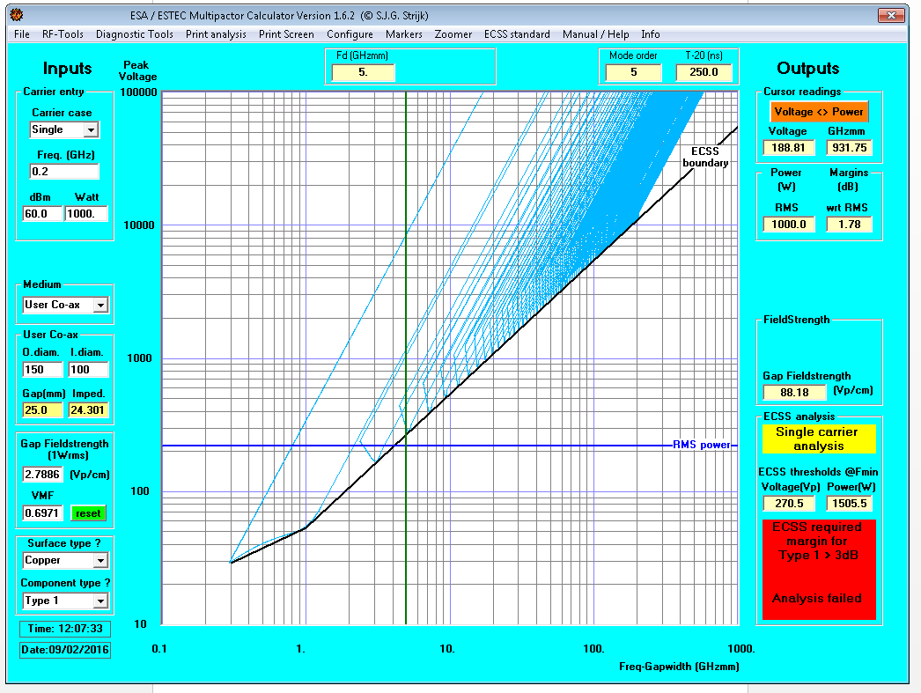
And with 10 kW travelling wave power=10 watt RF generator power for Q=100 you are really in the red area…
