JUAS 2020-Practical Work Day at CERN

Measuring the Properties of Superconductors

Jerome Fleiter, Iole Falorio and Amalia Ballarino

jerome.fleiter@cern.ch
______________________________________________________________
Superconductivity is a fascinating and challenging field of physics. The ability to carry electrical current without resistance has puzzled and attracted the scientific community since the first observation of the phenomenon in 1911.

Superconductors show their superconducting properties only when cooled to sufficiently low temperatures. The discovery of materials that become superconducting at the temperature of the liquid nitrogen (77 K or -196 °C) makes the demonstration of superconductivity much more accessible. These materials are called High Temperature Superconductors (HTS), in contrast with Low Temperature Superconductors (LTS), which require lower temperatures (4.2 K or -268.8 °C), usually achieved by using liquid Helium as a coolant.

During the practical session at CERN, the participants will be introduced to the field of superconductivity. They will work on ad-hoc designed experimental apparatus and they will use YBCO and BSCCO HTS materials for the demonstration and measurement of the physical properties of superconductors. In particular, the set-up will enable them to measure the Meissner effect, with a permanent magnet levitating on a YBCO bulk pellet; they will measure the critical temperature of a superconductor; they will measure the critical current of YBCO tapes; and they will measure the “zero resistance” of the superconductors when transporting currents at temperatures and fields below their critical ones. The participants will be introduced to the cryogenic aspects of the experiments and they will be guided through explanations of the observed phenomena.

The lecture given during the JUAS course (Superconducting magnets, Martin Wilson) provides the theoretical background needed for the understanding of the experiments.

Before starting the experiments, please read the section that describes precautions for safe handling of liquid nitrogen (LN₂) and materials cooled by it. LN₂ is colourless and non-toxic; however it is extremely cold and needs great care in handling and use. Discuss this section with the supervisory team and contact them during the experiments with any questions.

Experimental work
The experimental work will be organized in three activities, you will perform all of them by groups of 2-3.

- Activity A: Levitation and Meissner effect
- Activity B: Critical temperature measurements and electrical resistivity experiment
- Activity C: Critical current measurement and critical surface parameterization.

The detail of the experiment will be fully described in the next sections.

Precautions for using Liquid Nitrogen

Liquid nitrogen is hazardous if not handled properly. If liquid nitrogen is mishandled, it can cause frostbite, cold burns, eye damage, torn flesh, and asphyxiation. Follow these precautions at all times:

- Do not use liquid nitrogen for a liquid transfer if not directly supervised by a knowledgeable person;
- Wear long trousers and protective clothing; safety glasses should be worn at all times, and insulating gloves are required when handling liquid nitrogen or materials cooled by it. Both glasses and gloves will be provided by your supervisor. Be aware that spillage can soak or flow into gloves or other clothes. If this happens, the clothing should be immediately removed from contact with skin to avoid severe frostbite;
- Use liquid nitrogen in a well ventilated area. The gas, whilst non-toxic, can cause asphyxiation through the displacement of oxygen in enclosed spaces;
- Beware of splashing that can be generated during transfer of liquid, or during the movement of either containers with liquid nitrogen or objects in liquid nitrogen;
- Objects in contact with liquid nitrogen are extremely cold. Do not touch them with bare hands to avoid severe cold-burns;
- Many materials, like common glass, plastics and iron, become brittle and may shatter when cooled in liquid nitrogen. Do not submerge unsuitable materials in liquid nitrogen: they may shatter and send dangerous shards flying.
- Oxygen condenses and collects on objects cooled to liquid nitrogen temperature. If allowed to collect over a period of time, it will promote vigorous burning of any combustible material it contacts (absolutely no smoking!).

Activity A. Levitation
A superconductor is a material that is a perfect conductor and exhibits perfect diamagnetism. The perfect diamagnetism is known as the Meissner Effect following experiments by Meissner and Ochensfield in 1933 where they showed that magnetic fields are excluded from the interior of a material when it becomes superconducting. This can be exploited in various applications, like magnetic shielding, frictionless bearings etc.
Superconductors can be further classified into Type I and Type II. In Type I superconductors the surface energy is positive and the material exhibits perfect diamagnetism, with the magnetic field only penetrating over a short depth (50-500 nm - the London penetration depth) into the material. In Type II superconductors, the surface energy is negative and the magnetic field can partially penetrate the material in a form of Abrikosov vortices. The vortex consists of a core in non-superconducting phase with a diameter on the order the superconducting coherence length (ξ). The non-superconducting core of vortex is surrounded by screening currents that screen the rest of the superconductor from the magnetic field of the core. Each Abrikosov vortex carries one quantum of magnetic flux Φ₀.

Type II superconductors have two critical fields (H_{c1} and H_{c2}), below H_{c1} they behave as Type I superconductors with the magnetic field expelled from the interior. In between H_{c1} and H_{c2} is the vortex state: the vortex distribute in a lattice across the volume of the superconductor. Above H_{c2} the material is no longer superconducting. The penetration of flux line in the Type 2 superconductor allows the material to have a much higher critical magnetic field, allowing them to be used for power applications. Another characteristic of Type II superconductors is that they exhibit flux pinning: the flux lines are anchored to inclusions in the material. This specific property allows frictionless bearings and other magnetic devices to be made but does introduce losses due to hysteresis.

This section details a number of experiments to allow the investigation of a Type II superconductor both below H_{c1} where it exhibits true perfect diamagnetism and above H_{c1} where flux pinning occurs.
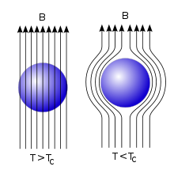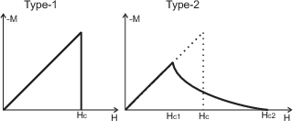
- Left: The Meissner Effect; the expulsion of an applied magnetic field upon transition from the normal to superconducting state. Right: Variation of Magnetization with Applied Magnetic Field Intensity for Type I and Type II Superconductors.

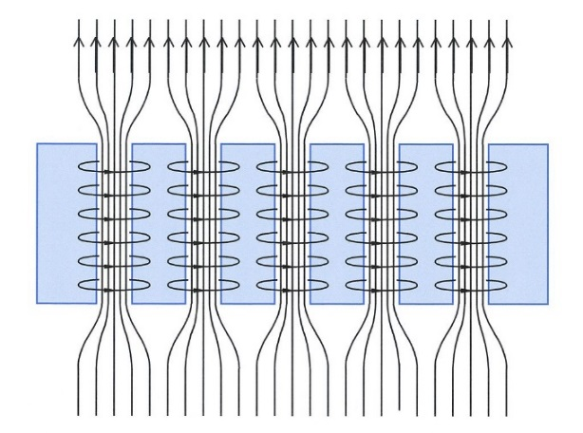
- Magnetic flux lines penetrating a type-II superconductor. The currents in the superconducting material generate a magnetic field which, together with the applied field, result in bundles of quantized flux.

A.1. Levitation with Zero Field in Cooled conditions
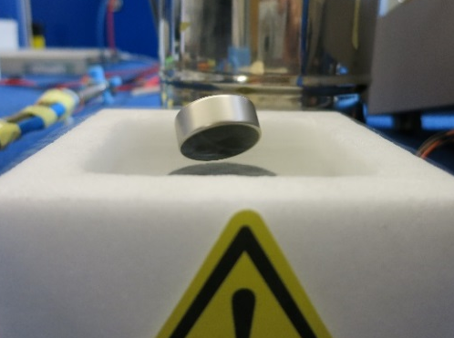
Aim: To observe and appreciate the perfect diamagnetism found in a Type II superconductor beneath H_{c1} and the flux penetration regime above H_{c1}.

Equipment
- Small cubic permanent magnet
- YBCO bulk
- Teslameter
- Foam Cryostat
- Liquid Nitrogen

Procedure
Measure the magnetic field of the magnet. Place the YBCO in the foam cryostat and cool it down to beneath T_{c} with liquid nitrogen. Try placing the permanent magnet above the superconductor with the nonmagnetic tweezer. Appreciate the repelling forces as you approach the magnet. When the magnet is distant from about 1 cm of the YBCO bulk, release the magnet. Does the magnet levitate? If no pick up again the magnet with the tweezer and approach it closer to the YBCO bulk. When the magnet levitates, observe and verify that nothing but magnetic interaction keeps the magnet from falling down. Push the levitated magnet with the tweezers so as to move it across the superconductor and detect that it will resist the movement. Notice that the magnet does not levitate but is pinned to the superconductor surface.

Discussion
Explain why the force is first only repulsive when you approach the magnet. Why when the magnet is close enough to the YBCO the levitation is stable? If the superconductor would have been replaced by an ideal perfect conductor (=zero resistance below T_{c}), would the stable levitation phenomenon have happened?

A.2: Levitation with Field and Cooled conditions
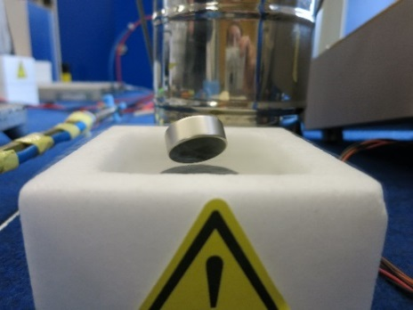
Aim: To investigate the pinning forces present in a Type II superconductor when exposed to a field above H_{c1}.

Equipment
- Small cubic and large permanent magnet
- YBCO bulk disc
- Foam cryostat
- Teslameter
- Liquid Nitrogen

Procedure
Measure the magnetic field strength at the centre of the small cubic magnet. Place the YBCO disk into the foam cryostat with the small cubic magnet on top of it. Carefully fill the Dewar with Liquid Nitrogen. Observe what happens. When the YBCO is cooled to the superconducting state (T_{c}= 93 K), observe the magnet suddenly jumping up into the air. Observe and verify that nothing but magnetic interaction keeps the magnet from falling down. With the non-magnetic tweezers, kick the magnet and observe it rotating in the air. Push the levitated magnet with the tweezers so as to move it across the superconductor and detect that it will resist the movement. Notice that the magnet does not levitate but is pinned to the superconductor surface. At the end of the experiment, quickly remove the magnet and measure the field trapped in the superconductor.
Repeat the experiment with the large permanent magnet. Measure the magnetic field strength at the centre of the large magnet. Place the YBCO disk into the foam cryostat with the large magnet on top of it. A non-metallic spacer (~1 cm thick) should be inserted in between the magnet and the YBCO bulk. Carefully fill the Dewar with Liquid Nitrogen. When the YBCO is cooled to the superconducting state (T_{c}= 93 K), remove the spacer. What happens? With the non-magnetic tweezers, kick the magnet and observe it rotating in the air. Push the levitated magnet with the tweezers so as to move it across the superconductor and detect that it will resist the movement. Try to lift up the magnet with the tweezer. What is happening? Explain why?

Discussion
The superconducting sample was cooled down with the permanent magnet already sitting on it at room temperature. If the superconductor would have been replaced by an ideal perfect conductor (=zero resistance below T_{c}), would the levitation phenomenon have happened? Levitation and suspension are demonstrated during the experiment. Are both of these experiments related to the Meissner effect? In particular, are both the resistance to the downward motion and the suspension related to the Meissner effect? Try to give and explanation for both cases.

A.3. Applied Force vs Levitation Height
Aim: Observe and quantify the levitation of a permanent magnet on top of a superconducting YBCO cylinder.

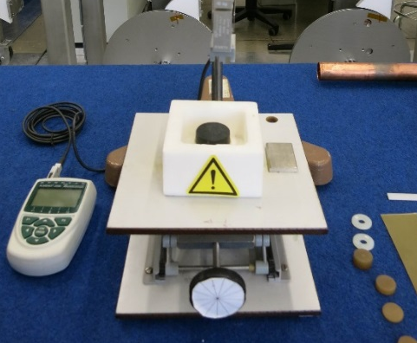
Equipment
- Rectangular permanent magnet
- Teslameter
- Moving stage
- Displacement transducer
- Force transducer
- Non-magnetic tweezers
- Liquid nitrogen and Foam Cryostat

Procedure

- Before starting the experiment, observe the set-up and identify its different components.
- Measure the maximum field on the surface of the permanent magnet.
- Attach the permanent magnet to the Force transducer. Approach the permanent magnet from the YBCO bulk. Vertical gap between magnet and bulk should be 5 mm. Make sure that the moving stage can either go downward and upward by about 5 mm in both directions.
- Observe your supervisor filling the foam Dewar and observe the levitating force on the transducer as versus the cool down time.
- Once the YBCO bulk is thermalized to 77 K, reduce the gap between the magnet and the bulk by steps of 0.5 mm down to 1 mm. Plot your measurements on figure 3. Once the gap is only 1 mm, increase it by steps of 0.5 mm and plot your measurements in figure 3.

Measurements

- Levitation force at 77 K

Discussion
Plot the levitation force recorded during the experiment as function of the levitation height. Which is the position of the magnet with respect to the superconductor corresponding to the highest levitation force? Which is the value of this force? May you explain why? What kind of application you can imagine?

Activity B. Critical Temperature and Zero DC electrical resistance

B.1 Critical temperature measurement
There are several ways for measuring the critical temperature (T_{c}) of a superconductor. The most common being to measure the electrical resistivity as a function of the temperature. Today you will measure T_{c} by using the Meissner effect. In this case, the critical temperature is defined as the temperature measured on the superconductor when a permanent magnet levitating above it comes to a complete rest on the superconductor’s surface.

Objective
Measure the critical temperature of bulk YBCO via the Meissner effect.

Tasks
Perform temperature measurements at cryogenic temperatures with a platinum resistance thermometer (Pt100) using the 4-wire technique. Experimentally determine the calibration curve of a Pt100. Finally determine the critical temperature of a YBCO bulk.

Equipment
- YBCO bulk equipped with a PT 100 temperature transducer
- Foam cryostat
- Liquid nitrogen
- Permanent magnet
- Teslameter
- Pt100 temperature sensor
- Instrumentation cables
- Multimeter suitable for 4-wire resistance measurement

Calibration of a temperature sensor (Pt100)
Connect a Pt100 sensor via the 4-wire method to the multimeter. Using the mercury thermometer measure room temperature, then measure the resistance of the sensor. Observe your supervisor pouring nitrogen in to the polystyrene box. Immerse the Pt100 sensor in the liquid nitrogen and measure the resistance. In figure 4, plot the calibration curve of the sensor (resistance as a function of temperature), corresponding to a straight line passing through the two measured points. Compare this curve to the manufacturer’s data (figure 4).

- PT 100 calibration chart

Critical temperature measurement
The YBCO bulk is equipped with a Pt 100 temperature sensor. Measure the magnetic field strength at the centre of the large magnet. Place the YBCO disk into the foam cryostat with the large magnet on top of it. A non-metallic spacer (~1 cm thick) should be inserted in between the magnet and the YBCO bulk. Carefully fill the Dewar with Liquid Nitrogen. When the YBCO is cooled to the superconducting state (T_{c}= 93 K), remove the spacer. Let the liquid nitrogen evaporate. The temperature of the YBCO slowly increases and the levitation force gradually gives way to the gravity. When the magnet comes to rest on the surface, record both the temperature of the superconductor and the warm up time. This is the critical temperature of the superconductor.

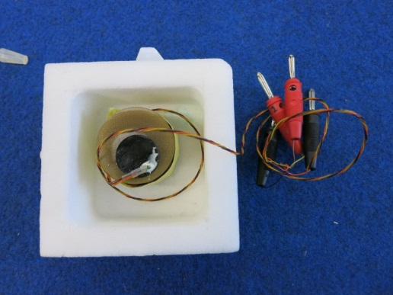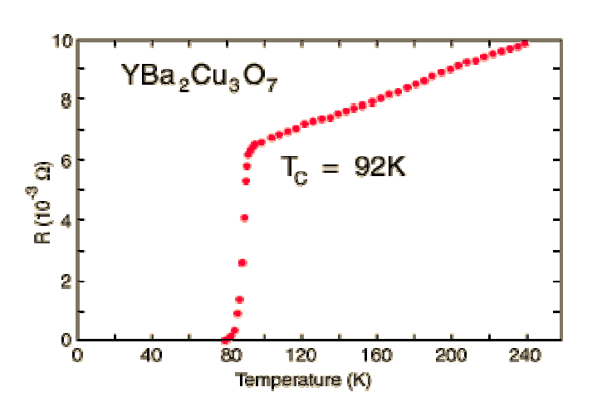

Results
TABLE 1 MEASURED T_{C} OF YBCO BULK
T_{c} of YBCO (Kelvin)
Warm up time (minutes)

Discussion
The critical temperature is defined as the temperature below which a material exhibits superconductivity at zero magnetic field strength. What impact does the field of the permanent magnet have on this?
Can you explain why the magnet floats lower and lower during the warming up of the YBCO instead of falling down suddenly on the superconductor?

Could the temperature measurement have been done using a two wire rather than a four wire method? (i.e. by soldering only one wire, instead of two, to each lead of the PT l00 sensor) Note that in this case the wires used for measuring the voltage are also the current carrying wires.

The device develops a level of frost only after the liquid nitrogen has boiled away. Why is this?

B.2 Electrical Resistance of a superconductor

Objective
Understand the difference between a perfect conductor and a superconductor. You will measure the electrical resistance of three tape conductors (namely Tape 1, Tape 2 and Tape 3); at room temperature and at 77 K. One of these three tapes is superconducting, being made of BSCCO 2223 filaments embedded in a silver matrix. The other two tapes are made of respectively copper and stainless steel. From your measurements, you will have to identify which of the tape is the superconducting one.

Tasks
Measure the electrical resistivity of the BSCCO and the resistive tapes at room temperature and at 77 K.

Equipment
- DC Power supply
- Digital Voltmeters suitable for low voltage measurement:
- Set-up consisting of an insert which supports, at its lower end, a superconducting tape and resistive tapes electrically connected in series.
- Glass Dewar with holder
- Instrumentation cables (Pre-installed):
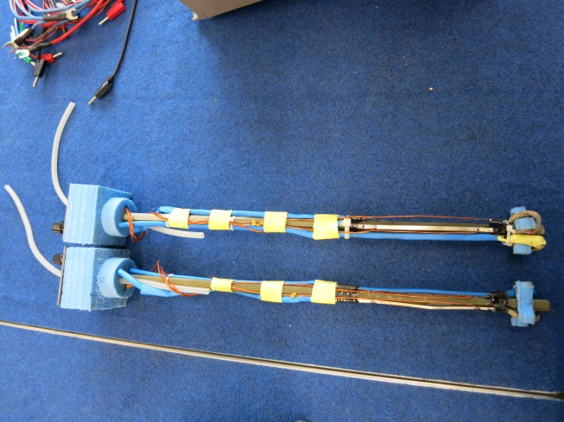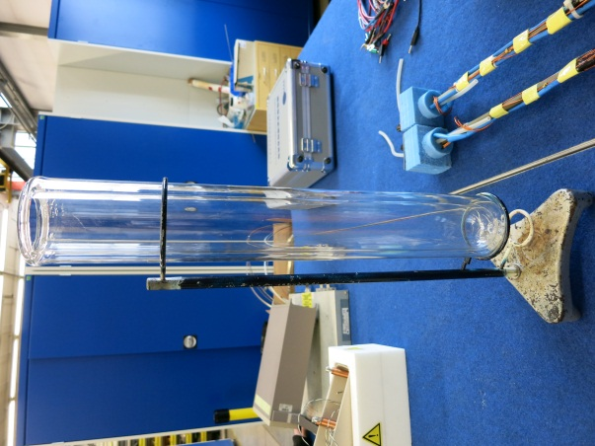

Procedure
Observe the set-up in order to understand its components. Measure the distance between the voltage taps located on the three tape conductors. Measure the electrical resistivity of the samples at room temperature: Record in table 1 and in figure 5 the voltage drop along the tape conductors using the voltage taps already soldered to the samples for currents in the range 0 -2 A with increments of 0.2 A. Observe your supervisor filling the flask with liquid nitrogen. Slowly immerge the insert first in the cold nitrogen gas evaporating from the flask and then in the liquid nitrogen. At this point are you able to say which one seems to be the superconducting tape? Measure the electrical resistivity of the samples at 77 K: Measure the voltage drop along the samples for transport current of 0, 1, 2, 3, 4, 5, 6, 7, 8, 9 and 10 A. Report your measurements in table 3 and in figure 6. Observe through the glass flask the three tapes when they are transporting a current of 0 A, 5 A and 10 A. Try to identify which is the superconducting one from the rate of nitrogen boiling. Compute the electrical resistivity at RT and at 77 K of the three tape samples (table 2). Please note that for the BSCCO tape, 30% of the cross section is made of BSCCO filaments the rest being made of silver. Determine from your measurements which of the three tapes is the superconducting one (table 2).

Measurements
TABLE 2 MEASURED RESISTIVITY OF THE TAPES
 | Tape 1 | Tape 2 | Tape 3
Distance between voltage taps (cm)
width of the tape (mm) | 4 | 4 | 4
Thickness of the tape (mm) | 0.2 | 0.1 | 0.2
Voltage at room temperature (@ 2 A)
Voltage at 77 K (@ 2 A)
Voltage at 77 K (@ 10 A)
Resistivity at RT (nOhm.m)
Resistivity at 77 K (nOhm.m)
Material of the tape?
(BSCCO+Ag, Steel or Cu)

TABLE 3 MEASURED VOLTAGE ALONG THE TAPE CONDUCTORS VS CURRENT
Tape 1 |  |  |  | Tape 2 |  |  |  | Tape 3
300 K |  | 77 K |  | 300 K |  | 77 K |  | 300 K |  | 77 K
I (A) | U (mV) | I (A) | U (mV) | I (A) | U (mV) | I (A) | U (mV) | I (A) | U (mV) | I (A) | U (mV)
0 |  | 0 |  | 0 |  | 0 |  | 0 |  | 0
0.2 |  | 2 |  | 0.2 |  | 2 |  | 0.2 |  | 2
0.4 |  | 4 |  | 0.4 |  | 4 |  | 0.4 |  | 4
0.6 |  | 6 |  | 0.6 |  | 6 |  | 0.6 |  | 6
0.8 |  | 8 |  | 0.8 |  | 8 |  | 0.8 |  | 8
1 |  | 10 |  | 1 |  | 10 |  | 1 |  | 10
1.2 |  | 12 |  | 1.2 |  | 12 |  | 1.2 |  | 12
1.4 |  | 14 |  | 1.4 |  | 14 |  | 1.4 |  | 14
1.6 |  | 16 |  | 1.6 |  | 16 |  | 1.6 |  | 16
1.8 |  | 18 |  | 1.8 |  | 18 |  | 1.8 |  | 18
2 |  | 20 |  | 2 |  | 20 |  | 2 |  | 20

- The voltage along the three tape samples as a function of the transport current at room temperature

- The voltage along the three tape samples as a function of the transport current at 77 K

Discussion
What did you notice from the glass flask when the tapes were transporting current of 0 A, 5 A and 10 A? Will it be possible to transport at 77 K an infinite amount of current through the superconductor with no Ohmic losses?

Activity C. Critical current and critical surface of a superconductor

For generating high magnetic fields (>3 T) in accelerator magnets we rely on the zero DC electrical resistance of superconductors. The superconducting state of the superconductor depends mainly upon temperature, magnetic field, and current density; these three parameters define the superconducting region of the material (Figure 7). All superconducting materials have critical values for these parameters, and if any of them is exceeded the material will no longer exhibiting superconductivity.

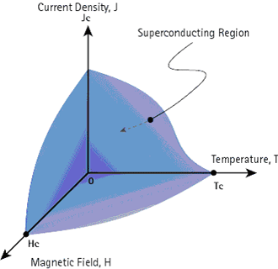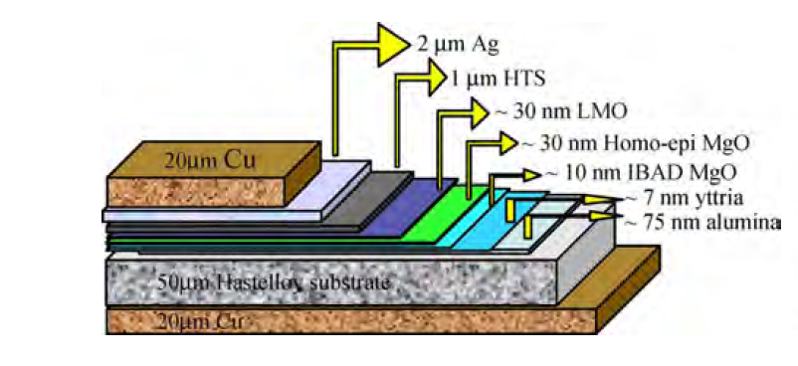
- Critical surface of a superconductor and cross section of the YBCO tape conductor. YBCO tapes are typically 4 or 12 mm wide and 0.1 mm thick with an HTS film of 1 μm.

The experimental determination of the DC critical current (I_{c}) of an HTS material (YBCO tape in our case) is done by circulating a DC current trough the sample and measuring the electric field along the sample. For HTS materials the critical current of the sample is defined as the transport current for which the electric field is equal to 1 μV/cm. For LTS materials (e.g. Nb-Ti and Nb₃Sn) the electric field criterion for determining I_{c} is 0.1 μV/cm. A four point method is applied for the measurement of I_{c}. For accelerator magnet we are interested in the engineering current density in the coil. Therefore we should translate the measured I_{c} in terms of engineering critical current density (J_{cen}) defined as the critical current divided by the total cross sectional area of the tape conductor. Typically for accelerator magnets it is about 400 A/mm². The engineering critical current density depends strongly on the quantity of stabilizer that is embedded in the conductor. In order to compare the performances of two superconducting tape or wire with different dimensions, it is also useful to derive from the critical current the physical current density in the superconducting filaments. The physical critical current density (J_{cph}) is defined as the critical current divided by the cross sectional area of the superconductor. For magnet application, we should also quantify the shape of the transition from superconducting state to normal state. During an I_{c} measurements, the transition of a superconductor to normal state is well described by the following equation:

$E=E_{c}{\left(\frac{I}{I_{c}}\right)}^{n}$ (1)
where E is the electrical field, E_{c} is the electric field criterion. The n-value gives the stiffness of the transition. Typically for practical conductors n ranges in between 20 and 60. For magnet applications it is also important to know the dependence of I_{c} as a function of magnetic field and temperature in order to compute the magnet margins (on load line and on temperature). The I_{c} dependence on magnetic field could be described in a first approximation with the following function:

$I_{c}(B)=\frac{A}{B}b^{p}{\left(1-b\right)}^{q}$ (2)
Where b=B/B_{c2}(T) is the reduced field and A, p and q are fitting parameters. Usually for a given sample p and q are the same at different temperatures.

C.1 Critical current of a superconductor

Objective
You will measure the critical current and the n value of an YBCO tape at 77 K in self-field and with external perpendicular fields.

Equipment
- 200 Amps DC Power supply
- I_{c} Sample Holder (stainless steel plate with Copper insert for current injection)
- Digital Voltmeter
- YBCO tape
- Foam cryostat
- Cylindrical Permanent magnet
- Cylindrical Neodymium magnet
- Teslameter
- Liquid Nitrogen

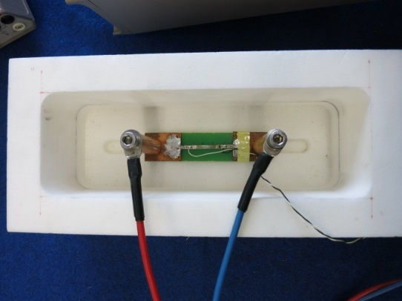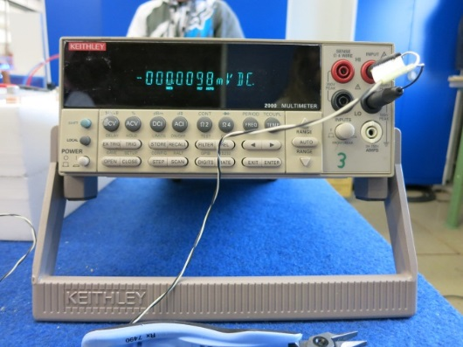

I_{c} measurements at 77 K
Aim: to determine the I_{c} and the n value of an HTS tape in self-field (YBCO tape, Tc=93 K cross section depicted in Figure 7). Measure the influence of magnetic field on the conductor critical current.

Procedure
Measure the YBCO tape thickness and width. Measure the distance between the voltage taps.

TABLE 4 YBCO TAPE DIMENSIONS
Tape thickness (mm)
Tape width (mm)
Distance between voltage taps (cm)

- I_{c} measurements without external field
Apply at room temperature 0.5 Amperes to the tape and measure the voltage drop across the tape (V_{HTS}). Observe your supervisor filling the Dewar with nitrogen. Immerge the sample holder with the tape in the liquid nitrogen bath and wait until the nitrogen boil-off stops. Apply 2 A to the tape and measure V_{HTS}. Increase the current by 10 A, and measure V_{HTS}. Continue increasing the current in steps of 5 A, measure and record the corresponding V_{HTS} (using table 5 and figure 10). When the voltage drop approaches the value corresponding to the 1 μV/cm electric field criterion, increases the current in steps of 1 A. Record the value of V_{HTS} until it reaches the value corresponding to 3 μV/cm of electric field. Once electric field of 3 μV/cm is reached, ramp down the current and shut down the power converter.

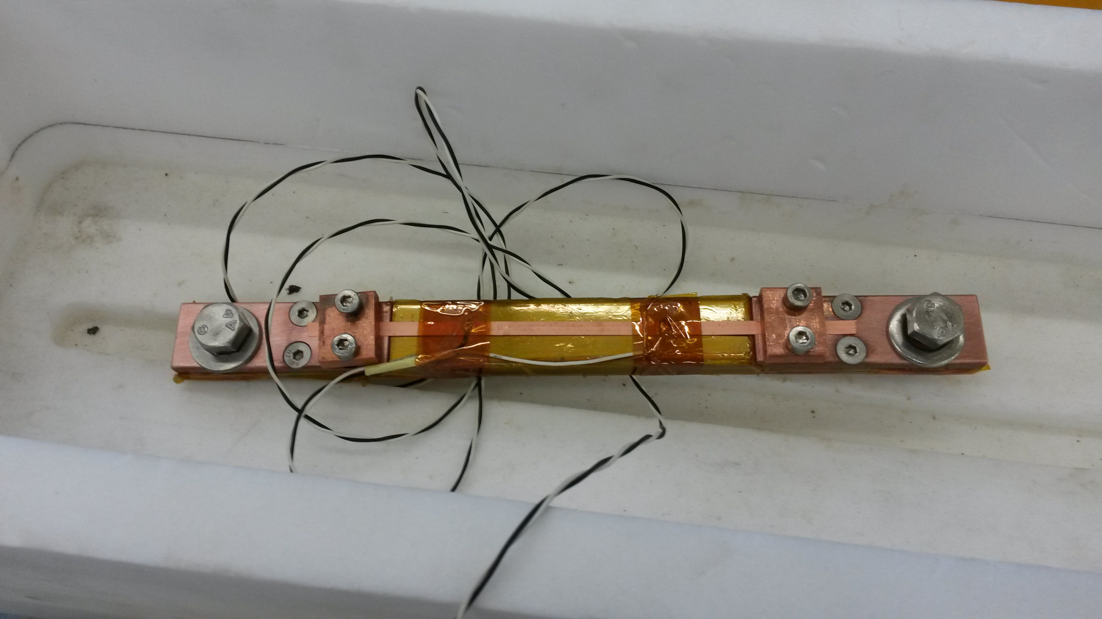
- YBCO sample mounted on the sample holder prior to Ic characterizatrion in self-field.

- With external field (paperboard magnet)
With the help of your supervisor remove the sample from the liquid nitrogen bath. Measure the strength of the paperboard magnet with the Teslameter. Put the magnet on top of the superconducting tape in between the two voltage taps used to record V_{HTS} as reported in figure 9. Immerge the sample holder with the tape and the magnet in the liquid nitrogen bath and wait until the nitrogen boil-off stops. Repeat the measurement performed in self-field in order to measure tape I_{c} and report the measured data in figure 10.

- With external field (neodymium magnet)
With the help of your supervisor remove the sample from the liquid nitrogen bath. Measure the strength of the neodymium magnet with the Teslameter. Remove the paperboard magnet and replace it with the neodymium one. Repeat the I_{c} measurements (report your measurements in figure 10) and report the computed I_{c} in the table 5.

TABLE 5 YBCO TAPE DIMENSIONS
 | Self-field | Paperboard magnet; ___Tesla | Neodymium magnet; ___Tesla
I_{c} (A)
J_{c,engineering} (A/mm²)
J_{c,physical} (A/mm²)
(remind that HTS layer is only 1 µm)

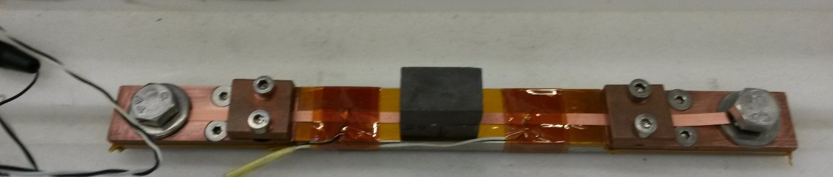

- YBCO sample mounted on the sample holder prior to Ic characterizatrion with background magnetic field.

- Determination of tape n value.
The electric field along the YBCO tape was measured as a function of current at 70 K and 2 T. From the reported measurements (see appendix B), please determine the I_{c} of the conductor and its n value.

- UI trace of a YBCO tape at 77 K in self field and with perpendicular field.

C.2 Critical surface of a superconductor

Objective
You will find a mathematical description for the field dependency of the critical current as a function of magnetic field. In reality the I_{c} of a superconductor is dependent on many other parameters like temperature, field orientation, strain … But we start with a simple case.

Procedure

Please find in the table place in appendix B the I_{c} measurements performed on a 4 mm wide YBCO tape at 60 K and 70 K in perpendicular fields of up to 14 T. Adjust the parameters of equation (2) in order to fit the measured data. The p and q parameters are identical at both temperature. Parameter p is typically in the range 0.5-2 and q is in the range 2-6. Plot on a graph the measurements and the I_{c} parameterization obtained.

Discussion
What are the implications of high or low n-values?
What is the influence of the field strength on the tape Ic?
Does superconductor are exposed to magnetic field in coils?
What is the influence of the field orientation on the YBCO tape Ic?
Does the tape I_{c} increase or decrease by reducing the operating temperature?

Appendix A – 4-Wire Measurement
The 4-wire measuring technique enables accurate resistance measurements and requires four separate wires even though the Pt100 sensor only has two attachment leads. Two wires are soldered to each lead with one wire transporting the current passing across the sensor, while the other wire is used for the measurement of the voltage drop across the sensor.
Power the Pt100 sensor by switching on the constant current source. The excitation current should be 100 μA. In these experiments multimeters with built in excitation current supplies are utilised and so care must be taken to attach the wires to the relevant sockets.

Appendix B– 4-EI trace and I_{c} (B) data set

The electric field measured along the YBCO tape at perp field of 2 T and temperature of 60K
The I_{c} measurements performed on 4 mm wide YBCO tape at 70 K and 60 K in perp field

