VERIFICATION – CALIBRATION MFC
- Access to the pc: username: gas…. Password: gas_expert12345678
- Mount the device on the clamp and connect the input with the correct gas line (usually with blue plastic pipe LINE GAS 2). If possible, use the same gas and same pressure indicated on the label of the MFC. If the line is occupied, ask to other guys if you can use it
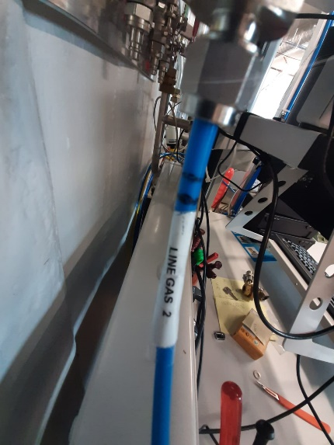
- Check if there is enough pressure in the line, if not adjust the pressure regulator in the gas room. (before LAB 256)
- Check on www.flluidat.com (username: g.gasoper password: gasoper1)(on the bottom of bronkhorst folder) the flow conversion to know which column (or rotor meter) you need to use. Remember that the column are calibrated for air at 1 bara.
- Connect the tube with the appropriate reference piston prover (or rotor meter) according to the device flow range
- Adjust the pressure at 4 bar on the black pressure regulator on the wall near the calibration stand to operate the pneumatic valve that open the exhaust (only for 2 columns, not needed for rotor meter)

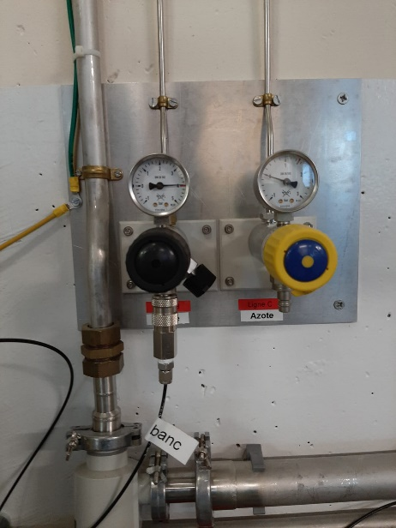
- Open (remember: Start -> Bronkhorst->) FLOWDDE and FLOWDDE2: Communication -> Open Communication (the device starts blinking)
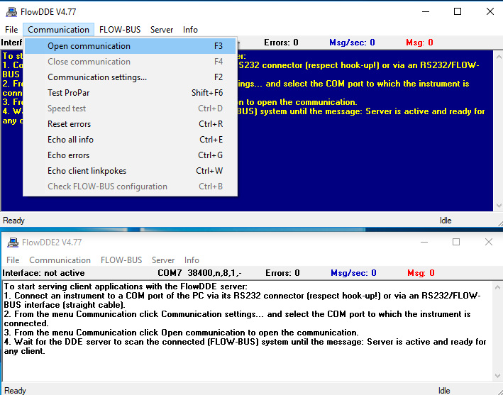
- Open FLuiCal

VERIFICATION
- Insert the informations about the MFC on Fluical
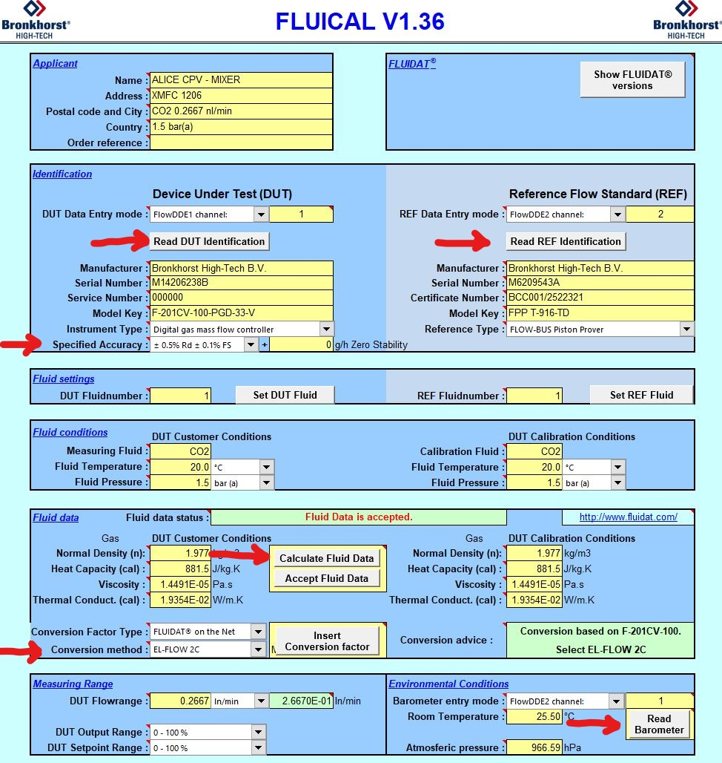
- Click Read DUT Identification check the next cells
- Choose the accuracy +- 0.5% Rd +- 0.1%FS (only for ATEX MFC=1%)
- Choose the REF channel. To check which one is the channel open FlowDDE2 window -> FLOWBUS -> Configuration. If you click on one of the devices lists the selected device starts blinking
As a reminder: FPP stands for Flow Piston Prover, FRM Flow Rotor Meter
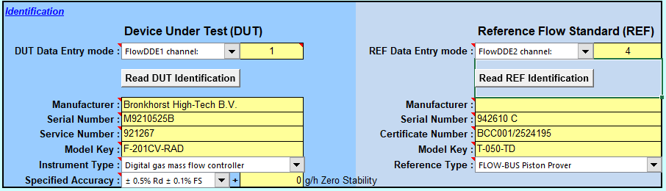
- Click Read REF Identification

- Fluid settings usually it is 1. You need to change it if you have more curves
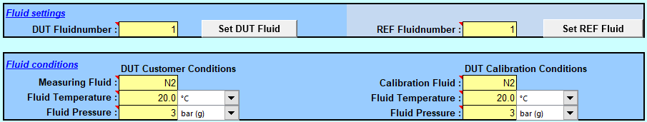
- Insert the fluid conditions (Watch out to bara and barg)
- Select the conversion method (see the green box on the right)
- Click Calculate Fluid Data
  - If you have a mixture use Fluidat on the Net to calculate the data and insert manually and after click on “Accept Fluid data”
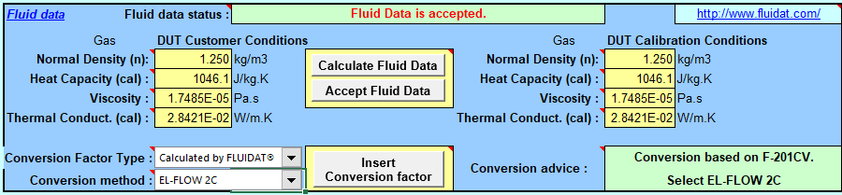
- Insert the DUT Flowrange
- To read the Barometer in the entry mode put flowDDE 2nd and the channel of the barometer (usually it is channel 1) and click on Read Barometer
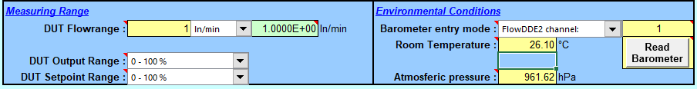
- Use the thermometer in the room and insert the room temperature in the correct cell
- Insert Flow Control settings (FlowDDE1 channel1 usually)
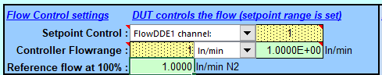

- Make some run in manual ( -calibration procedure) and stability check (-REF test procedure)
- Put Stability check in REF Test procedure and Manual in Calibration procedure and make some run to stabilize the device
- Put 4 different set point in the calibration table (100%, 75%, 50%, 25%) by clicking the 4 and then clear result; after that put auto (-calibration procedure) and stability check (-REF test procedure) and start with the measurement
- Check time to time the input pressure
- 0 must be done in Single Run, manual procedure (when the other have finished)
- To check if we are in the acceptable range you can also have a look to the plot on the certificate page (sheet 3)
- If the verification is PASSED and ALL the points are close to the zero line, it is not needed do the calibration. If it is PASSED but the points are far to the zero line, you have to do the calibration. Whenever you have to save the files
- Click on Complete report data to insert the information about the verification
- Save the file (excel) in the folder “Certificat de calibration” (G:\Departments\PH\Groups\TA1\Gas_group\Bronkhorst HITEC\Certificat de calibration)
- Select the 3 pages and export them in PDF format in the folder “Certificat de calibration”
SerialNumber - LS2 - V - Gas with Gas - date

CALIBRATION
- Put the flow at zero (on FlowPlot). Close the valve before the MFC and disconnect the pipe before the MFC
- Click on “Clear existing linearization and flow settings”
- Make the zero by clicking on “Zero”
- Reconnect the pipe. Open the manual valve
- Make few times the run at 100% in manual ( -calibration procedure) and sigle run
- If the deviation of 100% is NOT between -3% and 0%
  - Click on “calculate full scale” and insert the value to arrive in that range (MAX 3% for each time)
  - Make again the run at 100% manual and single run (repeat these operations until the deviation is in the correct range and go at the point 7)
- If the deviation of 100% is between -3% and 0%
  - make the run ( auto – stability check) for 6 points (100%, 80% , 60%, 40%, 20%, 10%)to be more precise or with 5 point (100%, 80%, 60%, 40%, 20%) and for 0% (manual- single run)
  - If the instrument is in mode “polynomial” Click on “calculate coefficients” and “Store in DUT”; if the instrument is in mode “lookup table” you just need to click on store in DUT. Check that the values on Flowplot (calibration) are changed.
- Clear the results and make the measure for 4 point (100%, 75%, 50%, 25%) in auto and stability check mode
- Click on Complete report data to insert the information about the calibration.
- Save the excel file in “Certificat de calibration”
- Save the 3 pages in PDF format in “Certificat de calibration” with title
SerialNumber - LS2 - C - Gas with Gas - date

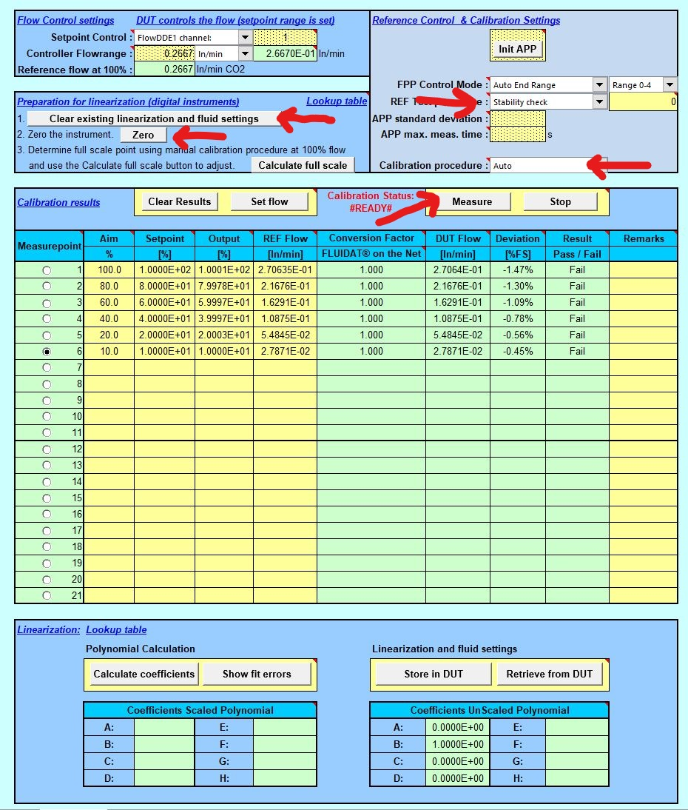
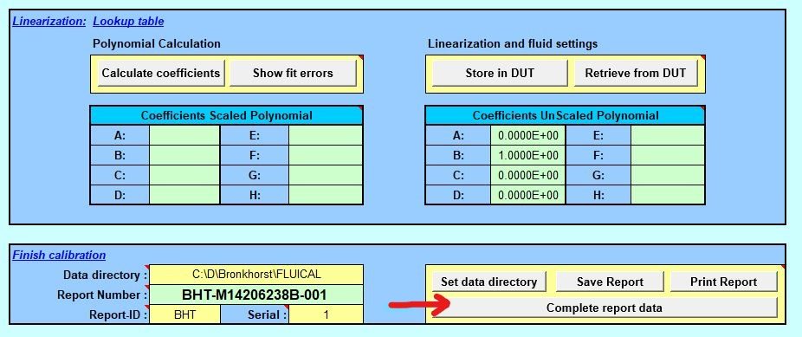

MFC with 2 CURVES
If you have a MFC with 2 curves:
Do the verification of the first curve as a normal verification. Save the excel file and the PDF.
SerialNumber - V1 - LS2 - GAS with GAS - Date
To do the verification of the second curve you need to put 2 in DUT & REF fluid number cells and check that the number is changed also on flowplot (if not, change it).

PHOTO FLOWPLOT basic *photo when we can access to flowplot
Now you can do the verification of the second curve as a normal verification. Save the excel file and the PDF. #SerialNumber - V2 - LS2 - GAS with GAS - Date
If at least once is failed you need to do the calibration of both curves. Do always both verification: it is possible that is needed it to check something in the future.
Put 1 in the fluid setting cells to calibrate the first curve. BE SURE THAT THE NUMBER CHANGED ALSO IN FLOWPLOT
- Put the flow at zero (on FlowPlot). Close the valve before the MFC and disconnect the pipe before the MFC
- Click on “Clear existing linearization and flow settings”
- Make the zero by clicking on “Zero”
- Reconnect the pipe. Open the valve
- Make few times the run at 100% in manual ( -calibration procedure) and single run
- Do the calibration
- Save the excel file in “Certificat de calibration”
- Save the 3 pages in PDF format in “Certificat de calibration”
SerialNumber - LS2 - C1 - Gas with Gas - date

For the second calibration put 2 in DUT & REF fluidnumber BE SURE THAT THE NUMBER CHANGED ALSO IN FLOWPLOT
***remember to purge the line if you are using a particular gas***
Clear existing linearization. NEVER TOUCH ZERO AND CALCULATE FULL SCALE you’ll modify also the first curve.
- Put the flow at zero (on FlowPlot). Close the valve before the MFC
- Click on “Clear existing linearization and flow settings”
- Open the valve
- Make few times the run at 100% in manual ( -calibration procedure) and single run, doesn’t matter if the deviaton at 100% is not between -3% and 0%, go directly at point 7.1
- make the run ( auto – stability check) for 6 points (100%, 80% , 60%, 40%, 20%, 10%) or 5 (100%, 80%, 60%, 40%, 20%) and for 0% (manual- single run)
- Click on “calculate coefficients” and “Store in DUT”; if the instrument is in “lookup table” mode you just need to click on store in DUT. Check that the values on Flowplot (calibration folder) are changed
- Clear the results and make the measure for 4 point (100%, 75%, 50%, 25%) in auto and stability check mode and for 0% (manual - single run )
- If they are all passed, go ahead. If not do again the point 8
- Click on Complete report data to insert the information about the calibration.
- Save the excel file in “Certificat de calibration”
- Save the 3 pages in PDF format in “Certificat de calibration”
    - SerialNumber - LS2 - C2 - Gas with Gas - date

***remember to purge the line if you are using a particular gas***
Check again (as verification) the first curve – maybe something changed during the second calibration- (you don’t need to save this verification). If this verification is fine, you have completed the calibration! (remember to save all the files).
***remember to purge the line if you are using a particular gas***

PAY MORE ATTENTION IF YOU HAVE A PARTICULAR GAS (like CH4, SF6, CF4, O2, R134a)
Connect the second line of Ar, He or N2 (the purge gas depends on the calibration gas) to purge the line ( the purge gas must be at higher pressure then the calibration gas).
Red pipe: particular gas line – with manual valve
Blue pipe: Ar, He, N2 line – with manual valve
They go both to the input of MFC.
You need to purge the line before starting , after calibration and when you disconnect the pipe for the zero , to avoid to leave the gas on the line (it can be toxic or explosive!).
For the R134a remember to control always the pressure of the gas before every change of set point during the verification and calibration, in particular with hight flow.
IMPORTANT: purge for few minutes the line before leaving!
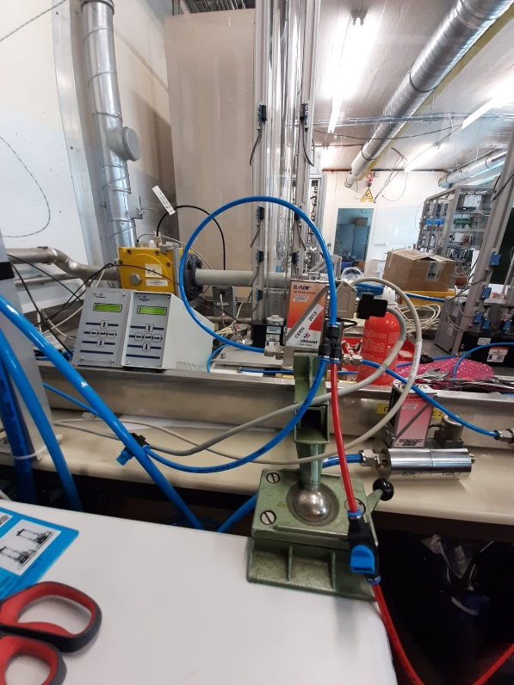

WHERE SAVE THE FILES?
>>> G:\Departments\PH\Groups\TA1\Gas_group\Bronkhorst HITEC\Certificat de calibration\BACKUP Serial number date
From FlowPlot Instrument Setting snipping ident+sens&vlv+controller
save as (serialnumber_date)
>>> G:\Departments\PH\Groups\TA1\Gas_group\Bronkhorst HITEC\Certificat de calibration
Excel file of FLUICAL (Validation and Calibration)
PDF file of FLUICAL (3 pages) (Validation and Calibration)
>>> G:\Departments\PH\Groups\TA1\Gas_group\002_LS2\PlanningComponents
Modify experiment & experiment PID LHC_MFC_INVENTORY_LS2
>>> http://eloggas.cern.ch/MFC/ new Elog (PDF of Validation and Calibration)
>>> http://eloggas.cern.ch/MFC/92 edit the table (elog 128)

>PRINT THE LABEL (blue label = calibration 2020)
Notes
- If possible connect the FLOWBUS to the device the day before the calibration, at least it starts heating
- Bar usually it means barg (bara=barg+1) (wall pressure reducer is in barg)
- Check the address physically (holes and arrows) and in the Instrument settings it can be wrong on the label
- Check on Winccoa the XMFC number it can be wrong on the label
- At the end of calibration with CF4, SF6, O2, CH4 and other particular gas, flush the line with Ar or N2 at 100% set point to clean the line.
- Calibrate CH4 MFC with N2 if u don’t have the CH4 (never with CF4, you could damage the MFC)

TRAINING BRONKHORST 20-21 November 2019
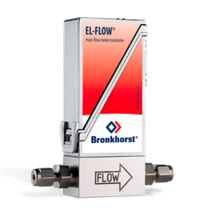
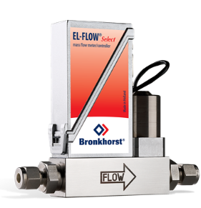
Notes and Calibration Procedure
XX-FLOW Select Products
Generalities
EL: Laboratory series (IP-40)
IN: Industrial series (IP-65 + ATEX)
MFC
MFM
You can have a Mass Flow Meter (MFM) or a Mass Flow Controller (Meter + Control Valve = MFC). MFM can also work as a controller if we add a valve (e.g. if we want the control valve at a certain distance from the meter).
Useful site for gas conversion factors FLUIDAT On the Net (registration needed).
Working Principle
It measures mass flow rate (kg/s or, as more often with gases, Ln/h). As a reminder, normal conditions (NTP) are T= 20 C; p = 1 atm.
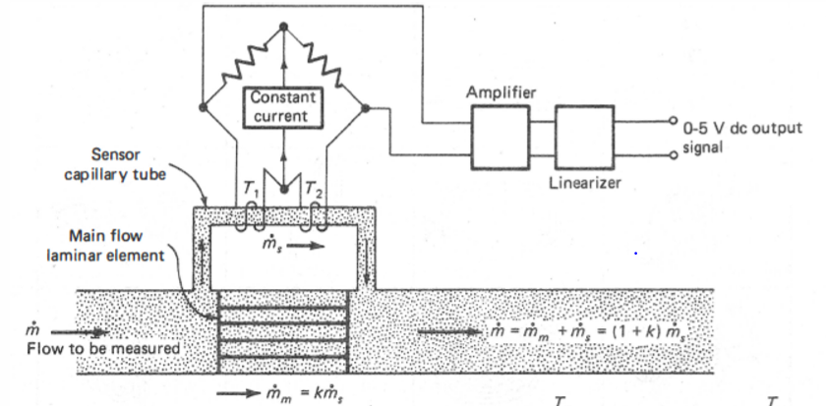
These thermal flow meters are based on a heat exchange principle. On a capillary bypass (capillary size from 0.2 to 0.8mm, it is used to reduce thermal power and keep the device cheaper) two PT100 are installed and they work both as heaters and temperature sensors.

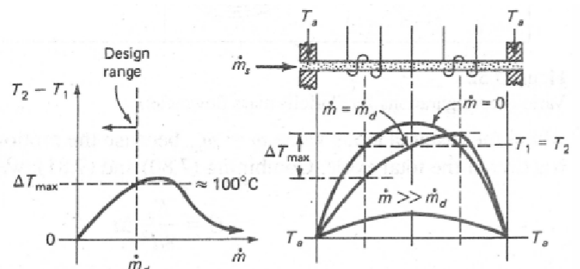
When the flowrate changes the temperature of the two filaments changes as well. The two resistors are part of a Wheatstone bridge in order to have an output proportional to the differential temperature T1-T2.

Without flow the temperature profile in the capillary is symmetric. If there’s a flow the profile becomes asymmetric: the temperature in the first element is going to decrease, the second one is almost the same.
Knowing the temperature difference and the thermal power introduced, it is possible to calculate the mass flow rate:
$\dot{Q}=\dot{m }c_{p} ∆T$
It is important to know the used gas, in order to know the specific heat factor of the gas.
$$SignalOutput=k c_{p} \dot{m}$$
Also, it’s important to operate within the linearity limits.
A Laminar Flow Element is introduced in the device in order to keep the flowrate proportional to the $∆p$. This LFE is made with several disks containing many micro channels: in each channels the flow rate is about 10 mLn/min.
The communication can be achieved with different buses: we use FLOWBUS or PROFIBUS-DP. The bus also gives the power supply and the analog signal to the device.
- If there’s written MBC3 (card board) it means that you can change the Analog Input from Software. Usually it’s for new models.
- Control mode (P12): I must tell the device which kind of setpoint / control signal I want to use (analog, digital, RS232). Usually P12 is set RS232.
- Knowing P1, P2, flowrate and gas you can calculate the proper Orifice Size
- There are different types of instruments: e.g. D type is for low $∆p$ and it cannot be used vertical nor tilted.
- Different kind of O-Rings depending on the gas: e.g. for Ar, N2, air -> Viton (green). For SF6, R134a -> EPDM (black).

Information communication
The communication can be performed using different buses. Most commonly used at CERN are FLOWBUS and PROFIBUS.
FLOWBUS is preferred with small laboratory installation: it’s more compact since it also supplies power to the DMFC. It’s possible to setup a dynamic mixer: one device is the Master and many others are the slave -> you set the flow on the master and different slave factors on the others line. There are always a beginning (red) and end (black) termination for the MFC chain connected by flowbus. It also possible to give power supply even using flowbus, but in that case all the devices on the chain must have a common supply.
PROFIBUS instead is for more industrial application (LHC experiments). Each MFC requires external power supply and each device is separated and independent. In this case there are no terminations of the chain but switches: end switch must be set OFF, the beginning enters the chassis and must be ON.
For the address setup there is a switch on the device. If you want to see the device address press 3 times the button on the top of the MFC and count the blinking flashes: the first color light are dozens, the second units.
Bright is a display for local reading: it allows to read locally the flow, set the setpoint, trigger alarms, etc. You can plug it on the bus port of the device and it requires a 24VDC power supply (e.g. PIPS).
Valves
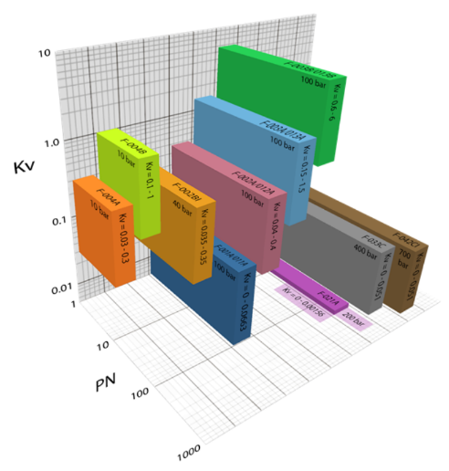
There are different kind of valves. An important thing to understand is that all of them are control valves, not shut off valves, so if there’s not the right pressure you can have a leak through it.

Also keep in mind that usually P2 is ~20% less than P1 (that gives an idea of the$∆p$). Obviously, the bigger the orifice, the smaller the pressure with which they can work. Remember: Kv is the flow of water Q in m3/h measured at 4°C (Density = 1000kg/m3) which for a pressure loss of 1 bar, passes through the valve considered as entirely open.
Orifice size, Kv, P1, P2 and flowrate should be considered when dimensioning the valve for each application.

Bronkhorst mainly uses two different types of control valves:
- Direct valves: all the flow passes through the body of the valve. The lift of the plunger is ¼ of the orifice diameter.
- Pilot valves: only a part of the flow passes through the valve. More complex design, there a piston moving accordingly to the pressure difference between the inlet and pilot chamber. Important: O-Rings of the main piston need lubrication with Krytox (Dupont).

